บช. 201 การบัญชีชั้นต้น
แบบฝึกหัด บทที่ 11
ผศ. ดร. อรพรรณ ยลระบิล

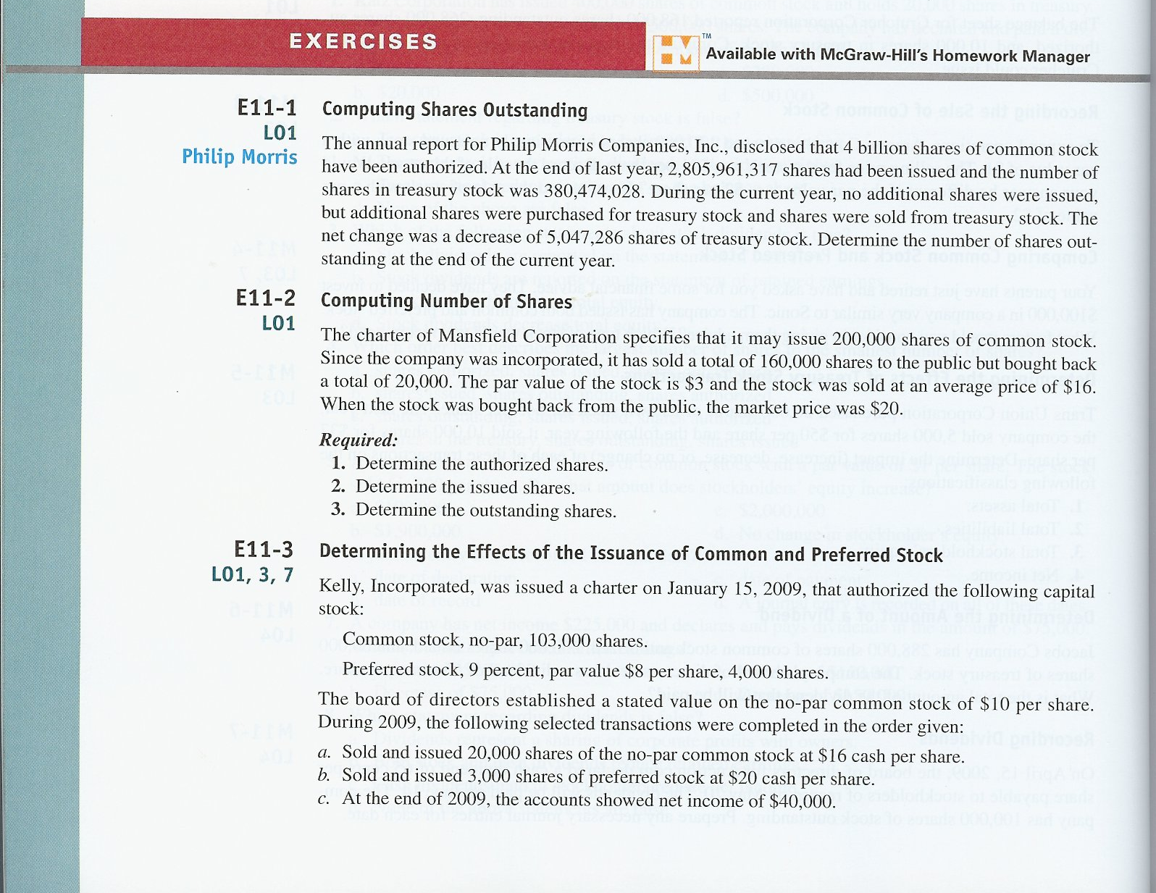
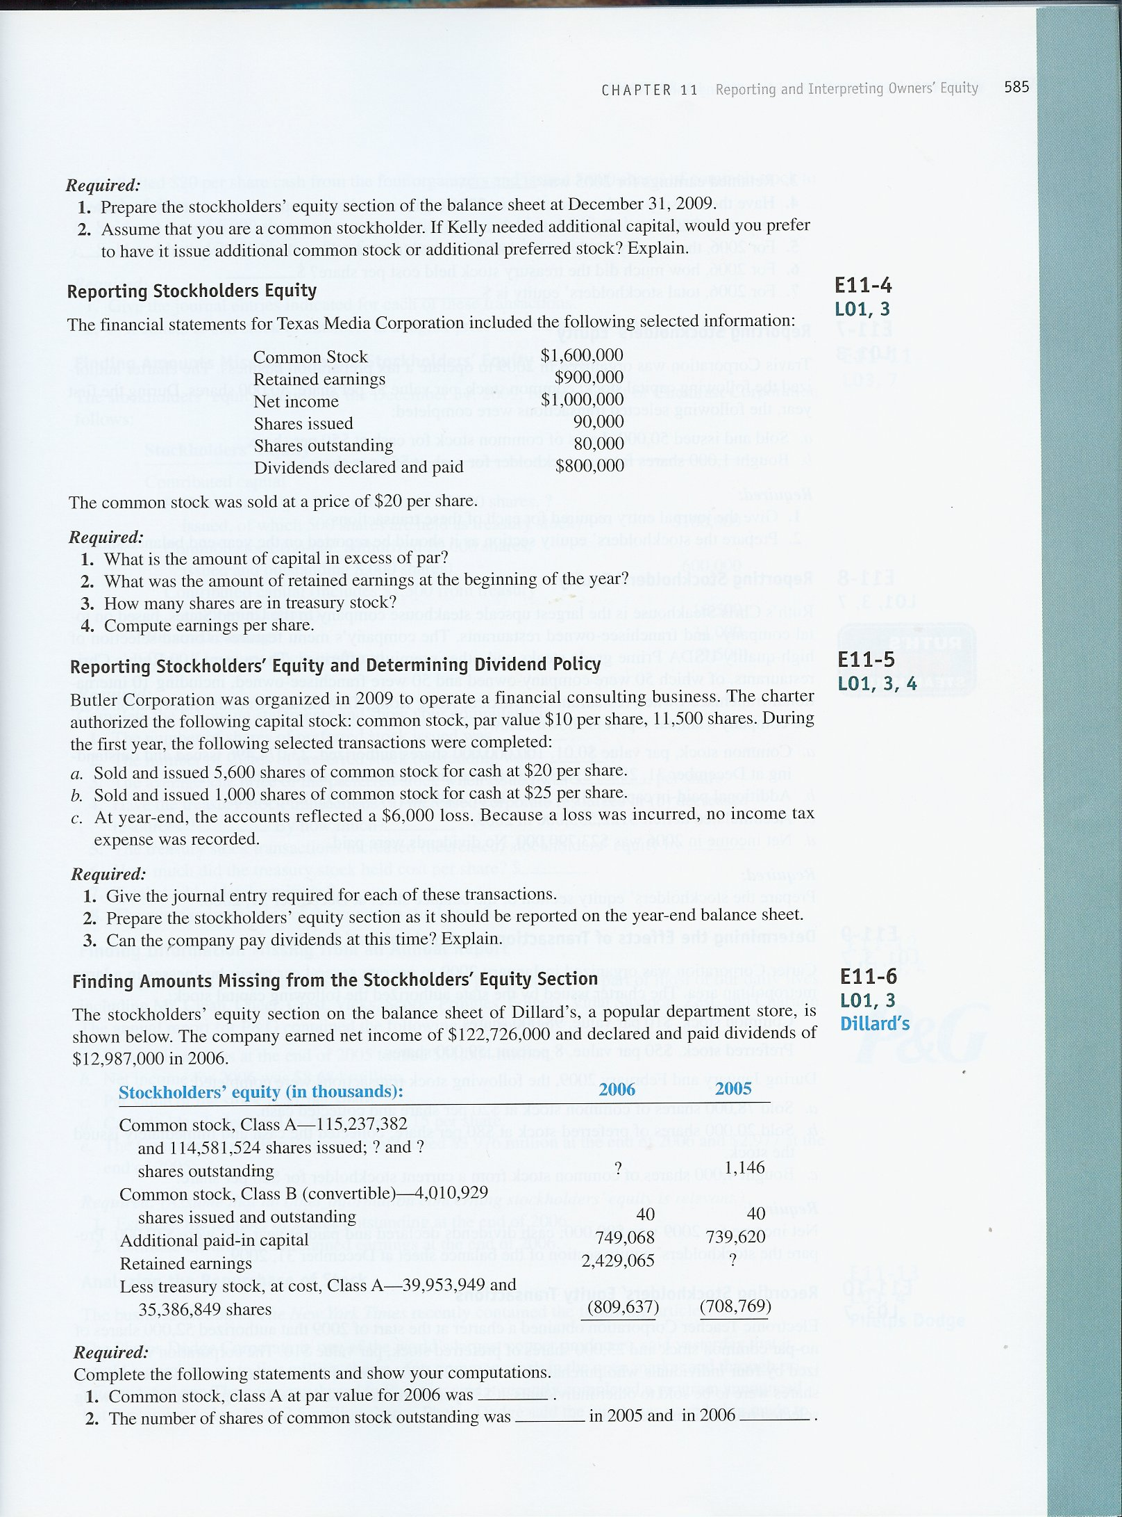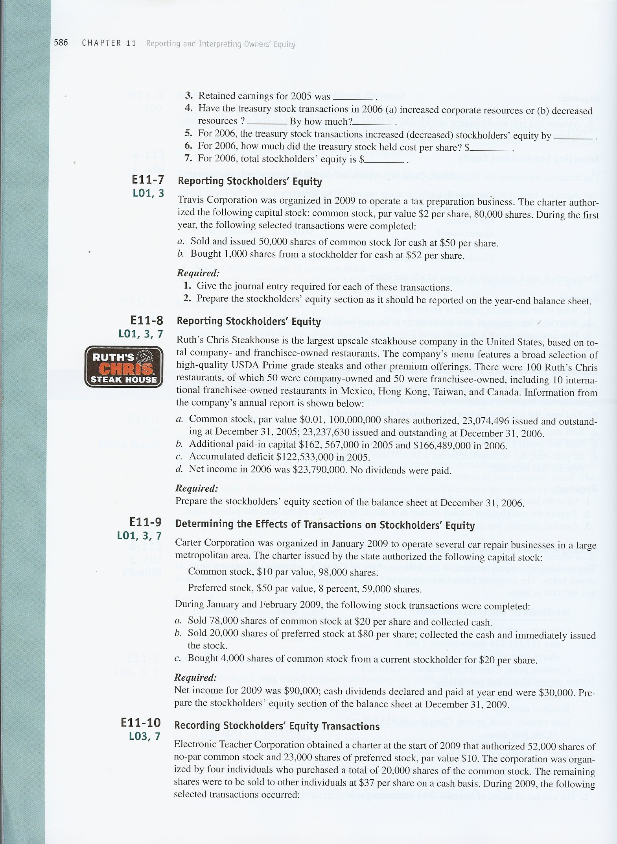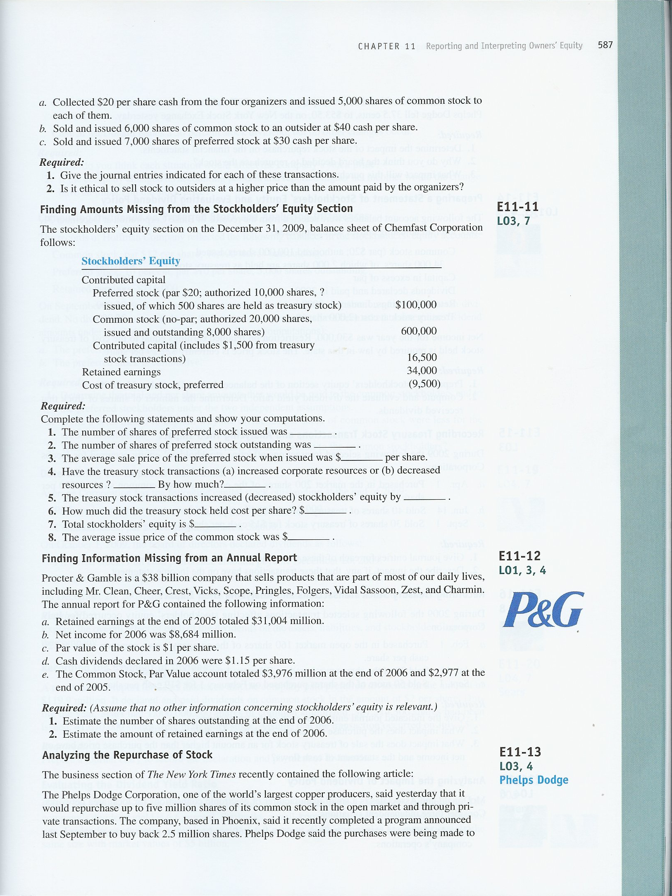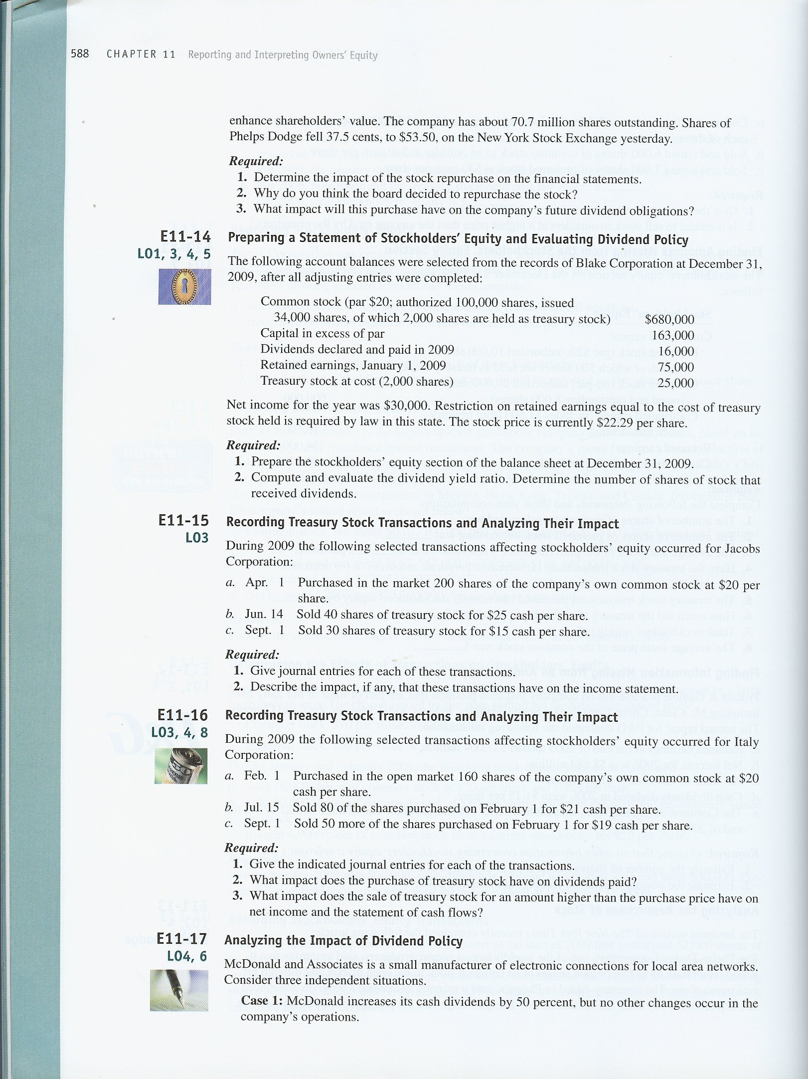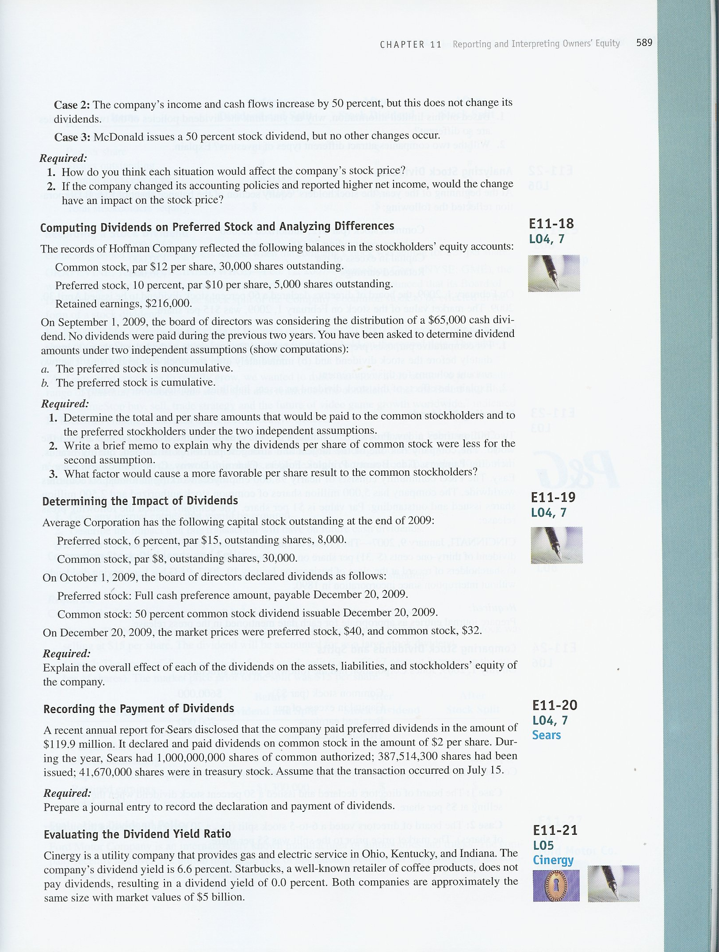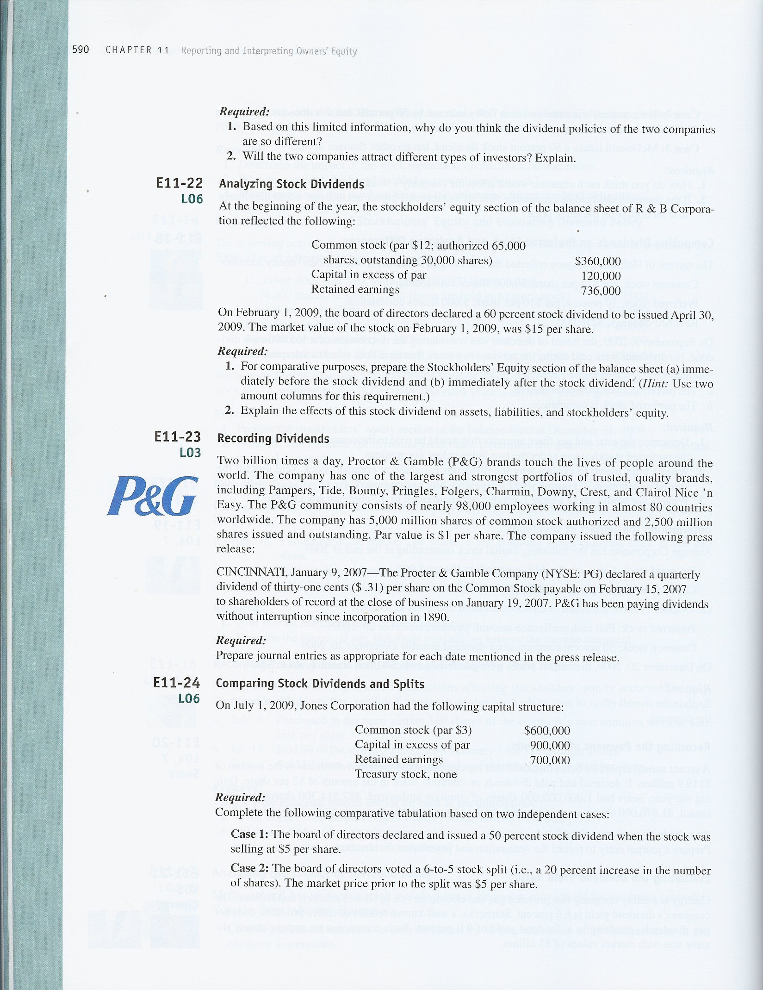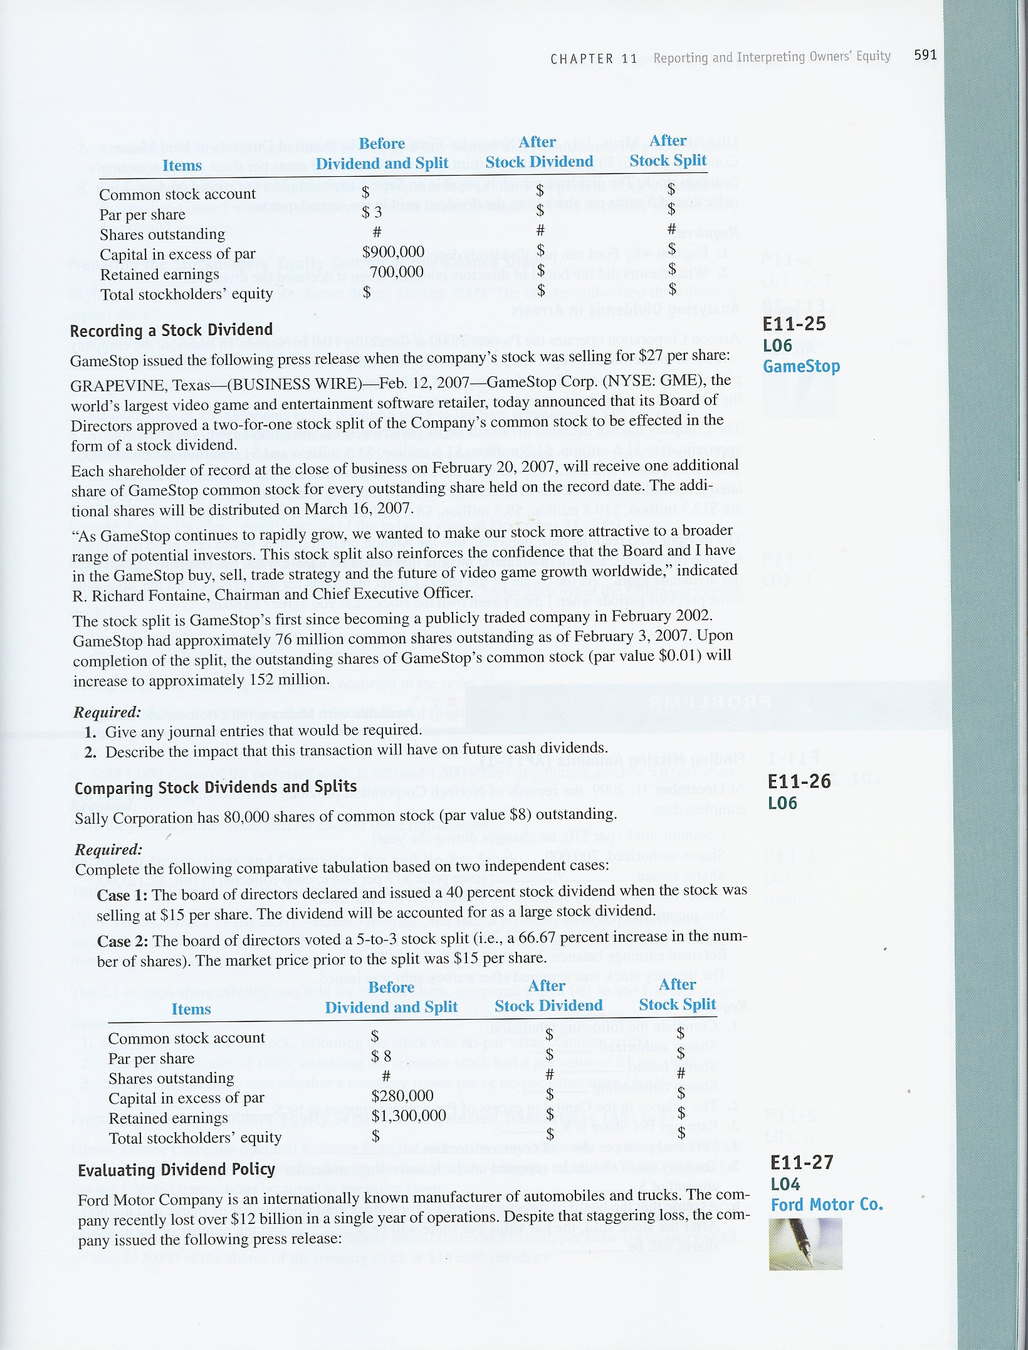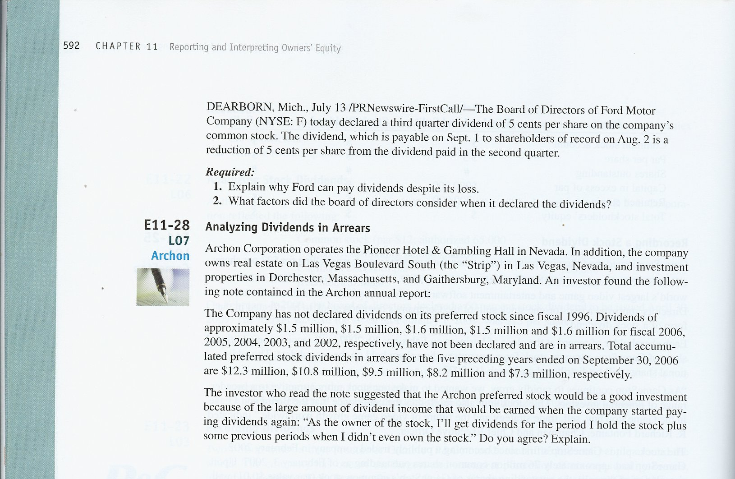

EEXERCISES
E11–1.
Computation of End of Year Balance for Treasury Stock:
Beginning balance 380,474,028
Net decrease ( 5,047,286)
Ending balance 375,426,742
Computation of Shares Outstanding:
Issued shares 2,805,961,317
Treasury stock ( 375,426,742)
Shares Outstanding 2,430,534,575

E11–2.
Req. 1 The number of authorized shares is specified in the corporate charter: 200,000.
Req. 2 Issued shares are the shares sold to the public: 160,000
Req. 3 Issued shares 160,000
Treasury stock (20,000)
Outstanding shares 140,000

E11–3.
Req. 1
Stockholders’ Equity
Contributed capital:
Preferred stock, authorized 4,000 shares,  issued and outstanding, 3,000 shares | $ 24,000
Common stock, authorized 103,000 shares,  issued and outstanding, 20,000 shares | 200,000
Contributed capital in excess of par, preferred | 36,000
Contributed capital in excess of stated value, no-par common | 120,000
Total contributed capital | $380,000
Retained earnings | 40,000
Total Stockholders’ Equity | $420,000

Req. 2
The answer would depend on the profitability of Kelly and the stability of its earnings. The preferred stock has a 9% dividend rate. If Kelly earns more than 9%, the additional earnings would accrue to the current stockholders. If Kelly earns less than 9%, it would pay a higher rate to the preferred stockholders.

E11–4.
Req. 1 ($20 x 90,000 shares) - $1,600,000 = $200,000
Req. 2 $900,000 - $1,000,000 + $800,000 = $700,000
Req. 3 90,000 shares – 80,000 shares = 10,000 shares
Req. 4 EPS = $1,000,000 ÷ 80,000 = $12.50

E11–5.
Req. 1
a. | Cash (5,600 shares x $20) (+A) | 112,000
 | Common stock (5,600 shares x $10) (+SE) |  |  | 56,000
 | Contributed capital in excess of par, common stock (+SE) |  |  | 56,000
 | Sold common stock at a premium.
b. | Cash (1,000 shares x $25) (+A) | 25,000
 | Common stock (1,000 shares x $10) (+SE) |  |  | 10,000
 | Contributed capital in excess of par, common stock (+SE) |  |  | 15,000
 | Sold common stock at a premium.
Req. 2
Stockholders’ Equity
Contributed capital:
Common stock, par $10, authorized 11,500 shares,  outstanding 6,600 shares | $ 66,000
Contributed capital in excess of par | 71,000
Total contributed capital | 137,000
Retained earnings (deficit) | (6,000 |  |  | )
Stockholders’ equity | $131,000

Req. 3
The company has a negative balance in retained earnings, which, in most cases, would preclude the payment of dividends. Dividends are a distribution of earnings to the owners. In the absence of retained earnings, dividends should not be paid.

E11–6.
Req. 1
Common stock, class A at par value: 115,237,382 X $0.01 = $1,152 (thousand)

Req. 2
Number of shares outstanding 2006: 115,237,382 shares issued minus 39,953,949 shares held as treasury stock = 75,283,433.
Number of shares outstanding 2005: 114,581,524 shares issued minus 35,386,849 shares held as treasury stock = 79,194,675.

Req. 3
(In thousands) Retained earnings for 2006: $2,429 065 minus net income for 2006 $122,726 plus dividends for 2006 $12,987 = $2,319,326

Req. 4
As of 2006, treasury stock had decreased corporate resources by $809,637.

Req. 5
For 2006, treasury stock transactions decreased stockholders’ equity by $100,868 ($708,769 - $809,637).

Req. 6
For 2006, treasury stock cost per share: $809,637,000 ÷ 39,953,949 shares = $20.26.

Req. 7
For 2006, total stockholders’ equity: $2,369,689.

E11–7.
Req. 1
a. | Cash (50,000 shares x $50) (+A) | 2,500,000
 | Common stock (50,000 shares x $2) (+SE) |  |  | 100,000
 | Contributed capital in excess of par, common stock (+SE) |  |  | 2,400,000
 | Sold common stock at a premium.
b. | Treasury stock (1,000 shares x $52) (+XSE, -SE) | 52,000
 | Cash (-A) |  |  | 52,000
 | Bought treasury stock.
Req. 2
Stockholders’ Equity
Contributed capital:
Common stock, par $2, authorized 80,000 shares,  issued 50,000 shares | $ 100,000
Contributed capital in excess of par | 2,400,000
Total contributed capital | 2,500,000
Treasury stock | (52,000 |  |  |  | )
Stockholders’ equity | $2,448,000

E11–8.
Shareholders’ equity (deficit) in thousands: |  |  | 2005 |  |  |  | 2006
Common stock, par value $.01 per share; 100,000,000 shares authorized, 23,074,496 shares issued and outstanding at December 31, 2005, 23,237,630 shares issued and outstanding at December 31, 2006 |  |  | 231 |  |  |  | 232
Additional paid-in capital |  |  | 162,567 |  |  |  | 166,489
Accumulated deficit |  |  | (122,533 | ) |  |  | (98,743 | )
Total shareholders’ equity |  |  | 40,265 |  |  |  | 67,978

E11–9.
Stockholders’ Equity
Contributed capital:
Preferred stock, 8%, par $50, authorized 59,000 shares,  issued and outstanding, 20,000 shares | $1,000,000
Common stock, par $10, authorized 98,000 shares,  issued, 78,000 shares | 780,000
Contributed capital in excess of par, preferred stock | 600,000
Contributed capital in excess of par, common stock | 780,000
Treasury stock | (80,000)
Retained earnings* | 60,000
Total stockholders’ equity | $3,140,000
*($90,000 – $30,000 = $60,000.)

E11–10.
Req. 1
a. | Cash (20,000 shares x $20) (+A) | 400,000
 | Common stock, no-par (+SE) |  |  | 400,000
 | .
b. | Cash (6,000 shares x $40) (+A) | 240,000
 | Common stock, no-par (+SE) |  |  | 240,000
c. | Cash (7,000 shares x $30) (+A) | 210,000
 | Preferred stock (7,000 shares x $10) (+SE) |  |  | 70,000
 | Contributed capital in excess of par, preferred (+SE) |  |  | 140,000
Req. 2
Yes, it is ethical as long as there is a full disclosure of relevant information. In any arm’s length transaction, an informed buyer will pay the market value of the stock.

E11–11.
Req. 1
Number of preferred shares issued: $100,000 ÷ $20 = 5,000

Req. 2
Number of preferred shares outstanding: 5,000 shares issued minus 500 shares held as treasury stock = 4,500.

Req. 3
Average sales price per share of preferred stock when issued: ($100,000 + $15,000) ÷ 5,000 shares = $23.00.

Req. 4
Decreased corporate resources by $9,500 - $1,500 = $8,000.

Req. 5
Treasury stock transactions decreased stockholders’ equity by $8,000 (same as the decrease in corporate resources in 4 above).

Req. 6
Treasury stock cost per share: $9,500 ÷ 500 shares = $19.00.

Req. 7
Total stockholders’ equity: $741,000.

Req. 8
Issue price of common stock $600,000 ÷ 8,000 shares = $75.00

E11–12.
Req. 1
The number of shares that have been issued is computed by dividing the common stock account ($3,976 million) by the par value of the shares ($1 per share) or approximately 3,976,000,000 shares.

Req. 2
Retained earnings end of 2005 | $31,004,000,000
Net income for 2006 | 8,684,000,000
Dividends for 2006 | (4,572,400,000 | )
Retained earnings end of 2006 | $35,115,600,000
The amount of retained earnings is an estimate because we do not know the exact number of shares outstanding (because we do not know the number of shares in treasury stock. This number is needed to determine the amount of dividends paid during 2006. We based the dividends on the estimate calculated in the previous requirement.

E11–13.
Req. 1
Assets | - $133,750,000
Stockholders’ Equity | - $133,750,000
The treasury stock account is a contra equity account, meaning that it subtracts from the total stockholders’ equity. Cash also decreases on the balance sheet by the same amount.

Req. 2
Many companies repurchase common stock in order to develop an employee bonus plan that provides workers with shares of the company’s stock as part of their compensation. Because of SEC regulations concerning newly issued shares, companies find it cheaper to give their employees shares of stock that were purchased from stockholders than to issue new shares. In this case, the company mentions the goal of enhancing shareholders’ value. If the company maintains its current level of income, earnings per share will increase with fewer shares outstanding. The management expects that the increase in EPS will be reflected in an increase in stock price.

Req. 3
Shares that are held in treasury stock do not participate in dividend payments. As a result, the purchase of treasury stock will reduce the amount of dividends that the company must pay in future years.

E11–14.
Req. 1
Stockholders’ Equity
Contributed capital:
Common stock, authorized 100,000 shares, issued 34,000 shares, of which 2,000 shares are held as treasury stock | $680,000
Contributed capital in excess of par | 163,000
Total contributed capital | $843,000
Retained earnings | 89,000
Total | $932,000
Less: Cost of treasury stock | 25,000
Total Stockholders’ Equity | $907,000

Req. 2
The dividend yield ratio is 2.24% ([$16,000 ÷ 32,000 shares] ÷ $22.29). While this yield seems small, it is a typical return on common stock. Investors receive a return from both dividends and stock price appreciation.

Treasury stock does not receive dividends. As a result, dividends should be paid on 32,000 shares.

E11–15.
Req. 1
a. | Treasury stock (200 shares x $20) (+XSE, -SE) | 4,000
 | Cash (-A) |  |  | 4,000
 | Bought treasury stock.
b. | Cash (40 shares x $25) (+A) | 1,000
 | Treasury stock ( 40 shares x $20) (-XSE, +SE) |  |  | 800
 | Capital in excess of par (+SE) |  |  | 200
 | Sold treasury stock.
c. | Cash (30 shares x $15) (+A) | 450
 | Capital in excess of par (-SE) | 150
 | Treasury stock (30 shares x $20) (-XSE, +SE) |  |  | 600
 | Sold treasury stock.

Req. 2
It is not possible to make a “profit” or “loss” on treasury stock transactions. Therefore, these transactions do not affect the income statement.

E11–16.
Req. 1
Feb. 1:
Treasury stock, common (160 shares x $20) (+XSE, -SE) | 3,200
Cash (-A) |  |  | 3,200
July 15:
Cash (80 shares x $21) (+A) | 1,680
Treasury stock, common (-XSE, +SE) |  |  | 1,600
Capital in excess of par (+SE) |  |  | 80
Sept. 1:
Cash (50 shares x $19) (+A) | 950
Capital in excess of par (-SE) | 50
Treasury stock, common (50 shares x $20) (-XSE, +SE) |  |  | 1,000
.
Req. 2
Dividends are not paid on treasury stock. Therefore, the amount of total cash dividends paid is reduced when treasury stock is purchased.

Req. 3
The sale of treasury stock for more or less than its original purchase price does not have an impact on net income. The transaction affects only balance sheet accounts. The sale of treasury stock is a cash inflow which would affect the Statement of Cash Flows.

E11–17.
Req. 1
Case 1: When companies unexpectedly announce increases in dividends, stock prices typically increase. Depending on course objective, the instructor may want to discuss research in finance concerning dividend policy.
Case 2: Stock price is based on expectations. If the increase in operating performance was not expected, the stock price should increase. It is not necessary to increase dividends to have a favorable stock price reaction.
Case 3: Stock dividends do not provide any economic value but they may have a signal effect and are often associated with increases in cash dividends. As a result, stock dividends do not appear to directly cause an increase in stock price but are often associated with factors that do impact favorably on price.

Req.2
Stock prices react to underlying economic events and not changes in reporting methods, per se. Markets are relatively effective in recognizing the difference between profits generated by operations and profits generated by the use of liberal accounting policies.

E11–18.
Req. 1 |  | Preferred (5,000 Shares) |  |  |  | Common (30,000 Shares) |  |  |  | Total
a) | Noncumulative:
 | Preferred ($50,000 x 10%) |  | $ 5,000 |  |  |  |  |  |  | $ 5,000
 | Balance to common ($65,000 – $5,000) |  |  |  |  |  | $60,000 |  |  | 60,000
 |  |  | $ 5,000 |  |  |  | $60,000 |  |  | $65,000
 | Per share |  | $1.00 |  |  |  | $2.00
b) | Cumulative:
 | Preferred, arrears ($50,000 x 10% x 2 years) |  | $ 10,000 |  |  |  |  |  |  | $ 10,000
 | Preferred, current year ($50,000 x 10%) |  | 5,000 |  |  |  |  |  |  | 5,000
 | Balance to common ($65,000 – $10,000 – $5,000) |  |  |  |  |  | $50,000 |  |  | 50,000
 |  |  | $15,000 |  |  |  | $50,000 |  |  | $65,000
 | Per share |  | $3.00 |  |  |  | $1.67

Req. 2
The total dividend amount and dividends per share of common stock were less under the second assumption because the preferred stock preferences increased while at the same time the total dividend amount remained stable.

Req. 3
Larger total dividend distributions are more favorable for the common stockholders.

E11–19.
Item |  | Effect of Cash Dividend (Preferred) |  | Effect of Stock Dividend (Common)
Assets |  | –No effect on declaration date.  –Decreased by the amount of the dividend ($7,200) on payment date. |  | No effect because no assets are disbursed.
Liabilities |  | –Increased on declaration date ($7,200).  –Decreased on payment date ($7,200). |  | No effect—no entry on declaration date because no contractual liability is created (no assets are disbursed).
Stockholders’ equity |  | Decreased by the amount of the dividend (retained earnings decreased by $7,200). |  | –Total stockholders’ equity not changed.  –Retained earnings reduced and contributed capital increased by same amount ($120,000).

E11–20.
July 15
Retained earnings (-SE) | 119,900,000
Cash (-A) |  |  | 119,900,000
Declaration and payment of preferred dividends.
Retained earnings (-SE) | 691,688,600
Cash (-A) |  |  | 691,688,600
Declaration and payment of common dividends.
Computation of shares outstanding:
Shares issued | 387,514,300
Treasury stock | 41,670,000
Shares outstanding | 345,844,300
Dividends paid:
345,844,300 x $2 = $691,688,600

E11–21.
Req. 1
Cinergy is a utility company that is very established. They have very little opportunity for growth and they have stable business operations. Therefore, they have the ability to have a high dividend yield. On the other hand, Starbucks is a fairly new company with a high opportunity for growth. Due to the fact that they are retaining all of their earnings to invest into their growth, they have a 0.0% dividend yield.

Req. 2
The companies will attract two different types of investors. Cinergy will attract investors who want and/or need current income, such as someone who is retired. Starbucks will attract investors who want appreciation on their stock price, such as someone who is planning for their retirement in 25 years.

E11–22.
Req. 1
 |  | Stockholders’ Equity
 |  | Before Stock Dividend |  |  |  | After Stock  Dividend
Contributed capital:
Common stock, authorized 65,000 shares
Outstanding: 30,000 shares, par $12 |  | $360,000
Outstanding: 48,000 shares, par $12 |  |  |  |  |  | $576,000
Contributed capital in excess of par value |  | 120,000 |  |  |  | 120,000
Retained earnings |  | 736,000 |  |  |  | 520,000
Total stockholders’ equity |  | $1,216,000 |  |  |  | $1,216,000

Req. 2
Item |  | Effects of Stock Dividend
Assets |  | No change because no assets were disbursed.
Liabilities |  | No change because no liability was created (no assets were to be disbursed).
Stockholders’ equity |  | –Total stockholders’ equity not changed.  –Retained earnings was reduced by the amount of the dividend.  –The common stockaccount was increased by the same amount.

E11–23.
January 9, 2007
Retained earnings (-SE) | 775,000,000
Dividends payable (+L) |  |  | 775,000,000
2,500 (million) shares x $0.31= $775,000,000
January 19, 2007
No journal entry required.
February 15, 2007
Dividends payable (-L) | 775,000,000
Cash (-A) |  |  | 775,000,000

E11–24.
Comparative results:
Items | Before Dividend  and Split | After Stock  Dividend | After Stock  Split
Common stock account | $600,000 | $900,000 | $600,000
Par per share | $3 | $3 | $2.50
Shares outstanding | #200,000 | #300,000 | #240,000
Capital in excess of par | $ 900,000 | $900,000 | $ 900,000
Retained earnings | $ 700,000 | $ 400,000 | $ 700,000
Total stockholders’ equity | $2,200,000 | $2,200,000 | $2,200,000

Comments: Neither the stock dividend nor stock split changed total stockholders’ equity because neither involved the disbursement of assets. The stock dividend capitalized retained earnings and increased the common stock account by the same amount; it increased shares outstanding but did not change par value per share. The stock split did not change any account balances; its only effects were to (1) increase shares outstanding and (2) decrease par value per share.

E11–25.
Req. 1

February 12, 2007---No entry
February 20, 2007---No entry
March 16, 2007
Retained earnings (-SE) | 760,000
Common stock (+SE) |  |  | 760,000

Req. 2
Without additional information, one cannot determine the impact on future cash dividends. In some cases, the company will maintain its dividend per share payout, in which case total dividends will increase. In other cases, the company may reduce the dividends per share and maintain the same total payout. In the case of GameStock, the company is not currently paying cash dividends, so there is no immediate effect.
E11–26.
Comparative results:
Items | Before Dividend  and Split | After Stock  Dividend | After Stock  Split
Common stock account | $640,000 | $896,000 | $640,000
Par per share | $8 | $8 | $ 4.80
Shares outstanding | #80,000 | #112,000 | # 133,333
Capital in excess of par | $ 280,000 | $ 280,000 | $ 280,000
Retained earnings | $ 1,300,000 | $ 1,044,000 | $ 1,300,000
Total stockholders’ equity | $2,220,000 | $2,220,000 | $2,220,000

Comments: Neither the stock dividend nor stock split changed total stockholders’ equity because neither involved the disbursement of assets. The stock dividend reduced retained earnings and increased the common stock account by the same amount; it increased shares outstanding but did not change par value per share. The stock split did not change any account balances; its only effects were to (1) increase shares outstanding and (2) decrease par value per share.

E11–27.
Req. 1
A corporation does not need to earn net income in a given year in order to declare and pay dividends. There are two requirements 1) the balance of retained earnings should be sufficient to pay dividends, and 2) there must be sufficient cash on hand.

Req. 2
Clearly the board determined that the balances in retained earnings and cash were sufficient to pay dividends. The board probably analyzed cash flow for the current year and the future to determine whether the payment of dividends would create any problems in subsequent years. The board also probably took into consideration the impact of skipping a dividend. If the company did not pay a dividend, many investors might assume that the board concluded that the company might lose money for several years. This lack of confidence could have a significant impact on the price of the company’s stock. By paying a dividend, the company sent a signal to the market that the board had confidence in the long-term health of the company.

E11–28.
The fact that dividends are in arrears indicates that the company has been experiencing some financial difficulty. Most companies do not want to suspend dividend payments because it will erode investor confidence. Typically, companies are experiencing severe cash flow problems when they take this type of drastic action. The investor assumed that he would get a large cash payment “when Archon started paying dividends again.” The student should have realized that he was making a large assumption; a financially troubled company may never pay dividends again.

