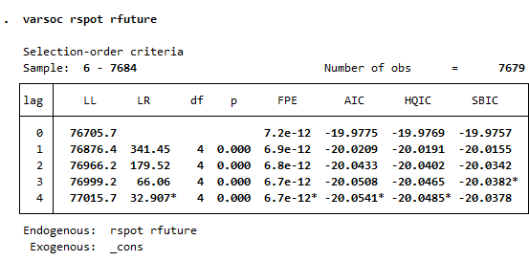
1.

From using SBIC approach, lag order that is most suitable is 3.
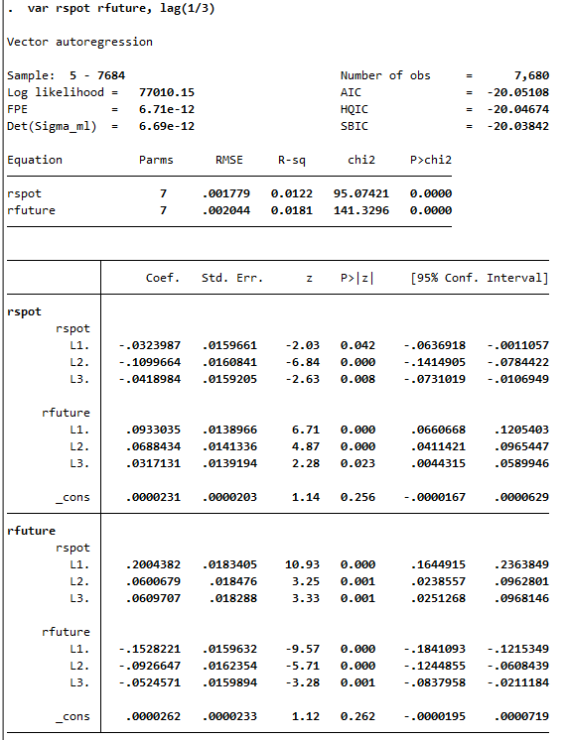
2.

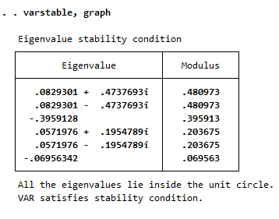

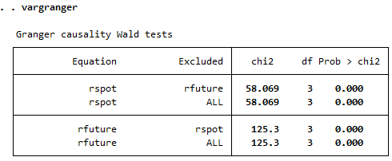

From the stability test, the system is stable as all points of eigenvalues are inside the circle. –
From the Granger exogeneity, both rfuture and rspot are all endogenous variables as all the tests are statistically significant.
3. 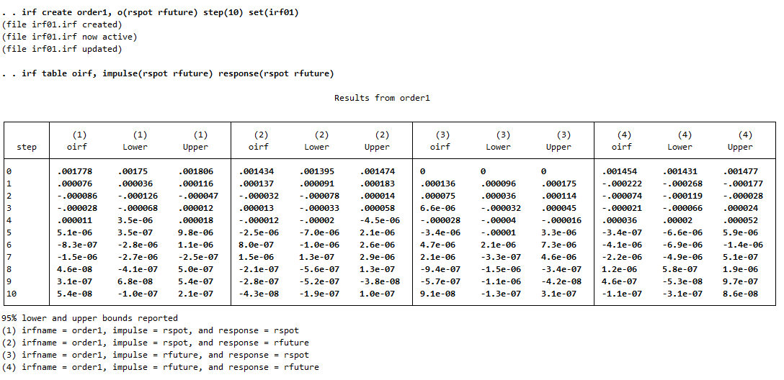

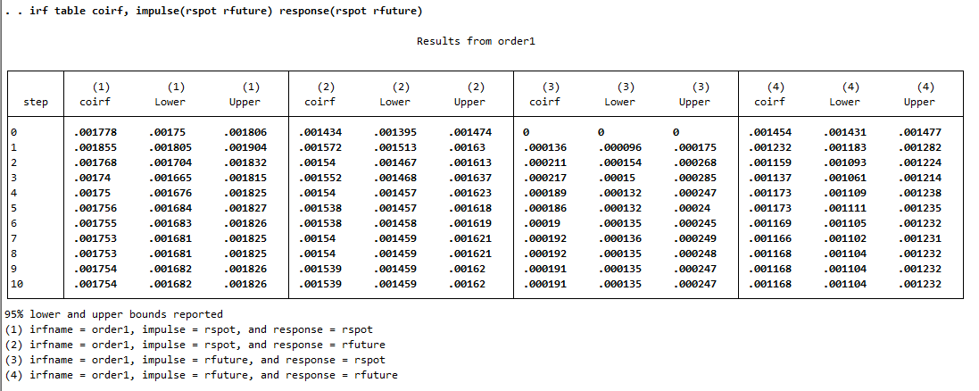

From applying IRF analysis approach, rspot does have more impact on rfuture.
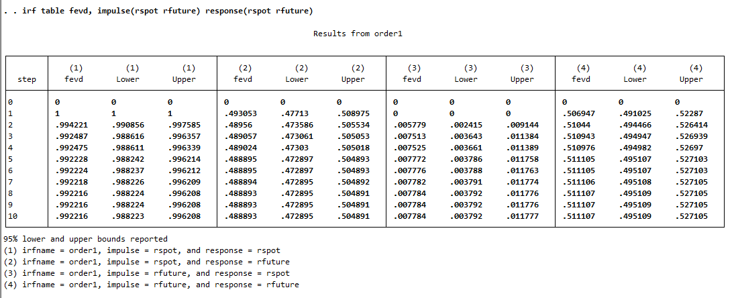
4.

From the Forecast error variance decomposition, rspot does have more impact on rfuture.

