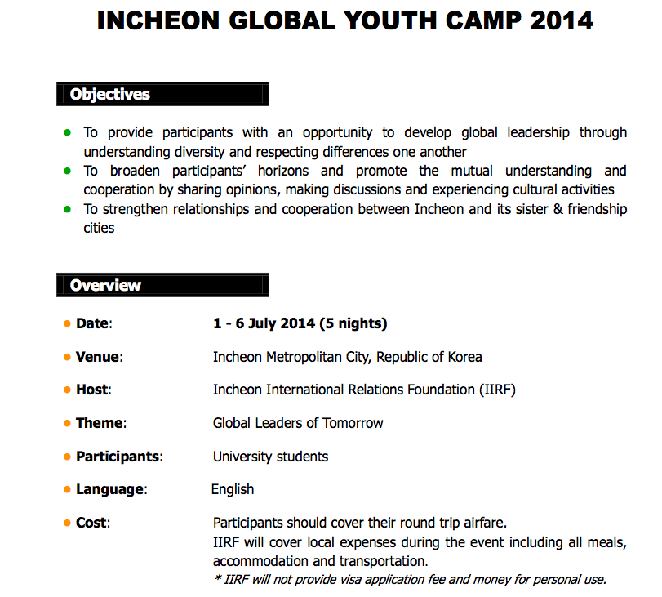
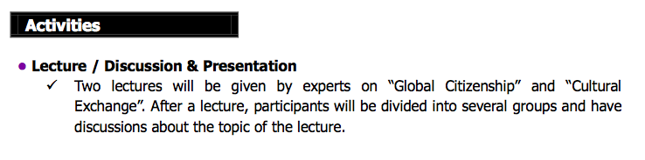

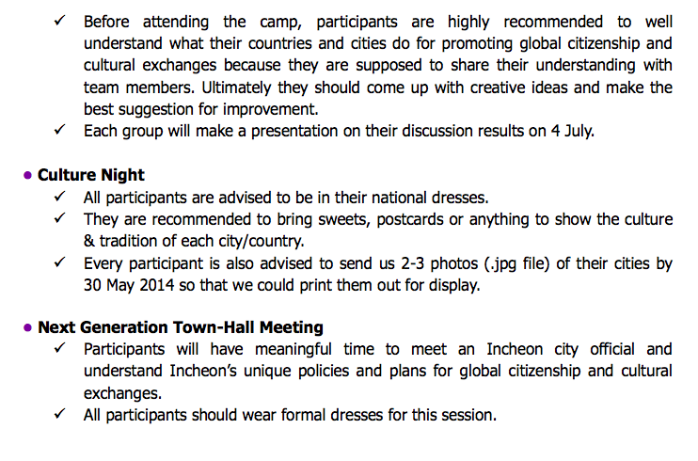
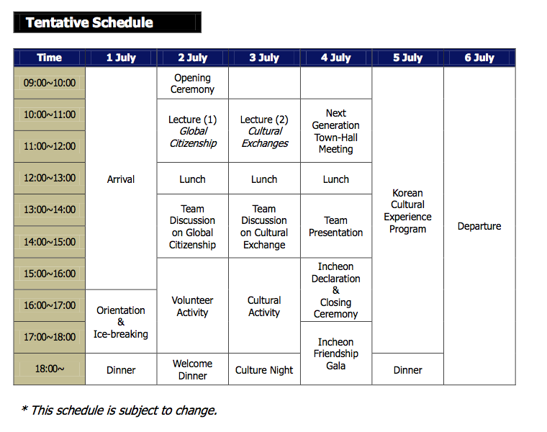

Application: Complete the Application Form on the next page and bring the form to an interview on Tuesday April 8, at 13:00 pm at Rim Nam Meeting Room on the 5th floor of Economics Building, Taprachan. Candidates will be nominated by Dr. Thanet Makjamroen to the Incheon International Relation Foundation.

INCHEON GLOBAL YOUTH CAMP 2014
APPLICATION FORM
1 - 6 July 2014 / Incheon, Republic of Korea

Name | _________ _________ _________  First Name Middle Name Family Name |  |  | Photo
Date of Birth | ______ / ______ / ______ Day Month Year | Gender | M / F
Nationality |  | Passport No.
Email |  | Telephone
Address
University |  | Major
Emergency  Contact | Name: Tel:
English Proficiency | □ Fluent □ Good □ Poor |  | Other Languages
Shirts Size | □ S □ M □ L □ XL □ XXL
Medication/Allergies/Dietary Restrictions, etc.

Brief Self-Introduction

What would you like to gain by participating in “Incheon Global Youth Camp 2014”?

I certify that the above information is true and accurate.

Name: ____________________ Date: ___________________

