“ The Middle Income trap and Thai Corporate Strategy in the Era of AEC ”
- Akira Suehiro

Part 1: Economic Performance and Trade Structure
- Annual growth rate between 2000 and 2014 is 3.94% - very low comparing to China which is about 8%
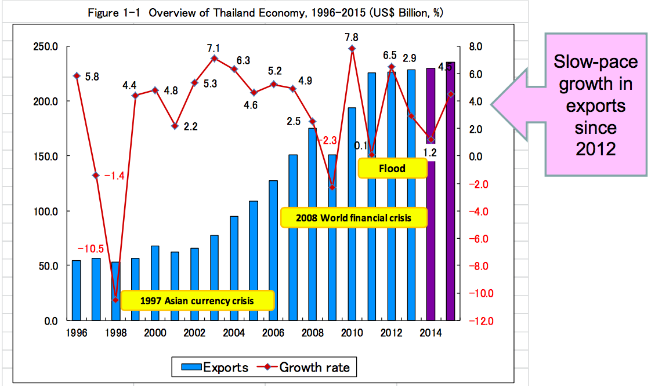
- From the figure, the rapid declines in economic growth come from 3 things (Asian Currency Crisis, 2008 World financial crisis, and flood). This implied that Thai economy is highly depending on factors outside Thailand
- Main elements boosting growth: Export and Domestic Consumption
- Major export commodities which are:
  - Agriculture, Agro Industry, and Garments are under control of Thai local firms, and also has high tendency in declining
  - Electronics and Automobile are under control of MNCs, has tendency to increase
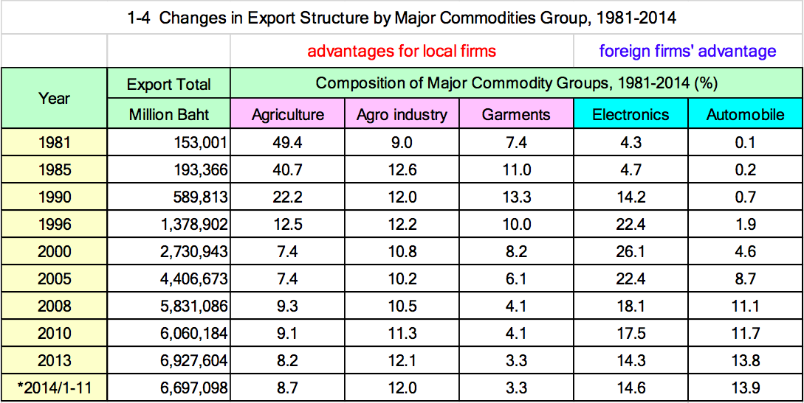
- Change in Trade Structure:
  - Big trade partners become ASEAN and China instead of USA and Japan
  - Rise of IT products and Automobile as shown in figure above, while labor – intensive products decline
- Economic Problems Facing Thailand
  - Stagnant in exports
  - Increase of minimum wage level
    - Uniformly introduced “300 baht per day”
  - The end of demographic bonus, the coming of aging society with smaller number of children
    - The annual growth rate of working-age population is decreasing
  - The absolute shortage of labor force in unskilled labor markets
    - Depending on migrant workers from Myanmar, Laos and Cambodia

Part 2: The Middle-income Trap in Thailand
Thailand used to enjoyed the rapid economic growth owing to input of cheap labor force and investment funds.
- If there is increase in labor cost and inefficient investment funds
- Economic growth will stall
- Thailand will fall into the trap between high income country and low income country
  - Cannot move to compete with high income countries
    - Because lack in innovations and R&D
    - Not creating enough value to be in global value chain
  - Cannot move to compete with low income countries
    - Because the wage increased, no more cheap labor
    - No cost advantage in production
- Thailand is ranked as a country with very low labor productivity
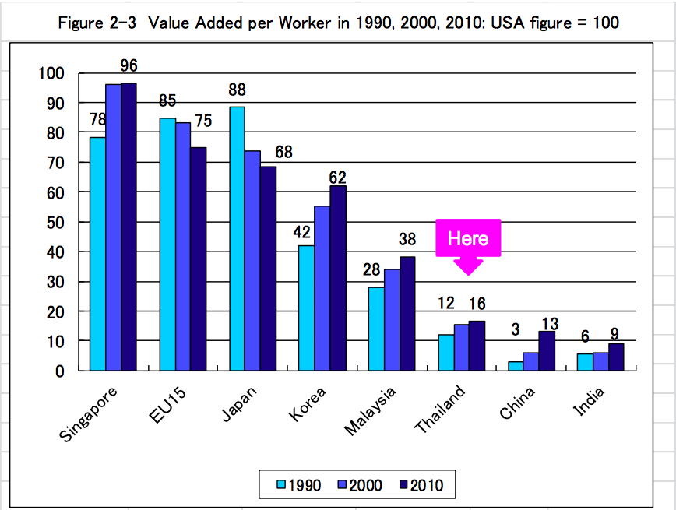
- Thailand has low level (and very inactive) of innovation, compared to NIEs
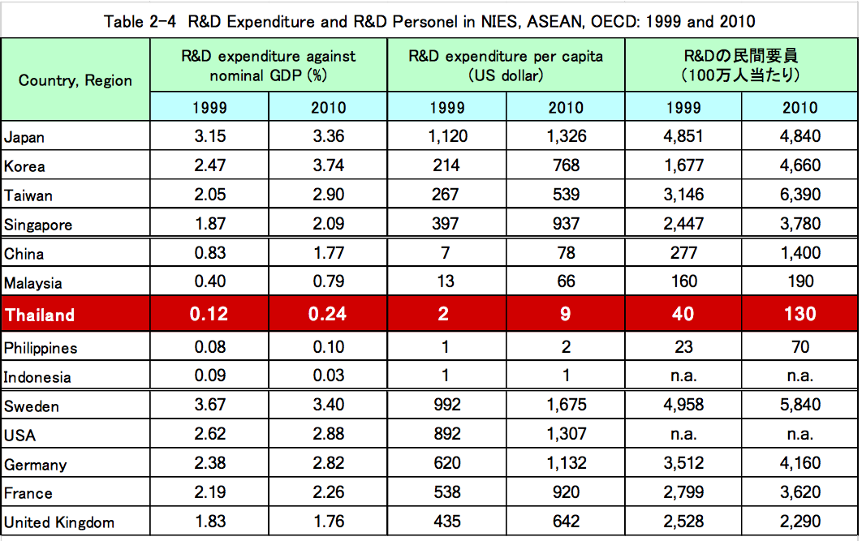
- Competitive advantages in Thai industries
  - Successfully target the core industries to enter into global supply chain
    - IT products and automobile
  - Creative Economy proposed by NESDB
    - Change from low-cost-advantage to unique industries
    - Especially those in non-manufacturing sectors, for example, service sector

Part 3: Big Firms and Revival of Family Business
- Top largest firms in Thailand are mostly Family business
- Family business is so big. Some of them (CP for example) own education institute, Panyapiwat, which the classes are lectures not in Thai but in English, Chinese, and Japanese. Family business is concluded to be very active in term of improving human capital.
- The price of land in Bangkok is very expensive, People shift from owning land to owning residence instead. The tendency is however, increasing.
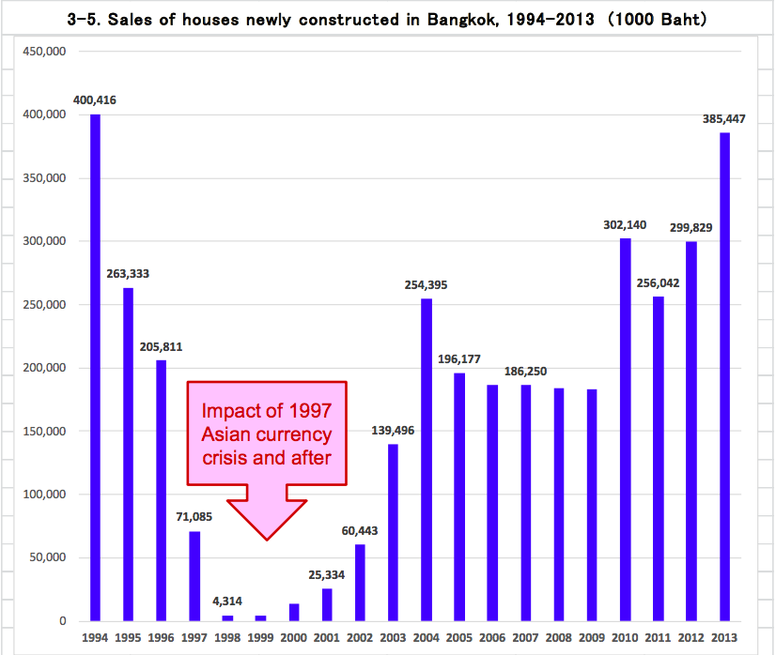
- Family business is also a strong stakeholder in non-manufacturing sector, in particular, service sector
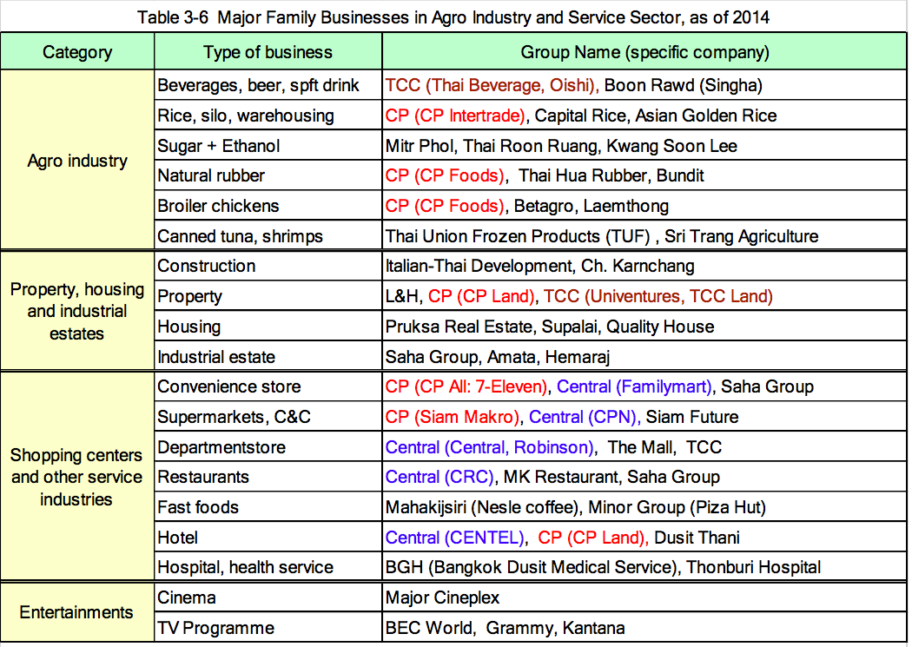
- Family business in Thailand also enjoy
  - Utilization of domestic resources knowhow for local market
  - Economic liberalization – lower tax rate
  - Political connection and regulation
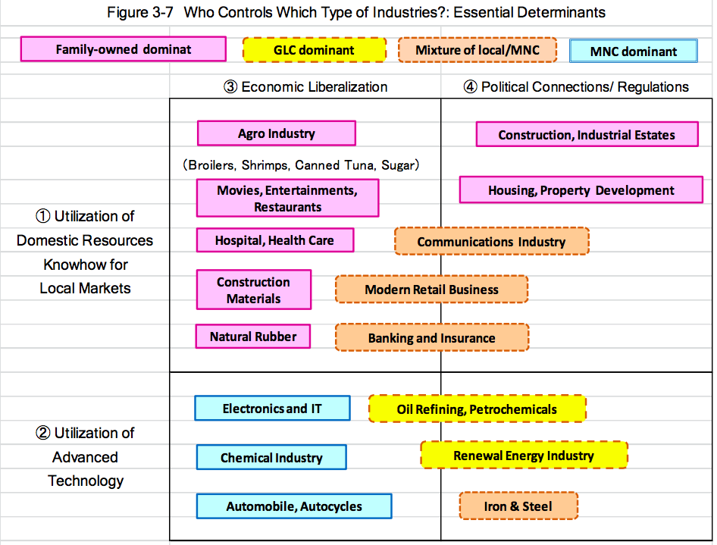

Part 4: New Strategies of Thai Big Corporations
- Thai family business in groups
  - Group 1: Growing bigger and bigger
  - Group 2: Revival and further expansion
  - Group 3: Newly Emerging group
  - Group 4: Collapse
- Strategies and means to expand business of Thai local family-owned firms
- Selection and connection
  - Not much on diversification
- Utilization of land as strategic assets
  - As mentioned before, land are expensive and price of land increase in a very high rate
  - Firms use the land as collateral for banking loans
  - TCC and CP has own a lot of land, even more than the king has
- M&A as a tool for expansion
  - Faster than organically grow business
  - Case of CP group and Pinyang life insurance in mainland China
- Response to the start of AEC
  - Targeting into those countries that are rich in resources, which are the CLMV
  - Targeting with the big trade partners, ASEAN
- Strategic alliance with Chinese firms
  - Case of CP

Part 5: Alternative to the East Asian Model
- Japan, Korea, Taiwan, and now China shared the similar growth pattern
  - Upgrading industry’s structure
    - Continuous promote innovations in manufacturing sector
- Thailand could choose different growth pattern since
  - It is not suitable with Thai culture and lifestyle, Thai embedded autonomy
  - Thailand has poor technological base in manufacturing sector
    - Low level of innovation
    - Low R&D
- The growth pattern that suit for Thailand is that
  - Should not aim at becoming a high income country, and approach it like others
  - Should seek for the different positioning
    - In non-manufacturing sector that Thailand already has some level of advantages
      - Agro industry
      - Service sector

