Suprachaya Chinda
5604641687
Assignment 2 (FN281)

- Discuss one Insurance product and comment on its benefits
Design your life with happiness after retirement with AIA Annuity Fix, which can satisfy your desire in both saving and pension, if you have a certain saving objective and are looking for pension used after retirement.
Condition: 1. Protection period: Start from purchasing day till buyer is 85 years old
2. Required Age of buyer is between 20 – 55 years old
Benefits received: 1. Protection. If you die before 60 years old (before receiving pension), you will get 105% of whole interest paid excluding additional interest of contact. If you die between 60-74 years old (pension paying period) meaning that you die before 15 years, company will pay the unpaid amount which equal to the amount that you get in the present based on pension value table for all leftover years.
2. Pension given age of buyer is between 60-85 years old. Male will receive 6.25% of original pension and Female will receive 5.95% of original pension.
3. Tax reduction.

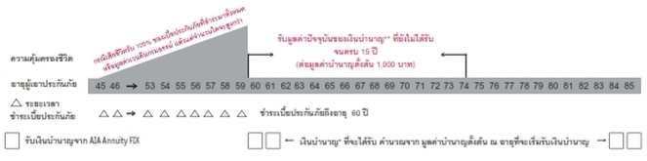

2) Which mortgage would result in higher total payments?
Mortgage A: $970 a month for 30 years
Mortgage B: $760 a month for 5 years and $1005 for 25 years

First, assume that the annual interest rate for mortgage is equal to 6%, so monthly interest rate is 6%/12 = 0.5% then find the present value (PV) of each mortgage in order to compare the total payment
- Mortgage A: Total payment = $970*(30*12) = $349,200
- Mortgage B: Total payment = ($760*5*12)+($1005*25*12) =
$347,100
Hence Mortgage A has higher total payments.

3) What are the two main types of consumer credit?

There are two main types of consumer credit that are Closed-End Credit and Open-End Credit

First one is Closed-End Credit. It is used for the certain objective such as loan for car given a specified amount of payments over a specific period. A written agreement for each credit purchase is required as an obligation for a borrower to pay back the loan in the future. In addition, creditor keeps title to the merchandise until all payments paid for example, installment cash credit and installment sales credit.

Second one is Open-End Credit. It is used for small purchase, which do not higher than line of credit (the maximum amount given). Payment of interest or financial transaction fees may occur like credit card, debit cards and overdraft lines.

4) What are the general rules of measuring credit capacity?

There are 2 ratios for general rules of credit capacity

- Debt Payments to Income Ratio should not higher than 20%
Debt Payments to Income Ratio = $\frac{monthly debt payments}{monthly income}$

- Debt to Equity Ratio should not higher than 0.5
Debt to Equity Ratio = $\frac{Liabilities}{Net Worth}$

5) A few years ago, Michael Tucker purchased a home for $100,000. Today, the home is worth $150,000. His remaining mortgage balance is $50,000. Assuming that Michael can borrow up to 80 percent of the market value, what is the maximum amount he can borrow?

Give information
- The present market value of Michael’s home is $150,000
- Michael can borrow up to 80% of the market value which is 80%*$150,000 = $120,000
- The remaining mortgage balance is $50,000

Therefore Michael can borrow up to the maximum amount which is 120,000-50,000 = $70,000

