Midterm FN312 Semester 1/2016

Question 1 (20 points)

Consider the following Treasury bill quote. For the Treasury bill that pays the $100 face value on 5 October 2000, answer the following questions:

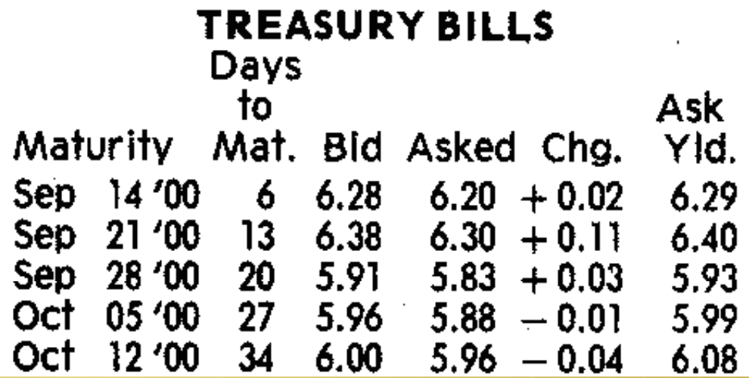

- (5 points) Calculate the Treasury bill bid and ask price. If you want to buy the Treasury bill from the dealer, which price would you face?

……………………………………………………………………..…………………
……………………………………………………………………..…………………
……………………………………………………………………..…………………
……………………………………………………………………..…………………
……………………………………………………………………..…………………
……………………………………………………………………..…………………
……………………………………………………………………..…………………
……………………………………………………………………..…………………
……………………………………………………………………..…………………

- (3 points) Calculate the bond equivalent yield based on the ask price and confirm that it is equal to the AskYld rate.

……………………………………………………………………..…………………
……………………………………………………………………..…………………
……………………………………………………………………..…………………
……………………………………………………………………..…………………
……………………………………………………………………..…………………
……………………………………………………………………..…………………
……………………………………………………………………..…………………

- (5 points) What is the actual rate of return you will earn over the next 27 days on the Treasury bill? What is the effective annual interest rate?

……………………………………………………………………..…………………
……………………………………………………………………..…………………
……………………………………………………………………..…………………
……………………………………………………………………..…………………
……………………………………………………………………..…………………
……………………………………………………………………..…………………
- (4 points) If the inflation rate over this period is 3% annually, what is your annual real rate of return? If you were to purchase a T-bill would you prefer low or high inflation rates? Why?

……………………………………………………………………..…………………
……………………………………………………………………..…………………
……………………………………………………………………..…………………
……………………………………………………………………..…………………
……………………………………………………………………..…………………
……………………………………………………………………..…………………
……………………………………………………………………..…………………

- (3 points) What is the difference between a primary and secondary market? Are the above Treasury bills listed on the primary or secondary market?

……………………………………………………………………..…………………
……………………………………………………………………..…………………
……………………………………………………………………..…………………
……………………………………………………………………..…………………
……………………………………………………………………..…………………
……………………………………………………………………..…………………
……………………………………………………………………..…………………
……………………………………………………………………..…………………
……………………………………………………………………..…………………

Question 2 (20 points)

The expected return and standard deviation values for three Vanguard mutual funds: S&P 500 index (VFINX), European stock index (VEURX) and the long-term bond index (VBLTX) are as shown below.

Asset | Mean  E(r) | Standard Deviation | Weight in global minimum portfolio | Weight in tangency portfolio
VFINX | 1.11% | 2.60% | 83% | -44%
VEURX | 1.68% | 3.70% | -27% | 139%
VBLTX | 0.51% | 2.85% | 44% | 5%
T-bills | 0.42% | 0%
Global minimum Portfolio | 0.69% | 1.83%
Tangency Portfolio | 1.88% | 4.23%

The covariance terms of the three risky assets are according to the table below.

 | VFINX | VEURX | VBLTX
VFINX | 1 | 0.8544 | -0.0163
VEURX | 0.8544 | 1 | 0.0479
VBLTX | -0.0163 | 0.0479 | 1

- (5 points) Plot the efficient frontier and denote all assets and portfolios on your graph. Don’t forget to fully label your graph.

- (5 points) Based on the variance-covariance matrix, do you think there will be diversification benefits from forming portfolios from the three mutual funds? If yes, which asset should provide the largest diversification benefit? Briefly justify your answer.

……………………………………………………………………..…………………
……………………………………………………………………..…………………
……………………………………………………………………..…………………
……………………………………………………………………..…………………
……………………………………………………………………..…………………
……………………………………………………………………..…………………
……………………………………………………………………..…………………
……………………………………………………………………..…………………
……………………………………………………………………..…………………
……………………………………………………………………..…………………

- (5 points) How much should be invested in T-bills and the tangency portfolio to create an efficient portfolio with the same expected return as VFINX? What is the standard deviation of this efficient portfolio? Locate this portfolio on your graph in part a).

……………………………………………………………………..…………………
……………………………………………………………………..…………………
……………………………………………………………………..…………………
……………………………………………………………………..…………………
……………………………………………………………………..…………………
……………………………………………………………………..…………………
……………………………………………………………………..…………………
- (5 points) The global minimum portfolio has a negative weight on VEURX. What is the interpretation of a negative weight? Is this position associated with any additional downside risk?

……………………………………………………………………..…………………
……………………………………………………………………..…………………
……………………………………………………………………..…………………
……………………………………………………………………..…………………
……………………………………………………………………..…………………
……………………………………………………………………..…………………
……………………………………………………………………..…………………
……………………………………………………………………..…………………
……………………………………………………………………..…………………
……………………………………………………………………..…………………
……………………………………………………………………..…………………
……………………………………………………………………..…………………
……………………………………………………………………..…………………
……………………………………………………………………..…………………

Question 3 (20 points)

Two companies have stock for which the expected returns and standard deviations are:

Company | A | B
Expected Return | 10% | 15%
Standard Deviation | 3% | 5%

- (5 points) Consider a portfolio with 60% in asset A and 40% in asset B. Assume that there is a risk-free asset available with 5% return and your degree of risk aversion is A=5. If the covariance between the two assets is zero and if you have $100,000 to invest, how much would you invest in stock A, B and the risk-free asset?

……………………………………………………………………..…………………
……………………………………………………………………..…………………
……………………………………………………………………..…………………
……………………………………………………………………..…………………
……………………………………………………………………..…………………
……………………………………………………………………..…………………
……………………………………………………………………..…………………
……………………………………………………………………..…………………
……………………………………………………………………..…………………
……………………………………………………………………..…………………
……………………………………………………………………..…………………
……………………………………………………………………..…………………
……………………………………………………………………..…………………
……………………………………………………………………..…………………
……………………………………………………………………..…………………

- (5 points) Draw the minimum variance frontier for the cases when the correlations between the returns on asset A and B are 1, 0, and -1. Also draw the capital allocation line(s) corresponding to the risk-free asset with 5% return.

- (5 points) Explain what is a perfect hedge position and when it can be achieved. Label the perfect hedge position on your graph in part b). What are the weights for asset A and B in this scenario? What is the expected return on the portfolio?

……………………………………………………………………..…………………
……………………………………………………………………..…………………
……………………………………………………………………..…………………
……………………………………………………………………..…………………
……………………………………………………………………..…………………
……………………………………………………………………..…………………
……………………………………………………………………..…………………
……………………………………………………………………..…………………
……………………………………………………………………..…………………
……………………………………………………………………..…………………
……………………………………………………………………..…………………
……………………………………………………………………..…………………
……………………………………………………………………..…………………
……………………………………………………………………..…………………
……………………………………………………………………..…………………
……………………………………………………………………..…………………

- (5 points) Would you prefer the portfolio in parts a) or c) if your degree of risk aversion remained equal to A=5? Would your answer change if you were a risk-loving investor? Explain briefly.

……………………………………………………………………..…………………
……………………………………………………………………..…………………
……………………………………………………………………..…………………
……………………………………………………………………..…………………
……………………………………………………………………..…………………
……………………………………………………………………..…………………
……………………………………………………………………..…………………
……………………………………………………………………..…………………
……………………………………………………………………..…………………
……………………………………………………………………..…………………
……………………………………………………………………..…………………
……………………………………………………………………..…………………
……………………………………………………………………..…………………
……………………………………………………………………..…………………
……………………………………………………………………..…………………
……………………………………………………………………..…………………

Question 4 (20 points)

- (5 points) List five main assumptions underlying CAPM.

……………………………………………………………………..…………………
……………………………………………………………………..…………………
……………………………………………………………………..…………………
……………………………………………………………………..…………………
……………………………………………………………………..…………………
……………………………………………………………………..…………………
……………………………………………………………………..…………………
……………………………………………………………………..…………………
……………………………………………………………………..…………………
……………………………………………………………………..…………………
……………………………………………………………………..…………………
……………………………………………………………………..…………………
……………………………………………………………………..…………………
……………………………………………………………………..…………………
……………………………………………………………………..…………………

- (3 points) In a CAPM equilibrium, can you have a risky asset that has a lower expected return than the risk-free rate?

……………………………………………………………………..…………………
……………………………………………………………………..…………………
……………………………………………………………………..…………………
……………………………………………………………………..…………………
……………………………………………………………………..…………………
……………………………………………………………………..…………………
- (3 points) If a portfolio has beta=1 does this mean that it is perfectly correlated with the market?

……………………………………………………………………..…………………
……………………………………………………………………..…………………
……………………………………………………………………..…………………
……………………………………………………………………..…………………
……………………………………………………………………..…………………
……………………………………………………………………..…………………
……………………………………………………………………..…………………
……………………………………………………………………..…………………
……………………………………………………………………..…………………
……………………………………………………………………..…………………
……………………………………………………………………..…………………
……………………………………………………………………..…………………

- (4 points) What is the security market line (SML) pricing relationship? Draw a graph showing this relationship and explain what the intercept and slope correspond to.

……………………………………………………………………..…………………
……………………………………………………………………..…………………
……………………………………………………………………..…………………
……………………………………………………………………..…………………
……………………………………………………………………..…………………

- (5 points) Explain why we tend to find that small stocks tend to lie above the SML and why large firms tend to lie below. How would you modify the CAPM relationship to account for this real-world anomaly?

……………………………………………………………………..…………………
……………………………………………………………………..…………………
……………………………………………………………………..…………………
……………………………………………………………………..…………………
……………………………………………………………………..…………………
……………………………………………………………………..…………………
……………………………………………………………………..…………………
……………………………………………………………………..…………………
……………………………………………………………………..…………………
……………………………………………………………………..…………………

Question 5 (15 points)

Consider the following single index model for asset returns

$$r_{it}-r_{ft}= α_{i}+β_{i}\left(r_{Mt}-r_{ft}\right)+ε_{it}$$

where i=1,…,n assets and t=1,…,T time periods.

- (2 points) What is the interpretation of the residual term in the single index model?

……………………………………………………………………..…………………
……………………………………………………………………..…………………
……………………………………………………………………..…………………
……………………………………………………………………..…………………
……………………………………………………………………..…………………

- (5 points) What is an important assumption that pertains to the residual term in the single index model? Do you think it is realistic? Discuss how you think this assumption may affect Markowitz portfolio optimization results.

……………………………………………………………………..…………………
……………………………………………………………………..…………………
……………………………………………………………………..…………………
……………………………………………………………………..…………………
……………………………………………………………………..…………………
……………………………………………………………………..…………………
……………………………………………………………………..…………………
……………………………………………………………………..…………………
……………………………………………………………………..…………………
……………………………………………………………………..…………………
……………………………………………………………………..…………………
……………………………………………………………………..…………………
……………………………………………………………………..…………………
……………………………………………………………………..…………………
……………………………………………………………………..…………………
……………………………………………………………………..…………………
……………………………………………………………………..…………………
……………………………………………………………………..…………………
……………………………………………………………………..…………………

Suppose you use the above equation to test CAPM for the Vanguard Utilities Index ETF and the S&P 500 index. You obtain the following results from the regression:

Asset | $$α_{i}$$ | SE($α_{i})$ | $$β_{i}$$ | SE($β_{i})$
Vanguard Utilities Index ETF | 0.0053 | 0.0130 | 0.0579 | 0.1882
S&P 500 Index | 0.0033 | 0.0035 | 1.2155 | 0.1268

- (5 points) Based on the estimated values of beta, what can you say about the risk characteristics of these two assets relative to the market index? Based on the characteristics of the two assets, do the magnitudes of beta for both assets make sense? Explain your answer.

……………………………………………………………………..…………………
……………………………………………………………………..…………………
……………………………………………………………………..…………………
……………………………………………………………………..…………………
……………………………………………………………………..…………………
……………………………………………………………………..…………………
……………………………………………………………………..…………………
……………………………………………………………………..…………………
……………………………………………………………………..…………………
……………………………………………………………………..…………………
……………………………………………………………………..…………………
……………………………………………………………………..…………………
……………………………………………………………………..…………………
……………………………………………………………………..…………………
……………………………………………………………………..…………………

- (3 points) Does the CAPM hold for both assets? Explain why or why not.

……………………………………………………………………..…………………
……………………………………………………………………..…………………
……………………………………………………………………..…………………
……………………………………………………………………..…………………
……………………………………………………………………..…………………
……………………………………………………………………..…………………
……………………………………………………………………..…………………
……………………………………………………………………..…………………
……………………………………………………………………..…………………

Question 6 (5 points)

What is the two-fund separation theorem and describe a scenario where it may not hold in practice. In your example, discuss what implications this may have towards the market portfolio.

……………………………………………………………………..…………………
……………………………………………………………………..…………………
……………………………………………………………………..…………………
……………………………………………………………………..…………………
……………………………………………………………………..…………………
……………………………………………………………………..…………………
……………………………………………………………………..…………………
……………………………………………………………………..…………………
……………………………………………………………………..…………………
……………………………………………………………………..…………………
………………………………………………………………………..………………

