Thammasat University
Bachelor of Economics, International Program

6204640103 Panupol Munkit
6204640939 Jinnapat kulpaiboon
6204641234 Viranchana Prypiroonrojn

Meningococcal

&

Meningococcal cases in Sub-Saharan Africa

Abstract
Background
Meningitis disease (MD) was first discovered in 1805. It was a pandemic which has a Case Fatality Rate (CFR) from 5% to 15%. In the world, there are two regions that face the disease up until the present days: Sub-Saharan Africa and Brazil. Sub-Saharan Africa is our interested region according to its diversity: Politics, Climate, and Social. Thus, we choose this region to study about its ways forward in dealing with the disease and the effect that comes from the incident.

Methods
To find the cause of severity and the effect of the disease, we compare the data to see the tendency and conclude them from the infection rate in the region and GDP per Capita of Burkina Faso accompanied with the data from the secondary data we researched from the websites and books because of the lack of data.

Result
We found out that the main reason for the severity of the disease is from poverty as well as lack of proper healthcare from the government to tackle the disease. This makes the spread of the disease in the region incessant.

Conclusion
The government should focus on the well-being of the citizens and acquire enough funds in order to combat the disease. Also, the lack of infrastructure, inadequate equipment, and limited expert leads to a failure in coping with Meningococcal disease. It should focus on education about the disease and healthcare policy more to solve this problem.

Introduction
Meningococcal disease (MD) is an epidemic caused by Neisseria meningitidis (the meningococcus) which has humans as the only natural host. It was first discovered more than 200 years ago. At present, the disease has developed into thirteen serogroups which four of them are the most significant as they cause disease. The six serogroups are serogroup A, B, C, W, X and Y. Each serogroup has different characteristics and different targets. The disease causes a neurologic damage permanently which can later develop to death. As a result, it is significant for the economists and policy makers worldwide to invest in public health in order to prevent this disastrous disease such as providing free conjugated anti-meningococcal vaccines for the citizens. Nevertheless, such a plan may not be applicable for every country to pursue due to the high budget of the vaccines, geological factors, cultures, etc.
In Sub-Saharan Africa (known as African Meningitis Belt), stretching from Senegal to Ethiopia, according to epidemiology, the epidemic is historically common since 1905, with periodicity every five to ten years. However, with the introduction of a meningococcal serogroup A conjugated vaccine in the region from 2010 on, No NmA epidemics have occurred.
Regardless of the success in dealing with Meningococcal serogroup A in the region, there are many factors we should learn behind this success and further characteristic of the disease in order to demolish the outbreak of the other two serogroups in the future. In this study, we aim to make a further study focus on the region by choosing Burkina faso as the country of interest since it is the country which has the highest infection rate in the region compared with other countries, especially in the dimension of social issues, economies, and the schemes made to reduce the infection rate in the near future.

Natural characteristic of the disease
- Transmission
Despite the fatal effect of the disease, meningococci is one of the normal microbiota of the nasopharynx in humans. It does not contribute a person-to-person transmission. Instead, it is categorized as an “accidental pathogen of humans; host invasion is a dysfunctional event for both the microbe and its host, from which neither gains any benefit”. (Ian, Andrew, and Manish, 2016)
The transmission of meningococci occurs through respiratory by droplet spread or intimate contact. Infection period starts with 10 days, and 2 to 4 days for a non-immune person has been exposed to an asymptomatic carrier or an untreated person. To facilitate colonization, pili facilitate attachment to the epithelial cell surface and opacity-associated proteins permit intimate engagement. Phase and antigenic variation of a number of surface components allow immune evasion during infection. The duration of carriage may last very shortly or many months. It is not static as there is not so much research about it. The duration may last nine or more months in Europe. Meanwhile, in Africa, it may last only three months.
In order to distinguish the species of the genus can be undertaken by using ‘biochemical techniques’ which are very effective. However, it is time-consuming, and lacks resolution as biochemical characteristics that are not always reliable. Molecular methods are used increasingly as well. It yields high-resolution methods for speciation. However, with its 16S rRNA, it cannot differentiate species within the genus. Apart from these two methods, there’re also a use of multilocus sequence analysis (MLSA) and ribosomal multilocus sequence typing (rMLST) that are very effective, especially for rMLST, which yields high-resolution rapid single–single locus approach.
In the winter the peak showed twice the incidence compared to the lowest incidences during the summer and autumn (Look at the Figure 1).

Figure 1 : The infection rate throughout the year

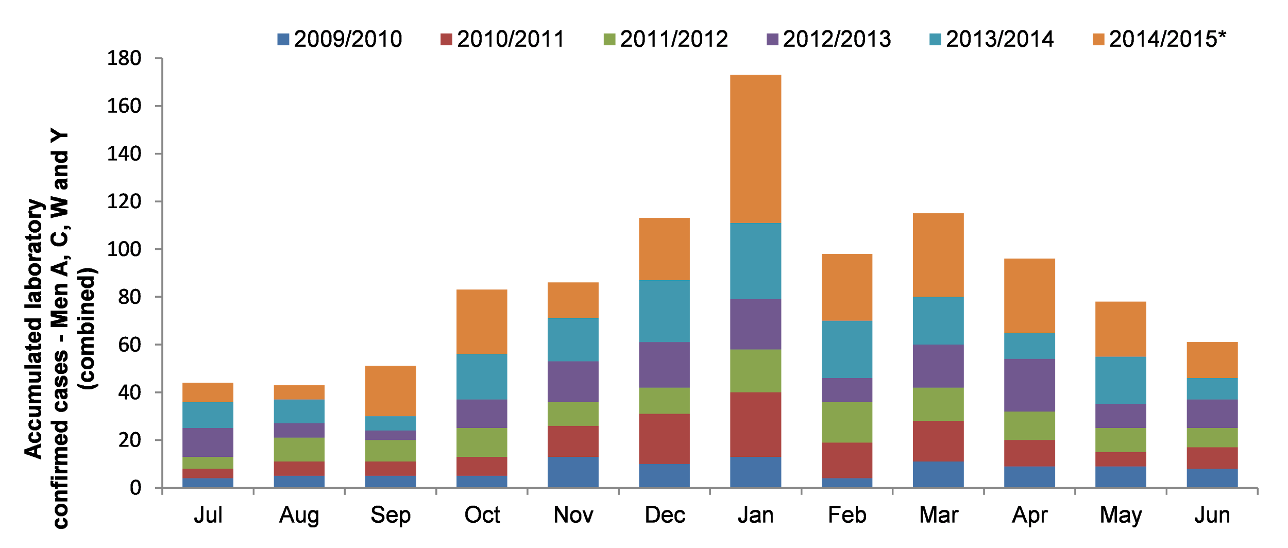
Source: Public Health England
- Epidemiology of carriage
The meningococci are diverse. It may include surface antigens which is expected in an organism that lives in close association with the human immune system, but it may be genome wide, including in ‘housekeeping’ genes. For the latter, it is not exposed to host immune responses. This means that not all variants are equally likely to cause invasive disease. Typically, the spread of meningococci c is ‘hyper-invasive lineages’, which is efficient at asymptomatic transmission and carriage, only a small subset of it causing disease.
Meningococcal carriage is age independent. It links with the social behavior during the teenage years that require close contact such as kissing and smoking at the pubs. However, in Africa, it attracts the younger more at the age of 5 to 14 years old.
The male has more possibility of having meningococcal carriage than the female. The places where it transmits well are places that are public or shared with many people such as university halls of residence and military training establishments, and rituals.

- Diagnosis of meningococcal disease
Invasive meningococcal disease (IMD) can be diagnosed by laboratory confirmation whether the patients have the sign of meningitis and/or purpuric/ petechial rash. To diagnose the disease, there are many ways to perform it. The most common specimen types are Blood and cerebrospinal fluid (CSF) and polymerase chain reaction (PCR). In a normal state, the use of CSF is the most suitable. The result will be shown as positive and negative, which positive test means infected while negative test means non-infected. However, in the event that IMD is suspected after the death of an individual, the use of PCR-based diagnosis is more suitable since it can test vitreous humor. However, the result in nongroupable isolates may be absent.

Conventional Diagnosis | Conventional diagnosis by culture | Yield N. meningitidis isolate for future testing | identification of Neisseria polysaccharea as N. meningitidis may not be accurate
Conventional Diagnosis | Nonculture Conventional Diagnosis | Detect capsule antigens by the use of latex agglutination test, immunochromatography method, and RDT. | It is less sensitive than Molecular diagnosis
Molecular diagnosis | PCR-based detection | Detect meningococcal DNA and capsular group such as A, B, C, Y, W, and X | The absence of nongroup- able isolates
Molecular diagnosis | Antibiotic susceptibility testing | Test the antibiotics of meningococcal for those who are under treatment | not reliable for meningococcal AST

- Clinical aspects of meningococcal disease
meningococcal infection may range from asymptomatic carriage to fulminant septic shock, which can result in death within a few hours. However, distinguishing early disease from more commonplace infections on the basis of clinical features is often difficult— especially for the countries which implement the use of meningococcal vaccine regularly. Despite the knowledge of the disease and the advancement of medical technology, the outcomes remain poor, with the Case Fatality Rate (CFR) of 5 to 15% in resourceful countries.

- Symptoms of disease
Most affected patients have shown non-specific symptoms in the first 4 to 6 hours. At a median time of 8 hours after the infection period, 72% of the patients show leg pains, cold hands and feet, and abnormal skin color. In early disease, the most common nonspecific symptoms are nausea and vomiting, fever, and lethargy. Other non-specific symptoms are a blanching, maculopapular rash, and salmon colored. for specific symptoms, the patients may see rash, headache, and seizures. For the rash, it only has 10-15% to be blanching while 70-80% are nonbleaching, and 5-10% of the cases don’t develop into a rash.
According to the study, the symptoms of meningococci vary depending on the serogroups, age, and other factors.

Early stage: Fever, photophobia, vomit, headache, seizure, Irritability, delirium
Specific signs: Neck stiffness, Brudziński sign, Kernig
Focal neurological abnormalities: Seizure with cortical necrosis, venous sinus thrombosis, or occlusive vasculitis
Other conditions: subdural empyema, other intracranial space-occupying lesions,and brain abscess

Figure 2 : maculopapular rash in the early staten (A) and the terminal state (B)

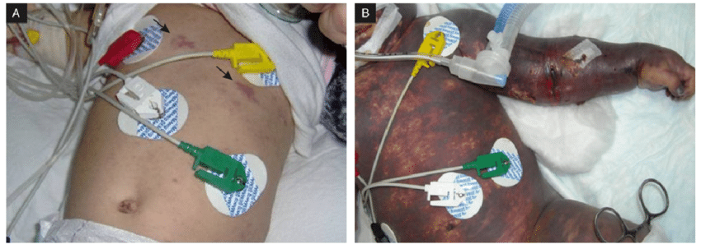
Source: Paris Descartes University

- Prevention of the prevalence
To prevent the Meningococci, Antibiotic chemoprophylaxis may be used to eliminate carriage along with the close contact needed during the outbreak. However, with Asymptomatic carriage, it may resolve naturally. With the introduction of capsular group C conjugate vaccines in the UK, large-scale studies show a significant drop in the prevalence of carriage of group C meningococci within one year. It also decreases in those who are unimmunized and signifies herd protection, which is a major success for these vaccines.
The effect of this study also influences the use of the group A protein-polysaccharide conjugate vaccine (PsA-TT) in African Meningitis belt (Sub-Saharan Africa) which can also successfully protect against carriage and create herd protection. The result was impressive as the infected cases were reduced by 99%.

The economic burden in Sub-Saharan Africa
The impact of the disease affects both the people and the economy of these African countries. When an epidemic occurs households and communities are left devastated and resources ruined. The most affected country in the region is Burkina Faso, Burkina Faso is a country located in the heart of the meningitis belt, It has an infected rate accountable for 65% of the whole case in Africa.
Most people in Burkina Faso can only afford essentials such as food, shelter, and clothing. They do not have money to get the basic necessities. When necessities are lost, the people and the economy of Sub-Saharan Africa lose labor. These people are losing valuable productive years of their lives or maybe, losing their lives (Figure 3).

Figure 3 : Poverty rate in Sub-Saharan Africa

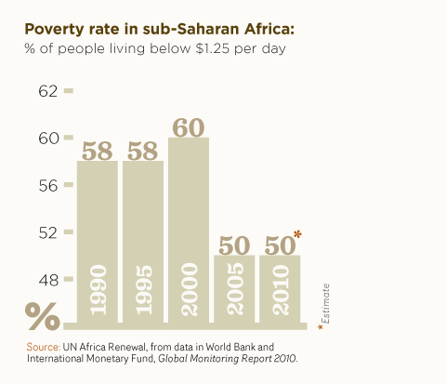
Source: United Nation

The economy of Sub-Saharan Africa suffers from minimal economic growth due to the effects of meningitis, people have to pay for the cost associated with the disease and they cannot work. Healthier workers will be more productive and can produce more quantities of output which carries over into the overall productivity of the economy. This implies that the workers in the meningitis belt are less efficient in their physical capabilities when affected by Meningococcal disease. At this time, the Sub-Saharan African economy is stuck in an unproductive and non-progress cycle. This led to the Great Recession which occurred in 2007-2008.
According to figure 4, From 2003 to 2013, Burkina Faso had a positive growth of 51.4% in an average GDP per capita and then at the Great Recession, the GDP per capita had a negative growth of 0.00%. Since the end of the Great Recession, Burkina Faso has returned to a positive growth of 25%.

Figure 4 : GDP per Capita of Burkina Faso

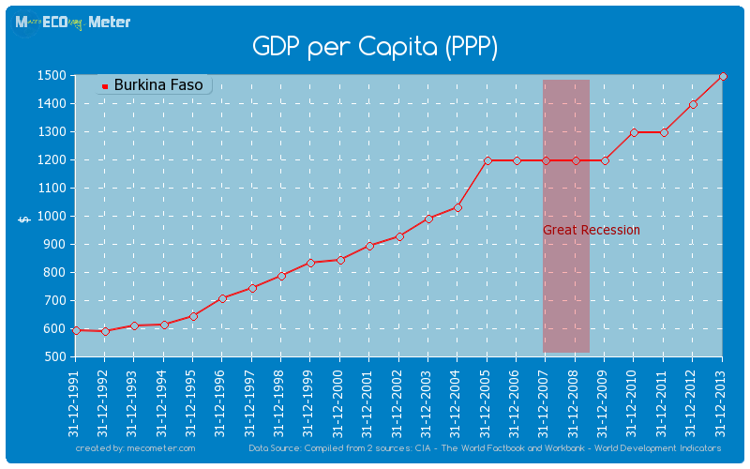
Source: Mecometer

Africa has made the least amount of progress, compared to any other region to complete the MDGs. The Millennium Development Goals represent the world’s commitment to deal with global poverty in many dimensions. To accomplish the Millennium Development Goals (MDGs) and other anti-poverty goals, vaccination of at-risk population must be pursued

The MDGs include these conditions to accomplishments such as :
- Reduce the fatality rate among children under five years old by two-thirds of the population.
- Reduce maternal fatality by three-quarters.

To improve the economy of Sub-Saharan Africa, we need to give more access to vaccination to people at risk for meningitis but the problem that obstructs is the lack of funding because the cost of vaccination for meningitis is expensive. The resources are not enough to cover the 430 million people at risk throughout the meningitis belt.
In 2000, the estimated price for a conjugate vaccine was $40-$80 per dose. This price is extremely expensive and the vaccine is not enough to cover the entire population in the meningitis belt. People in the Meningitis belt tend to reject the vaccines because they cannot afford the price of vaccination. With the help of a healthcare provider, one dose can be given to each person living in Sub-Saharan Africa which could directly affect their ability to be a part of the positive developments of the economy. The workers will be able to produce more resources, the students will not have to skip school and these lead to a long-term improvement of the Sub-Saharan Africa economy.

Current issues
The epidemiology of meningococcal disease will continue to evolve over the next few years. Thus, A new vaccine designed to protect against group B disease is now licensed (4CMenB) and it will be important to determine its efficacy and public health impact in large-scale population-based programs. The Meningococcal disease is continued and in many areas so improved observation is required to monitor epidemiological trends, assess the global burden of disease, and evaluate the impact of immunization programs.

Social issues
As we know that Meningococcal meningitis disease is an epidemic which causes high mortality rate and case fatality rates around the world, especially in the semi-area of Sub-Saharan Africa, known as Africa meningitis belt due to society and environment. The disease kills approximately 300 million populations there. Most cases of the disease occur in the winter and early spring which can boost the spreading of the virus rapidly easily. Meningococcal meningitis disease occurs from the bacterium called Neisseria meningitidis which can cause others severe disease either.

- Vaccination in the meningitis belt
In Southern Africa, bacterial or meningitis causes considerable morbidity and mortality. In particular, even with appropriate therapy, meningococcal disease is often fatal and approximately 20% of those who survive will suffer from complications, including hearing loss, seizures and some might have vision problems. If the infection is diagnosed early and treated promptly most people make a full recovery. Therefore, all South Africans, starting from 9 months of age, should be vaccinated to protect against meningococcal infection.
Most epidemics in the meningitis belt over the last 100 years were sometimes due to serogroup C, W, and more recently X, but the outbreaks in the meningitis belt were primarily due to serogroup A. Recently, meningococcal outbreaks in the meningitis belt have primarily been due to serogroups C. As a result, the health organization tried to evolve the Meningitis Vaccine Project.
The history indicates that 90% of serogroup A accounted for infectious cases and also the majority of massive-scale epidemics. Specific vaccines being made for individual serogroups, Since the emergence of the meningococcal A vaccine and the precautionary campaigns in the meningitis belt, the proportion of serogroup A has declined dramatically.
That is why vaccination is necessary, to prevent the spread of this epidemic meningococcal conjugate vaccine is recommended. The people who need the full series of vaccines are those who are at higher risk for meningococcal disease, not only adults, teens, or kids younger than 11 years old. For example, those who have some kinds of immune disorders. If the immune disorders persist, these children also need a booster dose depending on their age at the first dose a few years later.
Meningococcal can lead to bloodstream infections or meningitis and can be fatal if not quickly treated. Travelers who going to the Meningitis Belt of America or areas with current outbreaks should get a vaccination against serotypes A, C, Y, W-135
The Meningococcal epidemics created fear in people because of its inconstant and rapid spreading throughout countries. To prevent the disease, The UK Department for International Development developed an affordable 5-valent NmCV (NmCV-5) for serogroups A, C, W, X, and Y.
- Aero group X is one significant component of NmCV-5, in which the vaccines are not fully authorized.
- Recent research implies that NmCV-5 in healthy US adults (18 – 45 years of age) expressed that the vaccine is safe and well-permitted.
- That study confirmed that NmCV-5 is safe and capable for all serogroups

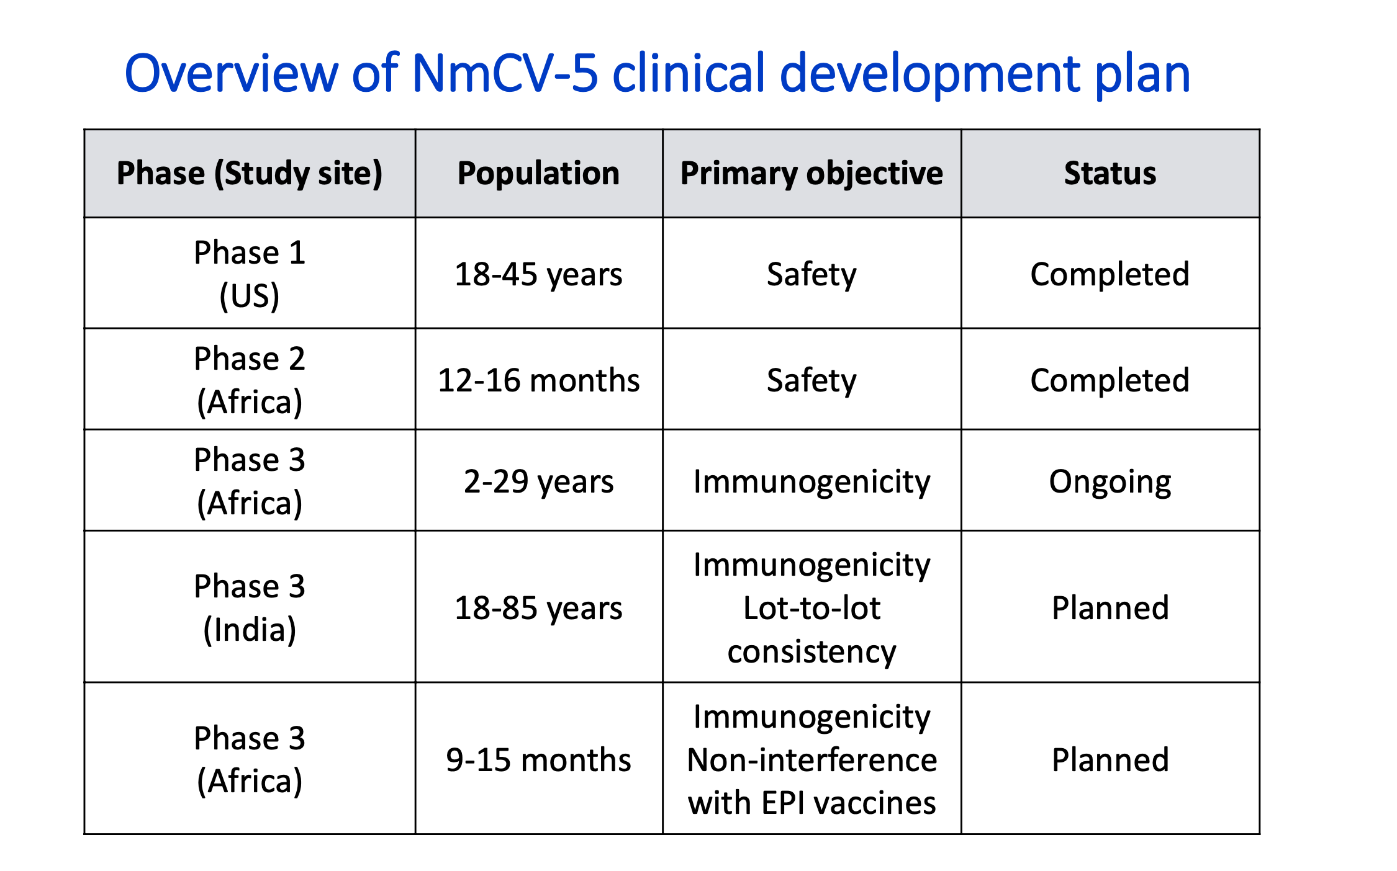
Figure 5: Clinical development plan

Source: Meningitis Research Foundation

Figure 6: The introduction of MenAfriVac in 2011–2012
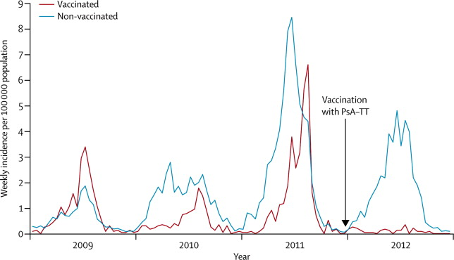

Source: THE LANCET

The important attribute of MenAfriVac was that at a cost of about US $0.40-$0.50 per dose, it was substantially cheaper than comparable conjugate vaccines which cost around $40-$80 per dose and MenAfriVac was developed less than one-fifth the average cost. Since the introduction of MenAfriVac (figure 6), the Cases of meningitis declined dramatically in vaccinated areas, but an epidemic continued in the rest of Chad. Until 2012, the remaining Chad population was vaccinated and the infection rate was stopped.

Figure 7: Price of MenAfrivac
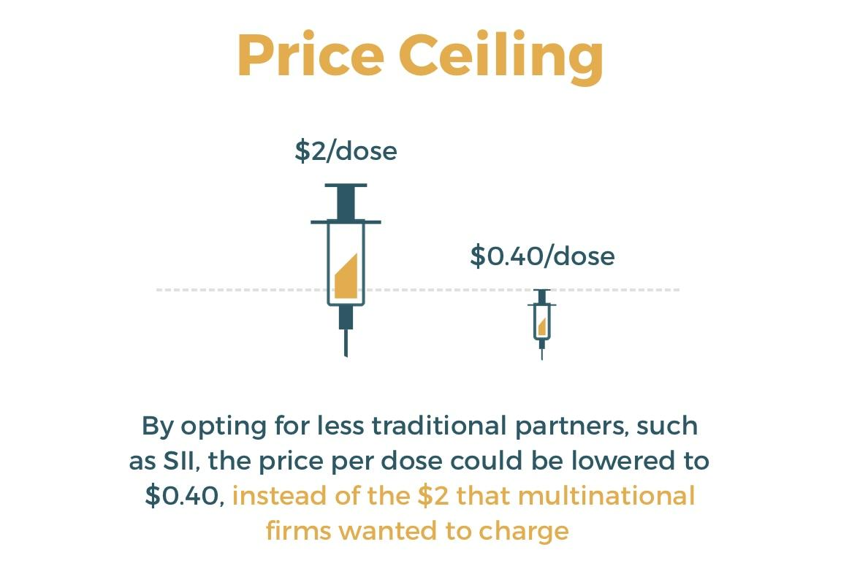
Source: Center for Global Development

Another factor to make MenAfriVac successful is because the MVP’s elastic organizational structure and informal, open operation enhanced collaboration and forged trust among partners. They lowered the price for one MenAfriVac dose.
MVP has stayed firm on its price ceiling for the vaccine causing the big Pharma to have a lack of interest to produce vaccines at a price lower than $2.00 per dose and that further increase the incentive of the vaccination (figure 7). However, Without health care providers, the fatal rate in Sub-Saharan Africa would continue to increase. If medical professionals conduct vaccinations then the people would receive immunity and decrease the infection. However, health care providers need funding to support vaccine campaigns. If there is enough funding, this will cure the patient’s burden and also save thousands of lives.

Public health care
For treatment, it needs to use antibiotics including penicillin, ampicillin, chloramphenicol, and ceftriaxone and Polysaccharide quadrivalent vaccines for serogroups A, C, W135, and Y which is must provided to population in each country by public health care. However, in Sub-Saharan Africa, there is a major global concern because they have the lowest quality of well being and health care accessible. People are very poor and live in bad environments. For the policy, their government fails to meet basic need health care until loss of trust from overpopulation. On the other hand, the population respects their government for their work without checking processes. Moreover, health care services are failing because of operation. The strategy that they use should be based on the environment , society, and history in each area, not depending on America. Therefore, as it happened in the past, major epidemics occur every 5 to 7 years reaching 1,000 cases per 100,000 people in the region. Causing that Meningococcal meningitis disease immediately becomes an important problem and difficult to cope with in those areas. Consequently it is not able to decrease the rate of infected people for the sake of gaps in the organization and inadequate infrastructure instead improving the situation, and it will be discussed in the following.

- Inaccuracy in Diagnosis
For diagnosis, blood culture, cerebrospinal fluid, aspirates from other normally sterile site specimens, skin rash aspirate or biopsy culture, and oropharyngeal swabs test are used for the investigation of populations who have a chance to infect the disease and the laboratory will confirm as quickly as possible for capacity to control spreading infection. Notwithstanding, can these really check on the meningococcal meningitis disease.
Due to the low quality of laboratory and limited resources in those areas, it causes investigations finding the meningococcal meningitis virus becoming nonspecific and unreliable result of testing. Since the complaint needs immediate treatment, it intends to increase the mortality rate. In Sub-Saharan Africa, to check health, people will make phone calls to tell their symptoms to local health care workers to restrain the disease while traveling to check with officers directly, and it will be sent to investigate at the laboratory, but it is easily a discrepancy as well. Because of Unknown in the medical fields of normal people, they can not describe their symptoms correctly. Nevertheless, it can be hard for going to check at hospitals or health care services.

- Inadequate on infrastructure
The countries in the meningitis belt area are faced with a problem of poverty in the living of the population. They can not afford better existence and healthcare, and it is not different from the government either. There is not enough funds supported for building laboratory capability to test the viruses or better facilities. For inadequate healthcare infrastructure is another barrier to receiving accurate test results as well. For example, there is a lack of basic essential equipment which normally every health care, clinic, or hospital should have to be able to service fundamental medical service. To test the virus, it needs to use high technology equipment. Same as insufficient in some hospitals, they earn only 2 bottles per ward and have to reuse blood tubes which should be saved for deep research to better understand the virus, and for advanced medical care for this disease. For most advanced people to understand the disease well, laboratories should follow up and record every case to compare and find the best results of each classified serogroup, but in the meningitis belt area, it is impossible to do so because of inadequate equipment leading to poor record keeping.
In addition, a limited number of skilled personnel can be said to be the most important problem for meningococcal meningitis disease since it needs a professional doctor to take part and cure the infected people. It causes unequal distribution between private and public health care. Lack of educators and training programs to educate every population, surely they do not have enough physicians for all patients and all responsible, so educators and training programs can reduce the burden and make some processes faster to serve all people in time.
No Quality logistical support is another difficulty for everyone to access public healthcare or provided hospital. Inside of medical care, they have to transfer any specimens such as a blood test which can delay leading to late confirmation on the test of patients and treatment in the correct ways. Showing that it has no standard for proper delivery and it may take too much time or degenerate virus resulting in underutilization investigation tests. Although some reports say that the treatment can reduce infected patients, mortality, and the spreading rate, it continues to increase. More patients occur while limited facilities are available for society.
Therefore, patients who need emergency treatment are taking more risk of death as meningococcal meningitis can kill patients in an hour of infection, and it allows the virus to spread to others because of unawareness and carelessness. Especially, in a rural area which is far from general facilities such as electricity, water, and space with limited equipment. For instance, there was 1 microscope per 100,000 population, and another need to be repaired or broken. Even though public health care can provide enough equipment for laboratories and treatment for people, they still lack capable doctors who are technical expertise. It is caused by the unaffordable better education system of people that is provided by their ineffective government.

- Inequality in society
On the other hand, social issues can mention the quality of people living that most cases occur with lower class and middle class people due to their environment and existence. Also this is the reason why Sub-Saharan Africa is called the meningitis Belt as being an area facing severely the meningococcal meningitis disease because they have very low quality of existence and poor environment. Showing that they receive a higher risk to infect the disease easily (20%-70%) because lower income can harder afford better facilities, food, education, and health care services, and they have to live with others in density housing and communities similar to underprivileged populations making the disease spreading easier.
Therefore, if one of the members attracts the disease, it can possibly spread to others quickly through their routine such as going to school or work. As a result, for all situations, it is difficult for them to reach public health care where it may far from their location and may have to pay. Besides, the pilgrimages of people in South Africa can be another factor in spreading the disease faster without their realization. For example, the most religious in South Africa is Christianity where Christians have to go to churches for ceremonies every week and have to face a lot of other Christians members, contracting in many hours in any activity, and also other ceremonies movements from other pilgrimages as well. And it can happen similarly with other cases such as spreading from one country to another country by traveling or tourists.

Summary points
- Even Meningococcal conjugate vaccines have been successful in reducing the rate of Meningococcal disease worldwide. However, Meningococcal disease is still a main cause of meningitis in children and adults.
- The price to pay for vaccination should be reduced so that Sub-Saharan countries will be able to afford to fight against meningitis.
- The government should provide public awareness especially education on the disease, such as a vaccine. Because people are uneducated about the disease and if affected, they will not seek the importance of treatment.

Conclusion
The meningococcal meningitis disease is a severe disease which harms people in many countries around the world with different serogroups in each area, and each serogroup has different targets. The great impact is on teenagers and children due to the behavior of the age as it spreads to others by close contact through social behavior.
The Meningitis belt is the most severe area in Sub-Saharan Africa where serogroup A, W, and X occur. Because of poverty, the countries in this region face radical destitution to either population or institution. For the country that has Inadequate infrastructure which includes insufficient equipment and limited expert physicians such as Burkina Faso, it can lead to inaccurate test results or ineffective treatment and finally fail in control and decrease rate of infection. Also, public health care provides inappropriate health care to each area. Furthermore, there is a lack of government support as the politicians do not pay attention as much as what people need. As a result, the number of mortality rates still certainly increases and destroys the community in those regions. Therefore, to improve the mentioned social issues, it should educate people more about the desease’s information and prevention. It can slow down infection as people will have more caution and know how to protect themselves. Then it should follow by offering infrastructure medical and professional physicians who have the ability to use high technical medical treatment. It can lead to better quality of people living and able to keep up with not only the meningococcal meningitis disease but also all epidemics and pandemic.

Reference
- Coulson, G. B., Gottberg, A. V., Plessis, M. D., Smith, A. M., Gouveia L. D., & Klugman, K. P. (2007). Meningococcal disease in South Africa, 1999-2002 . Retrieved Respiratory and meningeal disease surveillance in South Africa (GERMS-SA): https://www.ncbi.nlm.nih.gov/pmc/articles/PMC2725855/
- Petti, C. A., Polage, C. R., Quinn, T. C., Ronald, A. R., & Sande, M. A. (2006). Laboratory medicine in Africa: A barrier to Effective health care. Retrieved from https://www.researchgate.net/profile/Christopher_Polage/publication/7379518_Laboratory_Medicine_in_Africa_A_Barrier_to_Effective_Health_Care/links/58a0bf39aca272046aad6086/Laboratory-Medicine-in-Africa-A-Barrier-to-Effective-Health-Care.pdf?origin=publication_detail
- Maphumulo, W. T., & Bhengu, B. R. (2019). Challenges of quality improvement in the healthcare of South Africa post-apartheid: A critical review’ , Curationis 42(1)a1901. Retrieved from https://curationis.org.za/index.php/curationis/article/view/1901
- Department: health public of South Africa (2011). Guidelines for management, prevention & control of meningococcal disease in South Africa. Retrieved from https://www.nicd.ac.za/assets/files/DoH%20Meningococcal%20Disease%20Guidelines%202011.
- Feavers, I., Pollard, A. J., & Sadarangani, M. (2016). Handbook of Meningococcal disease management. Switzerland : springer nature
- Koutangni, T., Mainassara, H. B., & Murller, J.E. (2015) Incidence, Carriage and Case-carrier ratios for Meningococcal meningitis in the African Meningitis Belt: A Systematic Review and Meta-Analysis. Retrieved from https://journals.plos.org/plosone/article?id=10.1371/journal.pone.0116725
- Burger, L.. Economic burden of meningitis in sub saharan Africa and the importance of vaccination programs: a case study of Niger. Retrieved from http://www.philau.edu/sciencehealthandtheliberalarts/inc/documents/LB.pdf
- Batista, R. S., Gomes, A.P., Gazineo, J.L.D., Miguel, S. B., Santana, L. A., Oliveira, L. , & Geller, M. (2017). Meningococcal disease, a clinical and epidemiological review. Retrieved from https://www.sciencedirect.com/science/article/pii/S1995764517308714
- Burman, C., Serra, L., Nuttens, C., Presa, J., Balmer, P., & York, L. (2018). Meningococcal disease in adolescents and young adults: a review of the rationale for prevention through vaccination. Retrieved from https://www.tandfonline.com/doi/full/10.1080/21645515.2018.1528831

