

Swensen’s Marketing Mix Factors & Strategic Marketing Conduct Effects on Millennial Consumer Behavior in Bangkok

By

Tham Sawetkititham 5704642312

This seminar research paper is in the part of the study in EE489 course, for Bachelor of Economics (International Program), Faculty of Economics, Thammasat University.
Semester 1/2017

Abstract

In the modern days, digital age had created several of technological disruptive innovation, such as internet of things, online & social media channel. These caused the changes in the way of living for the people, especially their consumer behaviors. Millennial had been represented for the digital age, in the changes of purchasing behavior. They tended to be more informative, by surf up for information in the internet. The value of consumer become more significance towards the firms. They have more bargaining power for purchase, since internet had reduced the asymmetric information for them. The modern generation have more alternative in purchase products, for their best quality and quantity needs. The changes in digital trends have been urged the firms and brands to modify and adapted into the modern digital trends. Or else, it can effect a huge loss for the firms.
As for Ice-Cream market, this market is also effected from the modern age. It induced the rises in competitiveness for each player in the market. it's important for the firms to understand these changes in the trends of consumer behavior, that is why the topic of this research paper had been started, which the author wanted to study the Millennial consumer behavior and find out that which factors had been effected them on final purchase decision making an examined the marketing conduct effectiveness on their purchase intention. So, the author had chosen Swensen's Ice-Cream brand because this brand is the top-leading brand in Premium Ice-Cream market for almost 20 years. Also, Swensen's had been effected by the changes in digital trends too, which it need to adapt, or else it can lose the top-leading brand market position.
After the study, the author had find out that product's variety, uniqueness and beauty are the factors that effected in Millennial Purchase Decision Making and the Swensen's seasonal marketing conduct is only effective on inducing the product trial for Millennial.
The author had suggested two things. First thing is that Swensen's need to keep focusing on these three factors, which it can be beneficial in their profits and the next thing is that Swensen's should be focusing more on creating the product awareness in their marketing conduct, which it can generate higher chances of keeping the existed customers, and converted their potential leads to their new customers.

Table of Contents: Page

Chapter 1: Introduction 4-5
1.1: Importance of the study 4-5
1.2: Objective of the study 5
1.3: Scope of the Study 5
Chapter 2: Short Literature Review 6-11
2.1: Short Literature Review 6-8 2.2: Short Literature Review's Table 9-11

Chapter 3: Methodology, Conceptual Framework & Theories 11-19
3.1 Research Method Process 11-13 3.2 Conceptual Framework & Theoretical Definition 13-16
3.3 Questionnaire Design Table 17-18

Chapter 4: Findings 18-30
4.1 Demographic of the Respondents 19-20
4.2 Respondent's Past Buying Behavior 21-23
4.3-4.6 Marketing Mix Factors towards Impact Level 23-27
4.7 Hierarchy of Effect Measurement 28-29
4.8 Internet Usage for Food Promotion 29
4.9 Respondent's Future Comments 29
Chapter 5: Data Analysis 30-35
5.1 Swensen's Marketing Mix Factors Effects on Purchase Decision-Making 30-34
5.2 Swensen's Seasonal Marketing Conduct Effectiveness on Consumer Purchase Intention. 34-35
Chapter 6: Conclusion & Suggestion 35-36

Chapter 1: Introduction

Importance of the study

Ice-Cream industry had been existed in Thailand in the past centuries. In the modernization world, each of the countries had been opened through other cultures, blended with their own culture, which multi-cultural perception had been emerged in most of the countries.
As for Thailand, Thailand had been continuously accepted more of the western cultures, and blended into their typical day of living. Ice-cream is one of the most popular dessert products for Thai people, due to the hot and humid climate, throughout the year. Also, Thai people had a behavior of having desserts after the meal, which Ice-cream is one of their top choices in their consumption.
Looking more on the industry, Thailand’s Ice-Cream market had an approximation of 15 billion Baht for the market value, with 15 percent of the market growth (YoY). Also, the average of ice-cream consumption for Thai people per capita is 1.7 liter / Year, which is considered to be low, comparing with the average from our neighbor countries. Judging from the competitive factors, such as annual climates and competition among several players in the market. Ice-Cream industry had a lot of potential to grow continuously in the future. (Kasikorn Bank Research Institute, 2011)
As for the Thai’s Ice-Cream’s market structure, it can be segmented into three segments, which are local ice-cream’s market, mass ice-cream’s market and premium ice cream’s market.
For Premium Ice-Cream Market, this market is considering to be oligopoly with oligopolistic competition, since they consisted few international brand players that acquired most of the market share in the market (Tannysoft, 2015). the market capitalization is 6.8 billion baht for 2017 (Buffet Code).
Next, the emerging of technological innovation had ignited the changes in Thai society. It had changed the way of living and consumption behaviors for Thai people. This also had reduced the factors of asymmetric information for the consumers, the bargaining power in firms, and rises the bargaining power in the buyer’s side, because consumers can access and received more of information about the product and services. This can also shift the consumer trends that they try to seek better qualities of products, resources and services for their consumption.
In Addition to that, The Millennial behaviors had influenced the current modern trends in Thailand. Also, Millennial is beginning to have an impact on the market demands, which it will create a huge reflect for the players in the premium ice-cream market.
From the above, it had been increasing a huge value for the consumer’s demand. In many industries, there are facing in the changes in their business cycle, which the ones that were not improved and adjusted to the current trends, will be turned into sunset.
As for the premium ice-cream market, the current trends are creating a huge challenge for the existing players, understanding the current trends of the new behaviors in the Millennial, which they need to be carefully planned their firm’s strategies and execution strategies through the consumers. Also, the rising trends of home-made local ice-cream store is emerging, due to the entrepreneurial trends from the new generation and rising of income level for people. They are the quality- seekers in ice-cream products for their consumption. It’s importance for brands to adjust in this rising of competitiveness in this market.
The author chooses Swensen's Brand for the study, because Swensen's is the top-leading brand in the premium- ice cream market, which it had been existed for 31 years (The Minor Group 2017). Also, Swensen's is also effected from the changes in the consumer's behavior. As cited from (BuffetCode, 2017) data, Swensen's had a market share of 90% in 2005, but in 2016, Swensen's market share had decreased to 57%. Also, Swensen annual revenue is decreased from 4 billion baht in 2015 to 3.896 billion baht in 2016, More on that, Swensen's had 330 branches, which each of the Swensen's branch is only generating 11.8 million baht annually.
From the above, it's become a problem that Swensen's need to improve themselves and understand the behaviors of Millennial, or else, Swensen's will lose more on their market share, due to the rises in competitiveness in the market.
This paper will help Swensen's, understand more on the Millennial purchasing behaviors and factors that effects their decision-making, which it will be beneficial to their future of the business.

Objectives of the study

This paper aims to study the two following objectives:

- 1. To find and study on the impact level in each of Marketing Mix Factors for the Millennial Purchase Decision Making.

- 2. To measure, find and study the level of effectiveness in the Swensen's marketing conduct for the Millennial Purchase Intention

Scope of the study

At first, it's impossible to observe the total of Millennial in Thailand, so the author will narrow down the scopes of the samples through only in Bangkok. The author will try to gain the results of 200-300 Millennial, with the criteria of their demographic & past purchasing behaviors, so that the result will be more accurate in the conclusion of this study.
Secondly, the Swensen's conduct data will be used in during 2015 to 2017, which the author wanted the data to be fresh, so that the conclusion results is more accurate for this study.
Thirdly, I will use two of Swensen’s Seasonal Product Marketing Conduct as the example in the study for studying the purchasing behavior, since this conduct is one of the most successful and popular for Swensen's and their customers. it's impossible to study in all of the single conduct that Swensen had been performed on.
At last, I will use several marketing & econometrics model, such as marketing mix model and linear regression model in this study.

Chapter 2: Short Literature Review

1.Chanunsiri Jakkon (2007), Premium Ice-Cream Market-Structure and Competitive Analysis (In-Thai), Independent Study.

The author had found that Premium Ice-Cream is considered to be an Oligopoly market with an Oligopolistic Competition. Also, they will mainly compete each other by using non-pricing strategy in their competition. Swensen’s had taken the first-mover advantages on building Franchise Model and continuously developed their product differentiation, which these crucial variables are determine the sustainability of the player’s growth. It made Swensen’s “the leading player in this market”. Franchising is one of the crucial key for the success in Ice-cream’s dine-in market.

2.Pattawarunya Roongnpakul (2011), Marketing strategies and strategic management satisfaction towards the customers in Ice-Cream business: The case study of Swensen’s in the Minor Group Ltd (In-Thai), independent study.

In this paper, the author had suggested Swensen’s for the four Outside-In Strategic Approach Concepts from external environment to internal environment, which are Growth, Differentiation, Marketing Mix and CRM. These strategies are the solution that can cope 3 Macro &Micro Environment for Swensen’s (Organizations to operation), and it’s important for Swensen’s in sustaining growth, during the rising competitiveness in the Premium Ice-Cream Market.

3. Pongsri Saetum (2015), Consumer Behaviors and Satisfaction towards Service Marketing Mix: A case study of Swensen’s Ice Cream at Big-C Branch, Satun Province (In-Thai), Minor-Thesis.
For this paper, the author had analyzed the effectiveness of consumer’s satisfaction in Swensen’s Service Marketing Mix, which the Promotion is the least effectiveness in Satisfaction from the customers. In their survey, the author also stated that the different of characteristics on the samples population can result of the vary in the outcome of the survey, based on their Ages, Income, Life-style, and occupation.

4. Rangsima K. & Wahloonluck C. (2013), The Use of Celebrity Endorsement with the help of electronic communication channel (Instagram) : Case study of Magnum Ice- Cream in Thailand.
The authors analyzed the use of celebrity endorsement for induce purchasing intention and product awareness with the help of online-social media channels by using Instagram as an example case studies. The interesting outcome from the paper are that this digital marketing technique generates the positive responds on product awareness, in terms of credibility, trust-worthiness and attractiveness. This had been so useful on building brand awareness and good brand image. Although, this had created a neutral & negative responds to the purchasing intentions for the Thai Generation Y users, since they didn’t believe that the celebrities had consume Magnum Ice-Cream in their real life.

5.Ajan Shrestha (2015), Effect of sales promotion on purchasing decision of customer- A case study of Baskin Robbins Ice-Cream Franchise in Thailand.

The authors stated that the customer relationship and customer experiences are crucial variables in Sales Promotion for Premium Ice-Cream players, which Baskin Robbins had used these variables in implemented into their sales promotion, through price discounts, free samples, point-of-purchase display, and it create positive purchasing decisions from the customers. However, different in social-economic status had caused the different outcome from each status of the customers.

6. Jakkrit Nakprasert (2013), Factors affecting Behaviors of using the Service’s Premium Ice-Cream Shops in Central Plaza in Bangkok and Metropolitan Area (In-Thai).

The author had talked about the importance of the two factors in affecting the consumer behaviors of using the Service- Premium Ice-Cream Shops. Product differentiation is the first crucial variable, since it’s the first priority to sustain the brand loyalty from the customers and it’s the first criteria for the customers to choose the service. Product differentiation can be defined more as the difference in product taste, quality and variety. It must be unique and premium qualities. Strong Retail Channels is also crucial, since the customers will satisfy more if the store’s location is convenience in transportation, location and the store’s usage.

7. Woramon Boonsard (2016), Marketing communications to generation C consumers in the digital age (In-Thai), E-journal.

The author had talked about the rise of the digital age that had change the behavior of every generation. The author also had stated about the new generation called “Gen C”, which are the group, who are the online users, which use and interact with social-media & online tools, as part of their typical living. Also, this generation cares more about the Brand to Customer Relationship and quality of the online content, which it’s crucial for the strategic digital marketing conducts in the digital society.

8. Kwanchanok K. (2014), Social Media Use and Generational Identity: The Differentiation between Baby Boomers Generation vs. Y Generation (In-Thai), independent study.

In this paper, the author talked about the social-media usage’s behaviors in Gen Y and Baby Boomers, towards various function, such as, Like, Share and status etc. As for Gen Y behaviors, they use social-media to express their status, emotion, acceptance, personality and the concept of their living. It will be useful for conducting consumer insights and marketing execution, by understanding these behaviors of the Generation.

9. Prim Phisolayabutra (2005), Ice-cream purchasing behavior among people in Bangkok, and factors influencing their decision in purchasing, (Research Paper).

In this paper, the author talked about the factors influencing their purchased decision for the Ice-cream in Bangkok. Bangkokian will consider the three factors from the Ice-Cream players, which are good service, reasonable price and special sales promotion. From the survey’s result, there are some people had responds that is about the lacked in research and development for the product. The Author also recommend the new comers to focus on the Pricing-Strategy, which the players must find the best price to the customers.

10. Thana S. (2011), Consumer Behavior, Brand Awareness and Influential Factors Their Decision in Purchasing the Premium Ice-Cream among people in Bangkok, (In-Thai), Individual Study.
In this paper, the author had stated that the most important factor that effect the consumer in Bangkok is Price, since most of the Premium Ice-Cream is premium pricing, which is expensive than the market price. The customer tended to focus on the most reasonable price for the premium ice-cream. As for Swensen’s, it has been the Top-of Mind awareness brand in Bangkok, due to the top spending in advertising and traditional marketing for the NPL. Also, Swensen’s designed their displays store and logo to be very unique, which it’s create a strong brand recognition, and induced the impulse consumer to their store.

11. Zhenyi Q. & Panita S. (2013), The Relationship among Social Environment, Percieved Value, Customer Satisfaction and Re-purchase intention in Ice Cream Franchise, independent study.
In this paper, the author illustrates the importance of re-purchasing intention from the customer, since it’s the special purchasing decision that create the benefit to the brand. Customer Perceived Value is the most significance for the customer to re-purchase the brand, since their main consideration are tangible values, like product and brand image. This factors had higher positive relationship in customer satisfaction than the other factors. It’s important for the business owners, focusing the product development and strengthen their brand image for their brand.

2.1) Short’s Literature Review’s Table

1) Title, Writer’s Name | 2) Purpose of Study |  | 3) Methods of Study |  | 4) Results of Study
1. Premium Ice-Cream Market Structure and Competitive Analysis.  Channunsiri Jakkorn(2007). | - Study Market Structure and Competitive Analysis.  - Study in ways to enter the business and counter-action from the existing players. |  | - Concentrated Factors calculation in market structure.  - Using Primary Sources  - Using Secondary Sources. |  | - Players competes by using non-pricing strategy for brand and customer value.  - Franchising is one of the crucial in the business expansion  - Product& Differentiation are important for the new players entering the market.
2. Marketing Strategies and strategic management satisfaction towards the customers in Ice-Cream business: The Case Study of Swensen’s in the Minor Group Ltd.  Pattawarunya Roongnpakul,(2011). | - Study the problem, environment and satisfaction of the customers in Swensens.  - To set the Strategic Marketing plans and strategic management for Swensens. |  | - Qualitative& Quantitative research  - Using Primary Sources  - Descriptive Analysis. |  | - Suggested the 4 strategic approach to Swensens for Macro-Micro enviornments, which are Growth, Differentiation, Marketing Mix, and Customer Relationship Management Approach.
3. Consumer Behavior and Satisfaction towards Service Marketing Mix in Swensen’s Case study at Big-C Branch, Satun Province.  Pongsiri Saetum, (2015). | - To study the consumer behavior in Swensens Big C Branch in Satun Province.  - To study the level of relationship between customer’s satisfaction and Swensen’s Service Marketing Mix |  | - Primary Sources  - Questionnaire  - Data Analysis |  | - Most of the Service Marketing mix factors had effected positive responds from their customers.  - Promotion had the least effective to the customers.  - Promotion didn’t created much effect on them (customer value).
4. The Use of Celebrity Endorsement with the help of electronic communication channel(Instragam): Case study of Magnum Thailand.  Rangsima K. & Wahloonluck C. (2013), | - to describe the buying behavior of Gen Y Consumers in Thailand with regards to the use of celebrity endorsement through the electronic communication channel(Instragram). | - Primary Data  - Secondary Data  - Questionnaire |  | - This technique create the positive responds for brand awareness with credibility, on the other hand, it’s not effective on increasing purchasing intentions for the customers.
5. Effect on Sales Promotion on Buying Decision of customer: A Case Study of Baskin Robins Thailand.  Ajan Shrestha ,(2015) | -To study how certain sales promotion framework works better than the other and how it influences the purchasing decision of the customers. | - Primary Sources  - Qualitative and Quantitative Research method. |  | - Sale Promotion had positive impact on all of the customers.  - Different in Social-economic status yielded the different level of outcomes for the customers.
6. Factors Affecting Behaviors of using the Service’s Premium Ice-Cream Shops in Central Plaza’s in Bangkok and Metropolitan Area.  Jakkrit N, (2013) | - to study Premium Ice-Cream Shop customer’s characteristics.  - to study the factors that impact on using the Premium Ice-Cream Shop.  - To Study the Consumer Behaviors of customers. | - Using Primary Data  - Questionnaire  - Using Secondary Data |  | - Focus on two importance factors, which are product differentiation and retail channels.  - These will effect the positivity in consumer responds.
7. Marketing Communications to Generation C Consumers in the Digital Age  Woramon B. , (2010) | - to define the Generation C consumers and their characteristics  - to analyze the changes in marketing communication in the digital age. | - Using Secondary Data |  | - Generation C had become more influenced in the digital age, with high-internet usage, higher purchasing power and high-quality seekers  - It’s important for the business to keep adapted into the future periods.
8. Social Media Use and Generational identity: The Differentiation between Baby Boomers and Generation Y  Kwanchanok K. , (2014). | - to study the Social Media’s usage in characteristics of Baby Boomers and Gen Y.  - To compare the difference characteristics between the 2 generations. | - Qualitative Research Method  - Secondary data.  - Descriptive Analysis. |  | - Generation Y use social media for express their status emotions and lifestyle.  - Baby Boomers use social media to interact with the society and express their thoughts.
9. Consumer Behaviors, Brand Awareness and Influential Factors Their Decision in Purchasing the Premium Ice-Cream among people in Bangkok.  Thana S. , (2011). | - to study the consumer behaviors, purchasing decision , brand awareness in Premium Ice-Cream Industry. | - Using Primary Data  - Questionnaire  - Quantitative Research |  | - Customers tended to focus the most on the price factors. ( reasonable Price with high-quality of products and services.  - differentiation in store’s display is the key for re-impulse purchasing.
10. The Relationship among Social Environment, Perceived Value, Customers Satisfaction and Re-purchase intention in Ice-Cream Franchise.  Zhenyi Q. & Panita S. ,(2013) | - to study the relationship between these factors and the Ice-Cream Franchise market. | - Primary Data  - Questionnaire |  | - the importance of re-purchasing intention from the customer, since it’s the special purchasing decision that create the benefit to the brand.

3. Methodology, Conceptual Framework & Theories

3.1 Methodology Process
In this Chapter, it will be mainly talked about the methodology of this study. It's consisted of six process explanation of the finding method, which are the research method that I chose, the source of data for the analysis process, random sampling method, Data Collective Method, and tools for analyzing and evaluating the data.

1). Research Method: For this part, I use the quantitative research as my main research method. In more detail, this method will be involved in the survey-research method. This method will help to study the millennial samples in the wider area, which we can study the responds from them. Also, we can study the effective level of each marketing mix factors and conducts for the responders.

2). Source of Data: In this Methodology, it will be mainly used primary data as the source of data, since our topic is brand-new in this industry. By using quantitative research, it will be involving with the survey- method tool. We will be able to obtain the fresh-data for analyzing & studying the finding, through the conceptual framework.

3). Population Samples to study: In this part, Millennial is the sample group that the author wanted to study on, since Millennial is the new generation that emerged in the digital age. The characteristic of consumer behavior is unique, compared to the other generation. The online & social media tools have become more crucial in their Purchase Decision-Making behavior. I try to scope the demographic factor of millennial. The age of the Sample will be ranged between 18-27. The Income level will be scoped into range of income, The Internet Usage of the population samples and their consumption experience on Swensen's. Also, the millennial had a rise-potential of purchasing power, unique purchase-decision making and the quality seeker (Convenience, Speed, Suitable Price with suitable quality). So, I will choose the Millennial as my sample group for my survey and my study. It will be linked to my topic and objectives.

4). Random Sampling Method: For this part, the author is going to use the Purposive Sampling Method in this study, because the population sample group that the author will use is the Millennial, which they have unique characteristics in behavioral factors, such as their lifestyle, purchasing behavior, internet usage and preference. So, the Author tries to scope down, through the survey questionnaire, that the question will be targeted and focused directly to the millennial responders, so that It will receive more accurately result from them.
the author will reach targeted sample, by using mainly Online& Social Media tools, since it can reach and target more wider of the samples, due to their social media usage. It can be much faster to collect the information from the samples. Also, most of the samples will be the author's colleagues, juniors and seniors from the author's same high school and university, which they can be considered as a Millennial in this digital age. There Characteristics had matched the characteristics for the study's population samples pre-requirement criteria.
My Samples that I want to collect the information, consisted of at least 200 responders. It will be enough to analyze their behavioral responds and this number of samples will be credible for summarized the future results.

5). Data Collective Method: In this part, my Data Collective method will be solely the online questionnaire). The reason is that it will be most effective and simplest way for collecting the data in this research. The Online-Google survey will be used in this study because this tools is very effective and useful for post-data collective. It can provide statistical result and summarized the information from the responders.
In the Data collective process, I will distribute the link of the questionnaire to all of the online and social media channel that I had been activated, such as, LINE, Facebook and E-mail. It will be much more convenient and effective to reach a limitless of responders in the limited time given. The samples will be easily done the survey and it can reduce physical and mental costs to myself.
6). Data Evaluation & Data Analysis: In this part, the author will use the regression techniques for the data analysis.
As for the regression analysis, I will use the regression analysis to explain the relationship between the Millennial Purchasing Behavior (Y variables) & Marketing Mix Factors & Respondent's Demographic and Behavioral Characteristics (X variables). The author will use STATA program for helping in these analysis.

Y Variables: 1. Purchase Decision-Making (Buying behaviors) (timeuse, bahtused)
2. Purchase Intentions (Intended to buy) ( timeuse, bahtused)

X Variables: 1. Marketing Mix Factors (4P's)
2. Marketing Conduct: (Product Strategies, Promotional Strategies etc.)
3. Respondent's Demographic and Past Buying Behavior Characteristics.

3.2) Theories & Conceptual Framework

Conceptual Framework: (Figure 1)

1. Marketing Mix's Factors
Impact on
Purchase Decision Making
Millennial Consumer Behaviors

2. Marketing Conducts
Effectiveness on
Purchase Intention

Hierarchy of Effect Model, ATAR funnel

Source & Credit: Author & (Rangsima & Wahloonluck, 2013).
In Summary, this is the conceptual framework that explain the overview of the whole conceptual method process in the the study, which is "Swensen's Marketing Mix Conduct Effect on Millennial Behavior& Purchasing Decision in Bangkok".
This conceptual framework will be divided into two main topics that the author wanted to study on. The First topic is " which of the Marketing Mix Factors that have an impact on purchase decision making in Millennial behavior. The second topic is to measure the effectiveness of Swensen's marketing conducts in purchasing intention from Millennial Behaviors.
As for the first topic, the author aims to focus on the finding in which of the marketing mix main and sub factors are significance with the purchase decision making, which it the results will reflect on the Millennial Behaviors. It will be used in the author's suggestion, towards Swensen's future direction of improvements.
As for the second topic, the author aims to measure the effectiveness of Swensen's marketing conduct, by implied Hierarchy of effect model and ATAR funnel for creating the questions in the survey. It will be used to test the effectiveness of the conduct's awareness, first trial (purchase) and repeatability. The author had use an example of Swensen's seasonal conduct, which it's mostly used by Swensen's . The results can help the author to suggest Swensen's strength and weakness with the future direction in Swensen's improvements.
Theories Definition:

1.Marketing Mix (4P's): Marketing Mix had been originated by the marketer E. Jerome McCarthy, which is involved in the 4P's terms (Investopedia). Marketing Mix had consisted of 4 P's factors, which are Product, Price, Place and Promotion, which it's crucial to developing effective marketing strategy and make important decision for Marketing Execution in the marketing plans. It's also crucial for judging factor in launching new products and existed products. Next, I'm going to explain more detail in those 4P's classification.
1.1 Product: It's refer to an item that had been created and produced for satisfying the customer needs and wants (Marketingmix.co.uk). It's important to the brand, since the brand must create a product that is suitable to the consumer demand in the market. Any tangible and intangible factors is considered to be important factors for the product. Also, the brand must consider the utilitarian of the products, which is included the usage, packaging and so on. This can be summarized that the brand must clearly understand their targeted lead behaviors, so that they can made the suitable and right product to them. This part can be considered as the crucial fundamental for building the brand and penetrate into the target market of customers. Or else, it can be a huge problem, if the product isn't right for the targeted leads.
1.2 Price: After the Product part, Price is considered to tell the value of the product from the firm. Price will link to the revenue of the firm, since it will be one of the factor that helped to determined the total revenue of the company. Price towards Pricing Strategy is considered to be one of the most crucial factor in the marketing execution, since we need to set the right price for our product value and customer perceived value. Pricing products will be difference, due to the difference of products and target leads. The Brand must understand and find their customer perceived value, so that they will pricing their right price. It's can be effect in the long-term benefits of the product.
1.3 Place: Place can be considered as where do you placed your products to be sold, or what distribution channel do you choose to fight the suitable place for your product to be sold. In this case, it will involve the location & geographical area factors for the place to sell. it's important toward the brand, that they will have a suitable place for their targeted consumers. Place can be affected into your brand image and brand value. For Example, luxuries product will not ever be sell on the vendor street store, since it will demolish their brand images, didn't target the right customers and it will create a huge loss. Also, it's crucial that the brand must reached out the most far and as much as direct to the target customers as they can. Because of the budget constraint and competition in the reality. The marketing planner must be planned well and maximized their best choices for their location strategy. In the digital age, technology had been emerged to be a crucial role that revolutionized the place, in terms of eliminating the barrier that the brand can reach limitless to the customer, throughout internet, online websites and social media tools.
1.4 Promotion: For the promotion, it will be involved into the induction of the sales, brand image, brand awareness and marketing communication towards the customers etc. this part will help the other parts to be more effective. it need to aware the customers to acknowledge the brand's information, that occur in the market. The promotion must be suitable towards the other three parts for the targeted customers and markets. It's crucial for the maker to make the right promotion to the customers.
As from the four parts explanation, we can see that the four parts can be overlapped in the realistic world. It's important that the marketing planner must planned the 4P's parts to unify direction towards their targeted customers and markets. Marketing Mix are the fundamental parts that can be implement and extended to the other strategic decision and execution of the marketing plan.

2. Hierarchy of Effects Model: (Figure 2)
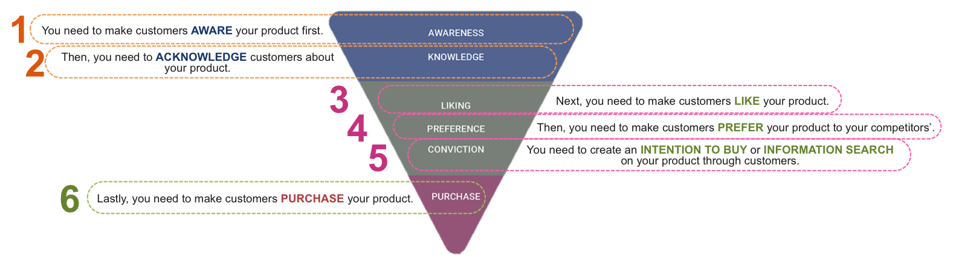

Reference Source: Aleena Pathirapong BE19.

Hierarchy of effect is the marketing communication model that explain the consumer buying behavior, which is created by Robert J Lavidge and Gary A Steiner in 1961 (learningmarketing.net). Marketing conducts had been usually used to study the effectiveness in the hierarchy of effect. This model can tell the impact and effects on the marketing conducts towards the consumer purchasing behavior.
Hierarchy of effect will consist of three phrases, which are cognitive phrase, affective phrase and behavioral phrase, and it will be subbed into six process, which are Awareness, Knowledge, Liking, Preference, Conviction and Purchase.
As for the Cognitive Phase, it's considered to be involved in the Brand awareness and knowledge towards the consumer's perception. As a firm, it's important to make our targeted consumers aware in our product first, and then we need to communicate our product knowledge clearly to the customers. This is the crucial starting part of the consumer's purchasing behaviors, since it can have an influence to the purchasing decision making process to the consumers and can induce the affective phase to them.
As for the Affective Phase, it's considered to be involved in the affection of the product. It's consisted of three process, which are Liking, Preference and Conviction. For Liking, it's crucial to make the customer express liking to our products, based on the product knowledge and awareness that we created. Next, the brand must create the preference responds from the customers over the competitor, which it can create the linked effect of conviction (purchase intention) to our products, so that they can find more additional of our information for the future purchase.
Lastly, Behavior Phrase will involve with the Final Decision on Purchasing, which it will effect based on the first five process that it's effective or not. It's also involved into the re-purchase of the product, which is crucial because it can help to expand the customer loyalty for our firm.
As a summary in this model, Hierarchy of Effect explained the consumer's buying behaviors into six process, which the firms must planned and executed their conducts to accomplish this part. It's also make the firm understand more of the consumer buying behaviors, through this model.

2.1 ATAR FUNNEL (PURCHASE FUNNEL)
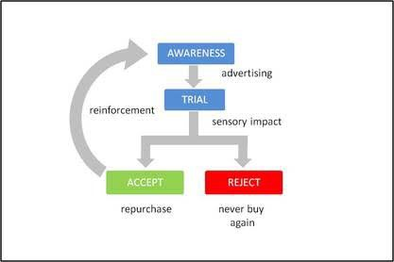

Credit: Aleena Pathirapong BE19.
As for ATAR funnel model, it's also a marketing communication model that explained the consumer buying process, which it's similar to the hierarchy of effect model, but it's in the reduced form. ATAR model explain the importance of the awareness from advertising, trial and repeatability. It's important to the firm that they must create promotional conduct awareness, towards their leads and consumers. This is the first crucial stage, in creating the higher chances for the final purchase.
Next, The Awareness need to be creative, urging the trial in the customers. Also, the firms need to make sure that they're offered the same quality as their marketing conduct claimed. These can create the higher chance of repurchase from the customers.
This model had been applied in the author's questionnaire. It can be clearly measure that whether the conduct is successful or not in the potential customers.

2.2 Millennial Behaviors applied in ATAR Funnel:
As for the Millennial Behavior, the author's will explain the linkage between Millennial buying process and ATAR funnel, which these explanations will construct in question 16 in the author's survey for the next chapters.
At first, Millennial tends to be high online mobile users, which mobile is considered to be one of their typical living. They tend to be easily aware in the products and brand's information, since they are high-internet users. They're participated in the online-society, which it's consisted of information sharing, liking and preference. This can be linked to the ATAR model that Awareness Stage is crucial for firms. It can be determined the positive nor negative effects for the firms, depended on their effectiveness in their conduct's awareness.
Next, Millennial tends to seek blogger's review and online information, after they aware the promotional conducts. They are logical in the sense of purchasing products. They need to be sure that the product, that they're going to purchase is suitable, in terms of price and quality of that products. Credibility in their information is crucial too, since they will use the other's past purchase experience for their upcoming purchase decisions. It's linked with the trial and awareness that the consumer will want to find enough information first, so that they can make a decision on purchase. The firms need to make sure that they're maintain their quality of products and customer services, which it can create the firm's credibility and brand loyalty from the customers.
Lastly, as for the ice-cream market, Millennial tends to be quality seekers, which the quality of products and flavors are receiving high-expectations from them. For re-purchase, they will usually focus mainly on the customer values that they received. It can be occurring if the Millennial received in their expectations or more than that. Or else, they will not purchase the products again. It can be linked to the ATAR funnel that, if the Millennial received lower than expectations. they will not comeback into this funnel again for the brand.

3.3) Questionnaire Design Table:

In the following, this is the summarized questionnaire table, that explain the purpose of the question and what do I wanted to know from each of the questions, so that I can used these for the future study of the finding results. It will be mixed with close and open format questions.
Questionnaire Number: | Type of Questionnaire | Aim of Questionnaire:
1,2-5 | Dichotomous Question, Multiple Question. | To ask the sample's past buying behavior for the Swensen's.  (Y variables).
6,7 | Multiple Choice & Satisfaction Rating Question. | To ask the Respondents for their Product's preference & Types od the products that they were usually consumed in the Swensen's.
8 | Importance Rating Question | To find the level of impact in each of the Product's factors in the respondent's purchase decision making behavior.
9,10,11 | Short Answer's Question and Dichotomous Question. (psychological question involved), (Use product example figures). | To find the past average consumption spending, customer price views on product's pricing and the worthiness of the customer value that they're received.
12. | Importance Rating Question | To find the level of impact in each of the Place's factor in the purchase decision making behaviors of the respondents.
13. | Importance Rating Question | To find the level of impact in each of the Promotion's Factor in the purchase decision making behavior of the respondents.
14. | Multiple Choice Question | To ask how respondents reached the Swensen's promotion information & marketing campaigns through online and offline communication channels.
15. | Rating Question | To find the level of Swensen's brand & product awareness from the respondents.
16. (16.1-16.3) | Dichotomous Question, Multiple Choice Question.  (Use Example of Seasonal Marketing Conduct launched figure). (Swensen's product promotional figure) Figure 2. | Using Seasonal Marketing Conducts Examples, for measured the hierarchy of effect on the responders (Purchase Intention)  - to measure the effectiveness in one of the Swensen's Marketing Conducts.
17,18. | Rating Question | To find the effect level of new launched flavors & Customer Relationship Management (Member Card Strategies) on Millennial Purchase Intention.
19. | Open-Format Question. | - To ask for their comments & future suggestion for Swensen's improvements. (This will help in the conclusion and suggestion parts for the author)
20-22. | Rating & Multiple Question | To ask for the online channel and internet usage behaviors, and uses in finding information about food & restaurant.
23-26. | Dichotomous & Multiple Choice Question | To ask for the general information , which it will describe the targeted respondents.

Reference Table Sources Credited: (Rangsima & Wahloonluck, 2013).

4. Findings

In this chapter, it will be about the result's finding from the questionnaire survey. The results will come from 250 qualified respondents, by purposive sampling on the targeted respondents, which the author had distributed numerous of online channel and direct channel to the targeted respondents. In the following, the author will classify the finding results into parts, justified by the objectives of the study. This finding results will be a crucial part in the next chapter of the data analysis.

4.1 Demographic of the respondents

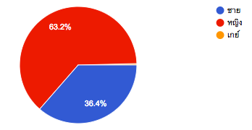
4.1.1 Gender (Figure 3)

Source: The Author Google's Questionnaire Results.

For Gender, there are 63.2% (158 respondents) of the total respondents are women and 36.4% (91 respondents) of the total respondents are men. There is 1 transgender respondent in this questionnaire. As for the general information, the results are completely qualified, since the author didn't require the specification of gender in this research.

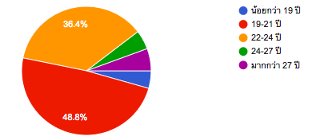
4.1.2 Age (Figure 4)

Source: The Author Google's Questionnaire Results.

For Age, most of the respondents are in the age ranged between 19-24, which are 48.8% for 19-21 years old interval and 36.4% for 22-24 years old interval. The results are qualified for our targeted respondent’s criteria, since the author wanted to focus mainly on new generation of Millennial, which they are usually ranged in this period of age.

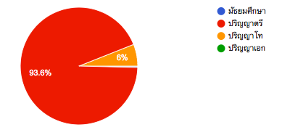
4.1.3 Degree (Figure 5)

Source: The Author Google's Questionnaire Results

For Degree, most of the respondents are currently studying or graduated in bachelor degree. There are some respondents, who are currently studying or graduated in master degree. From the results, these are qualified from the author's targeted respondents, since most of the millennial are receiving higher education. It can be indicated the behavior of logical decision-making and informative in the products for the premium ice cream market.

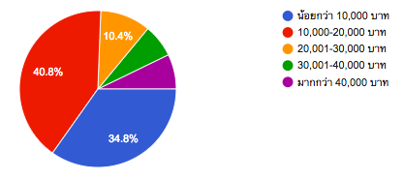
4.1.4 Income (Figure 6)

Source: The Author Google's Questionnaire Results

For Income level, there are 75.6% of the total respondents had a range of
< 10,000 Baht to 10,000 - 20,000 Baht. There are 24.4 % Respondents had a ranged of 20,001 Baht to more than 40,000 Baht. The result is qualified, since most of the respondents had a middle to high income level with mid to high purchasing power. Also, most of the respondents had been stayed and taken cared by parents, so the result is reasonable and qualified for this study.

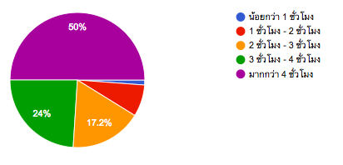
4.1.5 Internet Usage/ Day (Figure 7)

Source: The Author Google's Questionnaire Feedback.
For Internet Usage results, Half of the total respondents had use internet for more than 4 hours per day. there are 41.2 % of respondents had used internet for 2 to 4 hours per day. This result is qualified, since it matched with the Millennial Characteristics of highly spend time in the internet.

4.2 Respondent's Past Buying Behavior

4.2.1 Swensen's Experience (Figure 8)
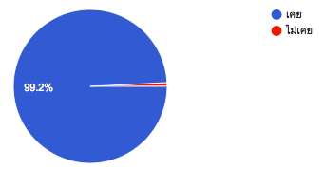

Source: The Author Google's Questionnaire Feedback.
For Experience, there are 99.2% who had an experience with Swensen's and there are only 2 respondents, who didn't have an experience with. This result is qualified, since the questionnaire aimed to target the Millennial that have an experience with Swensen's.

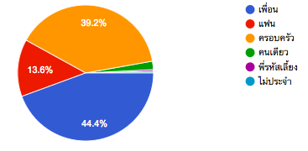
4.2.2 The People that respondents usually go with: (Figure 9)

Source: The Author Google's Questionnaire Feedback
In this part, we can see that most of the responders will using the service with their companions and loved ones, such as, friends, families and lovers. This is usually normal stereotypes for the Thai cultures that they didn't prefer to have an ice-cream by themselves.

4.2.3 Time Uses (Figure 10)
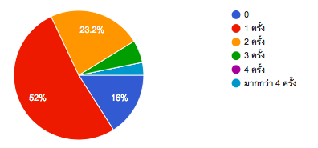
In this part, we can see that three quarters of the respondents had been regularly purchased and visited Swensen's store 1 to 2 times per month. Also, there are 16% of the respondents who didn't regularly purchased or visited Swensen's. there are 8.8% respondents who visited or purchased 3 to more than 4 times per month in Swensen's.

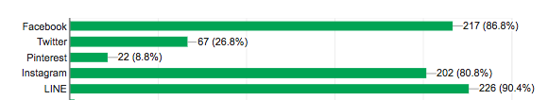
4.2.4 Online Media Channel Usage (Figure 11)

Source: Author Google Questionnaire Results.
For Online Media Channel Usage, these finding are only taken the most popular media channel that most of the respondents had been used on. From the results, most of the respondents had been used Facebook, Instagram and LINE for their online communication. these three social medias are one of the most popular online media channel that Thai People and Millennial had been using on. There are some interesting facts that 26.8% of the respondents had used twitter and 8.8% are using Pinterest.

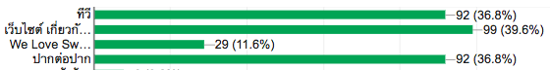
4.2.5 Promotion Awareness through Media Channel (Figure 12)

For Promotion Awareness responds, there are three most awareness channel for the responders, which are TV, Buzz and Promotion webpage, that the respondents had been aware on. Surprisingly, TV is one of the popular channel for the Millennial. It contrasted to the Millennial characteristics that they are mostly use the digital channel for their promotion's information, instead of the Television. Also, the millennial didn't aware much of the Swensen's promotion from their official Facebook page.

4.2.6 Respondent's Time Spending / minutes per time
Min. Time Spending | 5
Max. Time Spending | 120
Mean Time Spending | 37.5

Source: The Author Google's Questionnaire Results

From 250 respondents, the average from them of spending time in Swensen's store is 37.5 minutes per time. The maximum of time is 2 hours for Swensen's and the least time spending is 5 minutes.

4.2.7 Respondent's Preference On Swensen's Retail Channel (Figure 13)
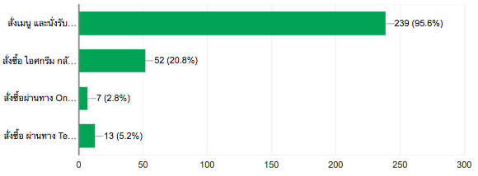

For the results, most of the respondents prefer to Swensen's Dine-In Channel, which is to order the designated product in the Menu and enjoyed in the shop. There are 20.8% of respondents, who preferred Ready to Eat Ice-Cream and the rest are online & telephone delivery service.

4.2.8 Respondent Past Average Purchasing Amount (Baht Used / Time)
Min | 0 Baht
Max | 1000 Baht
Mean | 195.128 Baht

Source: The Author Google Questionnaire's Results

In this part, the average of spending for the respondents is 195 Baht. The minimum spending is 0 Baht and the Maximum Spending is 1000 Baht per time. This results are qualified, since the author didn't have any criteria on the amount of spending from the respondents.

4.3 Product Preference & Product Factors Impact Level.
4.3.1 Respondent's Product Type Preference (Figure 14)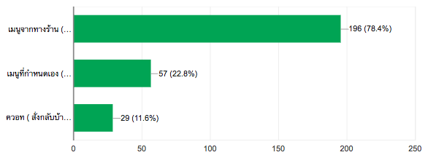
In this part, there are 78.4% of the total respondents, who preferred Swensen's Designated Menu, which is the most popular product type for the respondents. Also, there are 22.8% of total respondents, who preferred Swensen's customized products and 11.6 % of total respondents, who preferred Quart- Packaging Type.

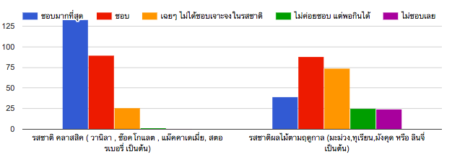
4.3.2 Respondent's Flavor's Type Preference (Figure 15)

From the results, there are two main flavor types for the Swensen's. Comparing between the two types, most of the respondents prefer more on the classic types than the seasonal fruit flavors. Classic flavors type tended to have more positive responds than the seasonal fruit flavors. Seasonal fruit flavors tended to be more neutral and it have more of the dislike preference than the classic ones.

4.3.3 Respondent's Product Factor's Level of Impact (Figure 16 & 17)
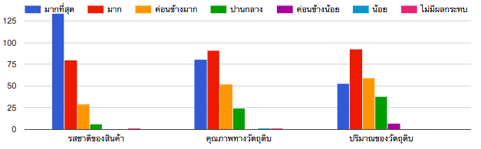

Source: The Author Google Questionnaire Results

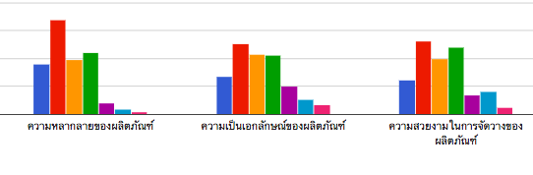
For the product factor, the author had defined the detail of Swensen's product's factor from Marketing Mix, which it consisted of six factors. As on the first three factors, The Product Taste is impacted the most for the respondents, receiving most positive responds from respondents. Next, The Quality of the Product l had a high positive responds with most of the respondents and Size of the products too.

For the last three parts, there are least positive responds than the first three factors. There are mixed with neutral responds from this three factors. Also, Uniqueness and Beauty of the products had a least impact on the product factors, for the respondents.

4.4 Respondent's Price View's for Swensen's

4.4.1 Respondent's Views on Swensen's Product Worthiness Compared with Price Point (Figure 18)
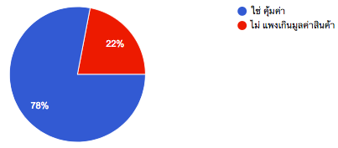

Source: The Author Google Questionnaire Results

From the results, there are 78% of the respondents, who thought that Swensen's product is worthiness, on the other hand, there are 22% of respondents, who thought that the Swensen's price point is expensive for them.

4.4.2 Respondent's Estimate Price Views towards the Swensen's Product Visual Example
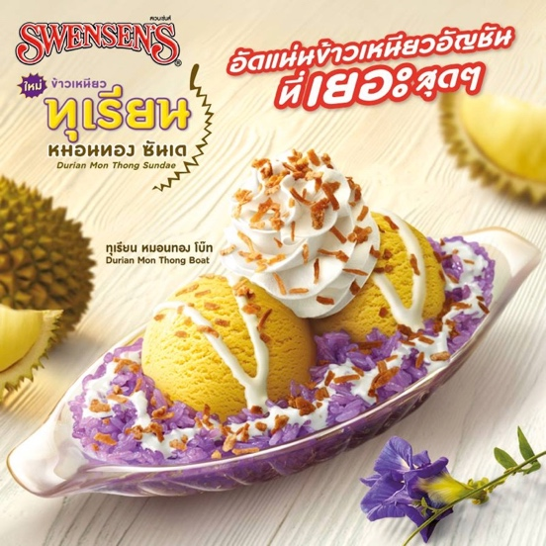
(Figure 19)

Min. | 59 Baht
Max. | 300 Baht
Mean. | 150 Baht

Actual Price = 139 Baht.

Source Credit: http://www.promotiontoyou.com/2017/07/promotion-swensens-durian-mon-thong-fever/

From the results, the average of the estimation price that the respondents had responded is 150 Baht for this product. The maximum estimation price point for the responds is 300 Baht and the lowest ones is 59 Baht. We can see on the respondent's average price point is more than the actual price point, which is 139 Baht for the durian designated ice-cream menu product.

4.5 Respondent's Place Factors Impact Level (Figure 20)
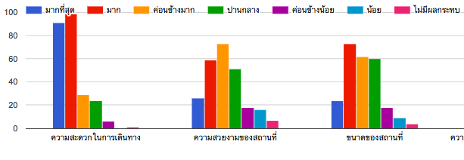

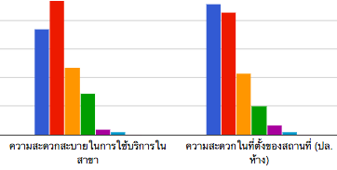

From the result, most of the factors are received the high-impact level responds from the respondents. Transportation Convenience, In-store Usage convenience and Location Convenience are the top three of highest impact from the respondents. Although, the other three remaining factors had received mid-high responds from the respondents.

4.6 Respondent's Promotion Factors & Conducts Impact Level
4.6.1 Promotion Factors Impact Level (Figure 21)
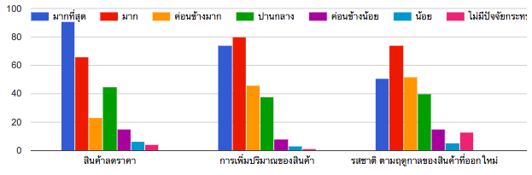

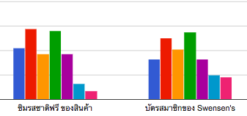

For the Promotion Factors results, most of the promotion factors have high impact level from the responders. Although, Free Samples & Swensen's Membership Card had the least impact from the respondents, compared it with the other 4 promotion factors.

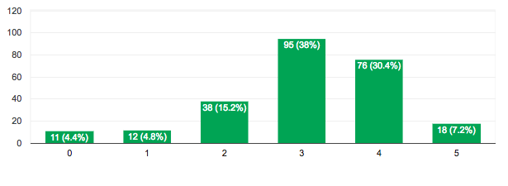
4.6.2 New Flavors Promotional Conduct Effects Level Towards Purchase Intention (Fig22).

Source: The Author Google Questionnaire Results
From the results, most of the respondents had mid to mid-high induce effect in purchase intentions on the Swensen's new flavor promotional conducts. It can be concluded as 68.4% of the total respondents. There are 7.2&, who have high induction effect on the strategies and there are roughly 24% of the total respondents, who have low effect from this strategy.

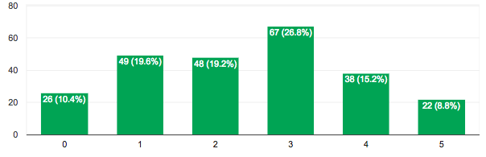
4.6.3 Swensen's Membership Card Promotional Conduct Effects Level Towards Purchase Intention. (Figure 23).

From this part results, there are 49% of the total respondent's, who have low to none effect level of responds in register new member card, effected from this strategy. There are 26.8% of the total respondents, who have moderate effect level of responds in register new member card and 23% of total respondents have a high effect level of register Swensen's member card, from this promotional strategy.

4.7 Hierarchy of Effect Measurement of Swensen's Marketing Conduct
4.7.1 Product Awareness (Figure 24)
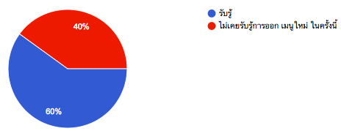

Source: The author Google Questionnaire results:

For this part, there are 60% of total respondents that aware in this Swensen's seasonal marketing conduct. there are 40% of total respondents that didn't aware in this Swensen's marketing conduct. This can be indicated there are more respondents who aware in this conduct.

4.7.2 Product's Information (Figure 25)
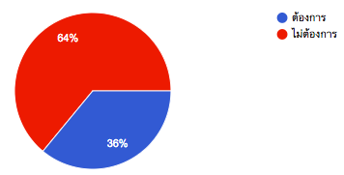

Source: The Author Google Questionnaire Results
For the results, there are 36% of total respondents, who wanted to find more information about the product and there are 64% of total respondents, who didn't want to find more about the product. This can be indicated that there are more respondents, who didn't want to find further information about this marketing conduct.
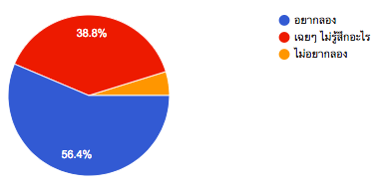
4.7.3 Product Try (Purchase) Preference (Figure 26)

From this part, there are more than half of the total respondents, who are interested to purchase and try the new product. There are 38.8%, who felt neutral to the product and the rest didn't want to try the new product launching.
4.7.4 Repeatability (Figure 27)

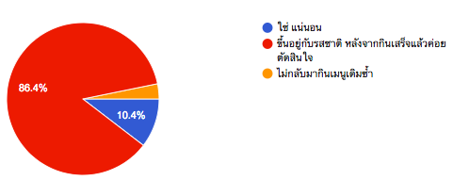

In this part, we can see that there are 86.4% who are depend on the taste in after their consumption, for their re-purchasing decision. There are 10.4% of total respondents, who will re-purchasing the product and the rest didn't want to re-purchase the product.

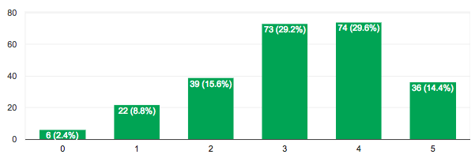
4.8 Internet Food Usage (Figure 28)

Source: The Author Google Questionnaire Results
In this part, most of the respondents had a high frequency level of using online media tools for seeking food promotional information. There are 73.2% of total respondents had frequency level between 3 to 5. there are 24.4% of total respondents, who had low frequency level between 1 to 2, and the remaining 6 respondents, didn't use online media tools for the food promotion informative.

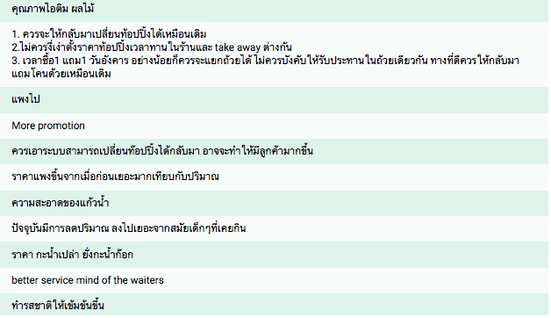
4.9 Respondents Comments toward Swensen's (Figure 29)

Source: The Author Questionnaire Results
These are the sample from the total 250 respondent’s opinions & comments towards Swensen's.

Chapter 5: Data Analysis

In this Chapter, the conceptual framework from chapter 2 (Figure 1) will be applied in this chapter for the guidance the topic of the data analysis. It will be focused on two main topics, which are the 4P's factors that have an impact on purchase decision making and marketing conducts effectiveness on purchase intention. Also, the author will use regression analysis tools, using a STATA program and descriptive statistics analysis from the author Google questionnaire results, for helping the data analysis. 250 observations will be used in this chapter.

5.1 Swensen's Marketing Mix Factors Effects on Purchase Decision-Making.

In this part, the author will conduct the regression analysis, by using the STATA program, running regression to the data. The results will use for the analysis, so the author can conclude that, which Marketing Mix's factors and sub-factors are effective on Millennial purchase decision making.
Also, the author will use 2 Y variables, which are the average spending per time of the respondents and the average time uses per month of the respondents. these variables will be the proxies for purchase decision making.
For X Variables, the author will use the Marketing Mix Factors variables and Respondent's demographic and behavioral variables, finding the relationship and significance between these 2 variables.
The Marketing Mix Factors will consist only three factors, which are product, place and promotion, because as cited from Channunsiri (2007) that the premium ice-cream market mostly competed, by using non-pricing strategy, which it's effected more on the consumers, so the author tried to focus more on these 3 factors.

5.1.1 Marketing Mix Factor's on Respondent's Purchase Decision Making
(Figure 30)

From the regression results (figure 30), the author will focus only the X's variables, which the p-values are smaller than 0.05 with 95% Conf. Interval. The X variables will be varied from the marketing mix factors and the respondent's demographic behaviors.

Prodscore - the coefficient for prodscore is 21.26618, which it can be indicated that every unit increase in prodscore, bahtused is predicted to increase in 21.26618 unit, holding the other variables constant. This can be indicated that the average spending is predicted to increase, when the average impact of the product's factor is increased. Also, the coefficient for prodscore is statistically significant because it's p-value is less than 0.05. This can be implied that the increases in impact level for product factor effects the increases in average spending of respondents.

Gender - the coefficient for gender is 42.21134, which every unit increase in gender, bahtused is predicted to increase in 42.21124 unit, holding the other variables constant. This can be indicated that Men tended to pay more than Women for 42.21124 unit. Also, the coefficient of gender is statistically significant, since it's p-value is less than 0.05 p-value.

Degree - the coefficient for degree is 75.38085, which every unit increase in degree, bahtused is predicted to increase in 75.38085 unit, holding the other variables constant. This can be indicated that increase in education attainment will effect the increase in average spending per time for the respondents.

5.1.2 Product's Factor on Respondent's Purchase-Decision Making

As from the first regression's results, the product factor is the only factor that effected the purchase decision-making for the respondents. In the following, the author will look deeper on the 6 sub-factors in the product factors, that which sub-factor effects the respondent's purchase- decision making.
1. Product Taste (Figure 31)

From the results, the product taste isn't statistically significant with the average spending per time, since this coefficient had a p-value that is more than 0.05.

2. Product Quality (Figure 32)

From the results, Product Quality isn't statistically significant with the average spending per time, since the coefficient had the p-value of 0.431, which is more than 0.05, so this variable didn't have any relationship with the bahtused.
3. Product Quantity (Figure 33)

For Product quantity, this variable's coefficient is not statistically significant with the average spending per time for the respondents, since it's p-value is 0.2, which is more than 0.05. So, this variable cannot be concluded in explaining the effects on purchase decision making.

4. Product's Variety (Figure 34)

For Product Variety, the coefficient is 11.39043, which every unit increases in the prodvar, the bahtused is predicted to increase in 11.39043 unit, holding theother variables constant. The variable's coefficient is statistically significant with the p-value of 0.031, which is smaller than 0.05.
This can be implied that the increases in impact level of Swensen's product varieties factor can effect the increases in the average spending per time for the respondents. More varieties of the product, can resulted of higher spending for the respondents.

5. Product Uniqueness (Figure 35)

For Product Uniqueness, this coefficient is 10.61107, which every increase in the produniq, the bahtused is predicted to increase in 10.61107 unit, holding the other variables constant. The variable's coefficient is statistically significant with the two-tailed p-value of 0.016, which is smaller than 0.05.
This can be implied that the increases in impact of level of Swensen's product uniqueness factor can effect the increases in the average spending per time for the respondents. More uniqueness of the product, can resulted of higher spending for the respondents.

6. Product's Beauty (Figure 35)

For Product Beauty, the coefficient is 11.23114, which every increase in the prodbeau, the bahtused is predicted to increase in 11.23114 unit, holding the other variables constant. The variable's coefficient is statistically significant with the p-value of 0.012, which is smaller than 0.05.
This can be implied that the increase in impact of level of Swensen's product beautifulness factor can effect the increase in the average spending for the respondents. More Beautifulness of the product, can resulted the higher spending for the respondents.

5.1.2 Marketing Mix Factors on Swensen's Times Used Per Month

(Figure 36)

As for this data result, the author changes the Y's Variables to the time used in visited Swensen's. Although, the results of this regression isn't effective. There isn't a single variable that can used in the analysis, so this Y variable can not be used in this study.

5.2 Swensen's Seasonal Marketing Conduct Effectiveness on Consumer Purchase Intention

In this part, the author will conduct regression analysis for the results in questionnaire 16, which use the examples of Swensen's Seasonal Marketing Conduct for measure the effectiveness in urging the Millennial Purchase Intention. Next, the author will set Time Uses per month in Swensen's as the Y Variables. The X Variables will be the results from each sub-question that explained the purchase intention and the Respondent's behavioral characteristics. The Author will use the hierarchy of effect model, helping in the explanation of this results.

(Figure 37)

As from the results, the author will focus only on the X's variables that had a p-value that smaller than 0.05. There are 2 variables that matched these conditions, which are Prodtry and promoinfoaware.

Prodtry: This variable has coefficient of 0.3191634, which every unit increases in prodtry, timeuse can be predicted to increase by 0.32 units. The coefficient is statistically significant with the p-values that is smaller than 0.05. This can be implied that the increases in intention of purchasing the products, can resulted of the increases in time-use from the respondents.

Promoinfoaware: This variable has coefficient of 0.1782062, which every unit increases in Promoinfoaware, timeuse can be predicted to increase by 0.1782 units. The coefficient is statistically significant with the p-values that is smaller than 0.05. This can be implied that increases in Swensen's promotion informative, can resulted of increases in time-use from the respondents.
6. Conclusion & Suggestion

As a conclusion of this study, the author had conduct the Quantitative Research, for finding the two results in the 2 objective of study in Chapter 1, which are Swensen's Marketing Mix Factors Effects on Purchase Decision-Making and Swensen's Seasonal Marketing Conduct Effectiveness on Consumer Purchase Intention. As the author had conducted the regression analysis in Chapter 5. There are several results findings that can answered these objectives, Next the author will summarize the conclusion in each of the objective.
As for the first objective, The Product Factors is the only Marketing Mix's factors that effects Millennial's Purchase-Decision Making. Looking more on that, there are three sub-factors, which are the Swensen's Product Variety, Uniqueness of the products and the beauty of the product.
For Product Variety, the author suggests that Swensen's should add more products line and categories, such as traditional Korean Shaved-Ice (Bingsu) or Organic Ice-Cream parfait etc. This expansion in the product variety will help to increase the spending for the Millennial and higher probabilities for the Millennial Purchased on Swensen's Product.
For Product Uniqueness, the author suggest that Swensen's should create more on the uniqueness of the ice-cream product flavors, such as the existed seasonal local fruits flavors like Durian and Mango. This will strengthen the Swensen's Brand Positioning, which this will effect the increase in Millennial Purchase & Spending on Swensen's.

For Product Beauty, the author suggest that Swensen's should focus more on the beautifulness and creativity of the product design, since it can apply to the Millennial behavior that they considered the beauty of the product design as crucial in their decision making. Millennial is also love to take picture and share into their social media. Swensen's need to control on the product's garnish. This can be effected on the decision and spending for the Millennial.
These 3 factors generate the impact of the Millennial Purchase-Decision Making. It will help to increase the success in purchase and spending from the Millennial. The Millennial will look on these three factors in their decision-making.

As for the second objective, Swensen's seasonal marketing conduct only generated the effectiveness in the behavior phase (intention of trying and purchasing the products for the Millennial). Although, the author suggested that Swensen's should improve more on the cognitive phase in the Conduct's Awareness, and intention to seek more information about this conduct.
From above, Swensen's need to improve more on their Integrated Marketing Communication, which it can helped to reach more of the product awareness for their targeted customers. The media channel must be Omni-channel, mixed with online and offline channel, because from the finding in Chapter 4. It showed that buzz-marketing is effective for the Millennial with 36% of the total respondents, aware through this channel. These will maximize the effectiveness in create more product awareness for the Millennial.
This phase can create more on the possibilities of convertibility for Millennial to purchase the product. The improvement of this conduct will be included in the creativity and the richness of the content that can interacted more with their potential leads. Sometimes, the conduct must be continuously improved and developed to the fast-changing digital age, fulfilled with unstable of consumer behaviors.

