บช. 201 การบัญชีชั้นต้น
แบบฝึกหัด บทที่ 8
ผศ. ดร. อรพรรณ ยลระบิล

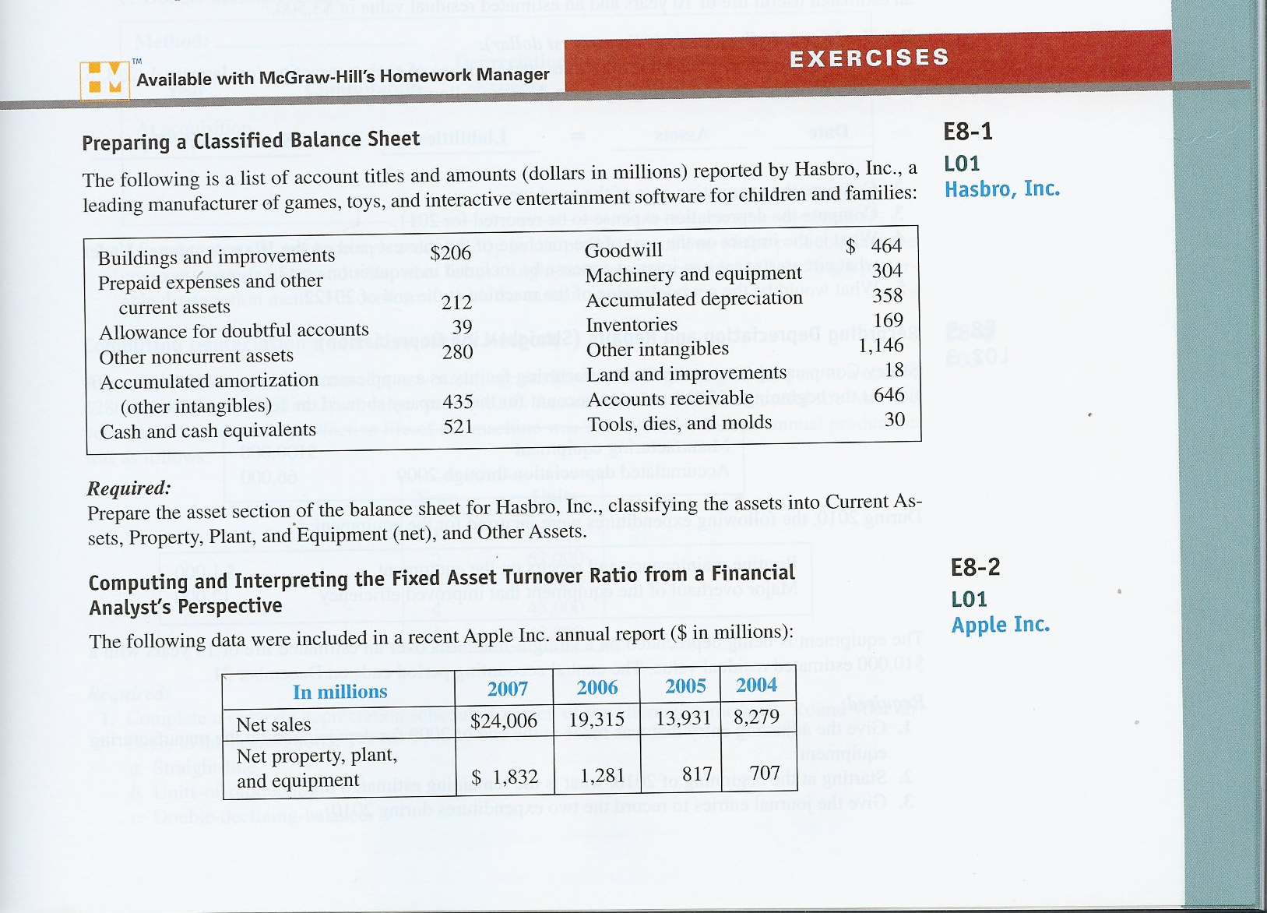
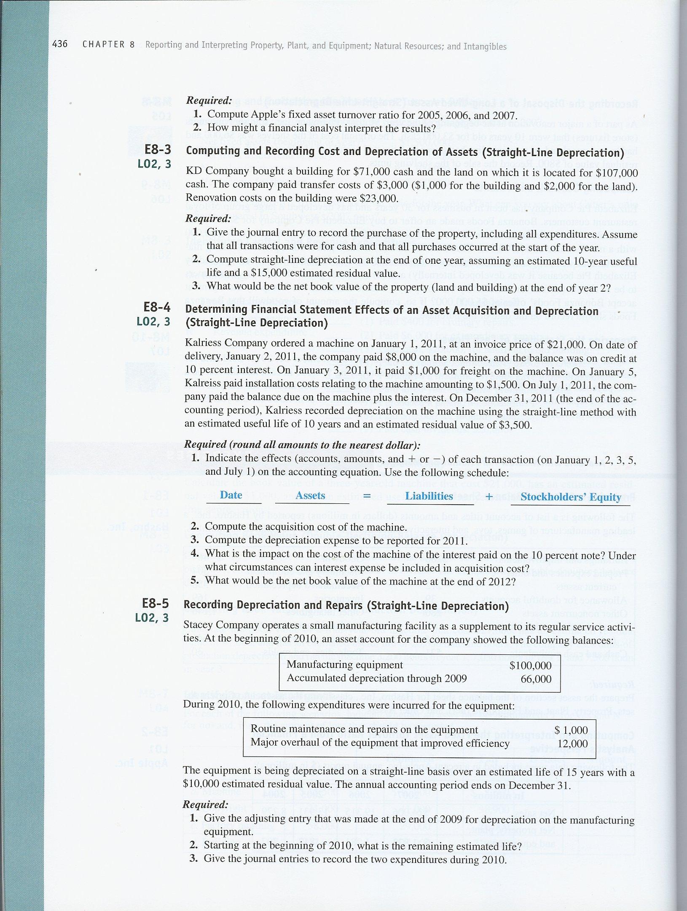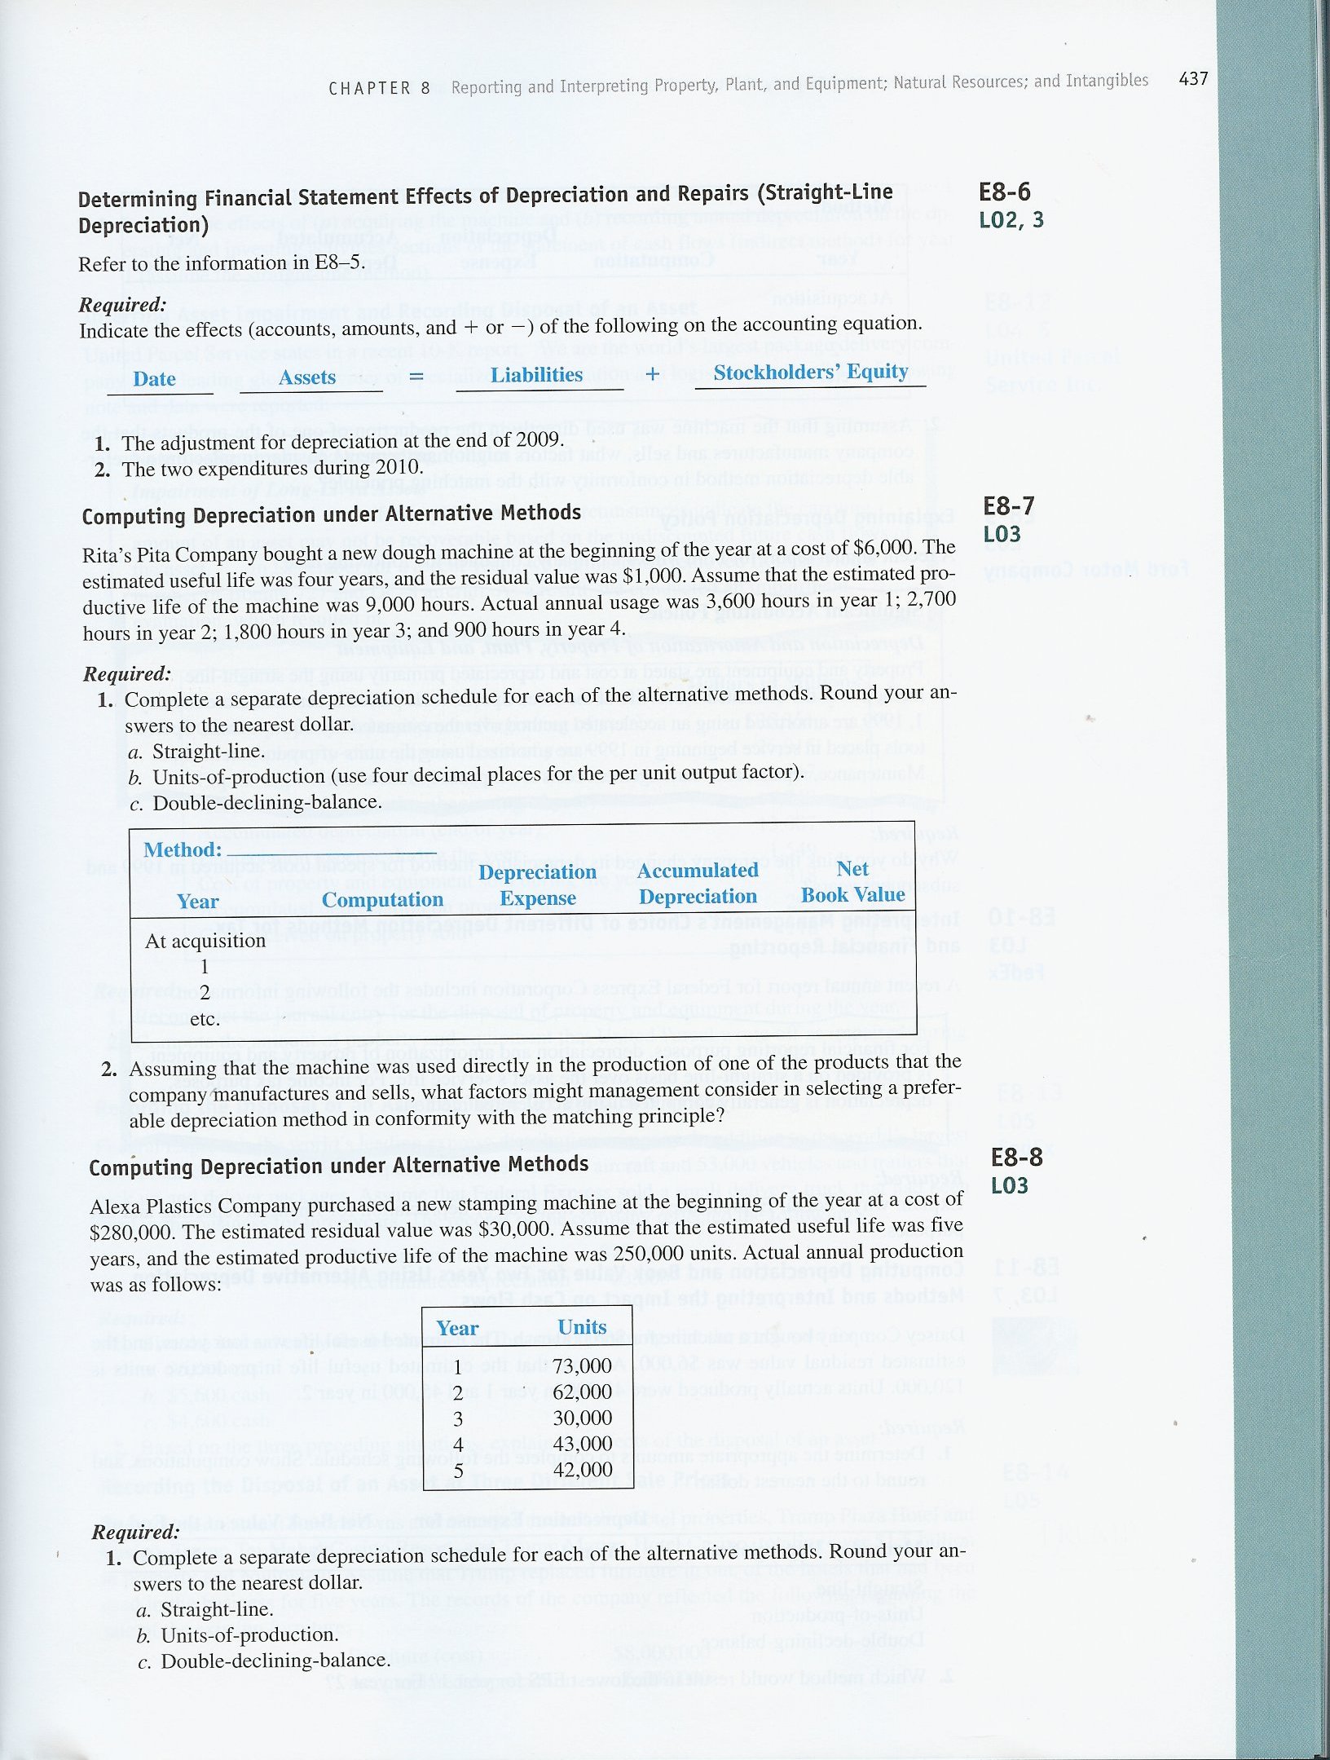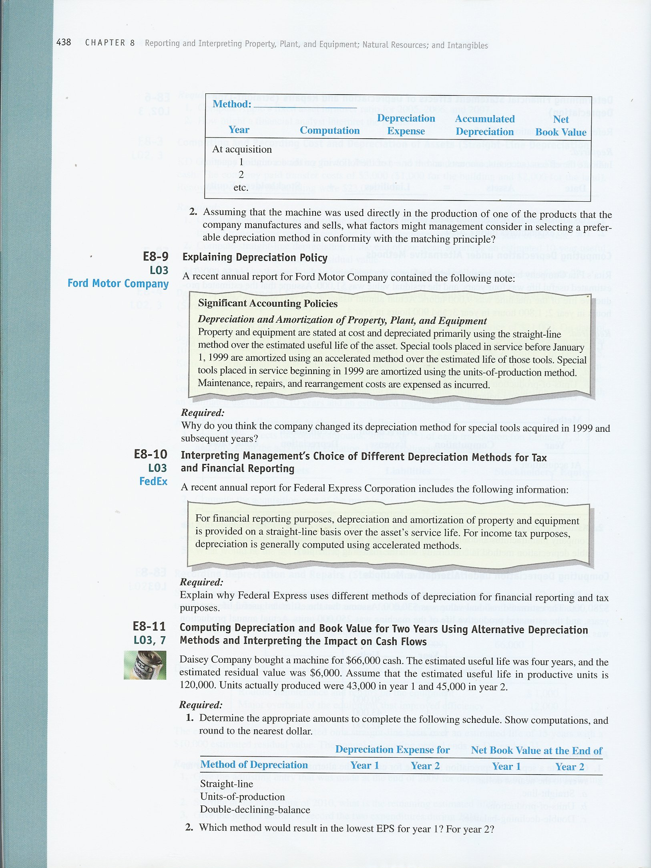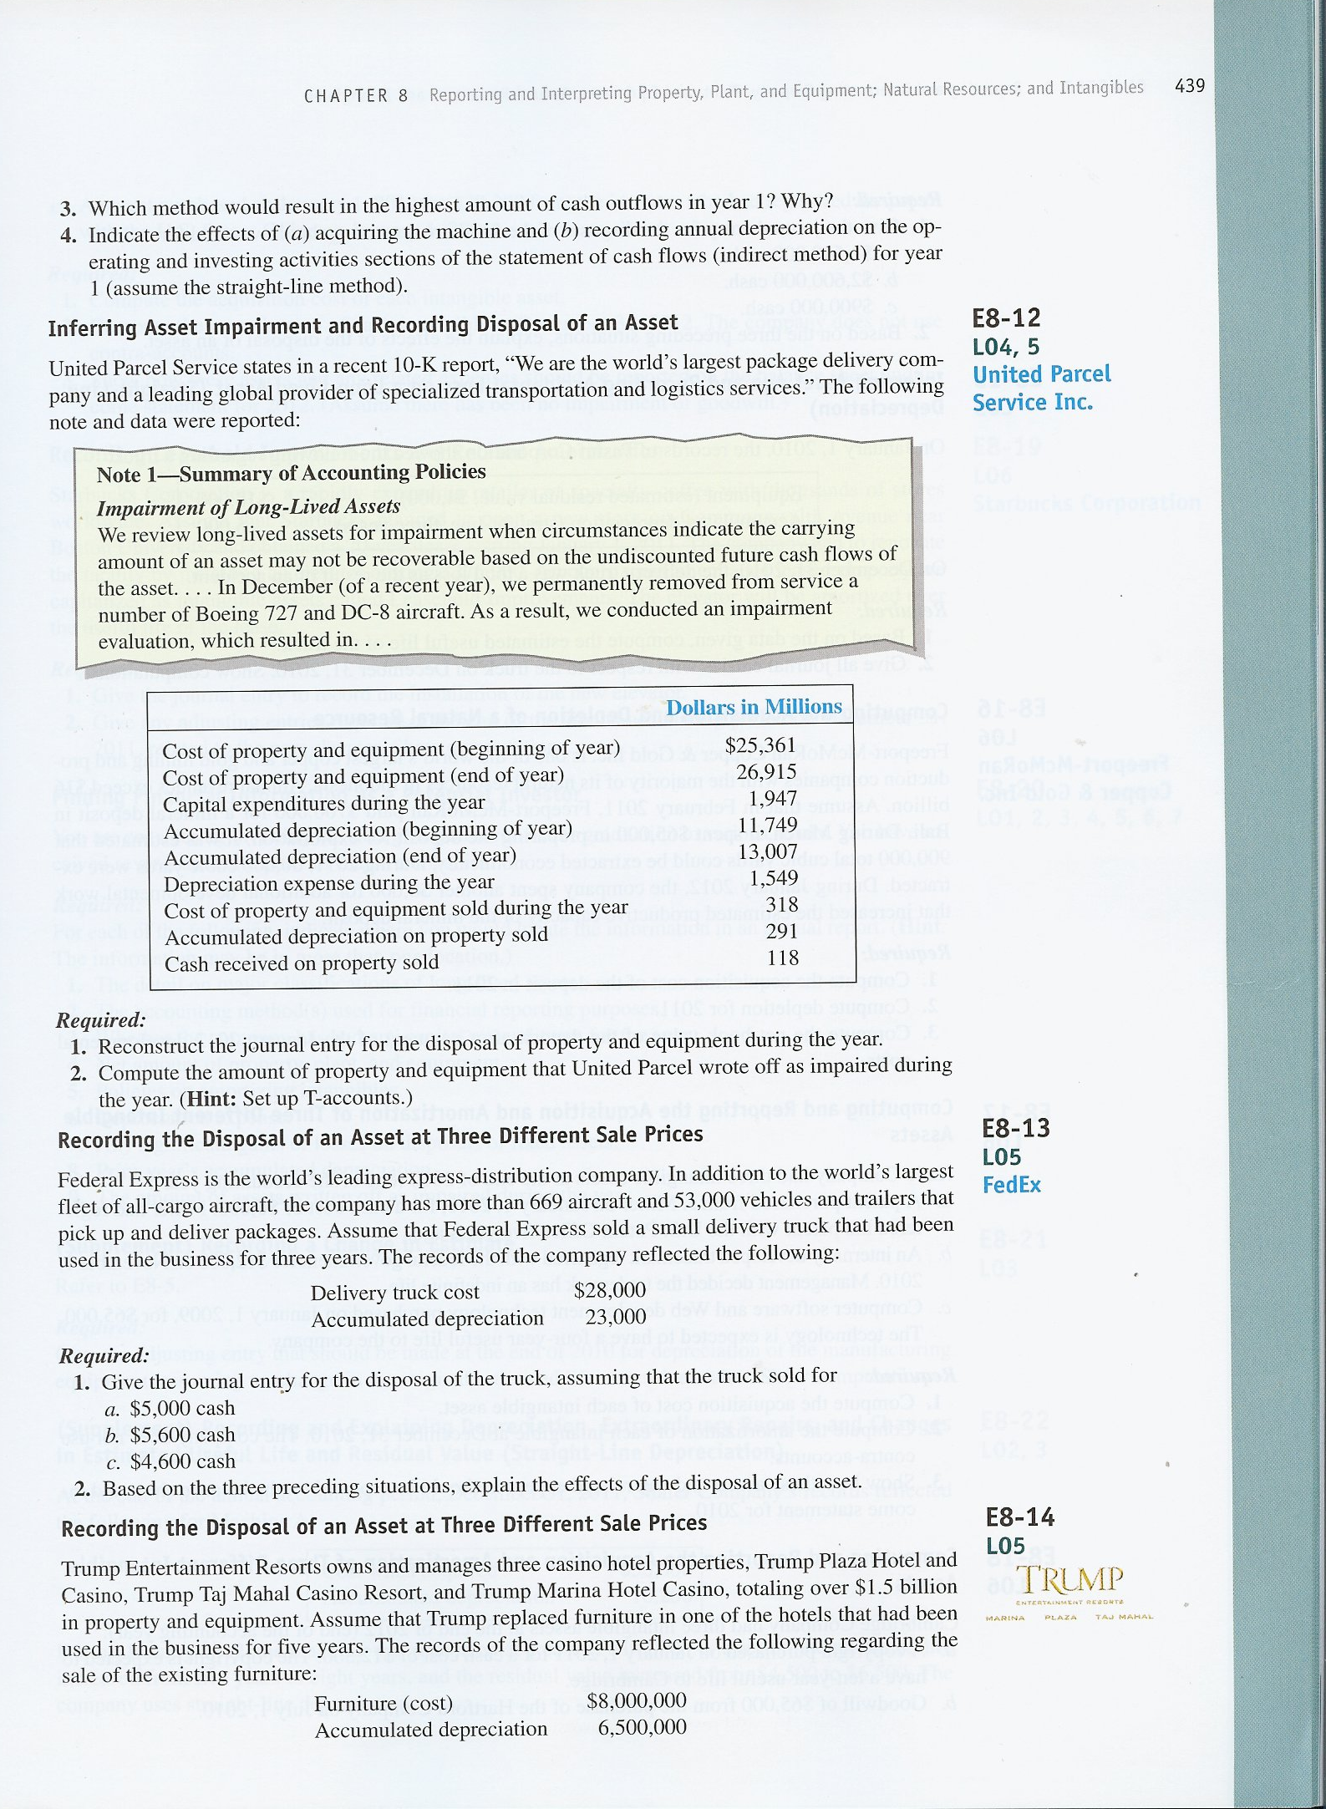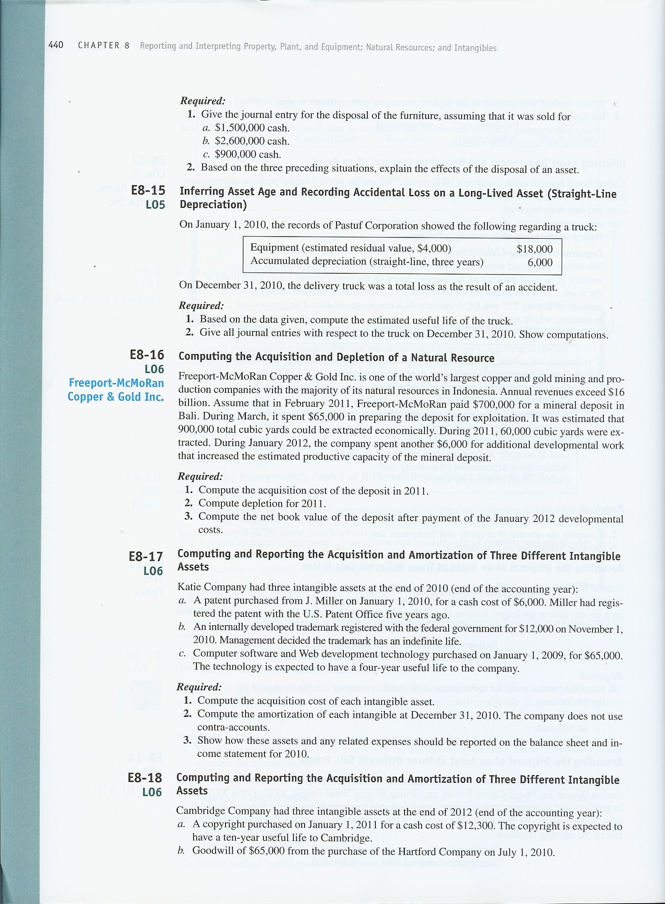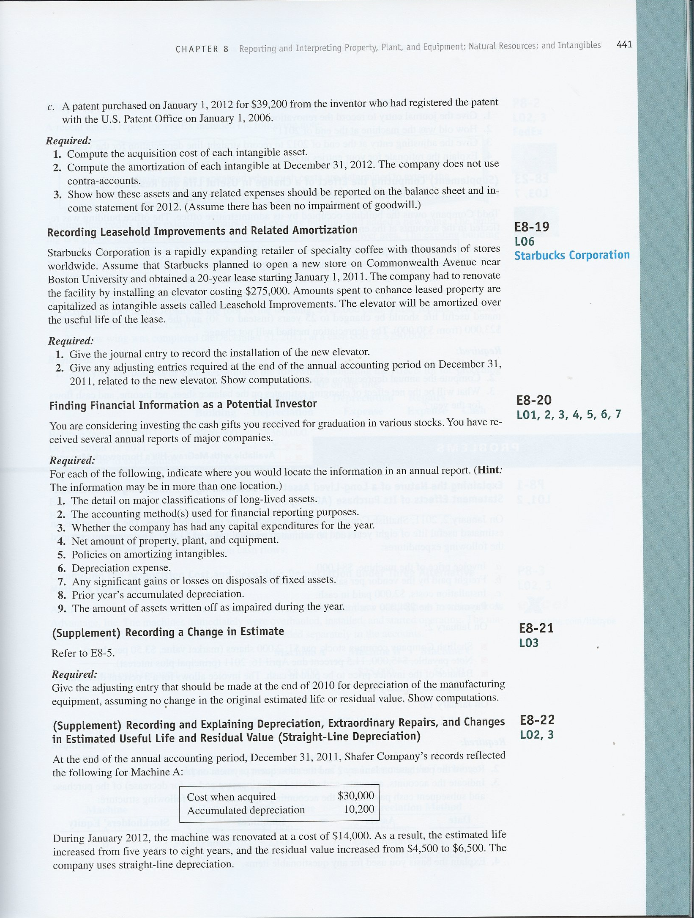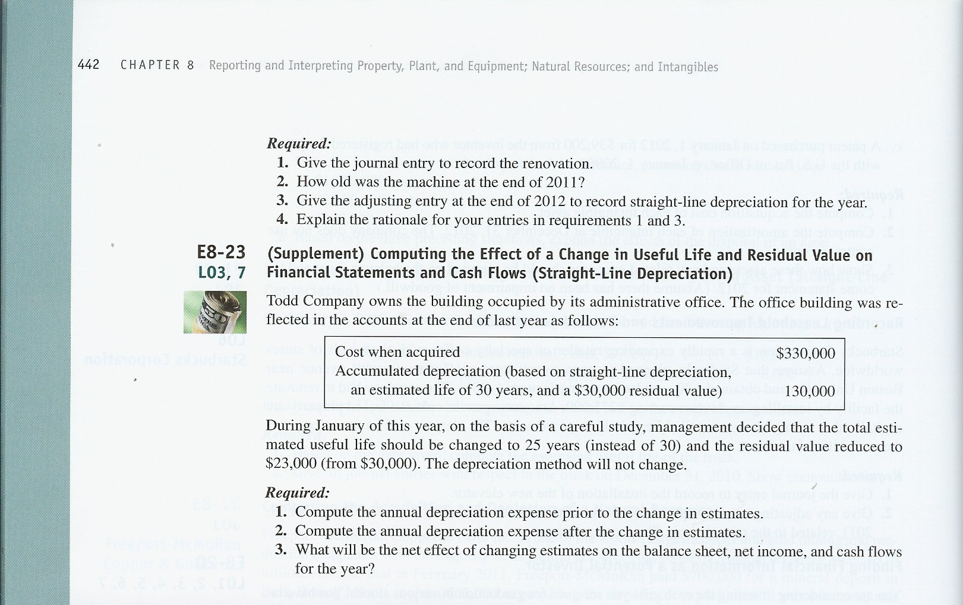

Exercises

E8–1.
Hasbro, Inc.
Excerpts from Balance Sheet
(in millions)
ASSETS
Current Assets
Cash and cash equivalents | $ 521
Accounts receivable (net of allowance for doubtful accounts, $39) | 607
Inventories | 169
Prepaid expenses and other current assets | 212
Total current assets | 1,509
Property, Plant, and Equipment
Tools, dies and molds | 30
Machinery and equipment | 304
Buildings and improvements | 206
Land and improvements | 18
Property, plant, and equipment (at cost) | 558
Less: Accumulated depreciation | 358
Total property, plant, and equipment (net) | 200
Other Assets
Goodwill | 464
Other intangibles (net of accumulated amortization, $435) | 711
Other noncurrent assets | 280
Total other assets | 1,455
Total Assets | $3,164

E8–2.
Req. 1
Fixed asset turnover ratio: (in millions)
Sales ÷ [(beginning net fixed assets + ending net fixed assets) ÷ 2]
2007 | 2006 | 2005
$24,006 ÷ $1,556.5 | $19,315 ÷ $1,049 | $13,931 ÷ $762
15.42 | 18.41 | 18.28
Computation of denominator:
2007 | ($1,832 + 1,281) ÷ 2 | = $1,556.5
2006 | ($1,281 + 817) ÷ 2 | = $1,049
2005 | ($817 + 707) ÷ 2 | = $ 762

Req. 2
Apple’s fixed asset turnover ratio rose slightly in 2006, then fell to 15.42 in 2007. This suggests that Apple’s management became less efficient at utilizing its long-lived assets over time. The decrease in 2007 was due primarily to a large increase in fixed assets that year. Although the turnover has declined, it is possible that the build-up of fixed assets may lead to increased sales in the future, thus increasing the fixed asset turnover ratio to prior levels. An analyst can use this longitudinal analysis to observe possible trends over time. In addition, the analyst may compare Apple’s ratios to those of competitors in the industry.

E8–3
Req. 1
Building (+A) | 95,000
Land (+A) | 109,000
Cash (−A) |  |  | 204,000

 | Building | Land
Cash paid | $71,000 | $107,000
+ renovations to prepare for use | 23,000
+ share of transfer costs | 1,000 | 2,000
 | $95,000 | $109,000

Req. 2
Straight-line depreciation computation:
($95,000 cost - $15,000 residual value) x 1/10 years = $8,000 depreciation expense per year
Note: Land is not depreciated.

Req. 3
Computation of the book value of the property at the end of year 2:
Building | $ 95,000
Less: Accumulated depreciation ($8,000 x 2 years) | (16,000) | $ 79,000
Land |  | 109,000
 |  | $188,000

E8–4.
Req. 1
Date | Assets |  | Liabilities |  | Stockholders’ Equity
January 1 | No effect |  | No effect |  | No effect
January 2 | Cash  Equipment | –8,000  +21,000 | Short term note payable | +13,000
January 3 | Cash  Equipment | –1,000  +1,000
January 5 | Cash  Equipment | –1,500  +1,500
July 1 | Cash | –13,650 | Short term note payable | –13,000 | Interest expense* | –650
* $13,000 principal x .10 interest rate x 6/12 of a year = $650 interest

Req. 2
Acquisition cost of the machine:
Cash paid $ 8,000
Note payable with supplier 13,000
Freight costs 1,000
Installation costs 1,500
Acquisition cost $23,500

Req. 3
Depreciation for 2011: ($23,500 cost - $3,500 residual value) x 1/10 years | $ 2,000

Req. 4
On July 1, 2011, $650 ($13,000 x 10% x 6/12) is paid and is recorded as interest expense. The amount is not capitalized (added to the cost of the asset) because interest is capitalized only on constructed assets. This machine was purchased.

Req. 5
Equipment (cost) | $23,500
Less: Accumulated depreciation ($2,000 x 2 years) | 4,000
Book value at end of 2012 | $19,500

E8–5.
Req. 1
Adjusting entry for 2009:
Depreciation expense (+E, −SE) | 6,000
Accumulated depreciation, equipment (+XA, −A) |  |  | 6,000
($100,000 – $10,000) x 1/15 years = $6,000
Req. 2 ( beginning of 2010)
Remaining life: 15 years – ($66,000 ÷ $6,000 = 11 years used) = 4 years remaining

Req. 3 (during 2010):
Repair and maintenance expense (+E, −SE) | 1,000
Cash (−A) |  |  | 1,000
(Ordinary repairs incurred.)
Equipment (+A) | 12,000
Cash (−A) |  |  | 12,000
Extraordinary repairs incurred and capitalized.

E8–6.
Date | Assets |  | Liabilities |  | Stockholders’ Equity
1. 2009* | Accumulated depreciation | –6,000 |  |  | Depreciation expense | –6,000
2a. 2010 | Cash | –1,000 |  |  | Repair and maintenance expense | –1,000
2b. 2010 | Cash  Equipment | –12,000  +12,000
* Adjusting entry for 2009:
($100,000 cost – $10,000 residual value) x 1/15 years = $6,000.

E8–7.
Req. 1
a. Straight-line:
Year | Computation |  | Depreciation Expense | Accumulated Depreciation | Net  Book Value
At acquisition |  |  |  |  | $6,000
1 | ($6,000 - $1,000) x 1/4 |  | $1,250 | $1,250 | 4,750
2 | ($6,000 - $1,000) x 1/4 |  | 1,250 | 2,500 | 3,500
3 | ($6,000 - $1,000) x 1/4 |  | 1,250 | 3,750 | 2,250
4 | ($6,000 - $1,000) x 1/4 |  | 1,250 | 5,000 | 1,000

b. Units-of-production: ($6,000 – $1,000) ÷ 9,000 = $0.5556 per hour of output
Year | Computation |  | Depreciation Expense | Accumulated Depreciation | Net  Book Value
At acquisition |  |  |  |  | $6,000
1 | $0.5556 x 3,600 hours |  | $2,000 | $2,000 | 4,000
2 | $0.5556 x 2,700 hours |  | 1,500 | 3,500 | 2,500
3 | $0.5556 x 1,800 hours |  | 1,000 | 4,500 | 1,500
4 | $0.5556 x 900 hours |  | 500 | 5,000 | 1,000

E8–7 (continued)
c. Double-declining-balance:
Year | Computation |  | Depreciation Expense | Accumulated Depreciation | Net  Book Value
At acquisition |  |  |  |  | $6,000
1 | ($6,000 - $0) x 2/4 |  | $3,000 | $3,000 | 3,000
2 | ($6,000 - $3,000) x 2/4 |  | 1,500 | 4,500 | 1,500
3 | ($6,000 - $4,500) x 2/4 |  | 750 | 5,250 | 750
 |  |  | 500 | 5,000 | 1,000
4 |  |  | 0 | 0 | 0
Too large. Net book value cannot be below residual value.

Req. 2
If the machine is used evenly throughout its life and its efficiency (economic value in use) is expected to decline steadily each period over its life, then straight-line depreciation would be preferable. If the machine is used at a consistent rate but the efficiency is expected to decline faster in the earlier years of its useful life, then an accelerated method would be appropriate [such as, double-declining-balance]. If the machine is used at different rates over its useful life and its efficiency declines with output, then the units-of-production method would be preferable because it would result in a better matching of depreciation expense with revenue earned.
For income tax purposes, accelerated methods may be advantageous, because an earlier tax deduction is preferable to a later tax deduction because of the time value of money. However, the accelerated methods may not satisfy the matching principle.

E8–8.
Req. 1
a. Straight-line:
Year | Computation |  | Depreciation Expense | Accumulated Depreciation | Net  Book Value
At acquisition |  |  |  |  | $280,000
1 | ($280,000 - $30,000) x 1/5 |  | $50,000 | $50,000 | 230,000
2 | ($280,000 - $30,000) x 1/5 |  | 50,000 | 100,000 | 180,000
3 | ($280,000 - $30,000) x 1/5 |  | 50,000 | 150,000 | 130,000
4 | ($280,000 - $30,000) x 1/5 |  | 50,000 | 200,000 | 80,000
5 | ($280,000 - $30,000) x 1/5 |  | 50,000 | 250,000 | 30,000

b. Units-of-production: ($280,000 – $30,000) ÷ 250,000 = $1.00 per unit of output
Year | Computation |  | Depreciation Expense | Accumulated Depreciation | Net  Book Value
At acquisition |  |  |  |  | $280,000
1 | $1.00 x 73,000 units |  | $73,000 | $73,000 | 207,000
2 | $1.00 x 62,000 units |  | 62,000 | 135,000 | 145,000
3 | $1.00 x 30,000 units |  | 30,000 | 165,000 | 115,000
4 | $1.00 x 43,000 units |  | 43,000 | 208,000 | 72,000
5 | $1.00 x 42,000 units |  | 42,000 | 250,000 | 30,000

E8–8. (continued)
c. Double-declining-balance:
Year | Computation |  | Depreciation Expense | Accumulated Depreciation | Net  Book Value
At acquisition |  |  |  |  | $280,000
1 | ($280,000 - 0) x 2/5 |  | $112,000 | $112,000 | 168,000
2 | ($280,000 - 112,000) x 2/5 |  | 67,200 | 179,200 | 100,800
3 | ($280,000 - 179,200) x 2/5 |  | 40,320 | 219,520 | 60,480
4 | ($280,000 - 219,520) x 2/5 |  | 24,192 | 243,712 | 36,288
5 | ($280,000 - 243,712) x 2/5 |  | 14,515 | 258,227 | 21,773
 |  |  | 6,288 | 250,000 | 30,000
Too large. Net book value cannot be below residual value.

Req. 2
If the machine is used evenly throughout its life and its efficiency (economic value in use) is expected to decline steadily each period over its life, then straight-line depreciation would be preferable. If the machine is used at a consistent rate but the efficiency is expected to decline faster in the earlier years of its useful life, then an accelerated method would be appropriate [such as, double-declining-balance]. If the machine is used at different rates over its useful life and its efficiency declines with output, then the units-of-production method would be preferable because it would result in a better matching of depreciation expense with revenue earned.
For income tax purposes, accelerated methods may be advantageous, because an earlier tax deduction is preferable to a later tax deduction because of the time value of money. However, the accelerated methods may not satisfy the matching principle.

E8–9.
Management of Ford Motor Company probably anticipated that the pre-1999 tools would be more productive or efficient in the earlier part of their lives than in the later. Thus, the accelerated method would provide the best matching of expenses with revenues in the same period. In 1999, however, Ford’s management may have recognized a change in the technology of the special tools such that a better matching would occur using the units-of-production method in which the amount of the depreciation expense that would be computed varies by actual production levels each period.

E8–10.
Straight-line depreciation (SL) is a simple method to use and understand. Managers often prefer SL because it results in lower depreciation expense and higher net income in the earlier years of an asset’s life when compared with the accelerated methods. Because SL depreciation results in higher income, it is not desirable to use it for tax reporting purposes with the objective of lowering tax liabilities. By using SL depreciation instead of an accelerated method in the earlier years for tax purposes, a company would have to pay higher taxes. In any case, the tax code specifies that MACRS, an accelerated method, must be used for most tangible depreciable property placed in service after December 31, 1986. It is important to note, however, that, over the entire useful life of an asset, total depreciation expense is the same regardless of the method.

E8–11.
Req. 1
 | Depreciation Expense |  |  |  | Book Value at End of
Method of Depreciation | Year 1 |  | Year 2 |  | Year 1 |  | Year 2
Straight-line | $15,000 |  | $15,000 |  | $51,000 |  | $36,000
Units-of-production | 21,500 |  | 22,500 |  | 44,500 |  | 22,000
Double-declining-balance | 33,000 |  | 16,500 |  | 33,000 |  | 16,500
Computations:
Amount to be depreciated: $66,000 – $6,000 = $60,000:
Straight-line: $60,000 ÷ 4 years = $15,000 per year
Units-of-production: $60,000 ÷ 120,000 units = $.50 per unit
Year 1: | 43,000 x $.50 | = | $21,500
Year 2: | 45,000 x $.50 | = | $22,500
Double-declining-balance (Rate: 2 x the straight line rate of 25% (2/4) = 50%):
 | Year 1: |  | $66,000 x 50% = $33,000
 | Year 2: |  | ($66,000 – $33,000) x 50% = $16,500

Req. 2
The double-declining balance method would result in the lowest EPS for Year 1 because it produced the highest depreciation expense and therefore the lowest income (from Requirement 1). In Year 2, the units-of-production method would result in the lowest EPS because it produced the highest depreciation expense and therefore the lowest income in that year.

Req. 3
Depreciation is a noncash expense; that is, no cash is paid when depreciation is recognized. Ignoring income tax implications, all methods have the same impact on cash flows in year 1. Assuming a method is applied for tax determination, the straight-line method will result in the lowest expense, highest net income, highest tax liability, and therefore the highest amount of cash outflows in year 1. Companies will select methods for tax purposes that reduce tax obligations.

Req. 4
The machine acquisition would decrease cash provided by investing activities by the purchase cost of $66,000. As a noncash expense, the annual depreciation should have no overall effect on cash provided by operating activities—however, because it is originally subtracted to arrive at net income, an adjustment needs to be made to reverse this effect for cash flows. Hence, $15,000 (the annual straight-line depreciation) must be added back to net income in the operating section of the statement of cash flows.

E8–12.
Req. 1
Property, Plant, and Equipment
 | Beg. Bal | 25,361 | 318 | Property sold
 | Capital expenditures | 1,947 | 75 | Write-offs
 | End. Bal. | 26,915

Accumulated Depreciation
 | Property sold | 291 | 11,749 | Beg. bal.
 |  |  | 1,549 | Depreciation expense
 |  |  | 13,007 | End. bal.

Disposal of property and equipment:
Cash (+A) | 118
Accumulated depreciation (−XA, +A) | 291
Property and equipment (−A) |  |  | 318
Gain on sale of property and equipment (+Gain, +SE) |  |  | 91

Req. 2
Amount of property and equipment written off as impaired during the year:
Beginning balance | $25,361
+ Capital expenditures during year | 1,947
- Cost of property sold during year | (318)
- Impairment loss during year | (?)
Ending balance | $26,915

Impairment loss = $75

E8–13.
Req. 1a
 | Cash (+A) | 5,000
 | Accumulated depreciation (−XA, +A) | 23,000
 | Delivery truck (−A) |  |  | 28,000
 | Sale of an asset at book value; the result is no loss or gain.

Req. 1b
 | Cash (+A) | 5,600
 | Accumulated depreciation (−XA, +A) | 23,000
 | Gain on sale of long-lived asset (+Gain, +SE) |  |  |  |  | 600
 | Delivery truck (−A) |  |  |  |  | 28,000
 | Sale of an asset above book value; the result is a gain.

Req. 1c
 | Cash (+A) | 4,600
 | Accumulated depreciation (−XA, +A) | 23,000
 | Loss on sale of long-lived asset (+Loss, −SE) | 400
 | Delivery truck (−A) |  |  |  |  | 28,000
 | Sale of an asset below book value; the result is a loss.

Req. 2 Summarization of the effects of the disposal:
- The loss or gain on disposal of a long-lived asset is the difference between the disposal price and the book value at date of disposal.
- When the disposal price is the same as the book value there is no loss or gain; when the price is above book value there is a gain; and when the price is below book value, there is a loss on disposal.
3. The book value does not purport to be market value, so a loss or gain on disposal of a long-lived asset normally would occur.

E8–14.
Req. 1a
 | Cash (+A) | 1,500,000
 | Accumulated depreciation (−XA, +A) | 6,500,000
 | Furniture (−A) |  |  | 8,000,000
 | Sale of an asset at book value; the result is no loss or gain.

Req. 1b
 | Cash (+A) | 2,600,000
 | Accumulated depreciation (−XA, +A) | 6,500,000
 | Gain on sale of long-lived asset (+Gain, +SE) |  |  |  |  | 1,100,000
 | Furniture (−A) |  |  |  |  | 8,000,000
 | Sale of an asset above book value; the result is a gain.

Req. 1c
 | Cash (+A) | 900,000
 | Accumulated depreciation (−XA, +A) | 6,500,000
 | Loss on sale of long-lived asset (+Loss, −SE) | 600,000
 | Furniture (−A) |  |  |  |  | 8,000,000
 | Sale of an asset below book value; the result is a loss.

Req. 2 Summarization of the effects of the disposal:
- The loss or gain on disposal of a long-lived asset is the difference between the disposal price and the book value at date of disposal.
- When the disposal price is the same as the book value there is no loss or gain; when the price is above book value there is a gain; and when the price is below book value, there is a loss on disposal.
3. The book value does not purport to be market value, so a loss or gain on disposal of a long-lived asset normally would occur.

E8–15.
Req. 1
Depreciation expense per year:
$6,000 accumulated depreciation ÷ 3 years of usage = $2,000 per year

Estimated useful life:
($18,000 – $4,000) x 1/? useful life = $2,000 per year
$14,000 / $2,000 = 7 year useful life

Req. 2
December 31, 2010:
 | Depreciation expense (+E, −SE) | 2,000
 | Accumulated depreciation (+XA, −A) |  |  |  | 2,000
 | To bring accumulated depreciation up to the date of the accidental loss ($18,000 – $4,000) x 1/7 years = $2,000.
 | Accumulated depreciation ($6,000 + $2,000) (−XA, +A ) |  | 8,000
 | Loss on disposal of truck (+Loss, −SE) | 10,000
 | Truck (−A) |  |  |  | 18,000
 | To record disposal of wrecked truck.

E8–16.
Req. 1
Computation of acquisition cost of the deposit in 2011:
February 2011: Purchase of mineral deposit $ 700,000
March 2011: Preparation costs 65,000
Total acquisition cost in 2011 $ 765,000

Req. 2
Computation of depletion for 2011:
$765,000 cost ÷ 900,000 cubic yards = $.85 per cubic yard depletion rate
60,000 cubic yards in 2011 x $.85 = $51,000

Req. 3
Computation of net book value of the deposit after the developmental work:
Total acquisition cost in 2011 $ 765,000
Less: 2011 depletion (51,000)
January 2012 developmental costs 6,000
Net book value $ 720,000
E8–17.
Req. 1
Acquisition cost:
Patent $ 6,000
Trademark 12,000
Technology 65,000
Req. 2

Amortization on December 31, 2010 (straight-line method with no residual value):

Patent: $6,000 x 1/15 years remaining = $400 amortization expense

Trademark: The trademark is not amortized due to its indefinite life.

Technology: $65,000 x 1/4 years = $16,250 amortization expense

Req. 3
Income statement for 2010:
 | Operating expenses:
Amortization expense ($400 + $16,250) |  |  |  |  | $16,650
Balance sheet at December 31, 2010:
(under noncurrent assets)
Intangibles:
Patent ($6,000 - $400) |  | $ 5,600
Trademark |  | 12,000 | **
Technology ($65,000 - $32,500*) |  | 32,500 |  |  | $50,100
* $16,250 amortization expense x 2 years
** Although trademarks are valuable assets, they are rarely seen on balance sheets.

E8–18.
Req. 1
Acquisition cost:
Copyright $12,300
Goodwill 65,000
Patent 39,200

Req. 2
Amortization on December 31, 2012 (straight-line method with no residual value):
Copyright: $12,300 x 1/10 years = $1,230 amortization expense
Goodwill: The goodwill is not amortized due to its indefinite life.
Patent: $39,200 x 1/14 years remaining = $2,800 amortization expense

Req. 3
Income statement for 2012:
 | Operating expenses:
Amortization expense ($1,230 + $2,800) |  |  |  |  | $4,030
Balance sheet at December 31, 2012:
(under noncurrent assets)
Intangibles:
Copyright ($12,300 - $2,460*) |  | $ 9,840
Goodwill |  | 65,000
Patent ($39,200 - $2,800) |  | 36,400 |  |  | $111,240
* $1,230 amortization expense x 2 years

E8–19.
Req. 1 (January 1, 2011):
 | Leasehold improvements (+A) | 275,000
 | Cash (−A) |  |  | 275,000

Req. 2 (Adjusting entry on December 31, 2011):
 | Depreciation (or amortization) expense* (+E, −SE) | 13,750
 | Leasehold improvements (−A) |  |  | 13,750
 | ($275,000 x 1/20 year lease = $13,750)
* Some accountants prefer to label this Rent Expense or Amortization of Leasehold Improvements. The cost of the improvement should be allocated over the shorter of the life of the improvement or the lease term.

E8–20.
Item | Location
- The detail on major classifications of long-lived assets. | (a) Balance sheet, or  (b) Notes to the financial statements
- The accounting method(s) used for financial reporting purposes. | Notes to the financial statements
- Whether the company has had any capital expenditures for the year. | (a) Statement of cash flows  (b) Increase in assets on the balance sheet  (c) Notes to the financial statements
- Net amount of property, plant, and equipment. | (a) Balance sheet, or  (b) Notes to the financial statements
- Policies on amortizing intangibles. | Notes to the financial statements
- Depreciation expense. | (a) Income statement, or  (b) Statement of cash flows, or  (c) Notes to the financial statements
- Any significant gains or losses on disposals of fixed assets. | (a) Income statement, or  (b) Statement of cash flows, or  (c) Note to the financial statements
- Prior year’s accumulated depreciation. | (a) Balance sheet, or  (b) Notes to the financial statements
- The amount of assets written off as impaired during the year. | (a) Income statement, or  (b) Statement of cash flows, or  (c) Notes to the financial statements

E8–21.
December 31, 2010:
Adjusting entry for 2010 depreciation:
Depreciation expense (+E, −SE) ………………. |  |  |  |  | 9,000
Accumulated depreciation, equipment (+XA, −A) |  |  |  |  |  |  |  |  |  |  |  |  | 9,000

Depreciation 2010:
($46,000 net book value - $10,000 residual value) x 1/4 years = $9,000

Net book value computation:
$100,000 original cost
12,000 capitalized overhaul
(66,000) accumulated depreciation through 2009
$ 46,000 net book value on January 1, 2010

Remaining life computation:
15 years estimated life
($66,000 accumulated depreciation ÷ $6,000 expense) – 11 years used
4 years remaining

E8–22.
Req. 1
Equipment (+A) | 14,000
Cash (−A) |  |  | 14,000

Req. 2
Age of Machine A at December 31, 2011:
($30,000 cost – $4,500 residual value) x 1/5 years = $5,100 depreciation per year.
$10,200 accumulated depreciation ÷ $5,100 = 2 years old at December 31, 2011.

Req. 3

Depreciation expense (for 2012) (+E, −SE) | 4,550
Accumulated depreciation, machinery (+XA, −A) |  |  | 4,550
Computations:
Cost when acquired | $30,000
Less: Accumulated depreciation (2 years) | 10,200
Undepreciated balance | 19,800
Add: Major renovation cost | 14,000
Total | $33,800
Annual depreciation:
($33,800 cost - $6,500 new residual value) x 1/6 years of remaining useful life (8 years total useful life – 2 years used) = $4,550

Req. 4
Requirement (1) assumed that the major renovation and improvement cost was a capital expenditure rather than a revenue expenditure. Because capital expenditures benefit future periods, the expenditure is added to the book value of the asset and then is depreciated over the remaining life of the asset.
Requirement (3) recognized an accounting change due to a change in estimate (both estimated life and residual value). A change in estimate is not an error correction; consequently it is treated prospectively. That is, the effect is spread over the current year and the future remaining life of the asset. This approach means that the undepreciated balance at the date of the change in estimate is depreciated over the remaining life using the revised estimates.

E8–23.
Req. 1
Depreciation expense prior to the change in estimates:
($330,000 cost – $30,000 residual value) x 1/30 years = $10,000 annual depreciation

Req. 2
Depreciation expense after the change in estimates:

Step 1 – Age of the asset: $130,000 ÷ $10,000 = 13 years of depreciation to date.
The building has been depreciated over 13 years as of the beginning of the
year.

Step 2 – Net book value: $330,000 cost − $130,000 accum. deprec. = $200,000

Step 3 – Computation:
(Net book value − new residual value) x 1/remaining life = Depreciation expense
($200,000 − $23,000) x 1/12 years = $14,750 depreciation expense per year
This was an accounting change due to a change in estimate (both remaining useful life and residual value). A change in estimate is not an error correction; the remaining book value is depreciated over the remaining useful life using the revised estimates.

Req. 3
The depreciation expense increases by $4,750 each year for the next 12 years. Therefore, net income will be lower by $4,750 (ignoring taxes) each year; this in turn will lower Retained Earnings on the balance sheet. Also on the balance sheet, the asset’s net book value will be lowered by an additional $4,750 each year for 12 years. However, since depreciation is a noncash expense, there are no cash flow implications (again ignoring income tax considerations).

