Appendix
Appendix 1: Policy on Amazon’s sellers
1.either U.S taxpayers or non-U. S taxpayers, regardless of the number of transactions, are required to complete the tax interview and a W-9 or W-8BEN form for identifying the tax identity according to Internal Revenue Service (IRS) regulations. The IRS form 1099-K will be filed to meet the following curriculums; more than $20,000 in unadjusted gross sales and more than 200 transactions.
2.local Amazon sellers must be collected state taxes by the appropriate local government except for the case of FBA (Fulfillment by Amazon) local sellers must depend on the location of warehouses. The sales taxes differ regarding individual states and the amount will be based on gross amount per month and your gross annual amount you made. The foreign sellers are not subject to the sales tax according to federal regulations. Unfortunately, some international sellers may have economic nexus depending on U.S states where you sell the goods. The sales tax nexus, was regulated on June 21, 2018, occurs when a seller, no matter where they lived at, earns a dollar from the sales in a state. Whether they have no physical presence or have a fulfillment by Amazon must have responsibilities to collect sales tax.
3. there are several fees which all sellers must pay to Amazon in order to enter the platform. Selling plan features have 2 types: individual and professional. The individual plan for sellers who selling less than 40 items in a month have no subscription fee but requires to pay $0.99 per item plus referral fees and variable closing fees (on media item) as selling fees whereas the professional plan for more than 40 items charges $39.99 monthly subscription fee and additional referral fees and variable closing fees. Referral fees occur on each item sold varying in each category.

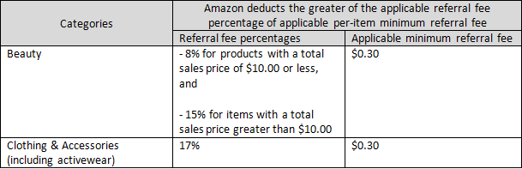

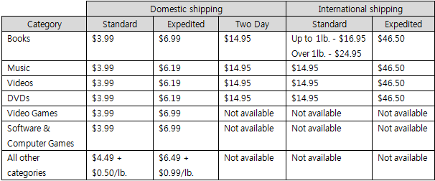
4.Amazon introduced the warehouses service as an option with the extra charge for the fulfillment. Fulfillment by Amazon that sellers store their products in Amazon’s warehouse centers when the products are sold, the service will ship immediately to the buyers. These tables show the rate of shipping credit that will be calculated for domestic and international, respectively.

Appendix 2: Growth of Lazada
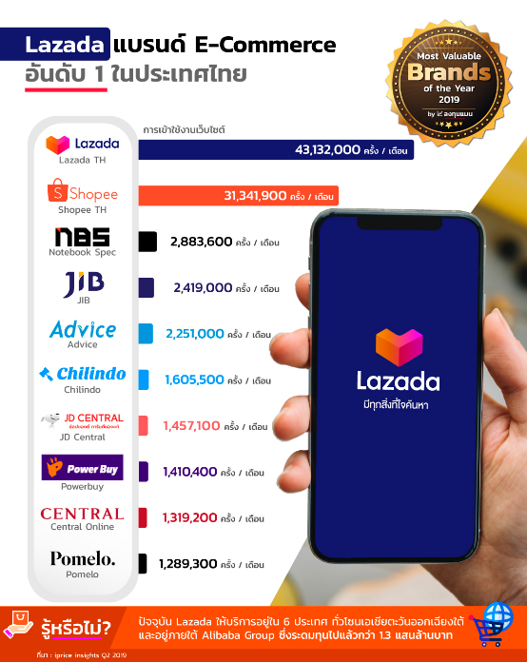

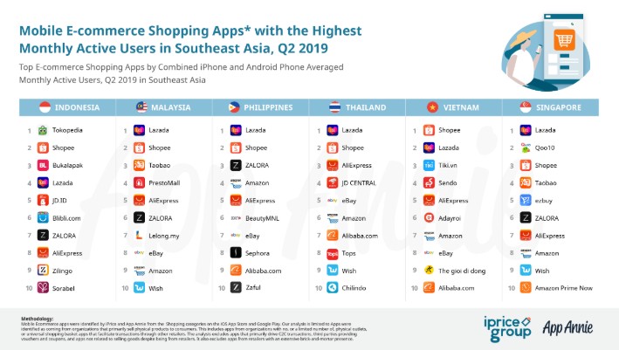

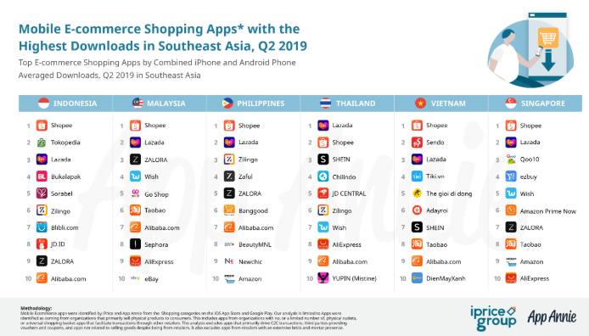

Appendix 3: Policy on Lazada’s sellers
1.Thai sellers who are exploring the possibility of selling products on the online marketplace can register for the group of local sellers or Lazada Thailand sellers. Those sellers will be exempted from the commission fee which is one of the Lazada strategies to compete with other e-commerce platforms. However, they still have to bear the cost of payment service fee or Financial transaction tax (FTT) of 2% and Value added tax (VAT) of 7%.
2.Lazada launched a new selling model called Lazmall as a tool to empower brands and sellers to become “Super eBusinesses”. Lazmall acts as a virtual mall for those brand owners in Thailand, or authorized distributors of branded products in Thailand. Lazmall sellers face the higher cost of entering into this platform as they have to pay the commission fee which differs according to the product category as well as FTT and VAT.
3.LazGlobal or Global Collection is the channel within the Lazada app for the cross-border sellers in China, Korea, or Japan and want to expand their ecommerce to Thailand. Although VAT may be exempted in some countries such as Singapore and the Philippines, it applies for deliveries to Indonesia, Malaysia, and Thailand. Hence, those cross-border sellers have to take the required policy of each country into account. The additional payment will be charged including commission fee 1-4%, payment service fee 2%, and Shipping fee.
Appendix 4: Commission fee on LazMall sellers
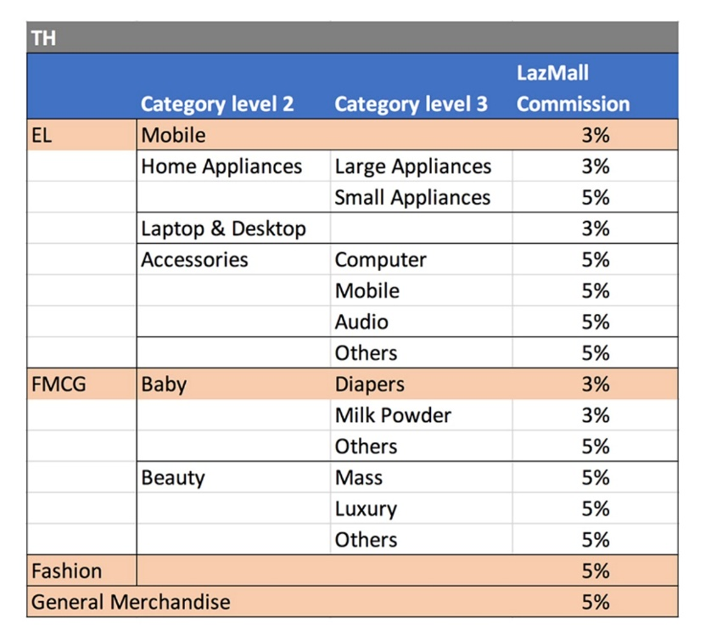

Appendix 5: Commission fee on LazGlobal sellers
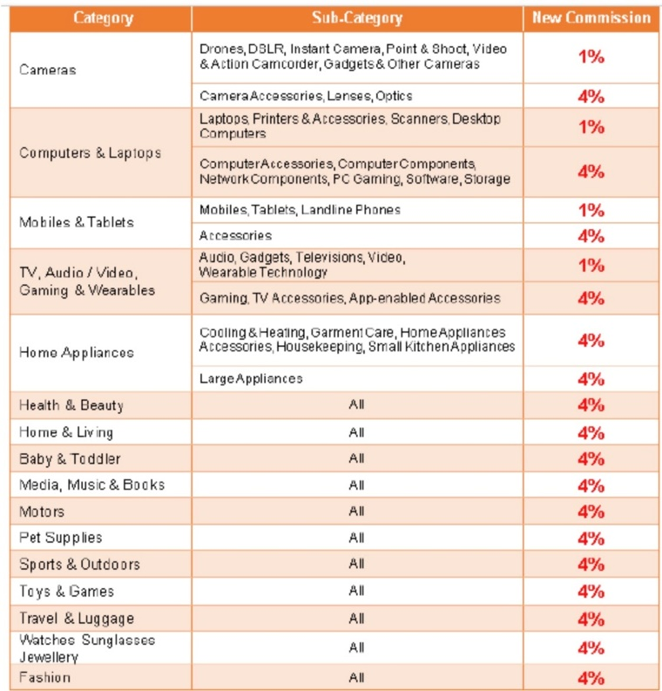
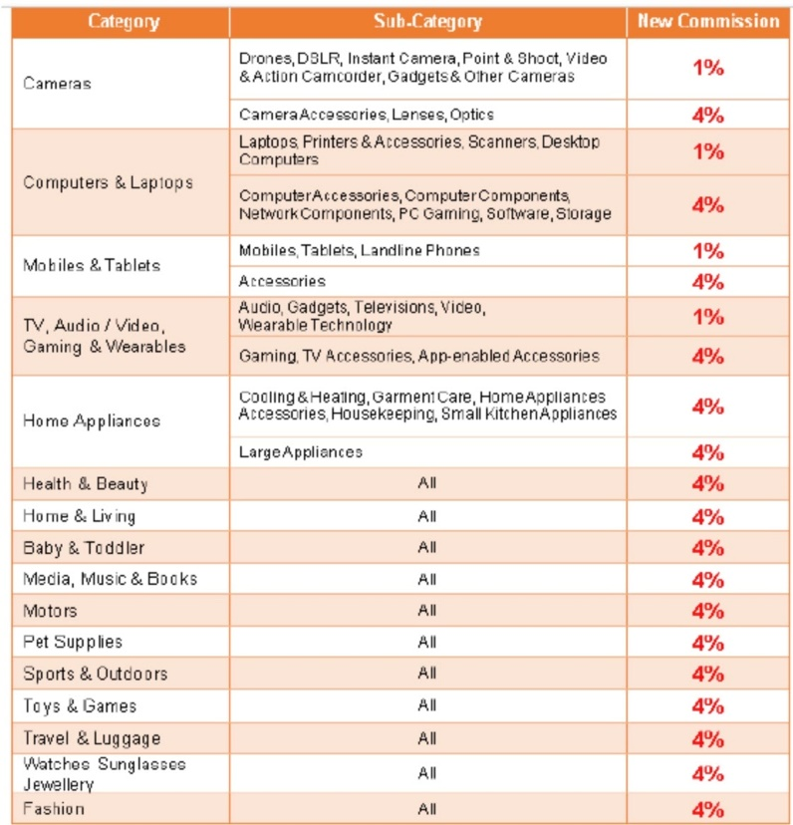

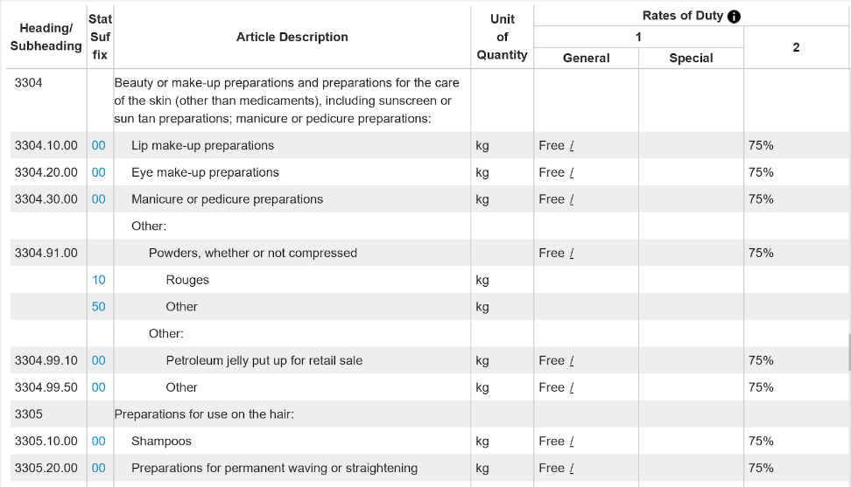
Appendix 6: Rate of Duties in United States

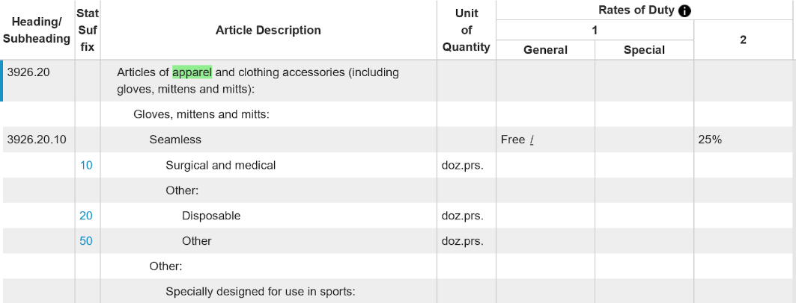

These allowances of duty are set by classification and origin. Cosmetic or Makeup (HS3304) was defined by the Customs and Border Protection as anything used to color and beautify the face or other parts of the body such as lipstick, eyeshadow, nail polish and sunscreen. The ingredients of makeup are not necessary to be approved by the Food and Drug Administration, except for the products with color additives. According to the Harmonized Tariff Schedule (2017), beauty or makeup preparations and preparations for the care of the skin are tax exemption products.

Appendix 7:

