EE 325
Download the data from www.mhhe.com/gujarati5e
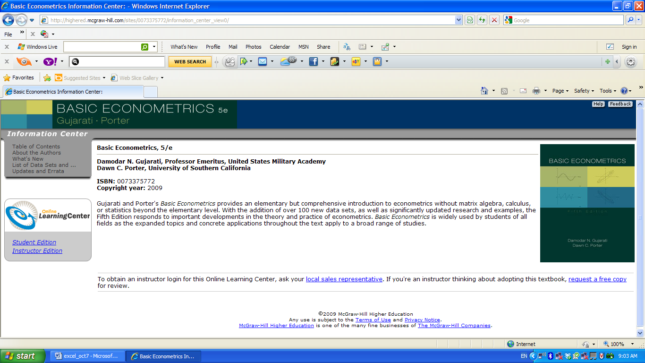
Click on student edition

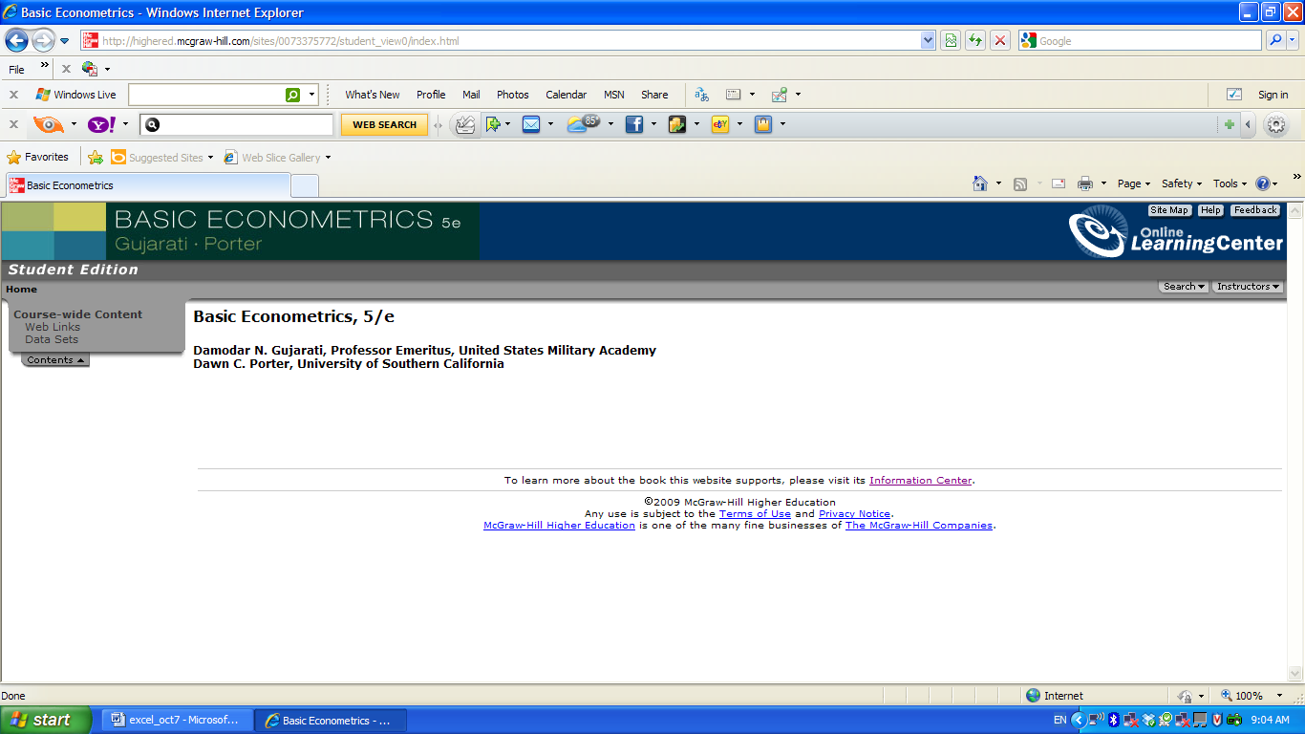
Then click on Data Sets
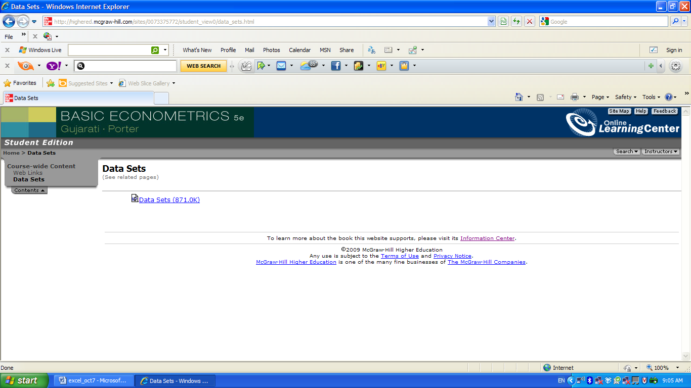
Double click on data sets and save it in one of your folder

