Macro & VBA in excel
According to Microsoft, a macro is a set of actions that you can run as many times as you want; it is used for automating those tasks that you do repeatedly. Macro can be created in two ways. One is by recording your mouse clicks and keystrokes; another way is by writing lines of Visual Basic code
Recording Macro
To record macro, go to developer tab then click the record macro button to start recording macro.
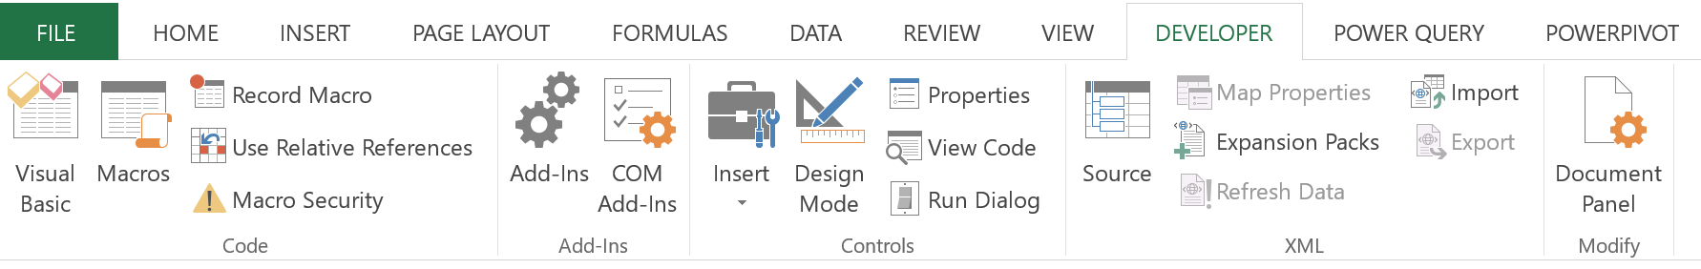
Then, name the macro as you wish and choose where to store the macro. Usually, if it is to be used only in the current workbook, you choose ‘This Workbook’. If you want to be able to use the macro across workbook, you have to store it in ‘Personal Macro Workbook’
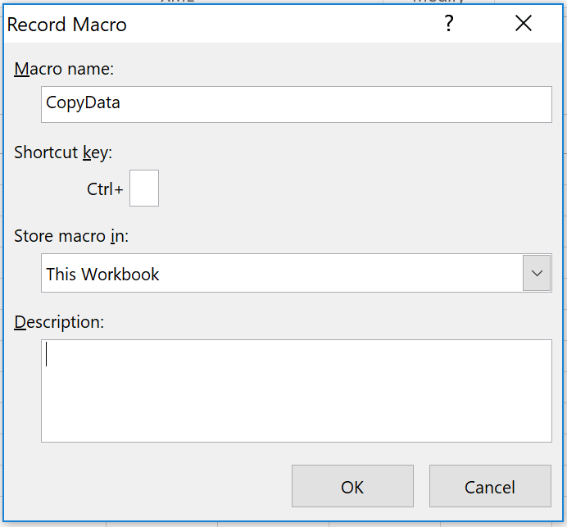
Once you have done recording macro, click stop to stop recording macro.
Running macro
There are a few ways you can run macro. One way is to go to developer tab click on macro button, select the macro name that you want to run and click run
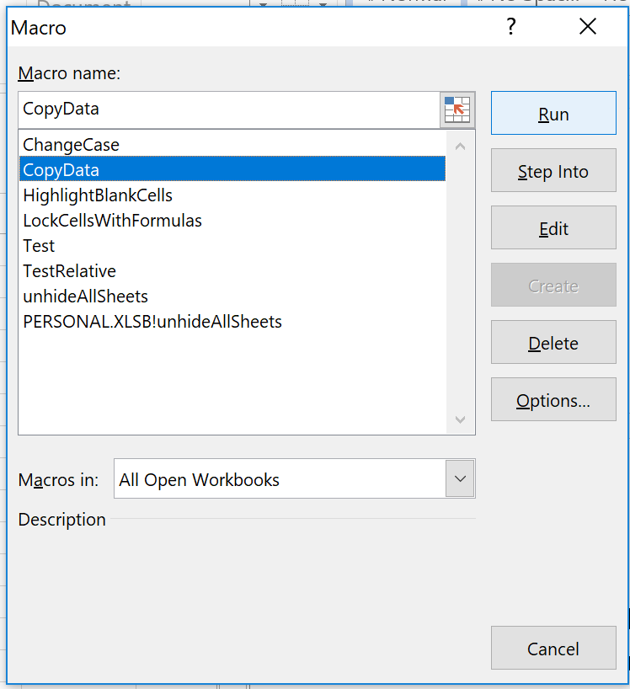
Another way is to create a button and bind the macro to the ‘button_clicked’ event. To put a button onto your worksheet go to developer tab, click insert, then drag the button and drop onto the worksheet (anywhere you want)
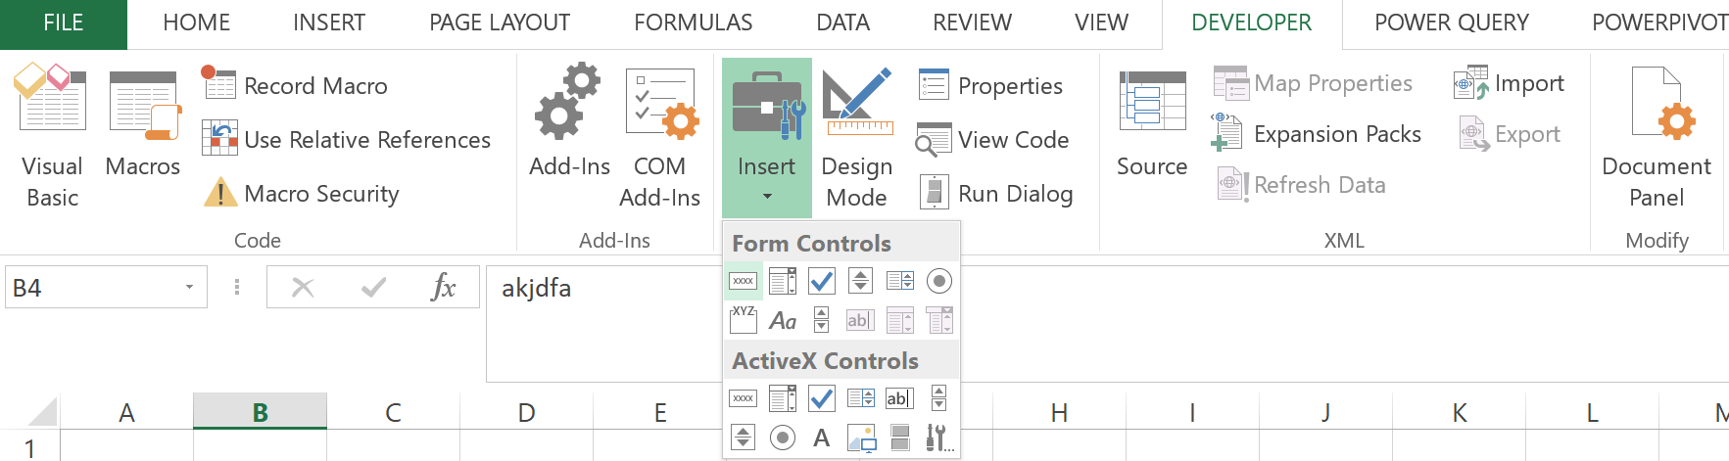

Once you put a button on the worksheet, the ‘Assign Macro’ dialog box will appear. Choose the macro that you want to tie to the button. Then, click OK
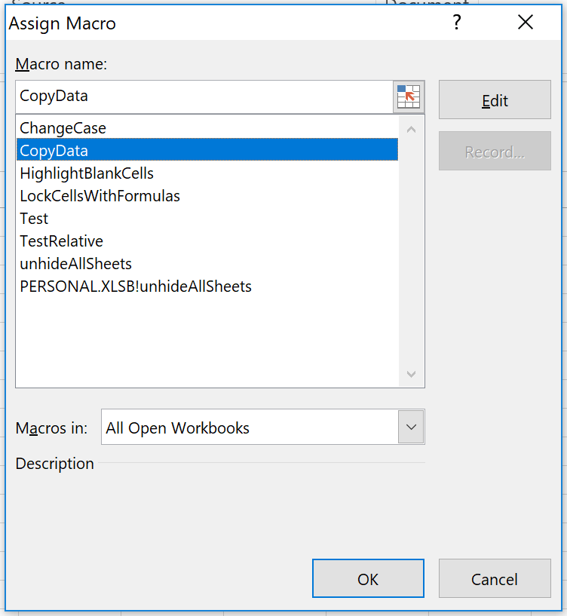
Example: recording a macro to copy data from one worksheet to another
Important note: Normally a macro is recorded in an absolute reference mode, meaning that if you clicked on cell A1 and then move to cell A2. When you are at cell J1 and click run the macro again, the focus will be moved to cell A2. If you want it to move relatively (meaning that move to J2 instead of A2) you need to turn the relative reference model on

Create a macro by writing VB code
VB codes need to be written in a VB Editor (VBE). To open the VBE, hold Alt + F11 key.

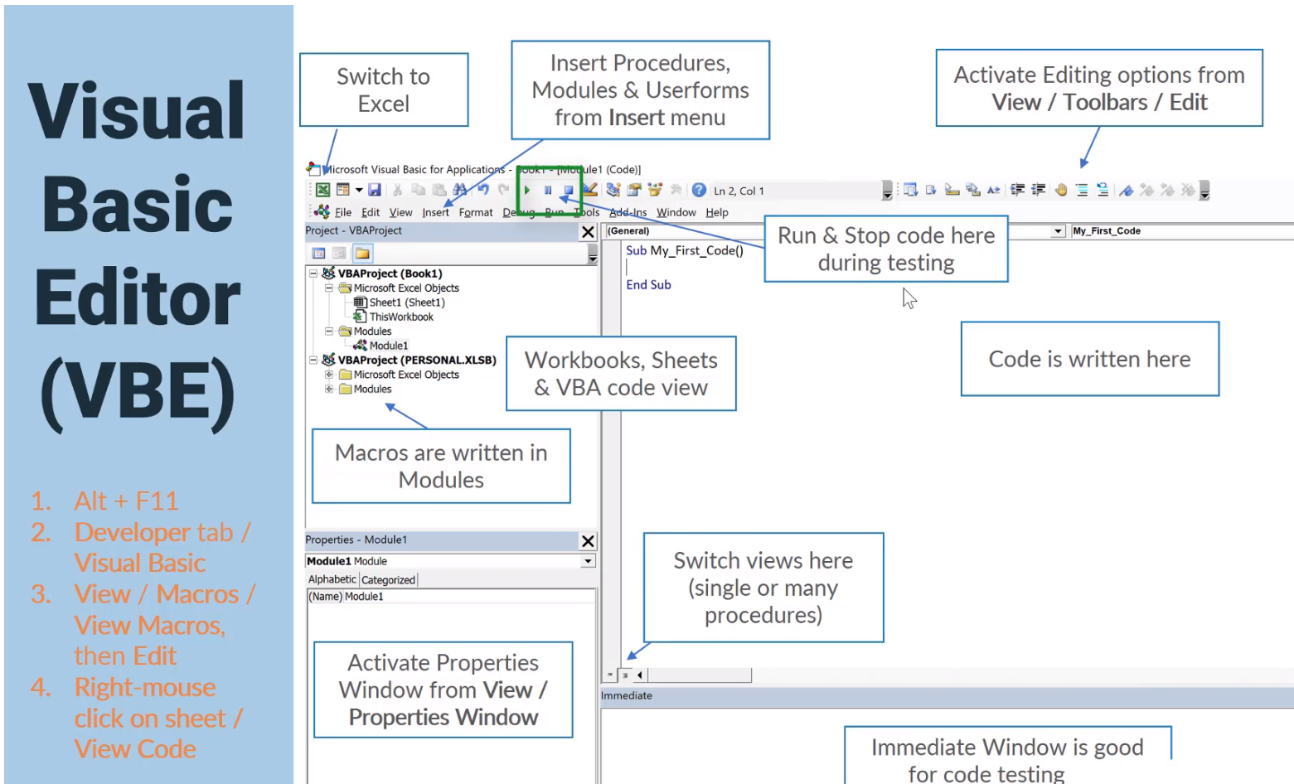
To open VBE

To start writing code for a macro for the first time, you need to insert new modules by right clicking at modules folder (under the current workbook) and choose insert > module
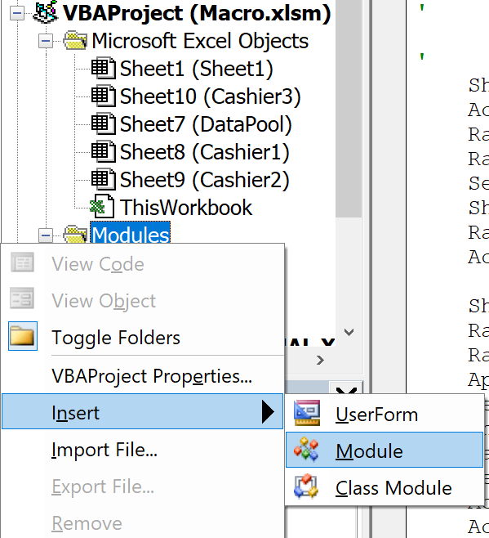

Methods to refer to and write to cells
- Range(“A1”).Value = “row1” refer to cell A1 in the current worksheet and write the word “row1” into cell A1
- Range(“A2:B2”).Value = “row2” refer to cell A2 to B2 and write the word “row2” into cell A2 and B2
- Range(“A3:C3,E3:F3”).Value = “row3” refer to cell A3 to C3 and cell E3 to F3 and write the word “row3” to cell A3, B3, C3, E3, and F3
- Range(“A4,C4”) = “row4” refer to cell A4 and C4 and write the word “row4” to the two cells
- Range(“A1:D5”).Cells(5,3).Value = “row5” refer to cell C5 and write the word “row5” to the cell
- Range(“A1”).Offset(5,2).Value = “row6” refer to cell B6 and write the word “row6” to the cell
- Activecell.address returns the address of the active or clicked cell if you select A2:C5 and ask for Activecell.address, it will return $A$2
- Selection.address returns the address of the selected area not just the active cell if you select A2:C5 and ask for Selection.address, it will return $A$2:$C$5
- Rows(“5:7”).RowHeight = 30 The height of row 5, 6, and 7 is set to 30
- Rows(“8:8,10:10”).RowHeight = 30 The height of row 8 and 10 is set to 30 (Row 9 is skipped)
- Columns(“H:J”).ColumnWidth = 10 The width of column H, I, and J is set to 10
- Columns(“K:K, M:M”).ColumWidth = 10 The width of column K and M is set to 10 (Column L is skipped)
- Cells.Columns.AutoFit all columns will be adjusted to autofit the length of text in each column
Methods to copy and paste
Copy method for a variable/fixed sized range
Range(“A1:D5”).Copy Range(“F1”) Copy Data from cell A1 to D5 and paste it to an area starting with cell F1
Range(“A2”).CurrentRegion.Copy Range(“F1”) Copy Data from the current region (the region in which A2 is) and paste it to an area starting with cell F1
PasteSpecial Method
Range(“A4”).CurrentRegion.Copy Copy the current region
Range(“A12”).PasteSpecial xlPasteValuesAndNumberFormats paste the selected data (both values and number formats) to an area starting with cell A12
Range(“F12”).PasteSpecial xlPasteComments paste the selected data along with comments to an area starting with cell F12
Use the Resize property to return a changed range
Range(“A4”).CurrentRegion.Offset(1,0)
_Resize(Range(“A4”).CurrentRegion.Rows.Count – 1).Copy Range(“A20”)
- If your data table has header or you want to copy only the data you can use offset to shift one row down and then resize the area (of the table) by reducing one row. Note that you have to resize because the offset (in this case) offset the whole region
If Then Else
Syntax for if statement is as follows:
If criteria Then
Statement 1
Statement 2
ElseIf criteria Then
Statement 3
Else
Statement 4
End If
Loop
For each x in collection
Statement(s)
Next x
Message Box
MsgBox(Prompt, [Button style], [Title], [HelpFile], [Context]) As VbMsgBoxResult
Note: The yellow-highlight part means MsgBox could return a result, and type of the result is VbMsgBoxResult
Examples
MsgBox "Hello " & Excel.Application.UserName, , "Welcome"
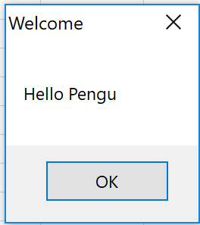
Dim ans As VbMsgBoxResult
ans = MsgBox("Are you sure you want to delete this", vbYesNo + vbQuestion, "Clear Cells")
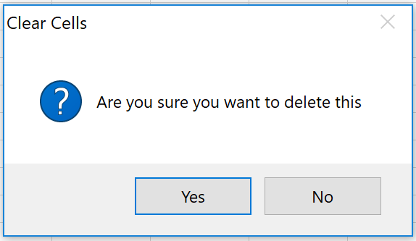
Note: when the button style is vbYesNo, it means a user could click either yes or no. In this case, if we want to know if the user answer yes or no, we need to set up a variable and assign the returning answer to that variable. The variable must be declared as VbMsgBoxResult

Check if File or Folder Exists
VBA.FileSystem.Dir (path [,attributes]) This function returns the name of file or folder
VBA.FileSystem.MkDir (path) This function is for creating a directory (folder)
Workbooks.Open (filename with full path) This function is for opening a specified file
Check if file exists, open it. If not, inform user
Sub FileExist()
Dim FileName As String
FileName = VBA.FileSystem.Dir("C:\Excel\charts.xlsx")
If FileName = VBA.Constants.vbNullString Then
MsgBox "file does not exist."
Else
Workbooks.Open "C:\Excel\charts.xlsx"
End If
End Sub

Check if folder exists, inform user. If not, prompt the user whether to create it
Sub FolderExist()
Dim path As String
Dim folder As String
Dim answer As VbMsgBoxResult
path = "C:\Users\Pengu\Documents\Excel"
folder = Dir(path, vbDirectory)
If folder = vbNullString Then
answer = MsgBox("The specified folder does not exist. Would you like to create it?", vbYesNo, "Create folder?")
If answer = vbYes Then
VBA.FileSystem.MkDir (path)
Else
Exit Sub
End If
Else
MsgBox "The specified folder is already existed"
End If
End Sub

Five often-used macro
Highlight blank cells
Sub HighlightBlankCells()
Dim Dataset As Range
Set Dataset = Selection
Dataset.SpecialCells(xlCellTypeBlanks).Interior.Color = vbRed
End Sub
Protect/Lock Cells with Formulas
Sub LockCellsWithFormulas()
With ActiveSheet
.Unprotect
.Cells.Locked = False
.Cells.SpecialCells(xlCellTypeFormulas).Locked = True
.Protect AllowDeletingRows:=True
End With
End Sub
Change to Uppercase
Sub ChangeCase()
Dim Rng As Range
For Each Rng In Selection.Cells
If Rng.HasFormula = False Then
Rng.Value = UCase(Rng.Value)
End If
Next Rng
End Sub
Unhide all worksheets
Sub unhideAllSheets()
Dim sh As Worksheet
For Each sh In Worksheets: sh.Visible = True
Next sh
End Sub

Get Only the Numeric Part from a String in Excel
Function GetNumeric(CellRef As String)
Dim StringLength As Integer
StringLength = Len(CellRef)
For i = 1 To StringLength
If IsNumeric(Mid(CellRef, i, 1)) Then Result = Result & Mid(CellRef, i, 1)
Next i
GetNumeric = Result
End Function

How to add macro shortcut to the quick access toolbar

- Go to Quick access toolbar > More Commands
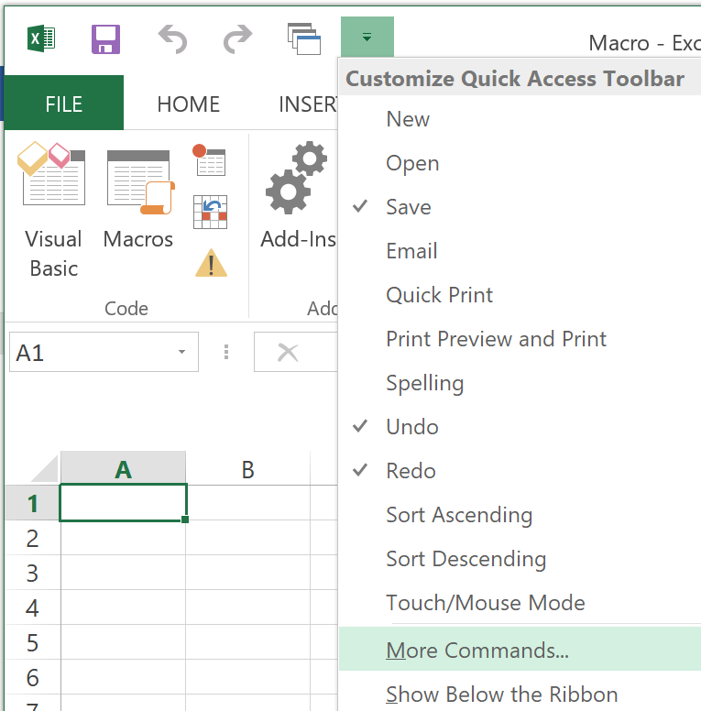

- Select “Macros” at the Choose commands from dropdownlist, then select the macro you want to add to the quick access toolbar, click add and OK



