How Avian Flu affected Asia's economy, society ,and raised up poverty in regions.

Abstract

Avian Influenza is a zoonotic disease that had a huge impact on Asia's economy, that led to the downfall of poultry industry, and society as a whole. Begins with the adjustment in price & demand affected to both consumer and producer in poultry production. Moreover, the loss due to the disease has been found in the input and downstream industry as well, for instance, the case in Laos that has an income reduction of 40% from normal. Beside this, in political aspects regarding the government's responses and strategies to combating the bird flu,4 cases from China, Indonesia, Vietnam and Thailand can be summarized that the institution of control measures,centralization of state’s power and openness of influenza information are crucial for an achievement of disease containment. The impact of social and culture in Avian influenza has many important factors. The factors are religion and higher price of poultry because the governments have to kill a lot of poultries. It also has a lack of food in Muslim countries more than other religious countries since there are a few substitutes for poultry products. It affects the price in the market and the expense of people so there is a lack of food.

Introduction

Avian influenza or you may know as bird flu, has been wildly concerned since the 1960s. Avian influenza refers to the infectious disease of birds caused by viruses which are primarily infected by birds but continuously by wild animals and humans. And this virus typically occurred in poultry areas of most developing countries— Middle and South East Asia, for instance, Thailand, Vietnam, Cambodia, Egypt, and Bangladesh etc. The first outbreak was concerned since 1997 and resurfaced again in 2003. The recent outbreak of the avian flu has raised concerns about a new global pandemic and has already damaged poultry production in several countries which most countries are poor households that depend on agriculture and livestock. Therefore, it shocks poor poultry farmers and this causes a lower potential economic growth and poverty will increase.

Background and outbreak

People acknowledge that the first known transmission of H5N1 (Avian flu) was detected in humans during a poultry outbreak in Hongkong since 1997, infected 18 people and 6 of whom died. (ncbi article) Moreover, it has been detected in over 50 countries. Some of them are considered to be epidemic Asian H5N1 viruses. First, they believed that it only came from birds but in fact, the virus can be infected not only by birds but also by humans as well as any other animals. And then the virus began transmitting easily and efficiently from person to person. Since humans have been infected with Avian Flu, there are severe diseases and deaths. The symptoms begin with cough, diarrhea, respiratory difficulties, high fever, head and muscle aches, also runny nose and sore throat. (Center of disease control and prevention) In addition, a poultry farmer, travelers who visit affected areas, a household member of an infected person and people who ate undercooked eggs may have a greater risk of contracting H5N1. After the 1997 outbreak, the H5N1 virus resurfaced in February 2003. The virus has a possibility to be the large outbreak of respiratory disease in Guangdong Province, China, which later turned out to be SARS.

​By the 2003 outbreak, humans infected with the H5N1 virus have been identified only in Thailand and Vietnam. Vietnam has confirmed the first human death from H5N1. Meanwhile, it caused 17 human cases and 12 deaths in Thailand. In 2005, the epidemic was still ongoing. And the outbreak caused massive economic losses, especially poultry workers. For instance, before 2004, Thailand was among the world's major poultry exporters but after the Avian flu outbreak the public lost confidence with the poultry products. And also H5N1 has killed millions of poultry throughout Asia. ​

A flu pandemic could be substantially more damaging in both human and economic terms. The World Health Organization (WHO) estimates 2–7 million people could die (WHO 2005), while other estimates are much higher, exceeding 100 million deaths. The risk of a mutation in the H5N1 virus that spreads easily among humans is quite real. As the outbreak is ongoing, estimates of the cost vary. One estimate puts the direct cost to the livestock sector in Cambodia, Thailand, and VietNam at $560 million. (adb.org)

Avian flu has already caused significant economic damage. Primarily to the agricultural sector, particularly in poultry production. And the ongoing outbreak caused massive economic losses which lead to poverty in Asia.

Overview on economics perspective

Avian influenza, the outbreak that is mainly located in the developing countries especially on the Asia continent, is considered to be one of the factors which lead these developing countries to have a larger gap in poverty and inequality compared to other developed countries that easier to avoid this epidemic. The evidence also shows that avian influenza which generally affects the supply side of poultry livestock can impact the economy hardly due to the fact that it undermines the production chain of suppliers and vice versa cause a decline in the price of poultry at the same time. Even though both situations seem contradictory, this really happens in most developing countries in Middle and South East Asia, for instance, Thailand, Vietnam, Cambodia, Egypt, and Bangladesh etc.

Impact on poultry consumers

In the micro views, these will impact the citizen’s life directly since people have lower consumption of poultry due to the drop in demand caused by consumer anxiety. This towards a rise in the price and demand for substitute goods. In non-Muslim countries, the most appropriate solution for them is using pork as a substitute while for the Muslims they substitute this poultry with fish and soya. Consequently, from the price rise, it offset the losses of poultry farmers that also raised pigs and passed losses on to consumers. This puts meat out of the reach of poorer households particularly in urban areas. From the figure 1, the data collected from various countries in 2004-2006 shows that both price and demand volume of poultry meats descend around 50-80% while the substitute meat price, for instance, pork and fish rise by 37.5 and 84.62 respectively (Kumar, 2008).

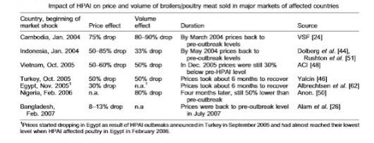
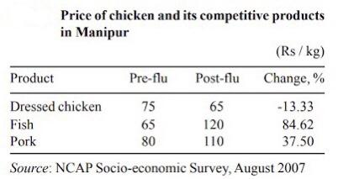
Figure 1 & 2 shows the variation in price of poultry meat compare between country and substitute meat

Effect on poultry producers

Meanwhile, the poultry livestock producer side has to face an enormous loss by the cost of culling and exterminating the contaminated product and livestock which results in the leave of a large number of small poultry production firms from this industry in various countries during 2003-2006. Thereby, a large number of employment in this sector will be decreased and led to some job loss or be suspended from his/her job temporarily until the epidemic stops spreading in high infection rates (Otte, 2008). Nonetheless, after the government can be controlled the spreading of disease effectively, those developing countries will meet shortage in supply of poultry immediately from the fact that after large numbers of small firms leave the industry, no one want to entry and invest in this industry yet due to the reason that most of the new potential producer still concern about the reappearance of epidemic which is their greatest risk.

Incidentally, from the data gathered, over 70 percent of the poultry production comes from integrated commercial farms like CP or Betagro who own a high-tech farm with better quality and sanitary system. While the rest 30% is considered to be a traditional farm that has a higher chance of infection from the lower quality in sanitary in their farming system (Heft-Neal, 2008). The data from figure 3 stating that 98% of all producers are small firms/peasants which don’t own enough budget to build the integrated commercial farms and have to suffer from the high cost of losses from culling, waste and vaccination cost. The information above also leads to the inference that why this disease shows up only in developing countries in Asia but not US, Brazil and EU who are the 3 biggest poultry producers is because of the difference in agriculture technology that still has a high gap for them to reach developed countries during that period of time.
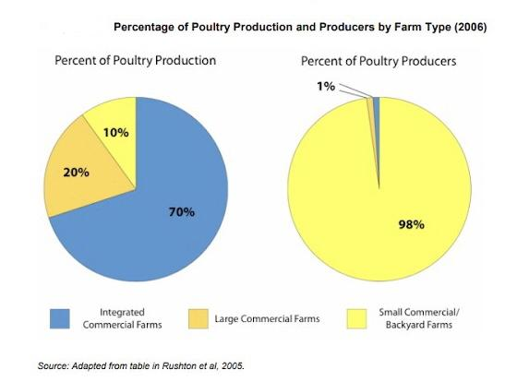
Figure 3 the poultry industry production percentage

Feeding industry and farmers near Mekong river

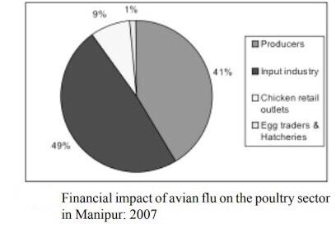
Another crucial industry that suffers from this epidemic is the feeding industry. As an upstream supply chain that relates to poultry, the evidence shows that most of the demand in this sector drops dramatically at an approximate rate of 70-90% which is enormous devastation in the agricultural product sector (Kumar, 2008). Furthermore, from the population of the most developing country in Asia, over 50% is working as self-employed in agriculture. This means that the first group of people who have to accept the burden from a drop in demand and price of crops is a farmer who is the main population of these countries. Thereby, the impact these people have to carry in this stage is considered to be even harder than the poultry producer and consumer.

Figure 4 Financial impact of avian flu on the poultry sector in Manipur 2007

Moreover, comparing the impact on these Asia countries, there is a statistic indicating that this epidemic is most likely to dominate the rice farming industry near the Mekong River the most. This epidemic causes a troublesome issue due to the reduction in duck population which usually plays an important role in getting rid of the pest. This resulted in larger damage from golden snails and increases in plant diseases during winter as all of these aspects lead to lower net income in both the poultry and rice industry (Xuan men, 2010).

Impact on downstream industry

Meanwhile, for the downstream industry, the effect did not become a crux to generate losses to the industry and household that much. Actually, there are 2 main businesses in these downstream supply chains involved with poultry. The first groups are the wholesalers and retailers. During the epidemic, traders and middlemen were groups that always got neglected by the government measurement. However, it was undeniable that among the influence of the disease directly impacts them the less liken to the poultry producer and peasant. Take Laos as an example, there is research that the middleman business after the avian influenza outbreak was conducted to an income reduction of 40% from the usual situation (Otte, 2008). However, after the first stage of the outbreak, these groups of people will adjust their supplies portion to equal the market demand and bore with less cost automatically. Thereby, the losses that traders have to accept straight away were caused by the demand shock at the initial stage of the outbreak only.

Besides this, some types of restaurants are also damaged by the prohibition of poultry. For instance, Kentucky fried chicken (KFC) who have to close some franchised stores to prevent the contagious virus and recheck their supply chain. In this particular period of time, tons of restaurants using poultry meat have to substitute their product with fish and pork. Nonetheless, the impact on this downstream supply chain is not that much. Incidentally, after the outbreak, these businesses were the group that has the fastest recovery rate even though it still did not meet the pre-epidemic situation (Otte, 2008).

Conclusion for economics perspective

In conclusion, the report interprets that the impact exists in micro level factors but not directly shows in GDP. For instance, the consumer burden from a change in the price of substitute products at the initial stage compared to producers and agriculturists. The losses producers have to bear from a huge amount of loss from culled cost which leads to regression in the industry output and being forced to lay off some workers. Similarly, agriculturist was a group who got the largest piece of impact by the dwindling of crops prices and reduction in duck population especially for the peasant around the Mekong River who may suffer the most. While the major of the downstream poultry supply chain only affected a small portion.

Government responses to avian influenza and strategy of each Asia region

In the area of global public health to fight and avoid the epidemic, the state is the most important actor and protector of its people (G.Curley and Herrington ,2011). Because the state is an authority and has the ability to defend, deter and avoid the epidemic and infection. In addition, the state has the capacity to deal with the monitoring process,medical support and economic subsidies for the victims of crisis.
States are also urged to respond to emerging threats to infectious diseases as quickly as possible in order to minimize infection and death rates, including the economic crisis triggered by the epidemic.

Given the differing variations in the typical national reaction to the confirmed avian outbreak,detaining the affected area, slaughtering or vaccinating infected or in-danger poultry and wild birds, monitoring the transport of poultry for commercial uses, checking and treating exposed people, conducting public health programs and finding access to antiviral medicines are involved (International Efforts to Control the Spread of the Avian Influenza (H5N1) Virus,2006). Broad guidance for ministries in charge of prevention and containment, mobilized resources and political power to improve monitoring programs have been established in the most active government responses and have partnered closely with foreign health authorities and neighboring countries.The strategic responses and policies of each region and state vary according to the government policy of each country, the size of the population, the consumption and demand of poultry, the importance of public health, etc. This section focuses on the actions of foreign governments to combat the spread of avian influenza, in particular the response of countries that have reported human deaths from the virus.

China

The leaders of the PRC have been more attentive to the catastrophic problems of the plague after they suffered from the 2003 SARS incident, which was their great lesson to be prepared for the potential epidemic.Consequently,the administration of healthcare systems to control the bird flu in Beijing has been even more swift and organized (International Efforts to Control the Spread of the Avian Influenza (H5N1) Virus,2006). However, no matter how effectively the strategies have been implemented, there are still a lot of problems in the process.

The Chinese Ministry of Health employed the National contingency plan for preparedness against the outbreak of avian influenza in September 2005.The Ministry arranged all local governments to draft their own contingency plans suitable and as they saw it fitted their conditions.The Ministry of health was accountable for managing and implementing contingency affair.High ranked health authorities were responsible to for the collection,registry and delivery of virus samples for testing (China’s Response To Avian Flu,2006). The PRC Ministry of Health reports that 63 influenza testing laboratories have been built across most of China and an emergency plan for an influenza pandemic, including a four-color-coded warning system, has been created and issued. Further to that, at a press conference in November 2005, PRC agricultural officials made an announcement of the introduction and imminent enforcement of contingency laws to tackle the transmission of the disease and prosecute government officials who withhold or obscure medical and science reporting on the virus.Officials in local areas are required to inform the central government in compliance with the legislation within four hours of a new outbreak (International Efforts to Control the Spread of the Avian Influenza (H5N1) Virus,2006).

By November 2005, PRC officials reported that significant quantities of domestic animals had either been killed or vaccinated, and expected to vaccinate the entire Chinese poultry population.Even so, owing to the immense scale of the poultry population of China and dispersed factories, they faced difficulties.In addition,The Chinese government has announced an allowance of 2 billion yuan from the budget to combat avian influenza and the blockade of poultry importation from 14 countries impacted by avian influenza (International Efforts to Control the Spread of the Avian Influenza (H5N1) Virus,2006). The Ministry of Finance and Agriculture issued the compensation for affected farmers who culled their birds approximately 10 RMB (1.25 USD) per bird (China’s Response To Avian Flu,2006).

There are some concerns regarding the transparency of the PRC on avian influenza issues,also China had a troubling period with continuous problems concerning local and domestic enforcement with officials of the central government.Overcall,China had been improving its openness,strategy of influenza containment,effective control measures and implementation of surveillance commitment better than in the SARS outbreak.

Indonesia

Indonesia launched a three-year national strategic strategy in December 2005 to combat the epidemic. The strategy involves culling, vaccination, community-based bird habitat monitoring, site assessments and data collection, and aims to test projects for adoption. The Indonesian government appeared unprepared and made little strides in handling and recognizing a major epidemic on a wide scale .There were reports stating that farmers were not fully compensated for their slaughtered birds from the government.As a result,many Indonesian poultry companies and local farms were reluctant to allow government culling and monitoring (International Efforts to Control the Spread of the Avian Influenza (H5N1) Virus,2006).In addition,the government hadn’t made an announcement of the disease until the first infection to human case occurred.

During the first period of the spread,Indonesia was trying to cover up and secretly contain the outbreak,also giving little attention to domestic and local regions (G.Curley and Herrington ,2011).Therefore,Indonesians lacked of public awareness and information of avian influenza virus,leading to large scale of poultry loss and infection cases due to lack of government communication to its citizens.

The main troubling factor in Indonesia's governance to control the outbreak was the failure of its regional and district governments to support emergency measures (G.Curley and Herrington, 2011).
Geography was the challenge of the lack of a central authority to enact steps to monitor and implement a health policy due to the topography of a large number of dispersed islands, which led to a deeply fragmented national government.Decentralized governance and poor links between central and regional authorities have made it impossible to manage the outbreak effectively.

Vietnam

The Vietnamese government's response to the outbreak began slowly. When the first human case was identified in 2003, the provincial government was not able to do well in detecting the disease and notifying the central government.
However, attempts to contain the epidemic and to health administration were later strengthened (G.Curley and Herrington ,2011).

The Prime Minister announced that the government, involving all state apparatuses and administrative bodies at all levels, must contain the virus as soon as possible.In 2005, the Government of Vietnam began to step up its response to the epidemic by setting up working group cooperating with FAO and WHO.The government authorized inter-ministerial steering committees to operate throughout the country.The National Pandemic Preparedness Plan was developed by the central government to be prepared for the impact of bird flu.

During the first outbreak period, the government managed to cull more than 40 million birds, although this was a disincentive to farmers due to low compensation.
In August 2005, the Government launched a program for the vaccination of poultry, and in early January 2006 the programs were declared successful in two phases of vaccination for more than 240 million birds.For subsidy and compensation policies,farmers who possessed more than 50 birds and who couldn’t sell their poultry because of the outbreak and market conditions would receive financial aid for 5,000 VND (30 cent) per bird (Vu, T.,2009). The Bank of Agriculture and Rural Development aided affected poultry farmers by extending loan terms,reducing the monthly interest rate by 0.15% and offering loans of up 50 million (3,100$). The reduction of tariff on frozen meat from 60% to 20% imposed by the government was to relieve a high expenditure on domestic meat products due to demand transition from poultry products to other meats.

The Minister of Finance and Agriculture and Rural Development approved a rise in aid to 15,000 VND for culled birds (approximately 70% of market value) (Vu, T.,2009). Since poultry sectors in rural and backyard farms were the most widely affected,resulting in difficult progress in surveillance and disease detection,the government provided incentives for farmers to upscale and modernize their production system.

The central government of Vietnam has managed to enforce its emergency. measures policies, control the spread and minimize the economic impact of the outbreak effectively, which has been praised for its rapid and cooperative response (G.Curley and Herrington ,2011). It can be said that the one centralized Communist Party government is a key factor in the success of securitization and the implementation of a strong measure of control.

Thailand

During the first period of outbreak,Thailand’s response was sluggish,and there were allegations and critiques that the government official covered up evidence of infection.The attempts of cover-up and keeping the outbreak secret and delay of actions were to protect the poultry industry’s interest since Thailand was the 4th largest poultry exporter (Chanyapate and Delforge,2004). Until the government couldn’t bear the tension and critique and the outbreak and report case were publicly disclosed,the government finally had led the effort to combat the bird flu.

Shortly after the first outbreak emerged in 2004,the government had called all top administrative officers from all responsible organizations and departments,such as: Minister of Agriculture,Public Health,Finance,Commerce,Foreign Affair,and Communication, to set up the emergency conference called the “War room” (Auewarakul et al.,2008). All committees would discuss and make decisions,given the updated outbreak situation during the meeting.Then,the final decisions will be communicated to operating units,such as the department of disease control,livestock development.Representatives offices of the Ministry of Public Health and Agriculture are responsible for regional and provincial fields.
These offices cooperate with the central officers and public health volunteers in villages,creating a two-way communication channel between locals and central authorities.Additionally,there are representatives called “Mister/Miss bird flu” whose duty is to coordinate outbreak control measures deployed by domestic officers.

Thai government initiated national plans, including the National Strategic Plan for Avian Influenza Control and the National Strategic Plan for Influenza Pandemic Preparedness for a three-year period (2005-2007) (Auewarakul et al.,2008).
The content of the plans is to strongly control and contain avian influenza,reduce the outbreak and infection,strengthen an effective surveillance system,stockpile antiviral drugs,increase preparedness and hospital capacity.Over 40 million birds were exterminated as part of the plan and surveillance teams were sent throughout the country.Thai government banned the use of bird flu vaccines due to fear of further mutation of the disease.

Thai government aided the farmers by the compensation at rates between 70-100% of the market price of a bird,there were approximately 61 million culled birds,resulting in a total payment of 46.5 million USD to 407,338 farmers.On top of the compensation,Thai government offered poultry farmers soft loans at 2% interest rate and recommended public bank restructure loans to the poultry industry (J. Otte et al.,2008).Thai authorities attempted to restore confidence in the poultry product and market sector by organizing a “chicken festival” and even eating chicken food on the media by themselves.

Eventually,Thailand was praised for successfully containing the outbreak and became a role model for other countries in control measures and strong institutions.

Overview on social and cultural impacts

A long time ago, all living things always evolved, especially animals and seeding. However, there is a small and dangerous animal that is a virus as well as bacteria. These are the cause of Avian Flu, Black Death, Co-vid19, and etc. In history, they always not only live with humans all the time but also evolve the level of violence to humans and other animals. One of the important and terrible situations is Avian Flu in Asia that has HPAI and A(H5N1). It not only mainly occurred in birds but also is highly contagious among them. The virus was discovered in 1996 in China. After that, in 1997, Asian H5N1 started to detect not only humans during a poultry outbreak in Hong Kong but also poultry and wild bird in over 50 countries around the world. Six countries, including Bangladesh, China, Egypt, India, Indonesia, and Vietnam, are considered to be epidemic. From the situation, Asia continent receives more the effect on social economy, and politics so people exactly protect and adapt to the situation.

Impact on population, number of poultry, global production , and culture

From TMBAM East spring, the research indicates that most of the population in Asia are agricultural careers. Thereby, if their poultries are Avian Flu, the government will kill them and people will exactly receive the effect in terms of income, living lifestyle, and social status. A lot of farmers contracted to large producers tend to suffer less in individual outbreaks, as they are supported by the contracting company to stay in production. In the immediate term, the death and killing of birds exposed to the disease represents an immediate loss of income for hundreds of thousands of poultry smallholders in Asian, Africa, and Europe countries. At the same time, however, a number of people have already died from the disease and fear of a human pandemic is leading many consumers to reject poultry, hitting heavily between small and large poultry producers, and creating a ripple effect for regional and international trade. The global poultry sector is dynamic and resilient. What is more, it has religious issues. Muslim countries (Indonesia) will face to lack of food because they cannot consume chinken and substitute goods (pork). At the same time, Buddhism countries(Thailand) exactly face a lack of food less than Muslim countries because they can consume substitute goods. When people encounter a lack of food, they will commit crime. It is an increase in the crime rate. Global production and trade have shown the potential to recover quickly from severe outbreaks until they were recently confined in East and SouthEast Asia. (Otte,M.J. et al.,2004)

Effect in south east asia countries

From the research of FAO Emergency Centre for Transboundary Animal Diseases Operations (ECTAD), there are five main factors to potential social impact that many countries are encountering. Firstly, it is a zoonotic disease, and can cause death in humans. Secondly, local effects of the 2003-2004 outbreaks were very severe, caused considerable losses of production, and loss of livelihoods of vulnerable people. Thirdly, several countries that experienced large outbreaks in 2003-2004, and have now seen the disease move to an endemic status. They face a financial problem for control costs.(FAO,n.d.). Fourthly, the movement of migratory birds has caused outbreaks to emerge in several countries and regions. If widespread outbreaks persisted and were not quickly controlled, they could disrupt the global poultry population and global trade. Hence, it is the impact on food, safety, income, residence, and security to a lot of citizens. (Agrifood Consulting International,2006)

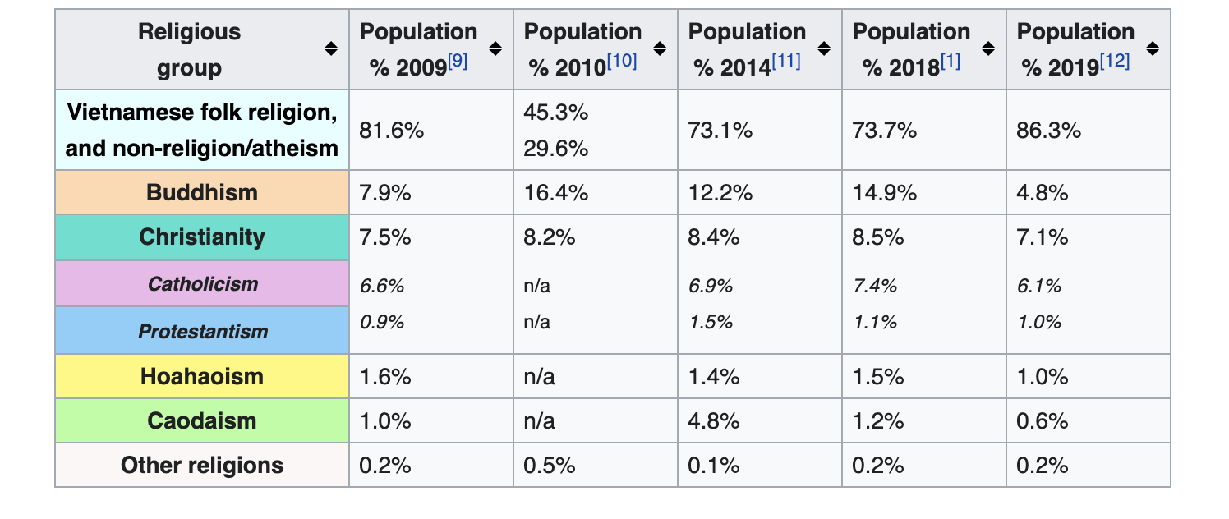
In Vietnam, the losses were felt by small commercial chicken producers with limited numbers of other livestock. Thus, the producers had borrowed money to fund poultry production and found themselves in debt when their birds died or were culled. A compensation rate of 50% of market value was recommended by the Department of Agriculture but in reality a rate closer to 30% was paid, not all farmers registered. Furthermore, it took weeks or months for compensation to be issued. On the instructions of the government, bank loans were extended to assist these farmers who had borrowed from banks. One case study in a Vietnamese village 4 paints a typical picture for a backyard producer. The loss of birds, loss of 2-3 months of production, were estimated to have cost US$ 69-108 for households involved in the outbreak – a large sum when compared to an income per person of $2 per day or less. Farmers and traders who were already engaged in pig operations were able to increase the size of their pig enterprises to take advantage of rising pork prices. Those who had previously focused on chickens were at disadvantage. The price effect swings on poor consumers is undocumented but may have been considerable because of the supply of chickens that was reduced for several weeks. At the same time, the price of alternative meats went up.(J.RUSHTON et al., 2005)

​In Cambodia, by contrast, there appears to have been a minor impact of HPAI in terms of direct deaths and control measures of stamping out, but a larger effect on prices of poultry products. The farmers who suffered losses received no compensation as the government had a policy not to provide it. Combining the fall in prices with the fall in quantities sold and comparing this with the recovery rates in the markets, it appears that the broiler and the egg market were most severely affected.(J.RUSHTON et al., 2005)

In Laos, although the total reported losses were only 3% of the national flock, the impacts were highly localised, with nearly 80% of the reported loss in commercial farms in Vientiane province. Now that the majority of poultry farming in Laos is on a small scale, this means that like Vietnam, the small commercial producers suffered badly.(J.RUSHTON et al., 2005)

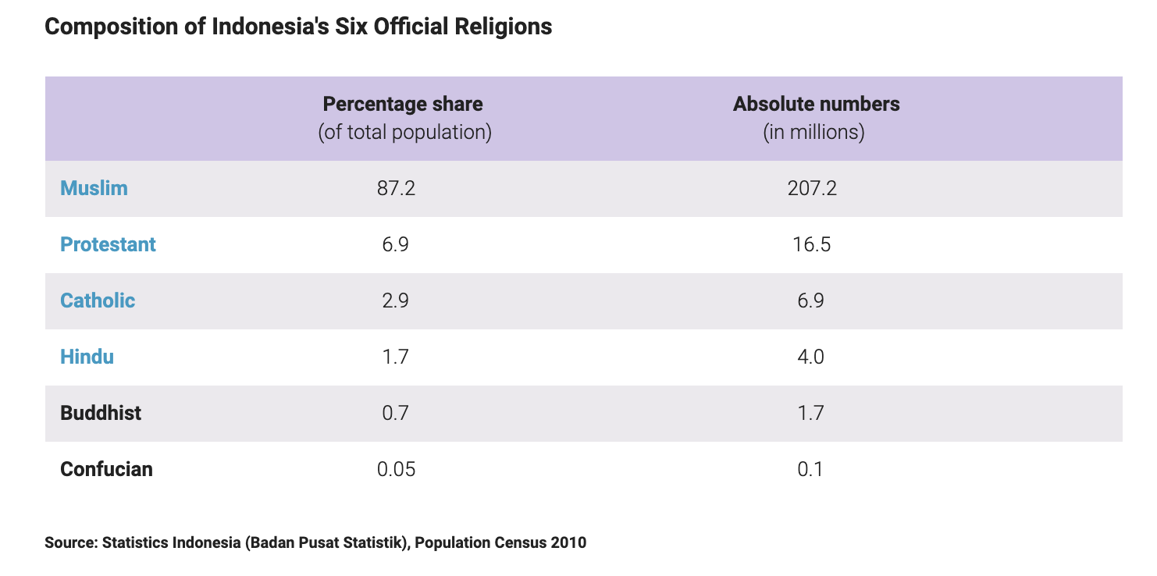

In Indonesia, the value of birds lost was between US$16.2 to 32.4 million. In addition, in farm level impacts, it drops from 45 to 60% in the demand of old chicks and feed inputs during the outbreak and a reduction in employment in the poultry industry. From the table, there is the number of populations who are Muslim is around 207.2 million. Muslims have a culture that cannot consume pork. Hence, when chicken lacks, they are faced with malnutrition more than Buddhist countries, such as Thailand, Vietnam, and etc. After malnutrition, it may have criminal problems because some people may steal food because of poverty and unemployment.(J.RUSHTON et al., 2005)

In summary, it is concluded that the price and demand of poultry are so high in all of the countries because the product lacks market. On farms, employees may be unemployed. Farms cannot sell products because the governments have to kill their poultry. Moreover, when the product is high price and lacking, people will encounter malnutrition. From the reference, religion is one of the important factors that support malnutrition. Muslim countries have culture that consume duck or chicken so these exactly are facing high price and lacking more than other countries seeing that people cannot consume substitute product, such as pork, meat, and etc.
In addition, it impacts on the product that uses poultry in material. One of the products is pet food. From some research, one of the most favorite foods of pets is chicken. Therefore, if chicken is expensive and lacking, it will affect its price and quantity. In avian flu, the price of pet food in the market is high because the producer cannot find chicken to produce the product. The higher price is higher expense, so some people decide to leave their pets because of saving money. Hence, the impact that citizens encounter with stray dogs or cats issues.

Reference
-An Assessment of Economic Losses due to Avian Flu in Manipur State B. Ganesh Kumara, P.K. Joshia, K.K. Dattaa and S.B. Singh
-Supply Chain Auditing for Poultry Production in Thailand S. Heft-Neal, J. Otte, W. Pupphavessa, D. Roland-Holst, S. Sudsawasd, and D. Zilberman
-DUCK FARMING SYSTEMS AND AVIAN INFLUENZA IN THE MEKONG DELTA OF VIETNAM Dr Bui Xuan Men Can Tho University, Can Tho City, Viet Nam
-Impacts of avian inﬂuenza virus on animal production in developing countries J. Otte1,*, J. Hinrichs1, J. Rushton1, D. Roland-Holst2 and D. Zilberman2
-Economic and social impact of avian influenza, Anni McLeod, Nancy Morgan, Adam Prakash, Jan Hinrichs, FAO (AGAL and ESCB).
-International Efforts to Control the Spread of the Avian Influenza (H5N1) Virus: Affected Countries’ Responses
-Institutional responses to avian influenza in Thailand: Control of outbreaks in poultry and preparedness in the case of human-to-human transmission,Prasert Auewarakul , Wanna Hanchaoworakul & Kumnuan Ungchusak
-The securitisation of avian influenza: international discourses and domestic politics in Asia,MELISSA G. CURLEY and JONATHAN HERINGTON
-Vu, T. (2009) The Political Economy of Avian Influenza Response and Control in Vietnam, STEPS Working Paper 19, Brighton: STEPS Centre
-CHINA'S RESPONSE TO AVIAN FLU: STEPS TAKEN, CHALLENGES REMAINING, AND TRANSPARENCY

-Impacts of avian influenza virus on animal production in developing countries, J. Otte, J. Hinrichs, J. Rushton, D. Roland-Holst and D. Zilberman

-THE POLITICS OF BIRD FLU IN THAILAND, Chanida Chanyapate and Isabelle Delforge

-Impact of avian influenza outbreaks in the poultry sectors of five South East Asian countries (Cambodia, Indonesia, Lao PDR, Thailand, Viet Nam) outbreak costs, responses and potential long term control,J. RUSHTON1*, R.VISCARRA1, E. GUERNE BLEICH2 and A. MCLEOD2

-Transboundary Animal Diseases:Assessment of sociology-economic impacts and international responses,Otte,M.J.,Nugent,R. and McLeod, A.

-The Impact of Avian Influenza on Poultry Sector Restructuring and its Socio-economic Effects, Agrifood Consulting International April 2006.

-Avian and Human Pandemic Influenza – Economic and Social Impacts,Milan Brahmbhatt, World Bank

