Spanish Flu and Inequality in The United States

Jidapa Phuwatpattanachart 6204640863
Natsurang Changjai 6204641184
Kritpatsorn Thatsanasuwan 6204641762

Submit to
Ajarn Thanasak Jenmana
Lecturer of EE406 Contemporary Economic Issues
Thammasat University
December 21, 2020

Table of Contents Page

- Introduction 2
- Background 3
- Etiology
- How it spread
- Mortality

- Impacts 7
- Promotion of the United States women’s right
- Economics effects

- Inequality 10
- Inequality and social status
- Inequality and race
- Inequality of the US in the past, future, and now and then

- Response 14
- How government responses or take action about medical and support
- How governments cope with the Spanish Flu
- Responses and Inequality in the United States during Spanish flu pandemic

- Discussion 17
- Which type of inequality in the U.S. that we should pay attention to ?
- References 18
- Appendix 22

Abstract
This paper is a narrative about a 100-hundred-year-passed disease which occurred in the United States(US) called “Spanish flu pandemic”, including the economic history of the US, etiology, impacts, inequality manifesting how the government treats the people, and the tendency of inequality issues in the US thereafter. This work will contain a discussion part or writer’s analysis part for whom would like to view in other aspects. In addition, it also makes a conclusion of all issues in the last chapter.

Introduction
The infectious disease has always been a significant part of humanity for many centuries, creating a tremendous impact on the economic environment. Foods, Shelters, Medicine, and Clothing, the 4 factors that we believe these are the basic needs for living, but do we literally think that everyone can take these sufficiently? In 1918, the United States(US) had a great flu pandemic called “Spanish flu pandemic”. This significant disease did not initially occur in Spain, as everyone understood, but the patient zero was found in Kansas—a state in the US. It was caused by the A H1N1 virus. The death rate was around 50 million worldwide leading to increased rates of physical disability, lower income, lower social-economic status, and etc.
In the US, there were many people having the effects caused by the pandemic, so it delivered the question “Does the US government treat people identically? ” or “Are the government working on chauvinism, materialism, and sexism? ”
Microeconomics states that scarcity makes people choose, since we cannot have everything all at once or constraint. As in the Budget line graph, along the X and Y axis, when they want to consume more X, they have to sacrifice some amount of Y. During the chaos, therefore, who is going to be X that we prefer? Who is going to be Y that we remove? or stop asking who is X and Y but we just keep both of them equally?

Background
The late 1800s and the early 1900s, it is a period of increasing prosperity rapidly. Since 1865, there has been an unexpected of immigration from several countries to the United States (US). For instance, Europe, Britain, Ireland, Scandinavia, Germany, Italy, Russia, Canada, and the other parts of eastern and central Europe, they get jobs in industry and mining. Even the European immigrants are welcomed, but there was intense anti-Chinese agitation. This caused the US to become a very progressive country and start to expand its industry and agriculture. In the 19th century, US became prosperous, being a global leading industrial nation.
Moreover, The US had developed many things, such as building more railroads to become more sufficient, creating new technologies, and plentiful natural resources, which led to the second industrial revolution. There is a war between Spain and the US. The US easily defeated Spain and had colonized many countries such as Puerto Rico, Alaska, and Hawaii.
In World War I, the US stayed neutral between the Allied Powers and Central Powers before entering the war, in 1917, since the US is a prominent supplier of France, the United Kingdom (UK), and other Allied powers. Even though the US had a delayed coming to the war, it is strong and powerful. This war is a symbol bringing democracy to the world.
In 1918, World War I had nearly ended, but before it came to an end, there was an influenza called Spanish flu pandemic that spread rapidly. It was not only the military that died from the war, but it was also from the Spanish flu outbreak.

Etiology
The 1918 influenza pandemic or The Spanish Flu is the most deadliest influenza pandemic in history. There are 3 theories of geographical origin of the Spanish flu.
The first theories said that the Spanish flu originated in the United States in the Camp of soldiers at Fort Riley, Kansas in Spring 1918. The second theory said that Spanish flu may have originated in China and then Chinese laborers traveled to the United States and brought the flu with them. The third theory said that Spanish flu originated from soldiers on western front that received the diffused from Chinese or The United States.
The theory that is famous is The Spanish flu originated in the United States. During World War I, The first person who was associated with the Spanish flu is a soldier in the US. Thereafter, a lot of soldiers in military camps were infected. The infection came from many factors such as a lower living standard of soldiers, overcrowding of soldiers in the camp, unclean, damp, cold weather, and associating with forest and domestic animals.
How Spanish flu spread
Spanish flu caused by the virus that is transmitted from person to person through airborne respiratory droplets. The virus can be transmitted into the air, can be inhaled by anyone nearby and by touching with the virus. Also people in that time do not have immunity. When the Spanish flu starts to spread, it is a very new influenza to everyone, even experts like doctors or scientists also don’t know how to handle it. Because it is new then there are no medicines, drugs or vaccines that can prevent or treat the flu.
The Spanish Flu has three waves of pandemic. The first wave started in Spring 1918 , which in March. In that time there was during World War I. In the first wave the Spanish flu spread rapidly across the country because the troops were mobilizing for the war in Europe and the assembly during World War I there’s an expansion of military recruits. This expansion of military institutions made the connection and community between people, the Spanish flu could spread through this. The flu spreads more and more people die. And starting to spread to Asia and around the world. In the first wave, the majority of people got infected because they have no immunity but only a few number of mortality in this wave. Initially the flu will make people feel like a fever so they called it “the three-day fever”. But when the time passes and people are more contracted with the disease then the flu is making the symptoms worse and longer.
The Spanish flu will strongly attack healthy young adults. People who have strong immune systems and the immune system is overreacted to the flu. In contrast, it’s not protect the body but destroys the lungs in an attempt to get to the virus. In July, the United States Army medical bulletin thought that the Spanish flu was already gone then stated that “influenza completely disappeared” .
Then the second wave came in August with a disease that made it more virulent. Began from the soldiers with symptoms that are different from the first wave. Hospital was overwhelmed and left thousands more sick and dying in barracks. Many military camps were in the same situation so the army canceled its nationwide draft call. Two-thirds of people died from Spanish flu deaths during this wave around October to December.
A third wave of Spanish flu occurs in the year shift 1918-1919 and becomes abate in March 1919. In the third wave the spread of the flu is not fast and the virus is not that lethal. It's maybe because the majority of people already have immunity.

Mortality - Number of deaths and infected
Spanish flu is the most devastating pandemic in the Modern Ages . It estimated about one-third of the world’s population or around 500 million people had got infected from Spanish flu. The death toll is around 20 million to 50 million victims worldwide (Kamradt-Scott A. (2012). By the end of 1918, the soldiers had not only died from the war, but they had died from the Spanish flu around 57,000 American Soldiers. Majority of people who are infected are young and healthy people, ages range 20-40 years old.
The United States Bureau of Census Mortality Statistics is the most prominent source of precise information of the pandemic’s deaths and death rates in America, but it still does not cover all data. Officially reported that 361 of every 1,000 soldiers in the United States admitted to treatment as flu patients. The number should be higher but some cases of the flu which doctors diagnosed that it’s other respiratory illnesses. More than 621,000 soldiers officially caught the flu in 1918. During 1918 to 1919 about ten months of pandemic totally killed 549,000 people in the country. But raw data can tell only 80 percent of the nation’s population. So, the best estimate for the number of Americans who died of flu is 675,000 which shows in Table 1. (Crosby, A. W. (2003).

Mortality Rates of 1918-1920 Influenza Pandemic :The Americas
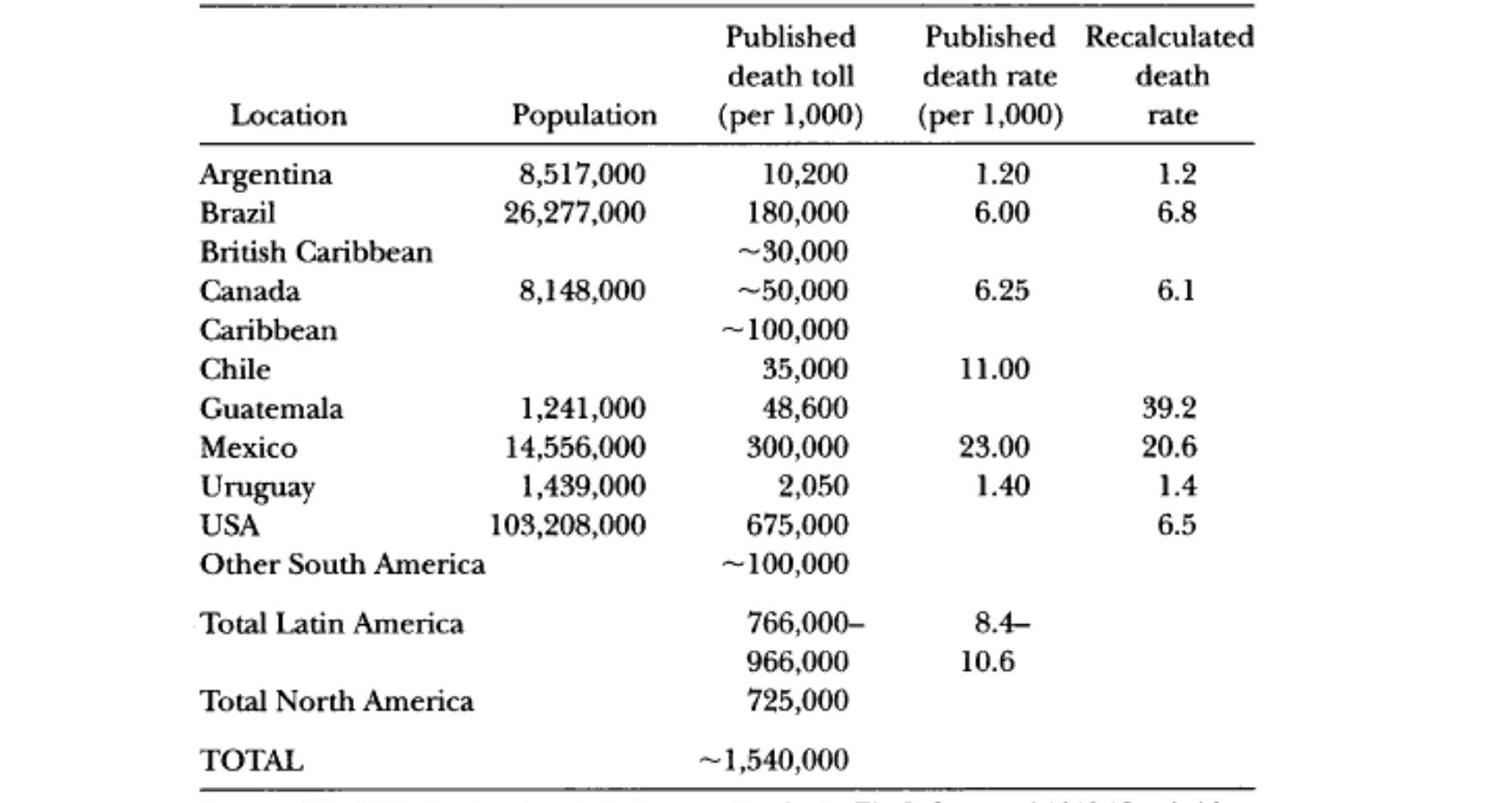

Table 1 JOHNSON, N., & MUELLER, J. (2002). Updating the Accounts: Global Mortality of the 1918-1920 "Spanish" Influenza Pandemic. Bulletin of the History of Medicine, 76(1), 105-115.

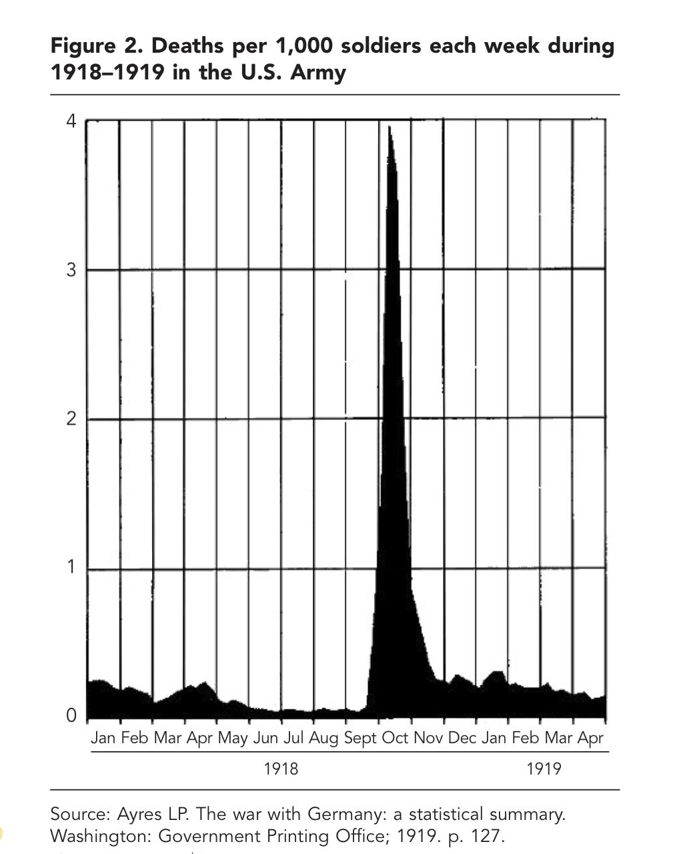

Table 2 Carol, R. (2010) . The U.S. Military and the Influenza Pandemic of 1918-1919

Table 2 shows that the peak time of pandemic that made soldiers die the most is from the end of September to the end of November which is the second wave of pandemic. According to the data that majority of people died in the second wave. The peak number of soldiers died per week is around 4,000 soldiers.

Impacts
The promotion of U.S women's right
While the U.S grappled with impacts of the Spanish Flu, the flu had led to the unexpected social change. In early America, women were usually running the household, farm, and plantation. Some women provided sewing, knitting, and other jobs in order to earn an extra income for their families. In other words, women’s opportunities during that time were so limited (Bryant, 2020).
On the other hand, the 1918 pandemic opened up and created new opportunities for women (Ketchell, 2018). It provided more freedom, independence, and political rights. Perhaps, the biggest reason for this change is the fact that more women than men are left from this coincidence.
According to the conclusion of world war I, the number of women in the labor force increased by 25 percent (The Siteseen Network, 2014). The demand for coal, steel, machinery, textiles, and other products which were needed for the war pushed women to enter the field that previously allowed for men only. This situation caused women to become more actively standing for their rights such as the economic power and the right to vote. They even demanded for the equal amount of salary for the same work as men (Alter, 2015). In addition, leadership positions in the workforce; the garment industry, the military finally occupied by women. As women rights played an important role in the US society, president Woodrow Wilson (Astor, 2018) started to argue that, in general, women were a part of the American war effort and economy. Thus, Women should be given the right to vote.
Besides the workforce, women became more engaged in society decision-making. For instance, in 1919, the Nation Federation of Business and Professional Women’s clubs was founded. The club emphasized on ending sexism in the workforce in order to ensure that women were paid the same amount and create an equal right amendment (Ketchell, 2018).

Economic effects of the Spanish flu
Economics Effects of the 1918 influenza pandemic from print media.
As the 1918 influenza spread during WWI, the war also interrupted the whole world’s economies. Even the neutral countries were damaged due to the conflict decrease trade flows by raising the costs to private agents of engaging in international business (Glick & Taylor, 2005). This has caused the difficulty in estimating the economics effects from the pandemic according to the existence of concurrent events. Given the available poor economic data, on the other hand, the evidence of the impacts of the 1918 pandemic on the US's business and industry are presented on the print-media during the pandemic are seem to be the almost complete of economic sources (Garrett, 2007).
Newspapers from the Eighth Federal Reserve District cities of the Little Rock, Ark., and Memphis, Tenn were published in the fall of 1918. These two newspapers will be used to elaborate the economic impacts from the 1918 influenza in the next following paragraphs.
Firstly, The Arkansas Gazette, The oldest newspaper west of the Mississippi River, was a newspaper in Little Rock or the capital city of the United states (Wikipedia, n.d.). In 1916, newspapers started to report the disease outbreaks including the influenza in military camps and the health status of camps, but it was not focused on the flu.
“How Influenza Affects Business”. (The Arkansas Gazette, 1918) There has been depression in all lines of business 40 to 70 percent and Little Rock businesses lost around $10,000 daily due to the 1918 pandemic and the quarantine at Camp Pike. Camp Pike is located in Pulaski County and there were about 52,00 men. Some merchants in Little Rock say their business has reduced approximately 40 percent. While others estimate the decline as high as 70 percent. People were not eating as much as normal conditions. Moreover, president of the Cox Cash Stores Company said the retail grocery business had decreased by one-third as so many people were ill with the flu. People were also frightened by the flu, so they ordered dry foods and goods over the telephone instead of going to stores by themselves. Furthermore, several businesses such as jewelry, shoe and hardware also reported the decrease in sales for 40-70 percent. Nevertheless, there had been an increase in the demand for beds, mattresses, and spring because patients had followed the advice “Rest in bed” as the treatment for the flu. Since there were no vaccines and cures, Isolation, and Bed rest have been the most effective way for treatment (Comer, 2020).
Next, The Commercial Appeal is a daily news of Memphis founded in 1886 (Wikipedia, n.d.). This newspaper reported business, government and legal news in Shelby County in the U.S. state of Tennessee. According to “Influenza Crippling Memphis Industries” Industrial plants were doing under the chaos (The Commercial Appeal, 1918,). Most of them did not receive help because of the draft. For instance, the coincidence caused a turning point in the textile industry. As the US entered the war, it created a high demand for clothes to costume American troops. Nevertheless, the industry encountered new challenges. Cotton farmers were sick and the boll weevil affected the cotton. Also the changes in the trend impacted the production which caused the very high cost in the production. Some factories were forced to close down and sell off their firms. Furthermore, the Cumberland Telephone Co. reported that they were unable to open their lines on usual schedule because over a hundred operators were absent. For that time, the telephone was the only thing to carry on citizens' lives (Mccracken, 2020). The demand for the telephone’s service was increasing. People used telephones to order goods from grocery stores and means of news distribution. Kids could even study from their home by having conversations with their teachers. The phone company infrastructure depended on the operators because they made the connection between each call. Since the operators were absent, the company limited usage to emergencies--for instance, calls for doctors, drug stores and every emergency call appeared from the flu.

The effects of influenza mortalities in the manufacturing wages in U.S cities and states
It is true that the Spanish flu had various negative effects on states and country’s economics. While one research paper reported the positive effect of the flu was a rapid increase in the manufacturing wages (Garrett, 2007,). The mortalities from the war and the 1918 influenza pandemic caused the decrease in the supply of labor so the marginal product of labor and capital were increased which resulted in an increase in wages rates(Table 1 in the appendix). Moreover, according to the graph, the growth in wages was significant in the cities and states that had a higher mortality from both influenza and World War I.
The reason behind this was the scarcity of the nation’s resources devoted to World war I. As many cities such as Pennsylvania, Alabama, Kentucky, Tennessee, and many more were reported the dramatically declined in coal outputs because they were having a difficulty to produce more. The cities that had the higher mortality rates led to the larger decreased outputs (Correia et al., 2020). As a result, the demand for coal, steel, machinery, textiles, and all products were needed for the war skyrocketed. Even though the pandemic affected people so harshly, the private sector kept pushing the production in order to fulfill the demand regardless of the lack of labor, as they became ill (Benmelech & Frydman, 2020). According to the Chronicle, 70,000 coal miners in central Pennsylvania voted to have extra workday in order to boost the production. As the government is still buying, the firms keep producing. Thus, the demand for workers also increased which made the manufacturing wage rates increase too.

Inequality
In the United States(US), inequality has been a major issue for a long time. There are many reasons why we have to pay attention to this issue. If we focus on the economic inequality issue, someone might say we have to be nice and treat people equally because they are poor. For instance, when we have consuming inequality it will lead to buying or producing decisions and possessions. However, why these poor people cannot spend even things for a living, while some people can spend their money for their dog’s birthday cake. The reason is that they are not diligent or they just cannot choose how they were born and pressured by surrounding capitalism? Inequality has many fields. As we can see this issue in the US from past to present, and it tends to be continued forward to the future—for instance political inequality, social inequality such as sexism, racism, and etc.

Inequality and social status
Inequality and Social Status The discrimination reminds some history from 1918 infectious pandemic. This chaos had shaded inequality, and it is true that pandemic is one of the 4 horsemen—things can get rid of inequality composed of warfare, revolution, lethal pandemic, and state failure—as Walter Scheidel claimed. Since we expect the lethal pandemic will create profound impacts causing many patients and dead people. Therefore the population on earth will be decreased. Due to the lower number of labor, they had more bargaining power to increase their wages which can decrease income disparity. (Walter Scheidel, 2017)
During the pandemic exposure, it was also the first World War era. The warring strategy of the American military is digging a 350-centimeter trench as a barrier, residence, hospital, or headquarter. The trench is not a nice place. There is still not good hydraulic management, so when it is flooded it will be soaked, muddy, and musty. Moreover, during the war time, they have no time to bury the dead people, so they use the trench as a morgue. The military had to live with these unsanitary places which are the cause of a lot of diseases, and the lower rank army tend to be infected from viruses and bacteria easier than the higher rank army since they do not need to associate with other people that much. They just commanded the army through the headquarters.

Inequality and Race
Camp Dodge—a military installation in the city of Johnston Iowa, the US. This place was found in the first case of the Spanish flu in September 1918, and there were 702 soldiers killed by the disease in November. Actually, there was still a mystery because the army concealed some part of the data. Camp Dodge had recruited the black soldiers to fight alongside the white, in the future, therefore they might allow the black integrate into the American society after the war. (Bill Douglas, 1917-1918) But, it is not the truth.
On October 1st, 1819 the flu lurched into the camp. The number of patients was increasing to 1,500 and the first death was a black soldier. There was a rumor that there were 50 black soldiers who had died in an anti-flu experiment. However, it was still a rumor because when the death rate was increasing, the government would stop reporting the situation. “Any time the government shuts off information, people will make up stories. And those stories will be repeated. If you don't come up with the truth, then people will make up something. These stories have been perpetuated in families." said the Camp Dodger. (Anonymous, 2020)
In 1919, a year after the end of WWI and also the year of the greatest racial violence called Red Summer—because bloodshed of the black. It was the year that African Americans were coming back from WWI.(Holland, 2019) The cause of this violence is a concern of the white people that the black people will take jobs, housing, and security from them. The white people saw the colored people as their competitors.(Fujita, 2019) By 1920, the number of African Americans in the US had skyrocketed due to immigration to find jobs. In New York the number increased significantly from 65,104 in 1880 to 198,483 in 1920. “Men are used to seeing Negroes in inferior positions; when, therefore, by any change a Negro gets in a better position, most men immediately conclude that he is not fitted for it, even before he has a chance to show his fitness.” (Bois, 1899)

Inequality of the US in the past, future, and now and then
At the beginning of 1600, the black were not discriminated against, and slaves were not merely the black. Until late August 1619, the first selling of black slaves occurred by the European who cruised to America, the New World, to sell the African slaves. It was claimed that there were around 10.7 million people out of 12.5 million people of black slaves who survived after being captured and kidnapped from Africa to Europe and to the New World.(Gates, 2013)
In 1660 the Virginia, a southeastern US state, declared all black servants must be slaves for life, and legal status of children must be depended on the mother’s.(Robinson, 2016,)
On Jan 1st,1863, the 16th president Abraham Lincoln declared the Emancipation Proclamation would be equipped and it would lead to the American civil war. However, reconstruction was not easy, since the freedmen were still working the same job. Most of them would like to rent the house and work with their former owners who paid their wages in a very low amount. (Zelm, n.d.)
From this point, even though the US government gave freedom to slaves, there was a racial and gender wage gap. It seems like this issue still was ignored by some Americans. Since 1900-2000, the race-based economic inequality in the US was shown the economic status of the son of white and black of the top 10 percentile from the bottom of the income distribution were around 32% for white and 10% for black in 1900, and in 2000 the rates were increasing up to 49% for white and around 28% for black. This data delivered that although a century passed, racism was most likely the same.(William & Marianne, 2017)

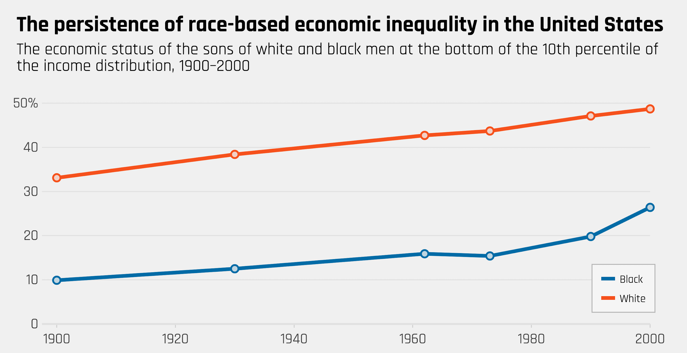
Table 1 : William J. Collins and Marianne H. Wanamaker. Up from slavery? African American intergenerational economic mobility since 1880. June 2017. 06132017-WP-African-American-intergenerational-mobility.pdf

It is not merely about racism because racial inequality always comes along with gender inequality.
In 2012, Hispanic people, the second tribe growing fastest next to the white in the US, have the same average working hours per week and weeks per year compared with the white, Asian, and color. The result is the Hispanic women have the lowest annual earnings among these 4 groups. The annual earnings are 40,277$, 44,576$, 55,821$, and 62,900$ for Hispanic, Black, White, and Asian respectively. Apart from that if we compare Asian men who earned 82,908 per year with Hispanic women, the gap is very large. Asian men have income per year higher than Hispanic women significantly 105.84% (Kate & Will, 2018).
Furthermore, in the recent years, 2017 if we count the mean the white female wage as 100% , then the wages of white female, black male, and black female were 81.7%, 73.1%, and 66.8% respectively. Looking at the comparison between the white male and black female, it could be assumed that if the white male earned wages for 100 dollars, the black female would earn 66.8 dollars as wages. Apart from that, people who receive high income have a tendency of higher education. In the same year, the study reported that the white female has the highest education there was a 49.6 of them having at least a bachelor’s degree, and the least level of education was black male which was only 28.5% of them having at least a bachelor’s. (Paul, et al., 2018) According to these statistics, so what will future American inequality be?
The modern day of the US, Donald John Trump is the 45th president of the US having a debate with Hillary Clinton in 2016. From American history, it never had a woman president, but there was just a candidate which was Hillary Clinton. There are many people who claim that Trump is an extreme racist "He’s the racist" said Joseph Robinette Biden Jr.(Joe Biden) who is a recent candidate of Trump in 2020. Moreover, in 2019, the poll revealed that there were 57% of Americans who think that Trump is the racist. Therefore, at this point, some people decided to vote Trump because they are racists too.
During the Trump era (2016-2020), even though the unemployed rate in America is decreasing, the black unemployment rate is always higher that the white’s.(Table 2) America still cannot get rid of inequality.
Nevertheless, in 2020, Joe Biden wins the 46th American presidential election, so he plans to develop health care disparity because there are black died from Covid-19, the pandemic spreading in 2020, more than white.(Joebiden, n.d.) He also wants to raise government revenue by a progressive taxes, which is one of the tools that can eradicate income inequality and reduce the belief of luck--people who born in the rich family is lucky.(DSOUZA, 2020)
The future of American inequality would be decreased if Joe Biden can follow his ideals. Plus, the Covid-19 pandemic has been killing a large amount of American population; it is similar to Spanish flu pandemic in the past. More death and less laborers will create more bargaining power for laborers for increasing their wages. Therefore, with the great disease, inequality problems will be relieved.

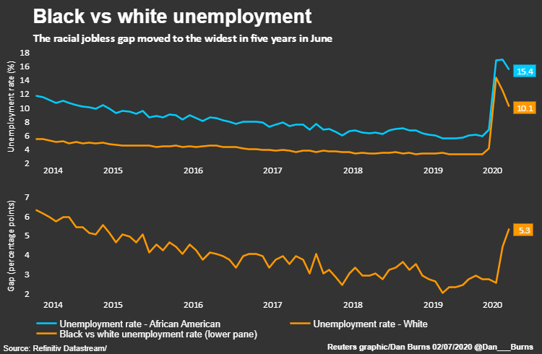
Table 2 : Jonnelle Marte. Gap in U.S. Black and white unemployment rates is widest in five years. June 2020. Gap in U.S. Black and white unemployment rates is widest in five years | Reuters

Responses
How government responses or take action about medical and support
Spanish flu epidemic occurs while the president in The United States is President Woodrow Wilson. The timeline that the Spanish flu pandemic occurs is the same time that World War I occurs. Wilson decided to focus on the war and ignore the Spanish flu, which devastated and killed lots of the Americans. Wilson didn't care how serious disease was and put all the efforts to the war. The governments didn’t take any action about the Spanish flu or any policy or guidance for the americans. Even though a load of American deaths, Woodrow Wilson still ignored, not talking about this situation or without helping the civilian population from The United States government. But it’s not only the white house that is ignoring the Spanish flu, but also the Federal and local health leaders, head of Health and Sanitation Section of the Emergency Fleet Corporation, they all have the same ways of the idea that the epidemic is under control and no cause for alarm if proper precautions took. (Melissa August, 2020) The civilians are so angry at them that they have concealed the truth about Spanish flu.
When the Spanish flu pandemic peak time the hospitals were overwhelmed quickly, people rapidly got infected because they have no immunity and there were no vaccines, medicines or a way to treat the Spanish flu. Due to ignored governments, the football league had to be cancelled in the war-time but they didn't cancel the match for the spanish flu pandemic. Not even limit the spectators in the football field (Mamelund, 2008). Then the people are together and there's a risk of infection. And the pandemic is still spreading. During the spanish flu pandemic, there was no announcement or regulations to lock down the city to stop this pandemic but majority of public places were closed whether it be schools, theatre, cinemas, pubs and churches. It Had To be closed one month or more. Most schools in the United States closed because of the spanish flu pandemic. The United States chose to make school nurses rather than send sick students to their house. Some states in the United States have regulations for the citizens to quarantine together with wearing face masks and closed the public places. In some cities have sprayed some chemicals that they believed could help restrain the Spanish flu.
The American Red Cross(ARC) of the United States plays a major role due to the Spanish Flu. While Spanish flu spread, the American Red Cross had expanded into many cities and hired more staff to support the infected people. And they also provide Public Health Service pamphlets and circulars on prevention and care of influenza, and direct its chapters to form influenza committees to work with local health authorities and regional American Red Cross divisions. (Marian Moser Jones, 2010)

How governments cope with the Spanish Flu
The Committee of the American Public Health Association(APHA) has several methods that Public Health and Influenza used to prevent the Spanish flu. First is Quarantine and Isolation, in many cases proof that this preventive method has failed. In contrast, In the country that strictly uses the quarantine such as Australia, they didn’t hit in the second deadly wave (Mamelund, 2008). And wearing a mask is another preventive measure that is used to prevent the spread of influenza. Moreover, there are also nonpharmaceutical interventions, like wearing masks, to local health authorities to close the public place. In some cities that have their own policy of restrain the spanish flu. The grocery stores need to limit people to avoid the congestion, some need to order by phone. Health officials limit the spread of the Spanish Flu by creating educational campaigns (Schwartz, 2018)
In September 1918, the second wave of pandemic the board of health in New York City reported the diseases and all cases must be isolated or quarantined at home or hospital. This allowed the civilian to be flexible in working time. In Addition, public gatherings were not allowed and social distancing was promoted together with closures of public places such as school, restaurants and theatres. Also prohibited public gatherings and travelling among cities. And in other cities people are required to wear face masks before getting into public transports. In contrast, Commissioner Copeland didn’t prohibit public gatherings or regulate the school to be closed (Environmental Research and Public Health, 2020). At that time they had a shortage of professional nurses because of the failure of using trained African American nurses. In the third wave, some states have a study of influenza to train women as “practical nurses” in response to nurse deficits which corporated with American Red Cross to asking for permissions for workers to have a day off if they are volunteered at hospital. The pandemic has ended because people who got infected died or the body built immunity.

Responses and Inequality in the United States during Spanish flu pandemic
During World War I or In the first wave of pandemic health officials converted schools or large private houses to emergency and open-air hospitals. Because open-air hospitals and sunlight have reduced the number of infections and death. And also helped patients to recover sooner than indoor nurse patients.
The Spanish flu affected the youngest and wealthiest people without any discrimination. The medical and public health reported that African Americans have morbidity and mortality rates two or three times higher when compared with White Americans. Many factors contributed to poor people or working-class urban neighborhoods have more possibilities to get infected such as overcrowded housing, poor sanitation service and cannot get into a good medical service or urban social programs. These all factors can make African Americans have a higher risk of death. At first African Americans lived in the Southern parts of the United States, but they migrated to Northern parts for better living conditions and job opportunities. During the Spanish flu pandemic, they lived in urban areas. Interestingly, In the second wave African Americans had mortality rates lower than White Americans. Clarify with several hypotheses like the places where African Americans lived(different between rural and urban) , African Americans have immunity, Military racist made African Americans soldiers less crowding than white soldiers it’s less possibility of flu to spread and underreporting of influenza of influenza cases and deaths for African Americans.
Moreover, it has some studied cases that are “black combat division” in the military camps. African Americans soldiers received less protein and less calories than white soldiers. Even they are taller and heavier than white soldiers. Even though the military data provides information that every soldier received everything equally. But the information cannot be confirmed.
During the first wave of pandemic, there is a lack of medical team : doctors, nurses and medical staff. So the hospital at that time refused to treat African Americans patients. Even The American Red Cross served as the recruiters of nurses but still rebuffed the African Americans who applied to be nurses for the army. Racism and segregation almost restrain African Americans and other non-white people to use or (Environmental Research and Public Health, 2020). African Americans received the treats below the standard which White Americans received. They have separated the hospitals for only served African Americans. When the hospital was overwhelmed the capacity and lack of medical staff so many patients were neglected, some died without seeing a doctor. Death bodies of African Americans were ignored by the general public infrastructure. (Environmental Research and Public Health, 2020)

Discussion
Which type of inequality in the U.S. that we should pay attention to ?
According to the previous data, the basement of all inequality is racial and gender discrimination or the discrimination of inborn physical. We cannot choose every desired thing since we were born, so we should not have to determine who is better or greater than whom. It might be a false consciousness built for a group of people—which forgot the fact that everyone is human.
For instance, due to racial and gender discrimination, it will create income disparity. Some people will earn lower income than the other—black people earn lower wages than those white, even with the same hourly working. In addition, they have a higher possibility for getting lower income jobs because of bias. When the income inequality is created, then educational inequality will occur. Education could be a guarantee of an amount of income in the future. Having low income cannot afford a good education for their children. Therefore it would be like a loop if we keep discriminating between race or gender.

Reference

Bahn, K. & McGrew, W.(2018). Washington Center for Equitable Growth, the intersectional wage gaps faced by Latina women in the US

Scheidel, W.(2017) The great leveler,Violence and the history of inequality from the Stone Age to the twenty-first century

Douglas, B.(1917-1918), State History Society of Iowa,wartime illusion and disillusionment :Camp Dodge and Racial Stereotyping

Anonymous,(2020 3 27). From the archives: 1918 brought a nightmarish flu epidemic to Iowa's Camp Dodge. Desmoinesregister.
https://www.desmoinesregister.com/story/news/local/2020/03/03/influenza-outbreak-700-soldiers-died-1918-iowa-camp-dodge-johnston-army-base-national-guard-flu/2843939001/

Holland, J. (2019 7 24) Hundreds of black deaths in 1919 are being remembered. HIstory. https://www.history.com/news/red-summer-1919-riots-chicago-dc-great-migration

Fujita, J.(2019 7 26). Red Summer of 1919: How Black WWI Vets Fought Back Against Racist Mobs

Bois, D.(n.d.). The Philadelphia Negro in 1899

Gates, H.(2013)100 Amazing Facts About the Negro How Many Slaves Landed in the U.S.?. pbs.
.https://www.pbs.org/wnet/african-americans-many-rivers-to-cross/history/how-many-slaves-landed-in-the-us/
Robinson, Y.(2016 7 14). “ELIZABETH KEY GRINSTEAD (1630–1665),” Blackpast

Zelm, A.(n.d.).Hope Within a Wilderness of Suffering: The Transition from Slavery to Freedom During the Civil War and Reconstruction in Tennessee. Tennessee Civil War National Heritage Area.

Paul, M., Zaw, K., Hamilton, D. & Darity, W. (2018).Returns in the labor market: A nuanced view of penalties at the intersection of race and gender.

The Biden plan to build back better by advancing racial equity across the american economy.
The Biden Plan to Build Back Better by Advancing Racial Equity Across the American Economy | Joe Biden for President: Official Campaign Website

Deborah D’souza.(2020 12 10). Joe Biden's Economic Plan, Save the Middle Class to Save America
Joe Biden's Economic Plan: Save the Middle Class to Save America (investopedia.com)

Alter, C. (2015, 4 14). The History of the Battle for Equal Pay for American Women. TIME. https://time.com/3774661/equal-pay-history/?xid=PS_smithsonian

The Arkansas Gazette. (1918, 10 19). How influenza affects business. The Arkansas Gazette. https://www.newspapers.com/clip/48702188/daily-arkansas-gazette/

Astor, M. (2018, 1 30). 1918 Brought an Armistice, but Also a World of Death. The New York Times. https://www.nytimes.com/2018/01/30/world/europe/1918-flu-war-centennial.html

Benmelech, E., & Frydman, C. (2020, 4 29). The 1918 influenza did not kill the US economy. https://voxeu.org/article/1918-influenza-did-not-kill-us-economy

Bryant, J. (2002). How War Changed the Role of Women in the United States. How War Changed the Role of Women in the United States, 3, 3.

Comer, L. (2020, 3 14). Don’t forget the lessons of the 1918 Influenza Pandemic. https://www.the-dispatch.com/story/opinion/columns/2020/03/14/dont-forget-lessons-of-1918-influenza-pandemic/112333136/
The Commercial Appeal. (1918, 11 5). Influenza Crippling Memphis Industries. 7.

Correia, S., Luck, S., & Verner, E. (2020, 6 5). Pandemics Depress the Economy, Public Health Interventions Do Not: Evidence from the 1918 Flu. https://poseidon01.ssrn.com/delivery.php?

Garrett, T. A. (2007, 11). Economic Effects of the 1918 Influenza Pandemic. Implication for a Modern-day Pandemic.

Garrett, T. A. (2007, 11). War and Pestilence as Labor Market Shocks. U.S. Manufacturing Wage Growth 1914-1919. https://citeseerx.ist.psu.edu/viewdoc/download?

Glick, R., & Taylor, A. M. (2005, 8 11). Collateral Damage: Trade Disruption and the Economic Impact of War. 2. https://www.frbsf.org/economic-research/files/wp05-11bk.pdf

Ketchell, M. (2018, March 1). How the devastating 1918 flu pandemic helped advance US women’s rights. The Conversation. https://theconversation.com/how-the-devastating-1918-flu-pandemic-helped-advance-us-womens-rights-91045

Mccracken, H. (2020, 7 12). How the telephone failed its big test during 1918’s Spanish flu pandemic. https://www.fastcompany.com/90484820/how-1918s-spanish-flu-outbreak-crushed-the-u-s-telephone-system

The Siteseen Network. (2014, 7 1). Women in the 1920s Fact 2. Women in the 1920s.
Wikipedia. Arkansas Gazette. https://en.wikipedia.org/wiki/Arkansas_Gazette
Wikipedia. The Commercial Appeal. https://en.wikipedia.org/wiki/The_Commercial_Appeal

Crosby, A. W. (2003). America's forgotten pandemic: The influenza of 1918 (2nd ed.). Cambridge ; New York: Cambridge University Press.

Schwartz J. L. (2018). The Spanish Flu, Epidemics, and the Turn to Biomedical Responses. American journal of public health, 108(11), 1455–1458. https://doi.org/10.2105/AJPH.2018.304581

Bouye, K., Truman, B. I., Hutchins, S., Richard, R., Brown, C., Guillory, J. A., & Rashid, J. (2009). Pandemic influenza preparedness and response among public-housing residents, single-parent families, and low-income populations. American journal of public health, 99 Suppl 2(Suppl 2), S287–S293. https://doi.org/10.2105/AJPH.2009.165134

Byerly C. R. (2010). The U.S. military and the influenza pandemic of 1918-1919. Public health reports (Washington, D.C. : 1974), 125 Suppl 3(Suppl 3), 82–91.

Kamradt-Scott A. (2012). Changing perceptions: of pandemic influenza and public health responses. American journal of public health, 102(1), 90–98. https://doi.org/10.2105/AJPH.2011.300330

Roberts, J. D., & Tehrani, S. O. (2020). Environments, Behaviors, and Inequalities: Reflecting on the Impacts of the Influenza and Coronavirus Pandemics in the United States. International journal of environmental research and public health, 17(12), 4484. https://doi.org/10.3390/ijerph17124484

Erkoreka A. (2009). Origins of the Spanish Influenza pandemic (1918-1920) and its relation to the First World War. Journal of molecular and genetic medicine : an international journal of biomedical research, 3(2), 190–194. https://doi.org/10.4172/1747-0862.1000033

Økland, H., & Mamelund, S. E. (2019). Race and 1918 Influenza Pandemic in the United States: A Review of the Literature. International journal of environmental research and public health, 16(14), 2487. https://doi.org/10.3390/ijerph16142487

Influenza pandemic of 1918-19 (2020) . In Encyclopaedia Britannica. Retrieved July 7, 2020,
from https://www.britannica.com/event/influenza-pandemic-of-1918-1919

All about history (2020, March 12) . Spanish flu : The deadliest pandemic in history. Retrieved from LIVESCIENCE.

Jordan, Tumpey and Jester (2019) . The deadliest Flu : The Complete Story of the discovery and reconstruction of the 1918 pandemic virus. Retrieved from Centers for disease control and prevention .

August (2020, August 11) . The 1918 Flu Pandemic Killed Hundreds of Thousands of Americans. The White House Never Said a Word About It . Time

Appendix

Table 1 - Total City Wage Growth vs. Wage Growth from Influenza Deaths

City | Percentage change in wages, 1914-1919 | Percentage point increase in wages from 10% increase in flu deaths. | City | Percentage change in wages, 1914-1919 | Percentage point increase in wages from 10% increase in flu deaths.
Albany  Atlanta  Baltimore  Birmingham  Boston  Bridgeport  Buffalo  Cambridge  Chicago  Cincinnati  Cleveland  Columbus  Dayton  Denver  Detroit  Fall River  Grand Rapids  Indianapolis  Jersey city  Kansas City, MO  Los Angeles  Louisville  Lowell  Memphis  Milwaukee | 61.2  93.3  119.0  92.4  73.3  114.5  97.1  66.1  84.5  77.9  105.4  78.6  117.9  62.0  110.8  88.2  88.1  70.6  102.5  65.9  51.9  76.5  111.8  50.0  82.0 | 3.29  2.08  3.47  4.02  3.84  4.22  3.04  2.84  2.04  3.12  3.29  2.06  2.42  3.88  2.00  3.62  1.28  2.37  3.94  3.92  2.80  3.60  3.13  3.28  2.24 | Minneapolis  Nashville  New Heaven  New Orleans  New York  Newark  Oakland  Omaha  Paterson  Philadelphia  Pittsburgh  Portland  Providence  Richmond  Rochester  San Francisco  Scranton  Seattle  Spokane  St louis  St. Paul  Syracuse  Toledo  Washington, DC  Worcester | 62.0  74.1  76.0  86.7  106.5  107.1  74.7  96.3  98.0  111.3  103.8  90.8  79.8  86.7  80.0  54.4  72.2  94.2  39.7  67.3  64.4  80.0  89.4  84.0  91.9 | 1.90  4.41  3.20  3.83  2.63  3.29  3.00  3.20  3.44  4.47  6.23  3.04  3.53  3.00  2.29  3.71  4.47  2.45  2.79  2.34  2.31  2.74  2.00  3.27  3.48

Note: The percentage point increase in computed by increasing influenza death rates by 10 percent
and multiplying by the coefficient on influenza deaths.



