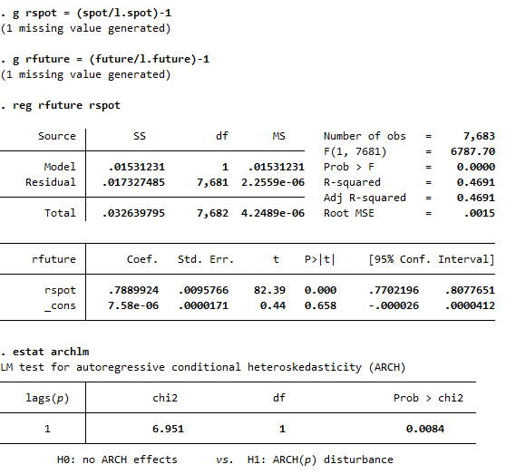
1.

From the table, the probability to have value higher than chi2 is 0.0084<0.05 making Ho to be rejected; therefore, ARCH effect exists.
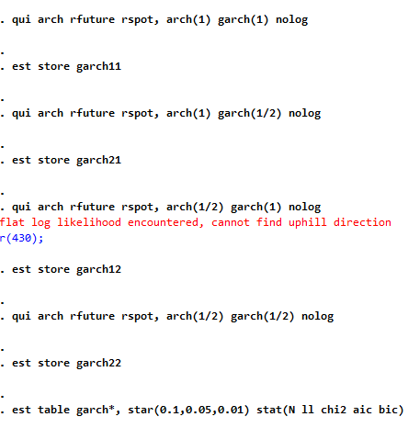
2.

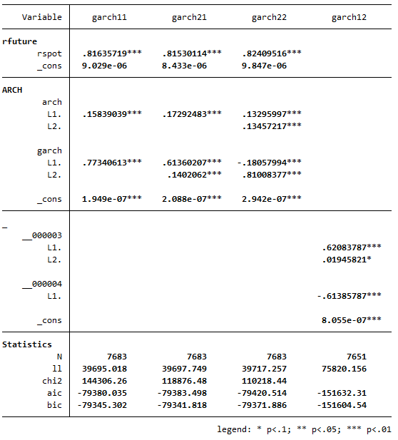

The table shows that garch11 represents the lowest value. Therefore, the most suitable order of (p,q) is (2,2).

3.
. predict sigma2, variance
. line sigma2 t

