Creating Forms
Forms facilitate users to add and edit data. Form structure consists of 3 components which are
- Header – Display header information of the form.
- Detail – Place data fields and controls.
- Footer – Display footer information of the form.

Creating a Form to manage data from single table
- Go to CREATE tab then select Form Design
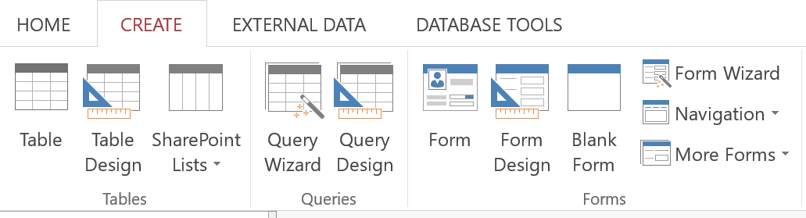
- Set the Record Source to the Form on property sheet of the Form. In this example, set table Cars as a record source.
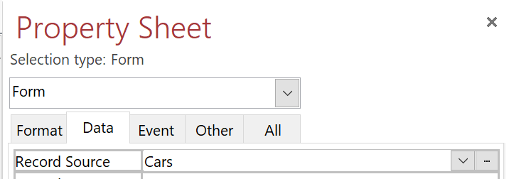
- Go to tab DESIGN then select Add Existing Fields
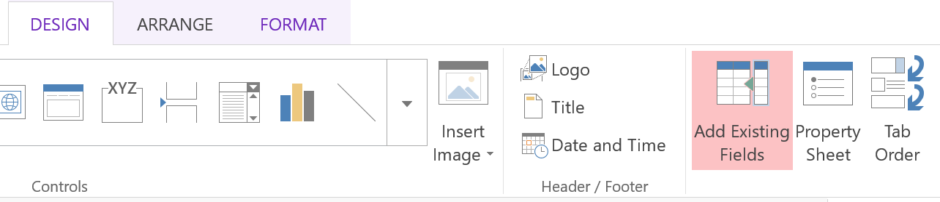
- Select the fields to place on the form by pressing Shift + click to select all fields or by pressing Ctrl and click to select multiple fields then the drag selected fields and drop on the form.
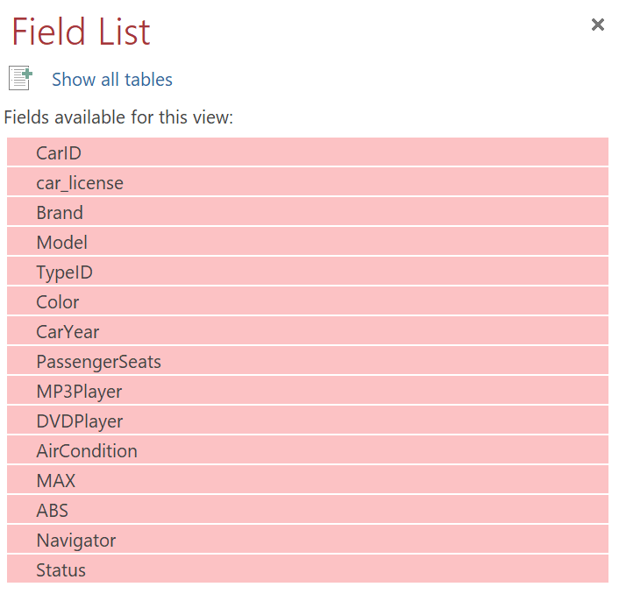
- Arrange the fields by using tools on tabs as follows.
- Design tab is used to add controls and images, including color theme selection of the form (same as choosing a color theme in Microsoft Power Point) and form header decoration (placing Logo, Title and Date)
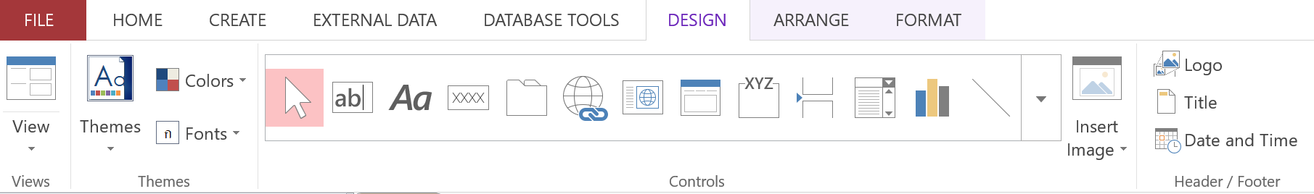
- Arrange tab helps to align and adjust fields and controls

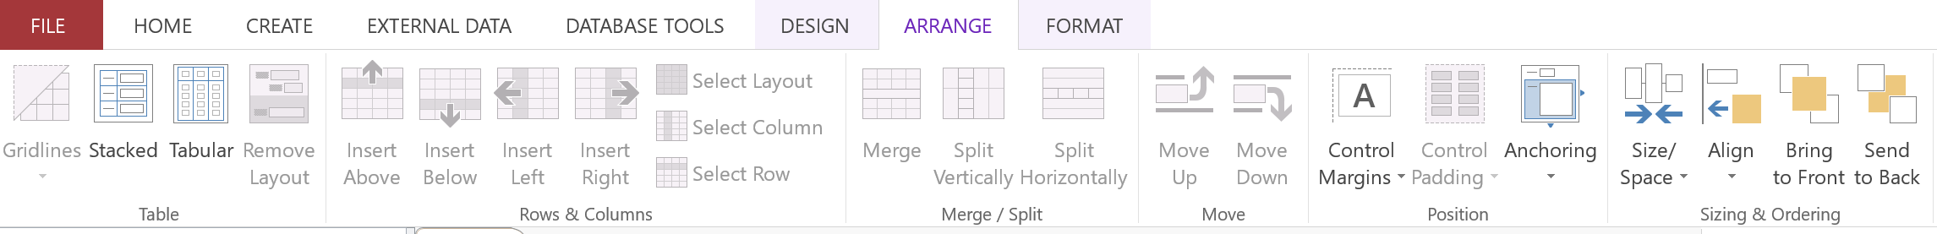
- Format tab helps to adjust text the format in font, size and color.

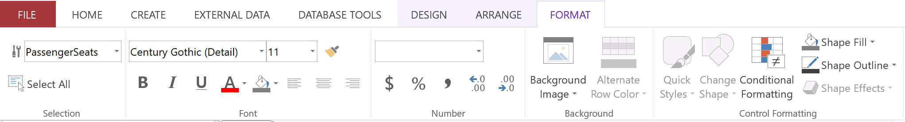

- Open the Form Header section by right-clicking on the top left box of Detail section to open the menu then select Form Header/Footer.
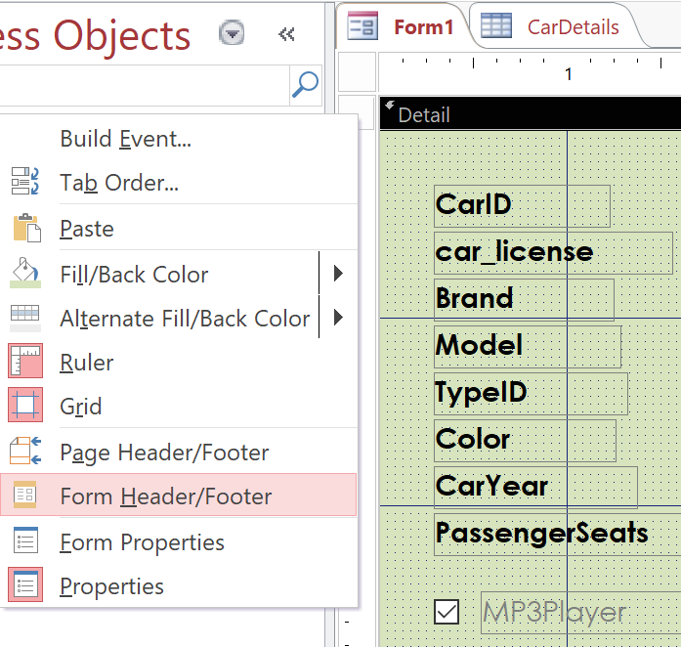

- Decorate the Header section, place the form name and logo as needed by going to Design tab and selecting Title and Logo.
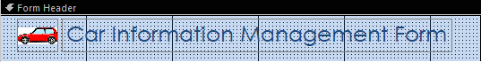
- Change to Form View to test the form by editing data and adding new data record. The newly added data record will appear in Cars table which is set as a Record Source of this form. (Right-click on panel outside the form and choose Form View or click on icon on bottom right of Microsoft Access window)
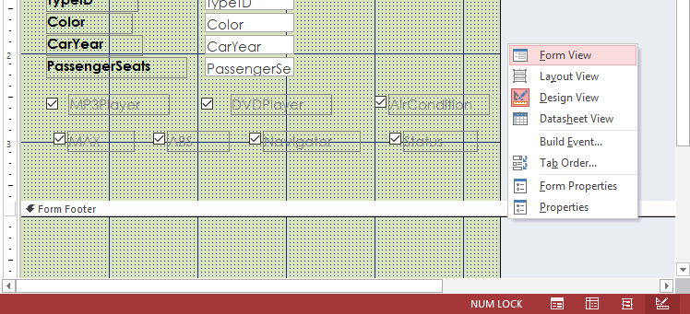

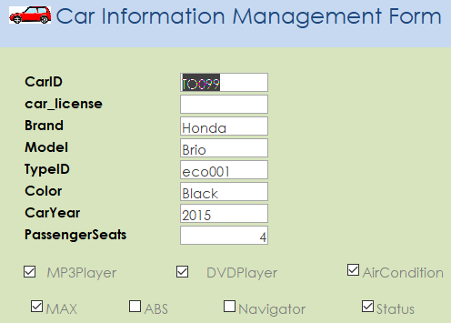

Creating a form with a subform for managing data from two linked tables
For car rental companies, transactions that will occur and must be saved every time are when customers come to rent a car and return that car. Renting cars create a new record in more than one table, so subform is very useful in this case. In the RentACar database, there is RentSchedule table that stores car rental list for each car, which is associated by the cust_id field in Customers table which stores customer information. Therefore, when a car rental occurs, the company may save customer information and car rental item as shown in the picture (Suppose one customer may book for multiple car rentals at the same time but may use in different period.
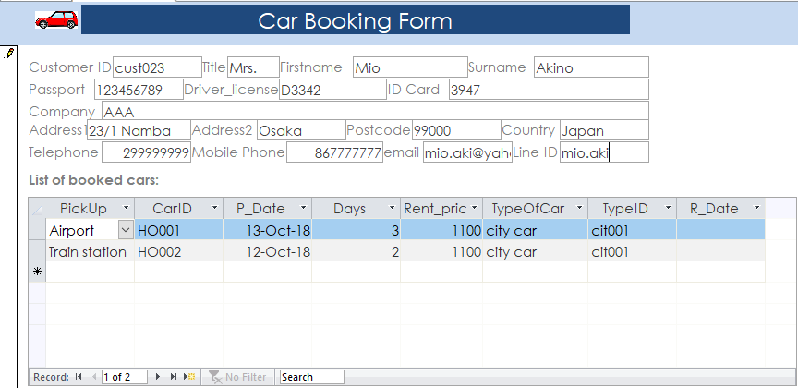

The principle of creating forms and subforms is to create two separate forms. One form is the main form, the other form is a subform. Once the two forms have been completed, then they can be linked together.
Steps to create forms and subforms for saving car rental
- Create the main form first. Go to Design tab and click Form Design then open property sheet of the form to set Record Source, in this case Record Source of the main form is Customers table which is customer information who rented cars
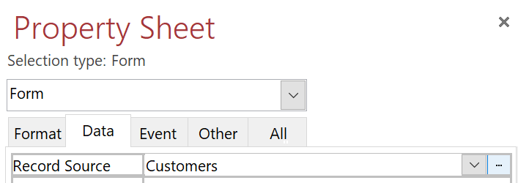
- Then click to select fields and arrange the selected fields as needed, then save the main form.
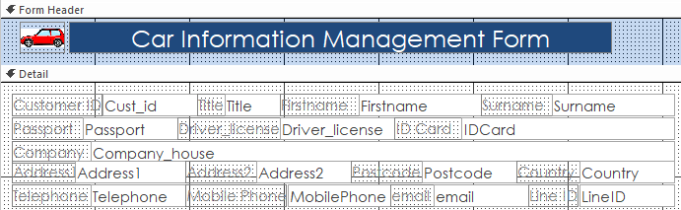

- Create subform by going to Design tab and click Form Design then open property sheet of the subform to set Record Source. In this case, we are going to create a new query to retrieve data from RentSchedule table and CarDetails table (The reason we need to add CarDetails table is because RentPrice field which is car rental fee is in this table).
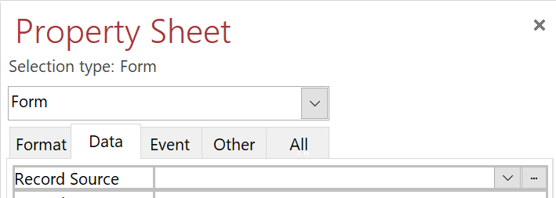
Click on button to open Query Design to create the query to be used as Record Source of the form. Then select fields from RentSchedule table and CarDetails table as shown in the picture.
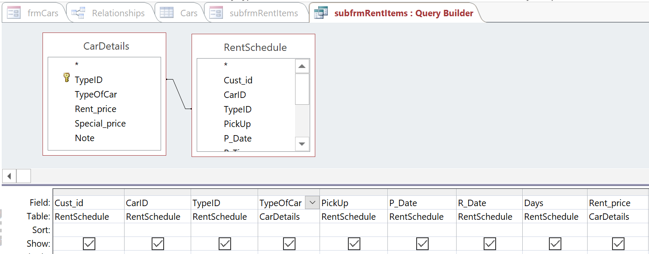
- Open the Design tab and select Add Existing Field List to select the desired fields to be placed in the form.
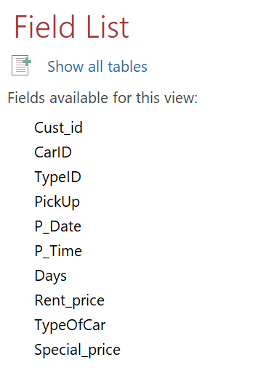
- Once you have placed the desired fields, there is no need to arrange them because we will adjust the data display format to DataSheet View, which Microsoft Access will automatically create data sheet when changing the Default View property of Form to DataSheet as shown in the picture
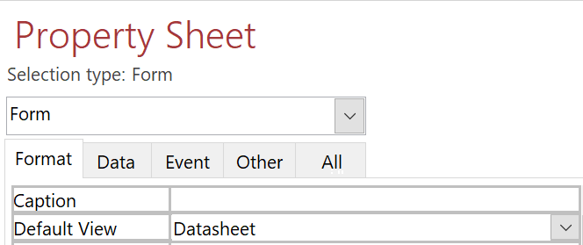

- Save and close the form. (the form need to be closed otherwise, it is not possible to put subform on the main form in Design mode)
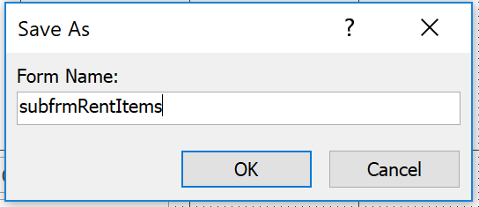
- Open the main form in Design mode and click on the subform name on Navigation Pane of the left then drag and drop it into the space of the main form. And link the subform and the main form by opening subform property and set Link Master Fields and Link Child Fields to the field to link main form and sub form together which in this case is Cust_id as explained earlier.
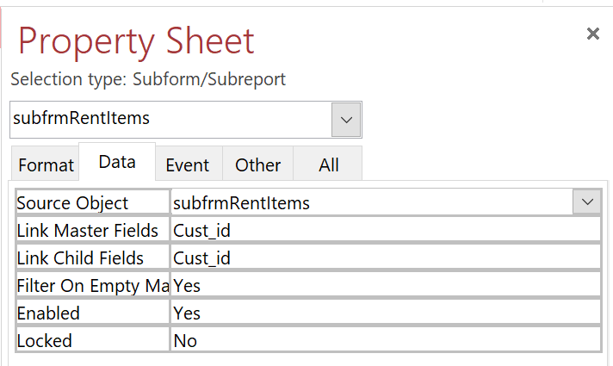
- Change mode to Form View to test the functionality and to test data recording. Customer information will be saved to Customers table and car rental information will be saved to RentSchedule table.
How to change controls in a form
Notice that by default, Microsoft Access uses Textbox as a control for text or number fields. However, developers can change type of controls. Using appropriate controls will help facilitate users and reduce errors in filling in data. For instance, filling out car rental information, you can see that TypeID is difficult to remember and easy to make typing errors. A list of items to choose from would be easier than user filling in all information by themselves. Likewise, the PickUp field, if there are a set of car pickup locations, the control should be changed to Combo Box to display all locations to choose from. It would be more convenient for the person filling out the information.
Example of changing a Text Box to a Combo Box
- Right click on the control to change and select menu Change To > Combo box
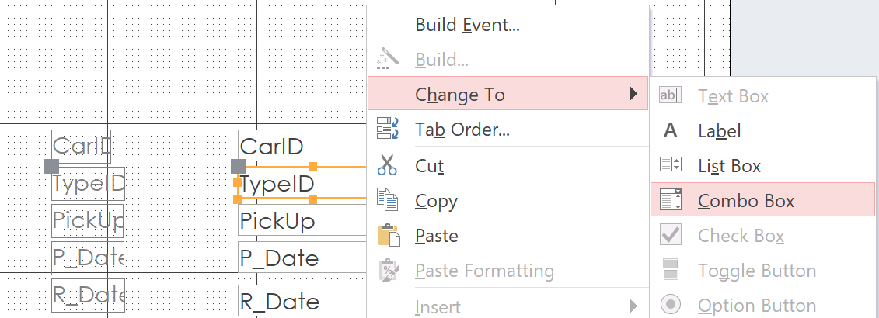
- Set Row Source to the control by opening property sheet and click on button next to Row Source.
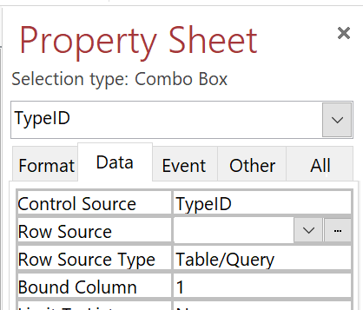
Then set Row Source as in the picture (In this example, we created query using data from TypeID field and TypeOfCar field from CarDetails table)
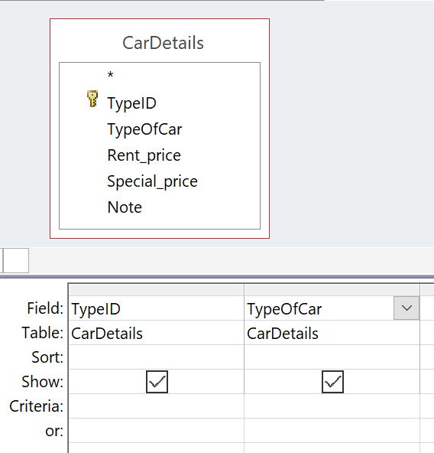
- Set the property named Column Count of Combo Box to 2 to display data of the two fields (TypeID and TypeOfCar) as shown in the picture.
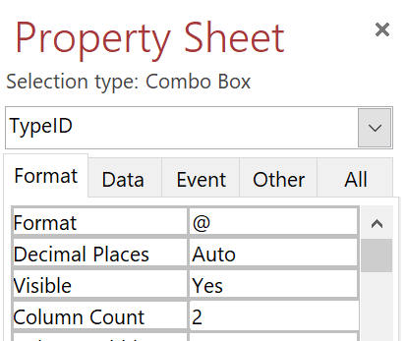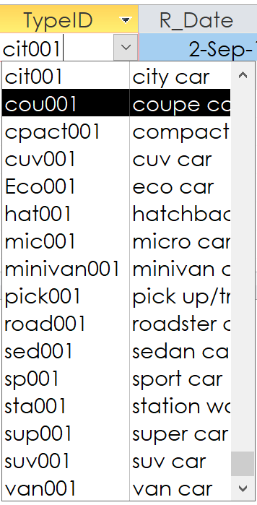

Exercise: Create form for FourTable.accb database
- Create a form for adding and editing product information.
- Create a form for adding and editing order information.
Exercise: other tips to make a form easier to use
- A car rental form should calculate rental price of each car by taking the number of rental days multiply by rental rate per day. How to add this calculation field?
- The order form (created in FourTable.accdb) should provide a Grand Total calculation which sums up total price of all product items in a certain order. How to add this calculation field?
- DLookUp is a very useful function used for looking up for values that match searching criteria. In the order form, for example, DLookup could be used to look up for name of customer whose ID is the same as current record. How to use the DLookup function?
- In the case that data is an incremental number or text, for example, new order id is always equal to latest order id plus 1. When filling a new data record, how to make the form generate and show new order id automatically so that users do not have to manually enter new order id?
- When filling in purchase order data, most of the time, the date of purchase is current date. How to make the form generate current date automatically without users having to fill in manually every single time?

