Student Information
[Insert your picture h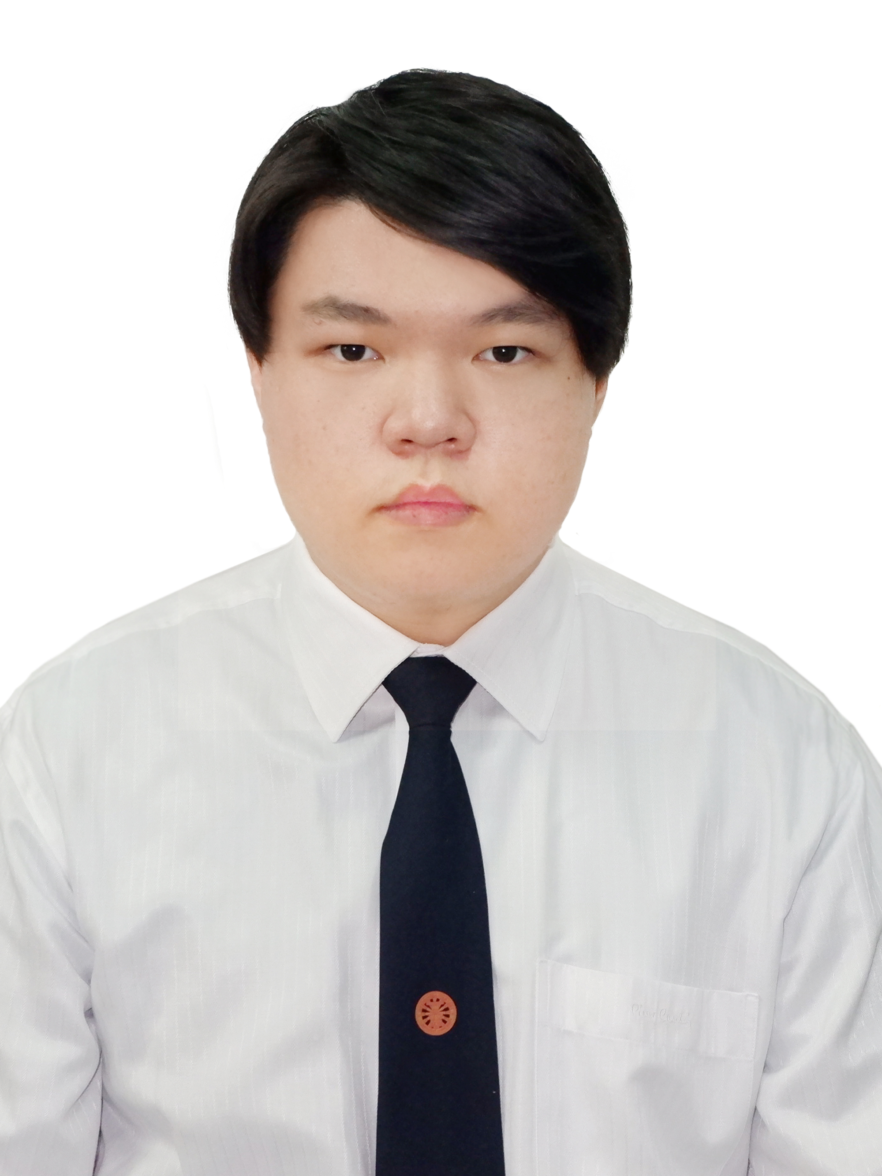ere.]
EE211 Microeconomics
Semester 1/2020
- Name ______PICHAYUT AIMWATANASIN____________________________
- Nickname ___George____________________________
- Email _____georgelee2202@gmail.com__________________________ Phone Number __065-2926-514___________________
- Year of program: [/] 1st year [] 2nd year [] 3rd year [] 4th year
- Major area (if any) ________________________________________
- Minor area (if any) ________________________________________
- Classes that you have already taken
____-_______________________________________________________________
___________________________________________________________________
___________________________________________________________________
- Classes that you are currently taking
Ee211,st216,tu100
___________________________________________________________________
___________________________________________________________________
- Classes that you plan to take in the next semester(s) or next academic year(s)
__I still can’t figure out what to do with my life, I mean next semester._________________________________________________________________
___________________________________________________________________
___________________________________________________________________
- What is/are your favorite subject(s)?
Microeconomics I guess haha. __________________________________________________________________
- What do you expect to learn from this class?
_Improve my skill about economics.__________________________________________________________________
- What is your concern, if any, about being in this class?
__Graph I guess, drawing graph is sometimes difficult for me._________________________________________________________________
- What would you suggest to enhance your learning experience while taking this class? Is there any teaching technique that other instructors use and you particularly like? If so, please suggest.
____Your class is very good right now, nothing to improve._______________________________________________________________
___________________________________________________________________
- Briefly describe your career aspiration(s). List the top two choices if there are many.
__Business man._That’s it.________________________________________________________________
___________________________________________________________________
- Other comments and/or suggestions.
______-_____________________________________________________________
___________________________________________________________________
___________________________________________________________________

(Note: All information is to be used for teaching purpose only, and will be kept confidential.)

