Nowadays, society and lifestyle has change significantly. Pet owning Thai household had increased trend. According to department business development, the data show that family with children and elder tend to adopt pet. It indicates that there is increasing in the demand in pet service and product due to rising in pet owners. The purpose of this paper is to examine factors that affect expenditure on pet product and service of pet owners in Bangkok.
The study is based on the result of survey that conducted in Bangkok. The sample of 238 pet owners is qualified respondents. The questionnaire included demographic information, lifestyle and pet information. The data collected was analyzed with regression technique (ordered probit) to demonstrate relationship between expense of pet business and other factors such as demographic, lifestyle and information about their pet. The following equations represent the relationship between expense and pet business:
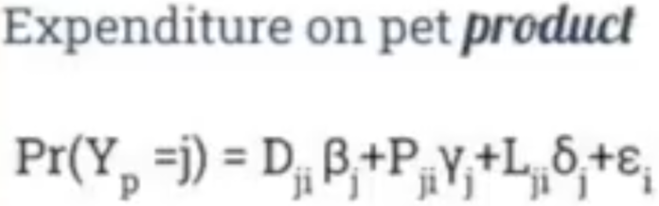
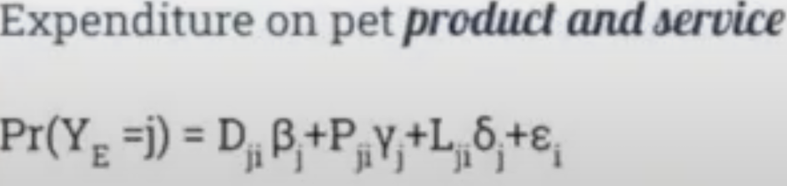

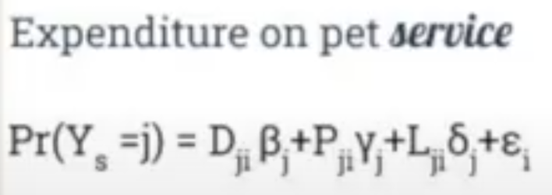

Dji is vector of demographic variable, Pji is vector of pet information variables and Lji is vector of lifestyle variables.
The result of study from ordered probit regression model. Master degree, 5-7 pedigree cats variables are statistically significant at specific expenditure range, indicating that negatively changes the probability on pet product and pet service respectively. Similarly, statistically significant variable of highest of pet of more than 25,000TH is positively and negative change the probability on pet product and service.
From my point of view, this research question is quite interesting since this offers benefit in many aspects. They explore reasons behind the purchases people make with their dogs which related to consumer behavior pattern. We can adapt in daily life to accommodate lifestyle with their pets. Moreover, it’s useful information for pet industry in aspect of marketing. The method adopted to answer research question is appropriate because its consistent with structure of data that used to control for fixed effects and test for measurement effort and correct the bias. And the model is being for prediction which response to intertemporal pattern in demand. Moreover, the variables used in model is appropriate. I’m more likely to agree with the results. With appropriate method, it does make sense with the result that factors influence expenditure on pet product and service of pet owners in Bangkok. In presentation part, chart and information is very clear and easy to read in PowerPoint. So, I am fully understanding on process of collecting data until interpreting the result. The objectives clearly stated. Presentations are beautiful and easy to follow.

