1.1
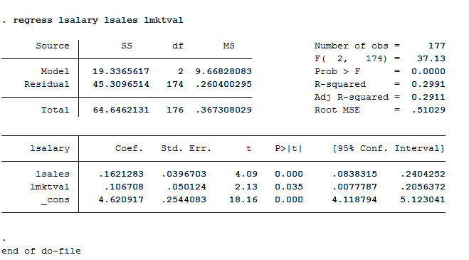
The “constant elasticity variety” means a model that is linear in elasticities. Elasticities are percentage changes.
So a constant elasticity model would be: log(salary) = β0 + β1log(sales) + β2log(mktval) + u.
The estimated model would be: log(salary) = 4.6209 + 0.1621log(sales) + 0.1067log(mktval)
1.2
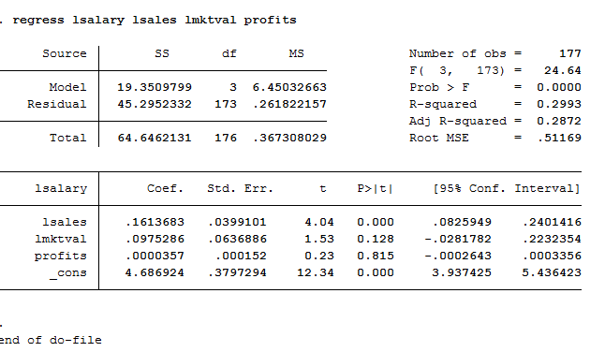

Since profit could be negative in some years and we cannot run log on negative value. Therefore, we don’t use log on profit.
The R-square is 0.2993 meaning that these firm performance variables could poorly explain most of the variation in CEO salaries.

1.3
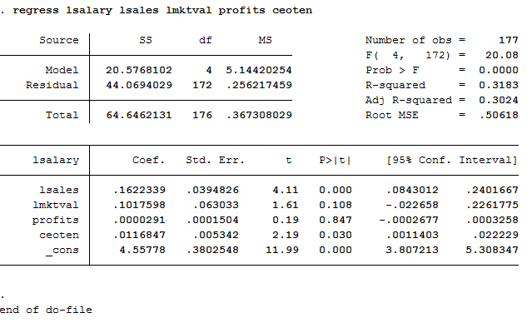
The estimated model is: log(salary) = 4.56 + 0.16log(sales) + 0.10log(mktval) + 0.00prof its + 0.01ceoten
1% is the estimated percentage return for another year of CEO tenure, holding other factors constant.

1.4
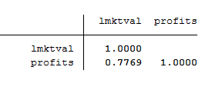
The sample correlation coefficient is 0.7769 log(mktval) and profits are highly correlated. Profits
and the log of market value move together in the positive direction.
2
2.1
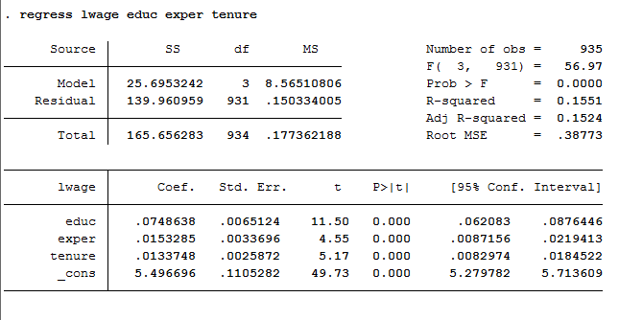
H0: β2- β3=0
Ha: β2- β3 ≠0
2.2
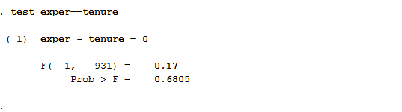
Assuming that using 0.05 level of significant, we accept Ho because p-value is greater than 0.05. So we can conclude that β2 = β3.

3.
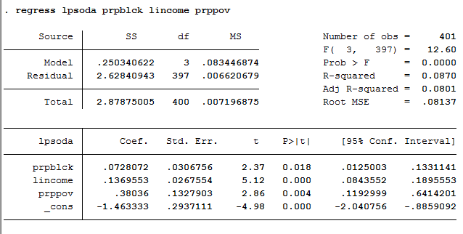
3.1. log(psoda) = -1.4633 + 0.728(prpblck) + 0.1369(income) + 0.3803(prpprov)
At 0.05 level of significant: Since P-value(0.018) of the estimated β1 is less than 0.05, we will reject Ho which means that the estimated β1 is different from 0 at 0.05 level of significant.
At 0.01 level of significant: Since P-value(0.018) of the estimated β1 is greater than 0.01, we will accept Ho which means that the estimated β1 is not different from 0 at 0.01 level of significant.
3.2
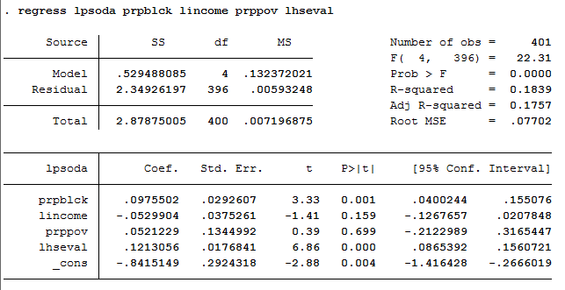

The coefficient of β4 is equal to 0.1213, which means that when the median housing value increases by 1 percent, the price of median soda will increase by 0.1213percent.
The p-value for Ho: βlog(hseval) = 0 is equal to 0.000(2) = 0.000
3.3 i) P-value of B2 increases from 0.00 to 0.159 which is higher than 0.05. So we accept Ho and log(income) is not statistically significant.
P-value of B2 increases from 0.004 to 0.699 which is higher than 0.05. So we accept Ho and prppov is not statistically significant.
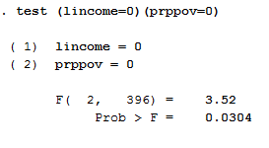
ii) The p-value is equal to 0.0304, which is less than 0.05. So we reject Ho at 0.05 level of significant. We can conclude that the two are jointly significant.

3.4 R-adjusted of the previous regression is less than the one from the later regression after adding log(hseval). (0.0801<0.1757)
We can conclude that this model is more reliable than the previous one without (hseval)
log(psoda) = -0.8415 + 0.0975(prpblck) – 0.529(income) + 0.0521(prpprov) + 0.1213(hseval).

