Latecomers, Flying Geese, and Competitive Advantage
The Prototype of the Latecomer Model
One of the keys to catch-up industrialization for latecomer countries is to go about combining trade policy (including import substitution and export promotion) with phased industrial development. A German economist Friedrich List, who published ‘The National System of Political Economy’, recognized that the principle of relative advantage in free trade would enhance the economic welfare of people in all countries that participated in trade. However, if the structure of the production costs of this economic welfare continued unchanged over a long period, then the international division of labor would become set in stone, condemning late-developers to a position if “universal subjection”.
In order for latecomer countries to develop their economies, a protectionist trade policy based on a system of tariffs is required. List stressed that there is a need for a distinctive economics that treated a nation as its fundamental unit of analysis.
There are 3 distinctive features of catch-up industrialization and developmentalism as follows:
- Justification of government economic intervention
- A theory of economic development that emphasizes manufacturing power
- A stress on nationalistic ideology
The Advantages and Disadvantages of Backwardness
About a century later, List’s concerns were revived by Alexander Gerschenkron, an economic historian, in his hypothesis of “the advantage of backwardness”
There are four key points to this theory of Gerscehnkron’s:
- The ability of latecomers to make use of technologies already developed by earlier developers means that latecomer industrialization often proceeds intermittently. With “great spurts” along the way, rather than by gradual progression. This implies that the more backward a country’s economy, the more likely was its industrialization to start discontinuously as a sudden great spurt proceeding at a relatively high rate of growth of manufacturing output.
- This kind of industrialization increases the weight of the manufacturing sector and demands larger-scale plants and larger enterprises.
- The more backward a country’s economy, the greater was the role of special institution elements designed to increase the supply of capital to nascent and to provide them with less decentralized and better informed entrepreneurial guidance.
- Latecomer industrialization requires “specific industrialization ideologies” or “strong ideological stimulus to industrialization” to mobilize nation toward meeting the goal of industrialization.
But still, there exists two serious errors in Gerschenkron’s work that need to be pointed out:
- Late developers commence industrialization with the most industrially advanced sectors.
- The scale of the “disadvantages of backwardness” and the conditions for overcoming them. There is no guarantee that a latecomer can fully enjoy the “advantage of backwardness”. For latecomers to achieve this, it must meet number of domestic conditions and have a certain level of independent capability in place.
The main mislead of Gerschenkron’s work is that it cannot be used to predict the likelihood of industrialization taking place in developing countries based on the advantages of backwardness and the term of internalizing those advantages can be interpreted in many aspects.
The Flying Geese Pattern and Product Cycle Model
The flying geese pattern theory was first coined by Akamatsu Kaname of Hitotsubashi University in 1962, but the concept was misinterpreted. It was instead being used for catching up in industrialization process in East Asia and NICS. Akamatsu first coined this theory with the use of two contrasting senses: using countries as his basic unit in order to illustrate world economic patterns of heterogenization and homogenization; and second, referring to specific industries in latecomer countries in order to illustrate cycle of importing, via domestic production and exporting to reverse importing.
The flying geese pattern theory is similar to Vernon’s product cycle theory. The product cycle theory was initially formulated as a way of illuminating the economic causes underlying the shift to multinational status and overseas production of US enterprise. From the perspective of latecomers, both theories fail to the trend of industrialization toward international economy.
The Catch-up Industrialization Model
The catch-up industrialization model attempts to explain the pattern of industrialization overtime. The model consists of two key elements: a policy combination of trading promotion and industrial promotion, and the use of imported technologies to accelerate the process of industrial development. The catch-up process can result in 3 different angles.
- A product gradually moves toward higher levels of technological intensity.
- The shifting production cycle of mainstay products for a given industry within a given latecomer country.
- The cycle through which the mainstay export products of a particular late comer country change.
This model indicates the importance to sustained catch-up industrialization of competition among enterprises and among countries.
The Theory of the Competitive Advantage of Nations
Porter developed this theory in order to understand why the US automobile industry cannot compete both in domestic and global market, being outpace by Japanese automobile firms. He described this situation of change as “competitive advantage of nations”. The conditions determining competitive advantage were not just differences in production costs, but also included other factors condition. Porter argued that apart from conditions mentioned above, some countries must suffer “inferiority in selective factors”. Japan and South Korea are a classic example of this type. However, there is one more factor that play an important role beside basic category factors which is constant innovation. Porter developed the interactive system of determinants the “diamond” that supports the dynamics of national advantage.
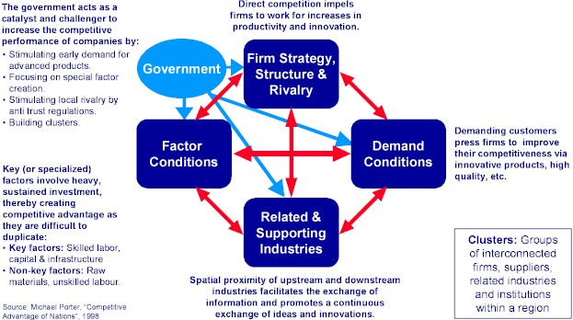
The diamond model also includes 2 other factors outside the whole conceptual framework; role of chance and government policy. Interestingly, Porter did not touch with the importance of individual role skill or other economic environment in the development of new products and technologies. Instead, he focused more on the promotion of innovation through inter-corporate competition and the organizational skills of individual enterprises.

