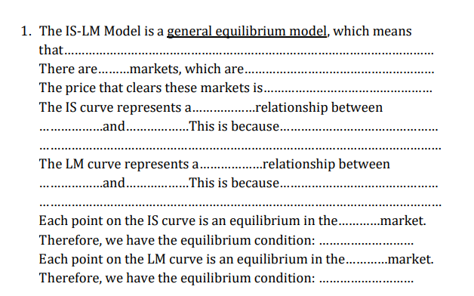
Exercise 6 (IS-LM Model)
Real Ms= Real Md
At higher level of Y (people have more income), people have more demand for money to buy goods and services. Higher demand for money drives up interest rate
Y
i
an equilibrium in Keynesian Cross at each level of interest rate Y=AE/ Y=planned expenditure

positive
Commodity/ goods and services
money market
the investment depends on i, resulting in having low output at high i and high output at low i.
Y
IA
negative
Interest rates
the goods and services market and the money market
2
there exists a common “price” that clears two or more markets.
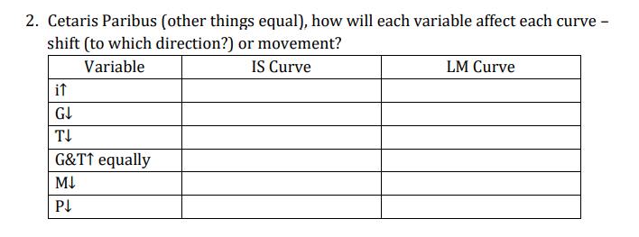
Shift up/ to the left
Shifts down / to the right
Does not shift
Shift left
Shifts right
Moves to the right
Shifts right
Does not shift
Shifts left
Moves to the left
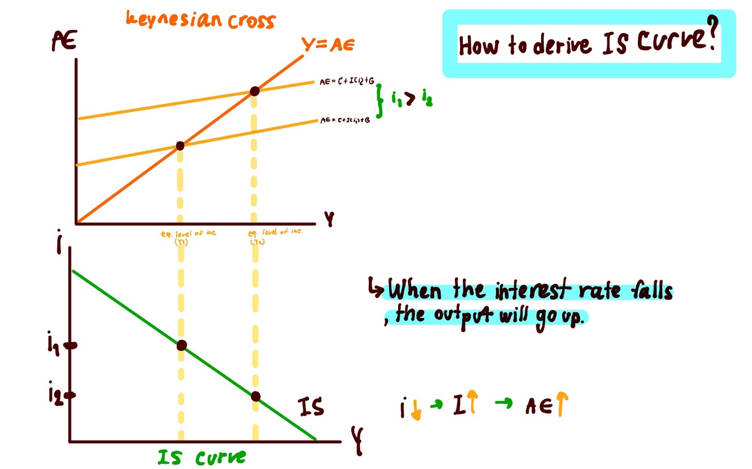
3. Explain, together with diagrams, how we can derive the IS curve from Keynesian Cross, and how we can derive the LM curve from the money market.

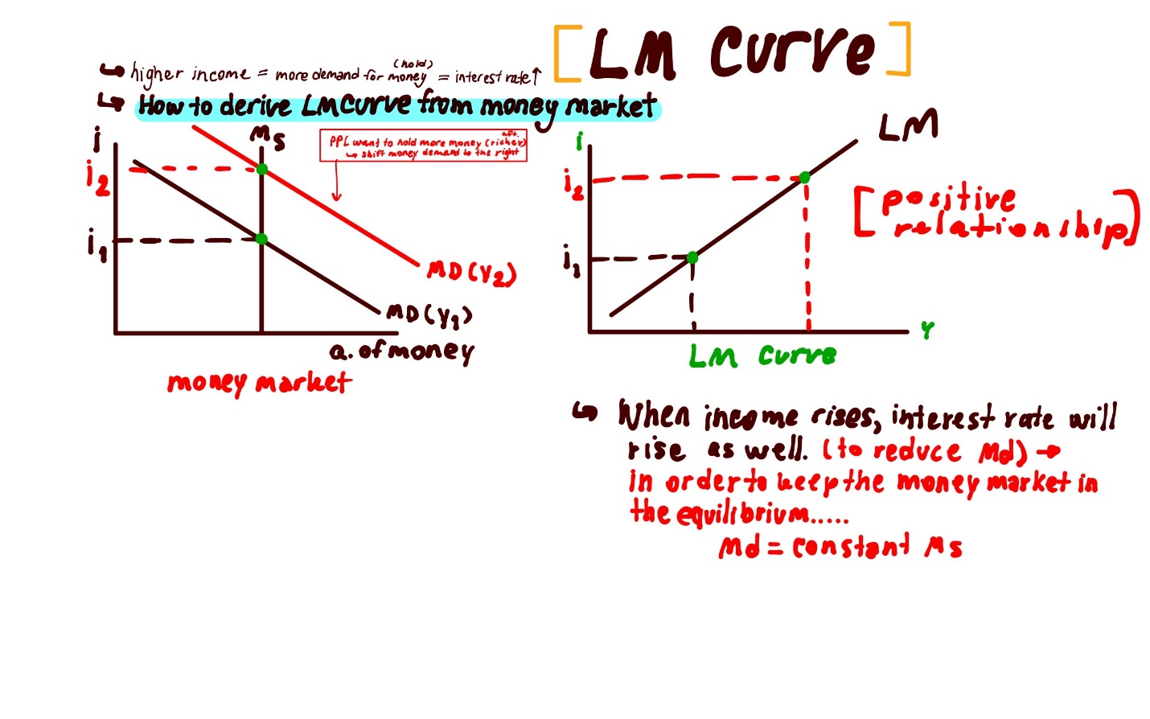

4. Assume a closed economy with the government. The economy has the following
parameters:
C = C0 + C1(Y – T) / I = I0 – I1∙ i / G = G0 / T = T0
L(i, Y) = LY∙ Y – Li∙ i / M = M0 / P = P0
Answer the following questions.
4.1 What are I1, LY, and Li?
L (i, Y) = LY∙ Y – Li∙ i
i = (LY /Li )Y – (1/Li )(M/P)
I = I0 – I1∙ i
- LY denotes the sensitivity of Md to changes in Y
- Li denotes the sensitivity of Md to changes in i.
- – I1 denotes the slope of the investment function, and the
sensitivity of investment to changes in interest rate.
4.2 Why are I1 and Li negative?
Ii is negative because 𝑑𝐼 is over 𝑑𝑖 = −𝐼1, which means that the interest rate increases by 1 unit, investment will decrease by I1 units.
Li is negative because it is determined by the interest rate according to the speculative demand, making the money demand o down when interest rate rises.

4.3 Derive the IS equation that shows how i and Y are related (Hint: Start with the equilibrium condition Y = AE. Then, substitute relevant variables into the expression. Lastly, rearrange i to the LHS and everything else on the RHS.)
Y = AE
Y= C₀+C₁Y-C₁T₀ +I₀-I₁i+G₀
Y- C₁Y= C₀-C₁T₀ +I₀-I₁i+G₀
Y(1-C₁)= C₀-C₁T₀ +I₀-I₁i+G₀
Y = (C₀-C₁T₀ +I₀-I₁i+G₀)/ (1-C₁)

Y= C+I+G
Y= C₀+C₁Y-C₁T₀ +I₀-I₁i+G₀
I₁i = C₀+C₁Y-C₁T₀ +I₀+G₀-Y
i = (C₀+C₁Y-C₁T₀ +I₀+G₀-Y)/ I₁

4.4 Find the slope of the IS curve. (Hint: The coefficient before Y is the slope of IS.)
Y= C+I+G
Y= [C0 + C1(Y – T0)] + [I0 – I1∙ i] + G0
Y= C₀+C₁Y-C₁T₀ +I₀-I₁i+G₀
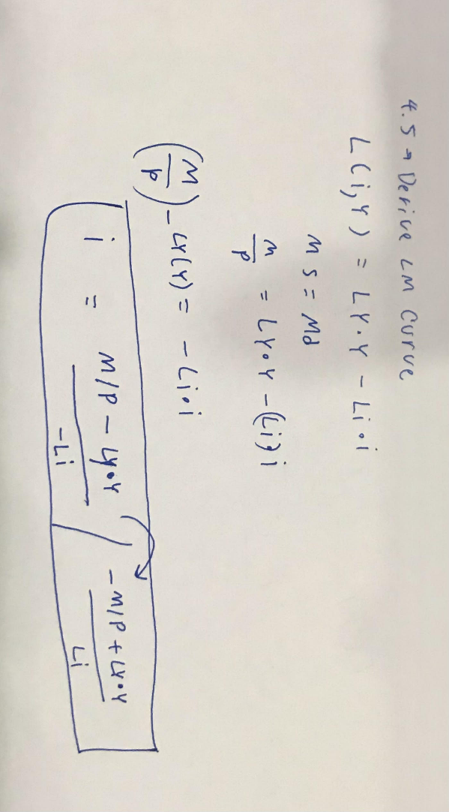
So, C1 is the slope of IS
4.5 Derive the LM equation that shows how i and Y are related. (Hint: Start with the equilibrium condition Md = Ms. Then, substitute relevant variables into the expression. Lastly, rearrange i to the LHS and everything else on the RHS.)

4.6 Find the slope of the LM curve. (Hint: The coefficient before Y is the slope of LM.)
i = (LY /Li )Y – (1/Li )(M/P)
i = (LY /Li )Y – (1/Li )(M0/P0)
(LY /Li ) = [i+(1/Li )(M0/P0)]/Y

5. From Question 4.4, we can see that the slope of IS curve depends on two factors.
Explain how each of these factors affects the slope of the IS curve.
- The slope of IS curve depends on the sensitivity of investment to changes in interest rate, and the multiplier. As mentioned, that, if investment is sensitive to changes in interest rate, then a decrease in interest rate causes a LARGE increase in investment. IS will be flat. If the multiplier is large, then an increase in investment causes a LARGE increase in output. IS will also be flat.
We also can see that the slope of LM curve depends on two factors. Explain how each of these factors affect the slope of the LM curve.
- LY denotes the sensitivity of Md to changes in Y and Li denotes the sensitivity of Md to changes in i
- When Y goes up, the Ly will o up as well. For Li, it depends on the interest rate according to speculative demand therefore it Is negative. So, the slope of the LM curve thus depends on LY and Li.

6. What is the Crowding-Out Effect?
Suppose that the government increases its spending, i.e. expansionary fiscal
policy. Use the IS-LM diagram to explain how the economy moves to the new
general equilibrium and the crowding-out effect.
- Crowding-out Effects when public sector spending (G) reduces or eliminates private sector spending (I). To put in a simple way, when G goes up, people became richer and demand more money, then i goes up, making I goes down.
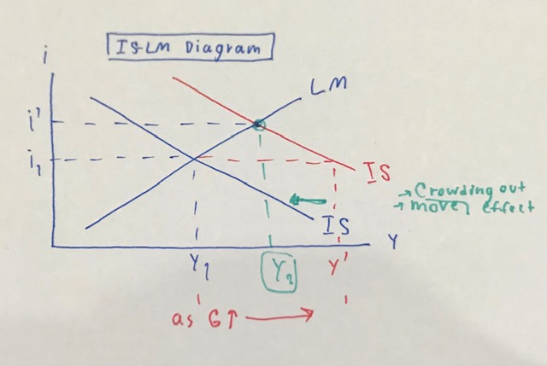
-

7. Suppose the central bank decreases its money supply, i.e. contractionary
monetary policy. Use the IS-LM diagram to explain how the economy moves to
the new general equilibrium.
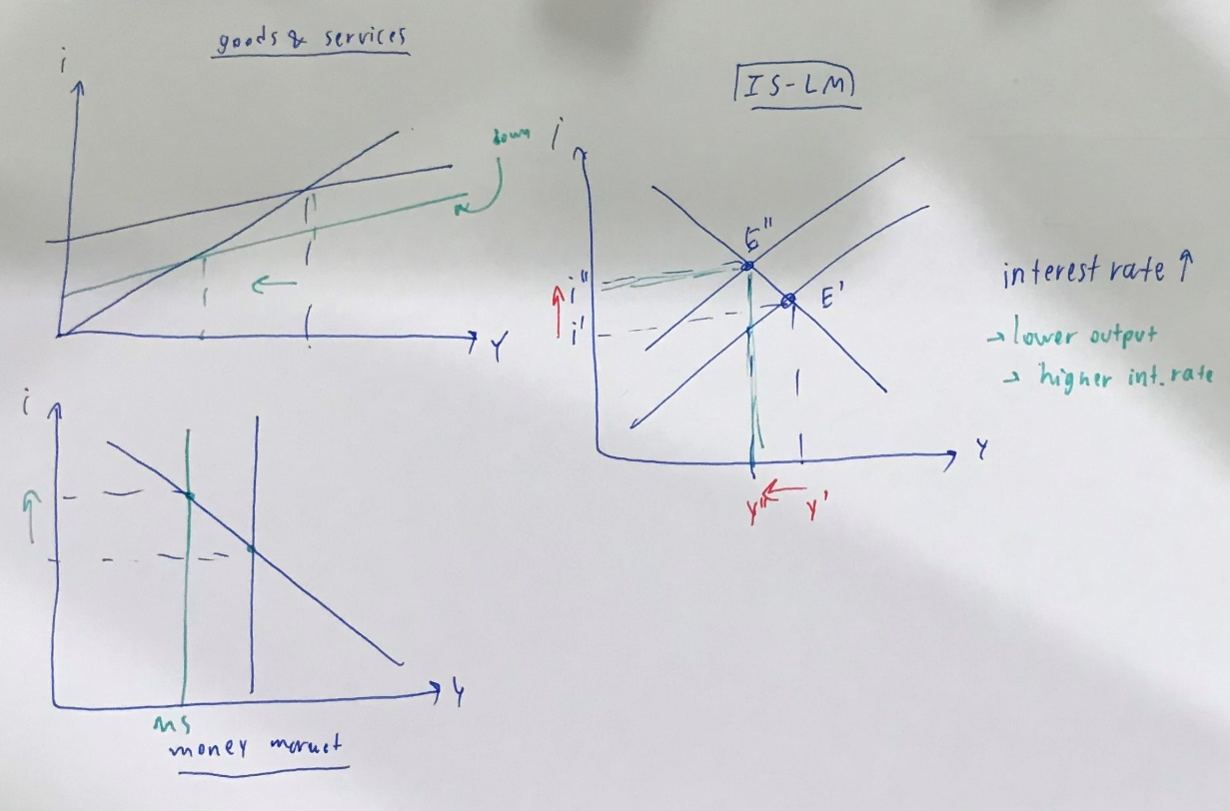
- The decrease in the money supply reduces raises the interest rate (making it more expensive for people to borrow). And the investment falls because the interest rate rises, making the output falls.

8. Use the graph below to answer the following questions.
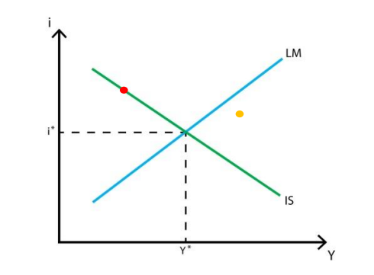
8.1 At the Red point, which market is in equilibrium, and which is not?
At the red point, the commodity or the goods and services market (GM) is in equilibrium, but it is not in the equilibrium of LM curve (money market, MM).

8.2 Explain how the goods and money markets at the Orange point will adjust
towards the general equilibrium (Y*, i*).
- By using the idea of phase diagram, the orange point can adjust towards the general equilibrium through the ongoing process. Starting with the position of the point that is below the LM curve. The interest rate will then rise up to be at the MM. After that, it discourages investment(I), making the output decreases. As Y decreases, the demand for money will also decrease, making interest rate decrease to the MM again. I will o up and make Y rise to M and the process continues.

9. The government is worried about the effectiveness of its policies. You are to
advise which policy – fiscal or monetary – should be used in each of the following
cases.
9.1 Consumers have high MPC.
Monetary policy(IS flat) multiplier large
9.2 Investment is NOT sensitive to changes in interest rate.
Fiscal policy (IS steep)
9.3 Money demand is very sensitive to changes in interest rate.
Monetary policy
9.4 Money demand is very sensitive to changes in income (Y
fiscal policy (LM Flat)

10. Assume a closed economy with the government. The economy has the
following parameters:
C = 100 + 0.5(Yd) I = 80 – 100(i) G = 40 T = 40
L(i, Y) = 0.5(Y) – 200(i) M = 400 P = 2
Answer the following questions.
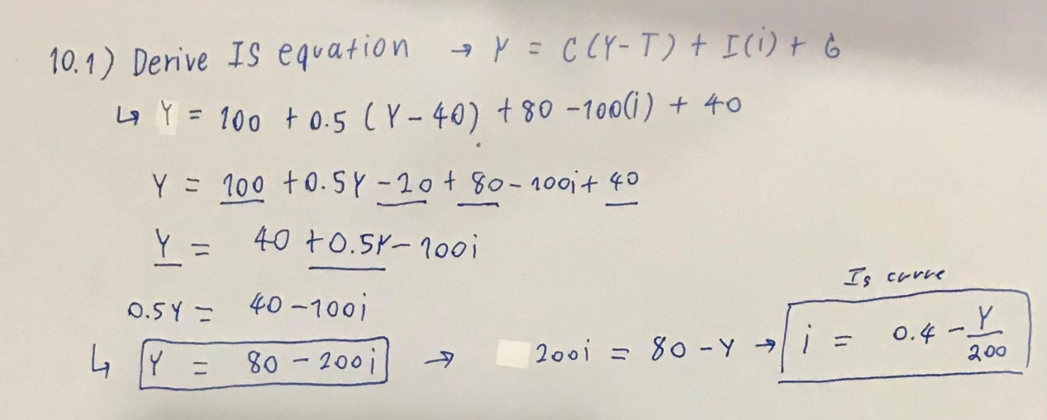
10.1 Derive the IS equation.

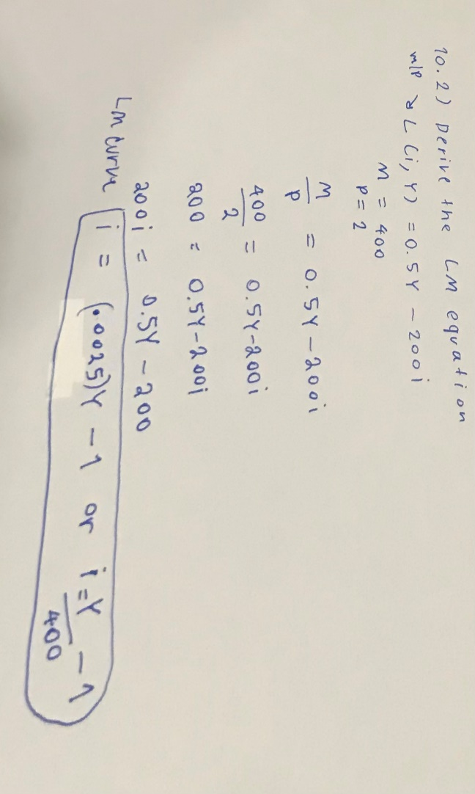
10.2 Derive the LM equation.

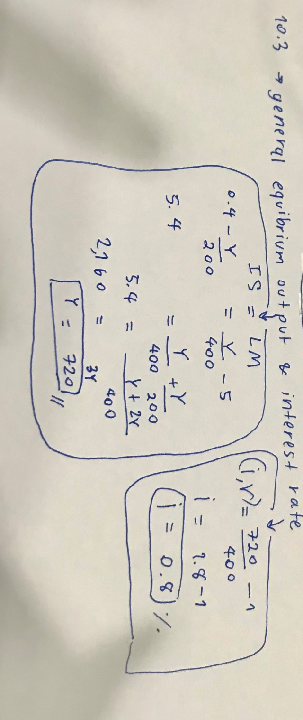

10.3 Find the general equilibrium output and interest rate

