EE461 Assignment 1 : Learning about indicators
• Graph #1 : using cross-sectional data
–Pick 2 variables (one of them is GNI per capita – ppp) related to development indicators available in the latest year (but need to be the same year for all variables & for all available countries).
–Plot a graph (scatter plot) between the other variable with GNIpc (put GNIpc on the X axis).
–Explain what you see from the plotted graph.

• Graph #2 : using time-series data + 3 countries (Panel)
–Pick 1 variable (not the same one as graph#1) related to development indicators for 25 years period.
–Pick 3 countries (one of them has to be Thailand).
–Plot graph for each variable with all 3 countries in the same graph (year is on the X axis).
–Explain what you see from the plotted (line) graphs.

• Data sources could be from World Development Indicators, or UIS-UNESCO
WDI: https://databank.worldbank.org/data/source/world-development-indicators
UIS: http://data.uis.unesco.org/Index.aspx
• Plot graphs using Excel, or Stata, or any statistical program
• Submit your file on Moodle (link of this assignment) by Jan 31

Example :
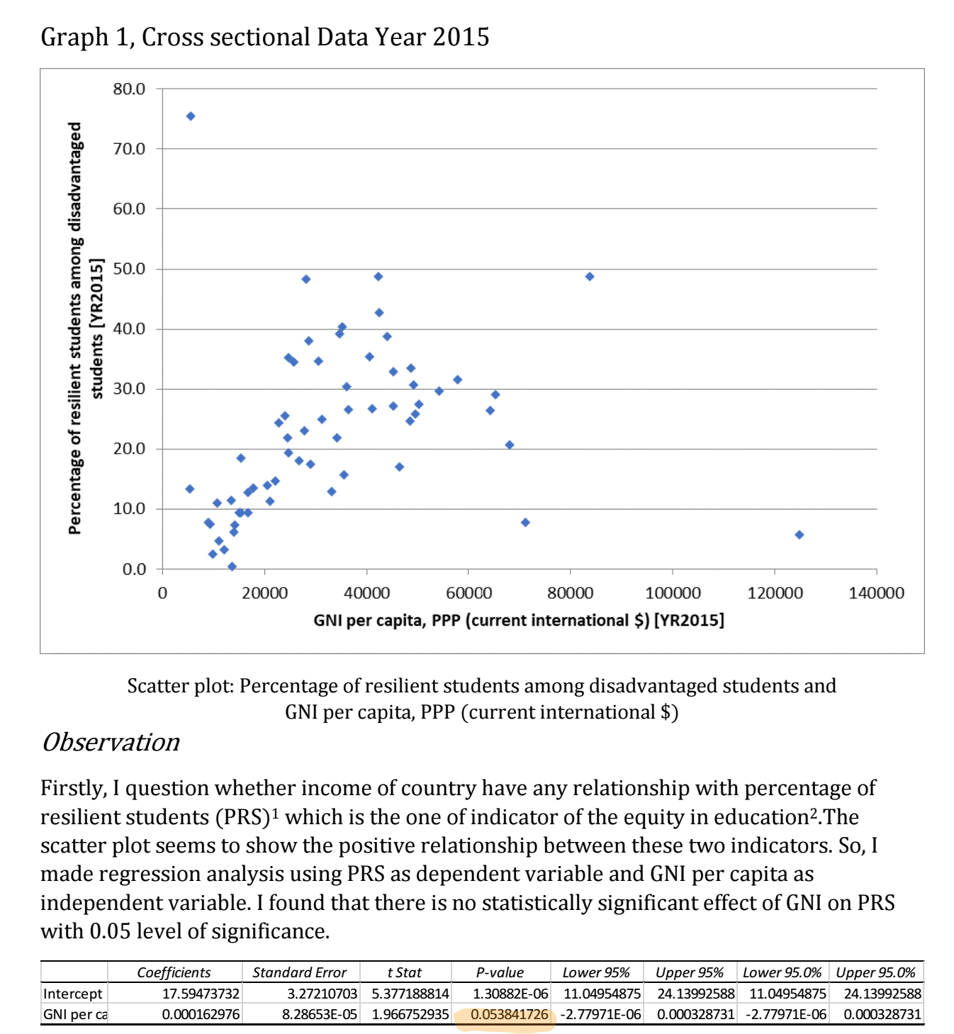

Note: if you use stata to do this, the code is:
regress prs gni
*p-value at 0.0538 could consider to be statistically significant at 0.10 level of significance. (Normally, there are 0.01, 0.05, 0.10 level of significance. The lowest level of acceptable is 0.10)


