The economic downturn
Checking the depth gauge

Which of the big rich economies has fared best and worst during the crisis?
Aug 20th 2011 | from the Economist print edition
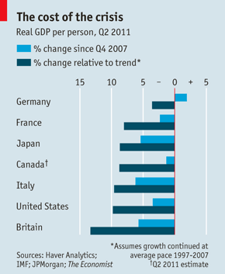
FINANCIAL markets and headline-writers pay a great deal of attention to quarterly GDP growth rates. For example, figures released over the past couple of weeks have shown that growth has slowed sharply in America and Europe in the second quarter, while Japan’s economy has continued to contract. For citizens of the countries themselves, however, the level of output (and hence income) relative to that before the crisis is what really matters, rather than the rate of growth.
If countries are ranked according to the change in real GDP since the end of 2007, Canada tops the league, with output in the second quarter estimated to be almost 3% higher than it was before the crisis. But Canada, like the United States, has a fast-growing population thanks to immigration, whereas the number of Germans and Japanese has started to shrink. GDP per person is therefore a better measure of relative performance.

By this gauge, Canada is still 1% below its pre-crisis level and America is almost 4% down (see chart). Even worse hit are Britain, Italy and Japan, where average income per head was 5-6% below its peak. In contrast, China’s GDP per person rose by an impressive 35% in the same period and India’s was up by 22%. Of the G7 countries only Germany has managed to get back to where it was at the end of 2007, but even there the second-quarter numbers were very disappointing: GDP growth slowed sharply to an annual rate of only 0.5%. (For a fuller ranking of 28 economies, see chart.)
Most economies still have a lot of lost ground to regain, but comparing output now with its level before the crisis understates the true depth of their slump. An alternative yardstick is to compare GDP per person now with what it would have been if it had continued to grow at the same pace as during the ten years before the crisis. On this basis, not even Germany has yet caught up: it is almost 4% below its trend. America’s GDP per person has fallen by 10% relative to trend, but by far the worst hit among the G7 is Britain, with a 13% shortfall. Even that looks mild compared with Ireland, where income per head is now about 25% below its previous (and clearly unsustainable) trend.
If the shortfall in GDP relative to trend in each year since 2007 is totted up, America has suffered a cumulative loss of $4 trillion, equivalent to a stunning $13,000 for each person. Stockmarkets and newspapers will cheer when growth rates eventually pick up, but most of the income that has been lost since the crisis began will never be recouped.

GDP recovery since the recession

Deep freeze
Aug 18th 2011, 15:18 by The Economist online
Which economies have fared best and worst during the global financial crisis?
GDP growth rates slowed sharply in most rich economies in the second quarter. So where does that leave output relative to its level before the start of the financial crisis? If we rank the G7 countries according to the change in real GDP since the end of 2007, Canada tops the league. But Canada, like the United States, has a fast-growing population, whereas the number of Germans and Japanese has started to shrink. GDP per person is therefore a better measure of relative performance. As the chart below shows, by this gauge Canada is still 1% below its pre-crisis level and America is 3.5% down. Among the G7 countries only Germany has regained its end-2007 level. Comparing output now with its level before the crisis actually understates the depth of the slump. An alternative yardstick (see article) is to compare GDP per head now with what might have been expected if it had continued to grow at the same pace as during the ten years before the crisis. On this basis, even Germany has not yet caught up, and Ireland’s income per head is now a painful 25% below its previous trend.


