
University
Thammasat
University

INSURANCE

Prepared for
Chatchai Thisadoldilok
CFA FRM

By group D
FN 281 Personal Finance

April 18, 2017

Nowadays there are many risks such as accident or natural disaster which happen on our world. Most of them we didn’t know when it’s going to happen so it is better if we protect ourselves before it causes damage or loss to our family or assets. Therefore, we should find the way to manage these risks.
Risks is the uncertainty or the things that cannot be predicted easily which it might make people to lose some of the property but it can be covered by insurance. There are many types of risk. Peril is the cause of a possible loss which might be fire, windstorm or death. Hazard is a condition or situation that increase chance of loss in an insured risk which might be driving drunk or the defective house wiring. Pure risk is occurring when the situation that there is a chance to loss or not but there is no chance to gain which Personal, Property, Liability risk are included to this type. Speculative risk is occur when the situation that possibility of either a financial loss and financial gain exist.

There are 4 risk management techniques
- Risk avoidance is a risk treatment that avoids, sidesteps or discontinues the actions that trigger a particular risk.
- Risk reduction is a collection of techniques for eliminating risk exposures. It is typically applied to lower risk probabilities and impacts to suit the risk tolerance of an individual or organization
- Risk assumption is when individual or business firm assumes expected losses that are not catastrophic losses through the purchase of insurance. For example, a business firm assumes the risk of its employees being absent because of minor illness, but buys disability insurance to cover absences due to extended illness. Also refers to (1) situations where insureds place themselves in situations that they realize pose a danger, and (2) the acceptance of risks by an insurance company.
- Risk shifting is the transfer of risk to another party. Risk shifting has many connotations, the most common being the tendency of a company or financial institution facing financial distress to take on excessive risk. Individual and firm can shift their risk by buying an insurance.

Insurance is protection against possible financial loss as long as the policyholder meet certain conditions stipulated in contract and it is the contract between an individual and the insurance company.
An insurance company is a risk sharing firm that have response to the losses from the insured risk. If people purchase an insurance policy, the firm assumes a risk which we called it as premium that the policyholder have to pays the premium periodically.
Choosing insurance can be complicated, Research and knowledge in required when deciding how much insurance to carry or what kind of insurance needed. So we have to plan the insurance program before making a real purchase.
Planning an insurance program is to put the risk management to work and adapt to ourselves .
4 steps of planning personal insurance program
1.Set your insurance goals and prioritize them
2.Develop a plan to reach the goals
3.Put your plan into action
4.Review the results

HOME AND AUTOMOBILE INSURANCE
2 Main types of risks related to a home and an automobile are
- property damage or loss
- your responsibility for injuries or damage to the property of others

Homeowner’s insurance
Homeowner’s insurance is coverage for your place of residence and its associated financial risks, such as damage to personal property and injuries to others.
- Potential property losses is the things that might happen which it makes homeowner to loss from different type of risks. House and other personal belongings are substantial financial commitment. Property owners are facing with two basic risk which are physical damage caused by the hazard which might be fire, wind or smoke. Those things can cause the destruction to our property. The second type is loss of use which due to the robbery.
- Liability protection which in variety most of people judge legally responsible for the bodily injuries or property damages. Liability is legal responsibility for the financial cost of another person losses or injuries. The legal responsibility is commonly caused by the negligence which is the failure to take ordinary or reasonable care such as the failure to supervise the children in the pool. Despite taking a great care, a person is still held the liable in the situation. Strict liability is the present when person is held responsible for intentional or unintentional actions. Vicarious liability occurs when a person is held responsible for the actions of another person.
Homeowner’s insurance coverages
The homeowner policy provides coverages for the house and other structures, additional living expenses, personal property, personal liability and related coverage.
The house and other structures The main component of homeowner insurance is protection against financial loss due to damage to a house or other structures which attached structures are covered for fire and other hazards.
Additional living expense is when there are some accident or event prevents the use of your home, the additional expense coverage pays for the cost of living in temporary location while the residence is being repaired.
Personal property are insured of your household belongings,covered for damage or loss up to a portion of the insured value of the home. Personal property floater that cover the damage or loss of a specific item of high value which a floater requires a detailed description of the item and periodic appraisals to verify the current value. In the event of damage or loss of property, you must be able to prove both ownership and value. A household inventory is a list or other documentation of personal belonging with purchase date and cost information.
Personal liability and related coverages the risk of financial loss due to injuries to others someone should be held the responsible for the costs incurred (e.g. neighbor falls on your property and get injured). The homeowner’s policy protects you from losses resulting from legal action or claim against you or your family members due to damages to the property of others. This coverage includes the cost of legal defense.
An ‘umbrella policy’ or ‘catastrophe personal policy’ : supplements basic personal liability coverage this policy also increase bodily injury and property damage coverage. Medical payment coverage pays the cost of minor accident injuries on the property and the injuries caused by our family member or pets.

Most of the insurance does not cover the losses from floods and earthquakes so the people who live in the area with these two type of natural disaster will need the special coverage (the endorsement or the addition of coverage to the homeowner policy)

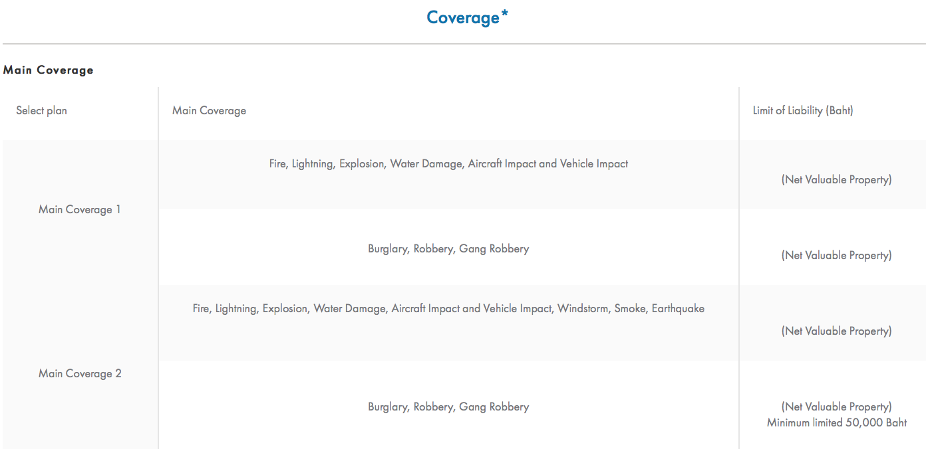
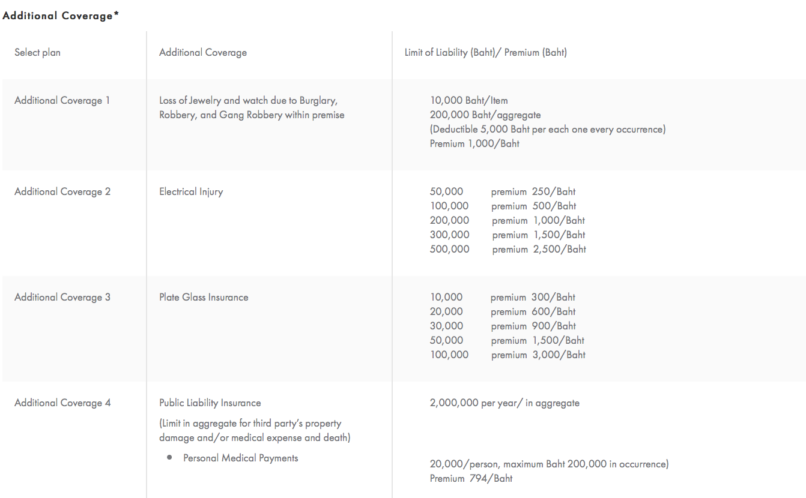
Home insurance policy forms
Home insurance policy forms is the insurance package policies. There are many types of form which are
- special form(HO-3) which is cover all the perils moreover it covers floods, war, earthquake.
- Tenants form(HO-4) that covers personal belongings against the perils.
- Comprehensive Form(HO-5) will expands the coverage of HO-3 to include the endorsement for items such as replacement cost coverage on contents.
- Condominium Form(HO-6) which covers personal belongings and additions to the living unit
- Country Home Form(HO-7) is for nonfarm business rural residents with coverage on agricultural buildings and equipment.
Home Insurance Coverage you need
the insurance coverage needed for your home and property should be based on the amount needed to rebuild or repair the house not the house price.
The insurance company have two base settlement methods which are
‘actual cash value(ACV) method’ that the payment that we received is based on the current replacement cost of a damaged or lost item less depreciation
‘replacement value method’ for settling claims which we will received the full cost of repairing or replacing a damaged or lost item which not consider the depreciation (this method yields 10-20 percent more than the actual cash value).
The factor that affect home insurance cost
Main influences on the premium paid for home and property are
-The location of the home which if filed in an area the insurance rate will be higher,
-Type of structure and the materials influence the cost of insurance coverage such as the brick house will cost less than the wood house.
-The coverage amount and policy type which the policy that we selected depend on the premium we pay.
-The deductible amount is affects the cost of insurance which is if we increase the amount of deductible the premium that we pay will be lower since the company pay us less in claim

Automobile Insurance
Automobile Insurance is an insurance for cars, truck, motorcycle or others road vehicles. It’s primary to use to provide financial protection against the physical damage or bodily injury resulting from an accident or traffic collisions.
Type of auto insurance coverage
There are two main type of auto insurance coverage
- Motor vehicle bodily injury coverages
can be separated to Bodily Injury Liability which covers the risk of financial loss that due to the legal expense, medical expense and other expense that associated with the injuries which caused by an accident. Medical Payment Coverage covers the cost of health care for the people that injured your automobile. Uninsured Motorist Protection which pays the cost of injuries to us which if you vehicle is hit by a person who is not has an insurance but it doesn’t cover the property damages. No-Fault Insurance is the system that intended to provide fast and smooth methods of paying for damage without taking the legal action.

- Motor vehicle property damage coverages.
separated into many types that are Property Damage Liability which it covers the damage to others person car when we are fault or make them to be in an accident. Collision is when our car is in an accident, collision coverage pays for damage to your automobile which not depend on who is at fault. If we are not fault, the insurer will try to collect from the person who property damage liability first and the coverage is limited to the actual cash value of the vehicle. Comprehensive Physical Damage is to covers the damage to the vehicle that is not caused by a collision which can be fire, windstorm or glass breakage.

There are also some other automobile insurance coverages which is Wage Loss Insurance that reimburse for any salary or income that loss due to the injury when there is an automobile accident. Towing and Emergency Road Service which pays for the breakdowns and the mechanical assistance.

The Automobile insurance premium factors depend on Automobile type which it can be separate to the year that you buy or the model of the car also the Rating Territory is depend on the vandalism rates in the area that you own the car. The Driver Classification are also the one factor which it depend on the age, sex, driving record or other personal things that assigned risk pool for the people who are unable to obtain the insurance.
Reducing Automobile Insurance Premium is the method that for lowering automobile insurance costs include comparing companies and taking advantage of commonly offered discounts. Comparing company which rates and service vary among automobile insurance companies. Premium discounts which the best way to keep your rates down is to establish and maintain a safe driving record. Taking steps to avoid accident and traffic violation will mean the lower automobile insurance premium. installing some security device such as fuel shutoff switch or alarm system will decrease the chance of theft and moreover it will reduce the insurance cost.

Auto insurance in Thailand
In Thailand, every vehicle owner is required to at least buy Compulsory Motor Insurance (CMI) , the government insurance and is a minimum requirement for owning a car. Covering life and injury of driver, passengers and third party. The cover however is very basic and if you do have an accident then be prepared to pay. Worse still if you are involved in a serious accident then you could well end up in jail as there is no bail bond to this insurance.

CMI Coverage is fairly limited and may not fully protect you. CMI is available to buy at the local Department of Land Transport Office (DLT), or from car insurance companies and from brokers, including online (such as at DirectAsia.co.th).
Additional Voluntary Motor Insurances in order to enjoy greater protection however it comes with a higher premium
1st Class: Comprehensive - Comprehensively covering the vehicle insured, life and injury of driver, passengers and third party property damage and liability.

2nd Class: Third Party Liability with Fire and Theft - Covering life and injury of driver, passengers and third party property damage and liability. PLUS a 200,000 Baht Bail Bond as well as theft and fire damage.

3rd Class: Third Party Liability - Covering life and injury of driver, passengers and third party property damage and liability. PLUS, a 200,000 Baht Bail Bond.

Step to do when accident occur
- Call the insurance company’s emergency number immediately. A good insurer will send someone within 20-30 minutes.
- Don’t admit any liability.
- Remain calm.
- If you are arrested, remain calm.
- Again preparation is important. Make sure you have copies of your policy documents in your car, along with your driving license and copy of your passport. Keep the insurers emergency number at hand.
- Check that your insurer has a 24-hour emergency number manned by ENGLISH speaking staff. It’s no good having insurance if you can’t get them to understand where you are or what happened.
The conditions to reduce premium
• Choose named drivers. Choosing any driver is more expensive.
• Offer to pay a deductible. i.e. you pay the first 3,000-5,000.
• Check the levels for medical etc. (sometimes these are too high).
• Don’t have accidents and get ‘no claims’ bonus.
• Review your policy annually.
Moreover, automobile insurance is also a part of personal finance. People should choose the insurance that fit with their lifestyle for example, people who has high risk of having car accident such as the truck driver since they have to drive long distance everyday should buy the first class insurance. With the automobile insurance, people do not have to worry about the expense when the accident occur.

HEALTH AND DISABILITY INCOME INSURANCE
Health insurance
Health insurance is a form of protection to alleviate the financial burdens individuals suffer from illness or injury. Health insurance includes both medical expense insurance and disability income insurance. They can be separate to group health insurance and individual health insurance. Group health insurance are mostly sponsored by the employer and often pays part most of their cost. Group health insurance is comprising about 90 percent of all health insurance that is issued by health life insurance companies. The individual health insurance covers either one person or a family. If the kind of health insurance you need is not available through a group.

Supplement is considering the health insurance benefits your employer sponsored plan provides for family members. Most of the group policy contract have a coordination of benefits provision. The COB is a method of integrating the benefit payable under more than one health insurance plan so it will be the benefit received from all source are limited 100 percent of allowable medical expense.

Type of Medical coverage
Type of Medical coverage can be separated into many type. Hospital expense insurance pays part or the full amount of hospital bills for room or other charges. Surgical expense insurance pays part or the full amount of the surgeon’s fees for an operation. Physical expense insurance helps pays for physician’s care that does not involve surgery and it does not include surgery. Major medical expense insurance protects against the large expense of a serious injury or a long illness. One of these features is a deductible provision that required the policyholder to pay a basic amount before the policy benefit begin. The other feature is ‘coinsurance provision’ that required the policyholder to share expense beyond the deductible amount. Hospital indemnity policies pays benefits only when you are hospitalized which we pay the fixed amount that is suitable to high risk group. Dental expense insurance provide reimbursement for the expense of dental service and supplies and encourage preventive dental care. Vision care insurance depend on recent development in health insurance coverage.
Major provision in a health insurance policy
Eligibility is defined who is entitled to benefit under policy which varies with age, marital status and dependency.
Assigned benefit is when the insurance pays your doctor or hospital directly which will be pay from the company.
Internal limits is a policy that with the internal limits will pay only a fixed amount for your hospital room no matter what the actual rate is.
Copayment is a type of cost sharing which most major medical plans define copayment as the amount the patient must pay for medical services after the deductible has been met.
Service benefit are expressed in term of entitlement to receive specific hospital or medical care.
Benefit limits is the maximum benefit possible or minimum payment that depend on number of days in hospital
Health insurance tradeoff is the benefit policies differ, the difference can have a significant can impact on your premiums
Reimbursement versus indemnity which provide benefit based on the actual expense you incur while an indemnity policy provides specified benefits, regardless of whether the actual expense are greater or less than the benefit
Internal limits versus aggregate limit stipulate maximum benefit for specific expense such as the maximum reimbursement for daily hospital room Other policies may limit only the total amount of coverage
Deductibles and coinsurance is the cost of a health insurance policy can be greatly affected by the size of the deductible
Out of pocket limit is a policy that limits the total of the coinsurance and deductibles you must pay will limit or eliminate your financial risk but also increase the premium
Benefit based on reasonable and customary charges is a policy that reasonable and customary medical expense limit reimbursement to the usual charged of medical providers in an area
Private insurance company is the company that sell the health insurance through either group or individual policies. The policies insurance companies sell health insurance policies to employers who in turn offer them as fringe benefits to employees and employers dependents. The premium may be partially paid by employers.
HMO is the health insurance plan that directly employs or contract with selected physician, dentist and others to provide health care services in exchange for a fixed or prepaid monthly premium. HMOs operate on the premise that maintaining health through preventive care will minimize future medical problems. They focus on prevention and wellness with the basic and supplemental services.
Preferred provider organization(PPO) is a group of doctors and hospital that agree to provide health care at rates approved by the insurer and the PPO expect prompt payment and opportunity to serve an increased volume of patient. the premium of PPO is higher than the HMO and if we are not PPO provider we have to pay more premium.
Government health care is the federal and state government offer health coverage in according with laws that define the premiums and benefits they can offer. Specific requirement as to age, occupation and family income may be used to determined eligibility for coverage. Two sources of government health insurance are Medicare and Medicaid.
Medicare is the federal program for those age 65 and older, and certain disabled persons. Originally Medicare had two parts: hospital insurance (Part A) and medical insurance (Part B)
Medicare hospital insurance (Part A) helps pay for inpatient hospital care which pays for all covered services for inpatient hospital care after pay the single annual deductible which cover hospital cost including doctor cost
Medicare medical insurance (Part B) helps pay for doctor’s service and a variety of other medical services and supplies not covered by hospital insurance. Each year will meet the annual medical insurance deductible, medical insurance will pay 80 percent of the approved charges for the covered services that you received the rest of the year.
Medicare advantage program (Part C) is a new plan may be less expensive than the original Medicare and offers extra benefit which the plan is run by private health care providers.
Medicare Prescription Drug benefit (Part D) help to cover some prescription medicine costs. People with limited incomes may qualify for extra help with prescription drug cost.
Medicaid is the federal program of medical assistance to certain low- income individuals and families

Health insurance in Thailand
Health insurance service in Thailand which is delivered by the public sector is called Universal Healthcare system (since 2006), it is the healthcare and financial protection to all its citizens. Health insurance service is provided through three programs:
- The civil service welfare system for civil servants and their families
- Social Security for private employees
- The Universal Coverage Scheme (UCS) is only one public health protection scheme, which provides health care coverage to all Thai citizens who are not covered by any other public health protection scheme. People joining the scheme receive a gold card which allows them to access services in their health district, and, if necessary, be referred for specialist treatment elsewhere. Now a day there are about 50 million people were registered under the scheme
According to the World Health Organization (WHO), 65% of Thailand’s health care expenditure in 2004 came from the government, while 35% was from private sources.

Disability Income Insurance
Disability Income Insurance provides regular cash income lost by employees as the result of an accident or illness. Disability income insurance is probably the most neglected form if available insurance protection. Good disability plans pay when you are unable to work at your regular jobs also make partial disability payments when you return to work on part time basis.

Disability trade-off:
Waiting or elimination period is the benefit don’t begin on the first day you become disabled. Usually there is waiting or elimination period of between 30 and 90 days. Some waiting periods may be as long as 180 days. Generally, disability income policies with longer waiting periods have lower premium.
Duration of benefits has the maximum time a disability income policy will pay benefit may be a few years to age 65 or for life. You should seek a policy benefit for life.
Amount of benefit which you should aim for a benefit amount that, when added to your other income will equal 60 to 70 percent of your gross pay.
Accident and sickness coverage consider both accident and sickness coverage. Some disability income policy will pay only for accident but we want to be insured for illness.
Guaranteed renewability is for no cancelable and guaranteed renewable coverage. The premium for these coverages is higher but the coverage are well worth the extra cost.

Sources of disability:
Employer provide disability income protection for their employees through group insurance plans. group disability plan may be short term or long term protection so the employer is the one who pays the cost of the plan
Social security which this program your benefit will depends by your salary and years you have been covered by the Social security. Covers total disability that last more than twelve months or more.
Worker’s compensation is when you have some accident or illness occurred at work, then you could be entitled to worker’s compensation benefits.

LIFE INSURANCE
Life insurance
Life insurance is a purchase policy that insurance company promises to pay a lump sum at the time of the policyholder death or sometimes while they are still alive. Life insurance is being purchased for provide your death benefit to someone, to cover medical expense and funeral costs, save money for retirement, education for children and paying off debt
The ways to estimating your life insurance are
- Easy method = 70 percent of your salary for 7 years
- DINK or Dual Income No Kids = Half of debts + Funeral expense
- Non-working spouse method = (number of years until the youngest child reaches 18) X 10,000 dollars
- Family Need Method = Consider employer provided insurance, Social security benefits, and income and assets.
- Online Calculator
Types of Life Insurance Companies
- Stock Life Insurance Companies (76%) which there are selling non-participating policies (NO DIVIDEND)
- Mutual Life Insurance Companies (24%) that selling both non-participating and participating policies and the premiums are higher and the premium or policy dividend are refunded to policyholder annually
Types of Life Insurance Policies
- Term life insurance which provide death benefits for a limited period of time but If you stop paying premium, coverage stops and they are low outlay. So you can purchase a larger amount of coverage for a lower premium, cover short term death, premium increases with age, there are no policy dividend, no maturity benefit and tax benefit
- Whole life Insurance (Straight life) is provide death benefits over person’s entire lifetime which an amount of premium depends on your age at the day you purchase the policy. In this type of insurance is the long term investment, pay premium as long as you alive, cover all ages until 99, help your financial discipline, cash value accumulation and usually no cash value for at least 3 to 5 years also there is tax benefit
- Limited payment policy which have to pay premiums for a stipulated period, usually 20 or 30 years, or until you reach a specified age (65) and your policy becomes PAID UP and you remain insured for life
- Variable life policy has minimum death benefit guaranteed, but the death benefit can be greater than the minimum depending on earnings of the dollars invested in a separate stock or bond fund. Also this policy not have downside protection and risk comes to not only the policyholder but also the beneficiary
- Adjustable life policy is a policy that whole life insurance policy, but you can change your policy as your needs change. You can change your premium payments to increase or decrease coverage and also it can adjust the premium you pay which the death benefit will change according to premium
- Universal Life is similar to the variable life policy but guarantee the return on investment on mutual fund and the cash benefit can be changed due to the interest rate risk. The premium can be change due to the interest rate risk which has more flexible- Give you more direct control
- Unit Linked Insurance Plan (ULIP) is a product offered by insurance companies that, unlike a pure insurance policy, gives investors both insurance and investment under a single integrated plan. Which the premium towards mortality charges i.e. providing life cover. The remaining portion gets invested funds of policyholder's choice. Invested funds continue to earn market linked returns. The policyholders can make use of features such as top-up facilities, switching between various funds during the tenure of the policy, reduce or increase the level of protection, options to surrender, additional riders to enhance coverage and returns as well as tax benefits which the example in Thailand is TMB Wealthy Link
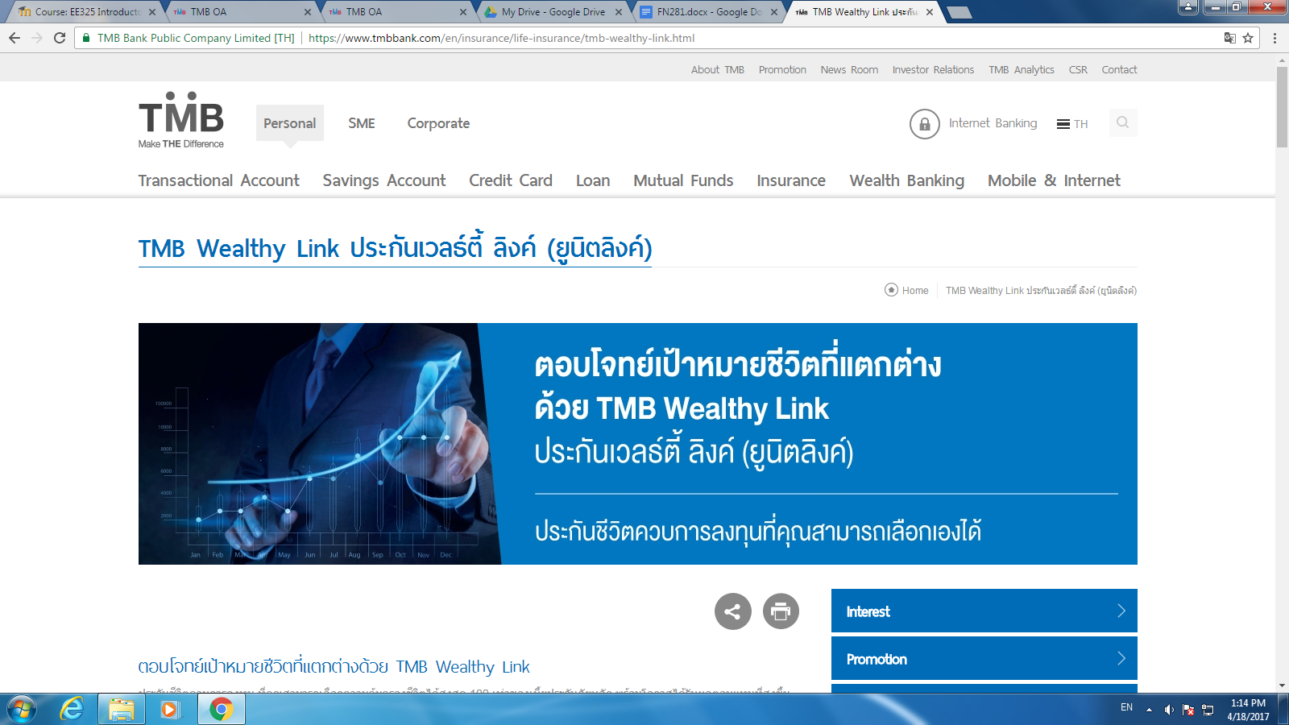
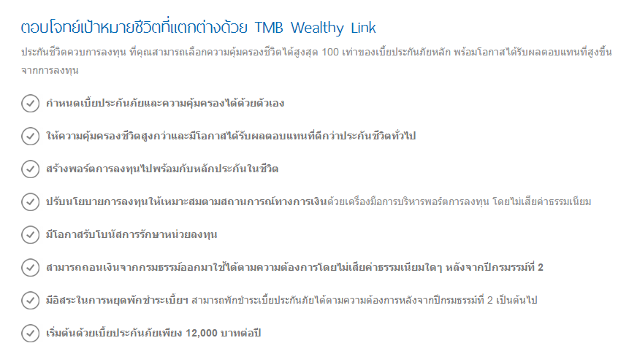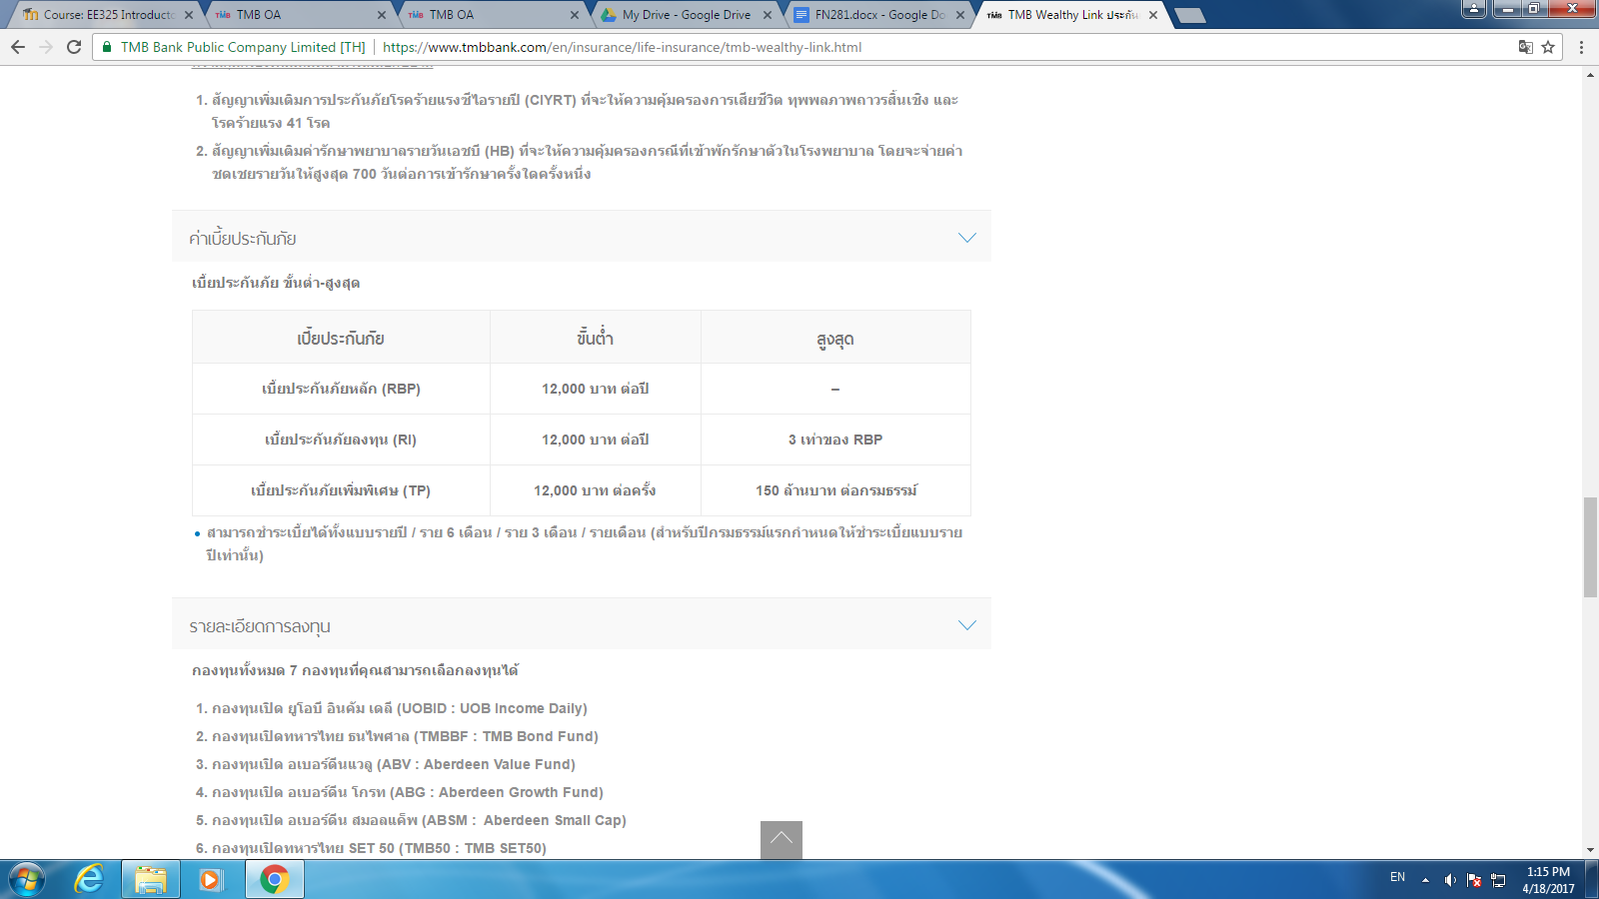

- Other type
Group insurance : protected in group of people
Endowment life insurance: provide the maturity benefit and death benefit.
Credit life insurance: pay off debt if death

Insurance and personal finance
Buying and insurance help us to able to control expenses because we will know exactly how much we have to play each month or each year so we can control our budget regardless to how big is the risk
for example, if today you sick and have to stay in the hospital for 1 night
- with full coverage insurance, you do not need to pay anything which means your expense equal to zero (no different between sick or not sick)
- without insurance, you are responsible for all the hospital and medical expenses which can cost up to 10,000 baht

Some type of insurance can help stable your financial cash flow, such as Disability Income Insurance which provides regular cash income lost by employees as the result of an accident or illness. Imagine you fall from the stair, and broke your arms you will be disable from work for a while. With the insurance, the coverage also covers the income that you lose while you injured. It provides you the money as regular income that you used to get and help insure from having financial difficulty.

In sum, Insurance plays a big role in personal finance. There are many risks in everyday as well as the uncertainty that you will lose money or personal properties, in order to make these risks and uncertainty predictable or insurable, buying insurance is worth to invest. It insures exact expenses that you need to pay as a premium or price of insurance but you can have a peace of mind that these expenses are limited at that cost. Without insurance, if something occurs, the expenses you have to pay may exceed your ability and there is a change the you go bankrupt or even end up in jail. Having insurance is insured both your financial and your life.

References : http://www.investopedia.com/terms/a/auto-insurance.asp
https://www.aainsure.net/insurance_faqs_thailand.html
http://www.investopedia.com/university/insurance/insurance1.asp
http://www.businessdictionary.com/definition/hazard.html
http://www.businessdictionary.com/definition/speculative-risk.html
http://www.businessdictionary.com/definition/pure-risk.html
http://www.investopedia.com/terms/r/risk-shifting.asp#ixzz4eOXhz4W8
http://www.businessdictionary.com/definition/risk-assumption.html
http://data.worldbank.org/indicator/SH.XPD.TOTL.ZS?locations=TH
http://www.webmd.com/health-insurance/tc/understanding-health-insurance-types-of-health-insurance#2
http://www.rmiia.org/homeowners/Walking_Through_Your_Policy/Homeowners_Insurance_basics.asp
https://us.axa.com/axa-products/life-insurance/articles/your-financial-plan.html
https://www.slideshare.net/VirajMahida/health-insurence-thailand-portfoliohealthpptx

