H5N1 and Economic Impacts
EE406

Group member
Natvara leyavanit 6204640228
Pattararutai lovichit 6204640533
Yanisa Niamson 6204640681
Tinn tanyawangrat 6204641721

Table of Contents

Abstract 3
Introduction 4-8
Economic Impact 9-11
Overview of 2003 11
Overview of 2004 12
Overview of 2005 12
Overview of 2006 13
Overview of 2007 13-14
Overview from 2017 to 2020 14-17
Policy Responses 17
Producer Side 17-18
Export Sector 18-19
Comparison between Thailand and other countries 19-21
Summary and discussion 22
References 23-25
Appendices 26-30

Abstract

Purpose: The purpose of this paper is to investigate Thailand’s economy during the H5N1 or Bird Flu outbreak. The poultry sector is considered a very important segment and plays a significant role in Thai’s economy because the poultry sector occupied more than 5o percent of Thailand’s meat and feed production. As H5N1 once became a serious problem in Thailand, this study is designed to investigate how the virus has affected Thailand’s economy and also politics.

Design/methodology/approach: Reading the published report and data are used to collect the data for this study. A published report and data were already created by the related and responsible organizations or those who were affected by the outbreak situation. There was no third party research group contracted to recruit subjects for this study.

Finding: This study provides a background of the virus, the impacts from the virus, and policies responded to the situation.

Introduction

Poultry export is one of the main economic sectors in Thailand, over the past forty years Thailand’s poultry sector has transformed itself from backyard farming into a leading poultry exporter, One of the main factors for its success is the fact that poultry is the cheapest source of animal protein with a relatively short lifetime, thereby minimizing costs. Back in 2015, the poultry sector occupied more than 50 percents of Thailand’s meat and feed production, ranking number four in Asia’s poultry meat production with a total of almost 1.8 million tons in 2015 and increasing due to potential growth in export demand and an anticipated increase in chicken production capacity

As the poultry sector is playing a significant role in Thai’s economy, any cause that is able to create a negative impact on the poultry market will ultimately bring the economy into negative shock. One of the events that create a negative impact is H5N1 which is also called “Bird flu”.

Back in time around 2000, Thailand was the fourth poultry exporter in the world with 7 to 12 percent in volume and trade. But during the outbreak in 2004, Thailand had an economy with a considerable poultry industry, the impact of Bird Flu has been around 1.5 percent of GDP.

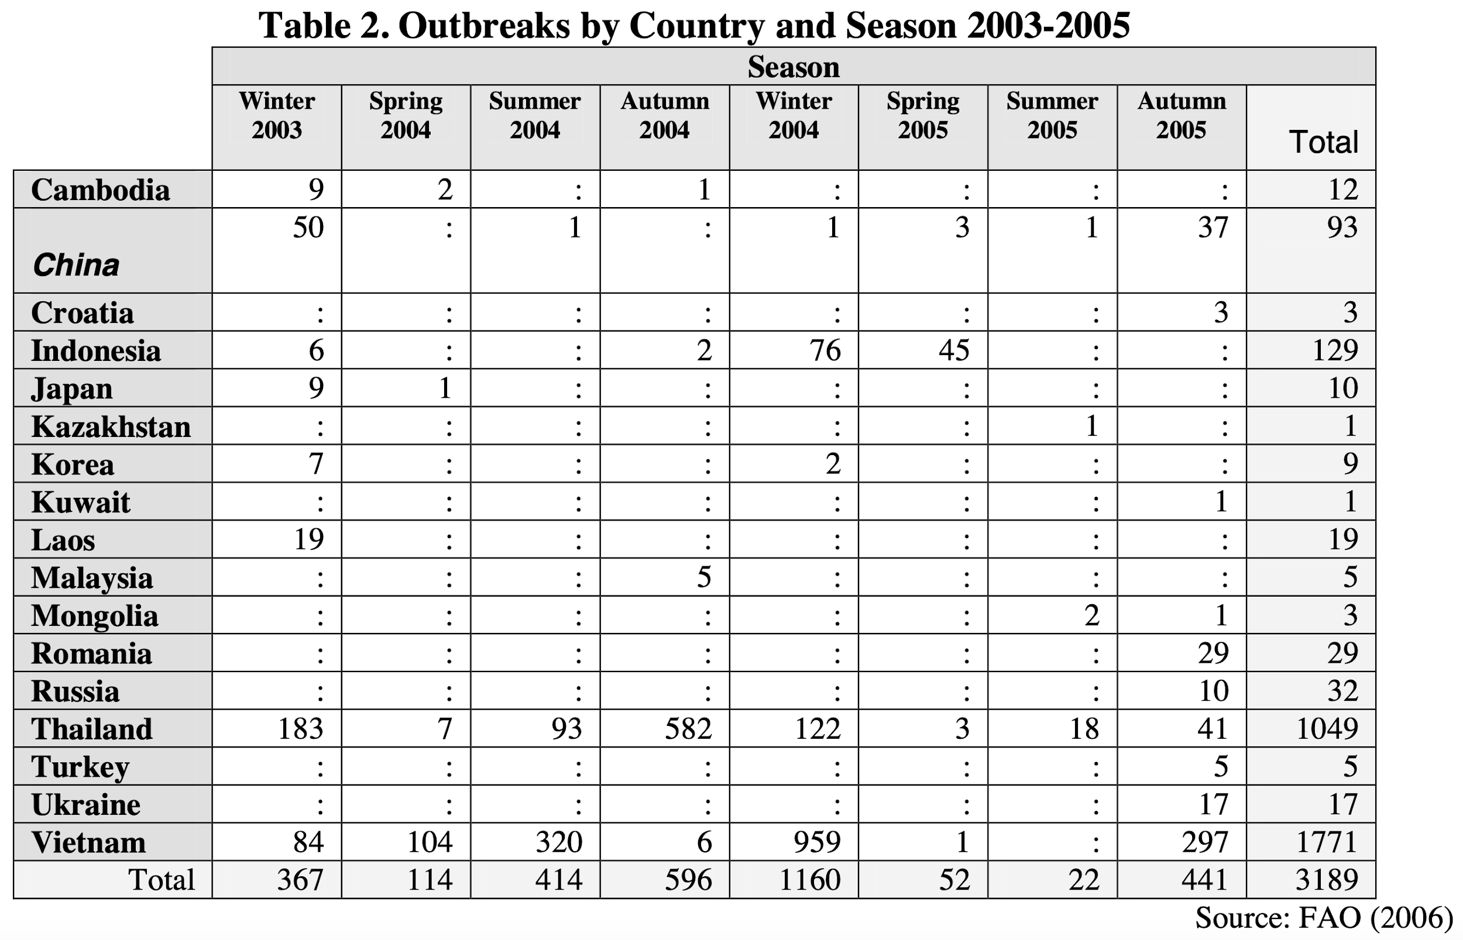

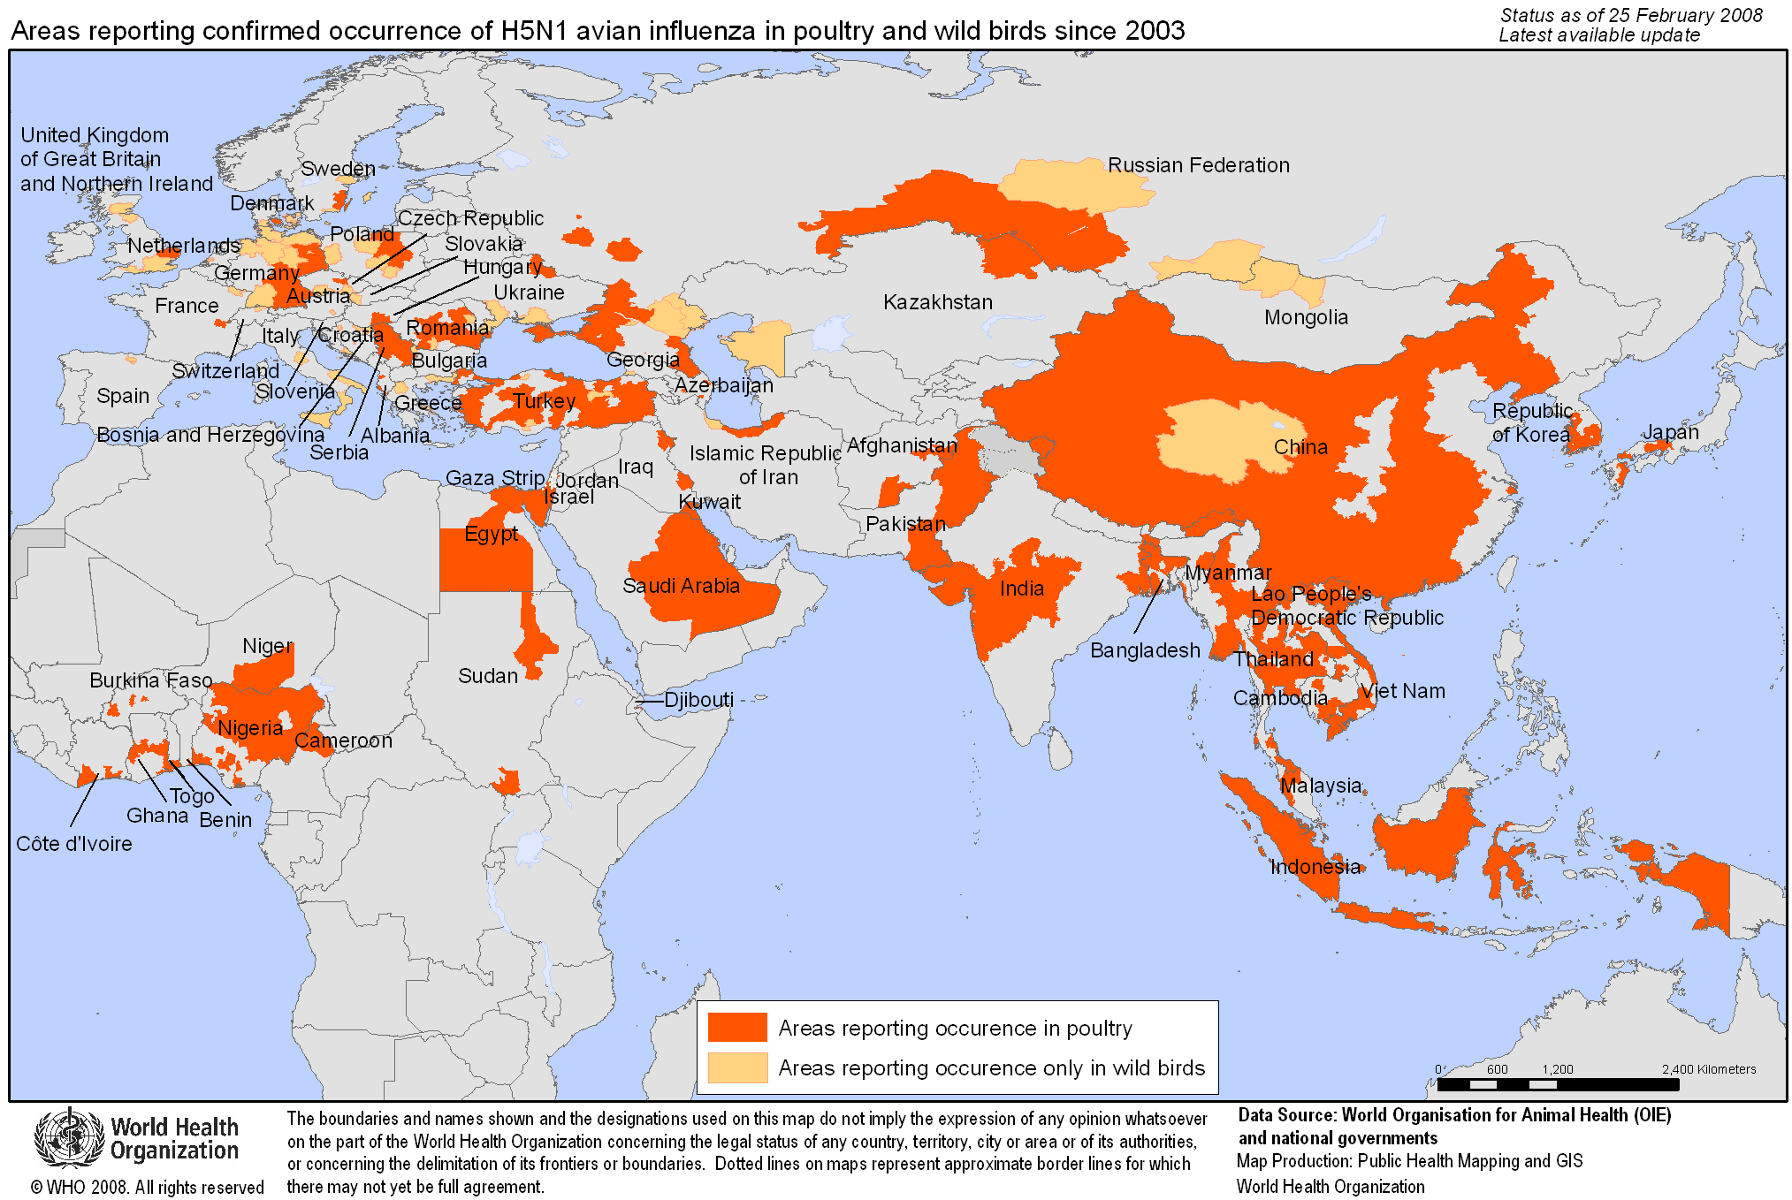

Asian highly pathogenic avian influenza (HPAI)A (H5N1) also called “bird flu” is the type of influenza virus that causes an exceedingly infectious, severe respiratory disease. The virus occurs mostly in poultry and is greatly catching and transmissible among them. H5N1 is significantly deadly for avians. In China, the virus was first detected in 1996 in geese. Asian H5N1 was first detected in humans in 1997 during an avian outbreak in Hong Kong and has since been detected in poultry and wild birds in over 50 countries around the world in Africa, Asia, Europe, and the Middle East; consequently, six countries including Bangladesh, China, Egypt, India, Indonesia, and Vietnam are considered to be indigenous or Asian HPAI H5N1 virus in avian.

Domesticated birds which include, for example, chickens, turkeys, and ducks may become infected with avian influenza A viruses through direct contact with infected waterfowl or other infected poultry and through contact with surfaces that have been contaminated with the viruses. Infection of poultry with Low Pathogenic Avian Influenza(LPAI) viruses may cause either no disease or mild illness; in addition, the virus may only cause mild signs (such as ruffled feathers and a drop in egg production) and may not be detected. Infection of poultry with HPAI viruses can cause severe disease with a high mortality rate. Both HPAI and LPAI viruses can spread exponentially and rapidly through groups of poultry. HPAI virus infection in poultry can cause disease that affects multiple internal organs; as a result, the fatality rate is up to around 90%, often within 48 hours; moreover, some poultry can be infected without any signs of illness.

Most the H5N1 cases that infection in people all around the world has been significantly associated by contact with either infected birds and other species of poultry, both live or dead, and H5N1-contaminated environment. In fact, the virus does not infect humans easily and also appears that it is unusual to be spread from people to people, nor there is no strong evidence showing that the virus can be spread among people through properly prepared and cooked food. As mentioned, The virus is difficult to be spared among people; nevertheless, when people do become infected, the mortality rate is up to about 60 percent which is surprisingly high.

The symptoms of H5N1 infection may include fever (often high fever higher than 38°C) and malaise, cough, sore throat, and muscle aches. Other early symptoms may include, for instance, abdominal pain, chest pain, and diarrhea. The infection may progress quickly to severe dysfunction of respiratory systems which include, for example, difficulty breathing, shortness of breath, pneumonia, Acute Respiratory Distress Syndrome (ARDS), and neurologic changes (altered mental status or seizures). Asian HPAI H5N1 viruses have infected the human’s respiratory system; accordingly, causing severe illness (e.g. pneumonia and respiratory failure) and death in some infected.

Most humans infected with Asian HPAI H5N1 have occurred mostly among children and adults younger than 40 years old. The mortality rate has been highest in people aged around 10 to 19 years old and also in young adults. Most human Asian HPAI H5N1 cases have presented for medical care late in their illness and have been hospitalized with severe respiratory disease. Nevertheless, some clinically mild cases have been reported, especially in children. Of the few avian influenza A viruses that have crossed the species barrier to infect humans, the Asian HPAI H5N1 virus has caused the largest number of detected cases of severe disease and death in humans. However, statistically speaking, it is possible that the most severely ill people are more likely to be diagnosed and reported; meanwhile, milder cases are less likely to be detected and reported. Despite the high mortality, human cases of Asian HPAI H5N1 remain rare to date, even among persons exposed to infected poultry.
Since this virus was developed in the 19 century and began on the Arctic side, it spread in Thailand in 2004, which caused the most deaths by 16 out of 24 patients. Moreover, We can’t know exactly how the virus spread throughout the country or from country to country.
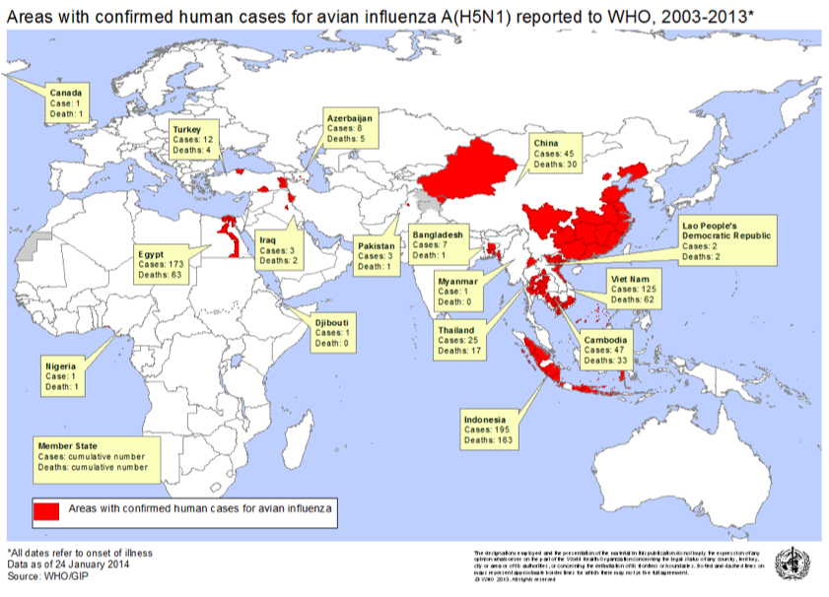
Overall, there were 25 cases and 17 people out of them were dead and the last case in Thailand was found in 2006.
From the research, the virus was spread from birds meaning that it mostly came from chicken and duck that people ate. They might be imported from the countries that are infected by H5N1, when they arrived in Thailand the virus is not well-known or shows the symptoms. Therefore, the merchant received these animals and sold them to people.
In addition, the virus could spread through immigration. The infected birds from the other side of the world may fly to Thailand in the winter because Thailand is located near the equator and filled with resources.

Economic Impacts

Preventative measures of H5N1 were applied differently in each country and also the period of time, which depends on how tough the situation was. Nevertheless, the preventive measures in Thailand were lacking in consideration of impacts on many factors such as import and export in the poultry market.

Import and export losses, there was a great loss in Thailand during the spreading of H5N1 between 2003 and 2006 due to the ban on the importation of chickens from Thailand in Europe, Japan, China until January 31st, 2005, while Thailand was the worlds’ fourth-largest exporter of chickens at that period.

In 2003-2004, The Thai government was trying to conceal the truth that bird flu was spreading in the country. However, the speed-up of killing too many chickens in a day became the appropriate reason to prove the fact that the bird flu was actually spreading. Thaksin Shinawatra, the prime minister at that time, said that the government was taking steps to keep the spread of the virus right after they suspected it, but they did not want to create any panic, so they did not announce it officially to people. Finally, Cholera was blamed as the reason for the deaths of chickens because the government was afraid that it would affect economic stability, which was the poultry industry such as the exporting of chickens.

Eventually, bird flu became a big issue for the country. To illustrate, first of all, the government seemed to be unreliable to other countries, so that Thaksin needed to take part to assure that all chickens were safe and edible by eating those chickens in public to show Thai people in order to convince them that those chickens were not dangerous. Moreover, even the farmers, who got affected by bird flu, were sad as well since chickens might be the only hope for them to make a living and now the chickens all died. As a result, from January to August in 2004, the export value dropped rapidly approximately 41.5% compared to 2003 due to the restrictions on imported chickens from Thailand. Thus, they decided to export processed chickens instead of frozen chickens, which did not make much money as it used to be because those countries could import chickens from other competitive countries like Brazil. However, the price of chickens from Thailand was cheaper and the quality was better, then when the spreading was off, the number of imported chickens from Thailand were expected to increase soon. Moreover, it also had negative impacts on other industries that were associated with the poultry industry as well, for example, the feed industry, animal medical supplies, chicken farming equipment. Meanwhile, the consumer demand for pork rose due to the bird flu, implying that people tended to consume pork instead of chickens so that the price of pork increased.
Export Value and Quantity for Chicken of Thailand
Types | Unit/year | 2003 | 2004 | 2005 | 2006 | 2007 | Growth rate  (percentage)
Frozen chicken | quantity(tons) | 370,588 | 26,581 | 1,940 | 7,966 | 18,567 | 54.07
 | value  (million baht) | 24,775 | 1,746 | 243 | 592 | 997 | 8.15
Processed chicken | quantity(tons) | 128,635 | 174,248 | 235,897 | 253,333 | 278,117 | 22.54
 | value  (million baht) | 15,904 | 20,853 | 27,606 | 29,011 | 32,205 | 20.10
Total | quantity(tons) | 499,222 | 200,829 | 237,837 | 261,299 | 296,685 | -0.55
 | value  (million baht) | 40,678 | 22,599 | 27,849 | 29,603 | 33,201 | 1.98
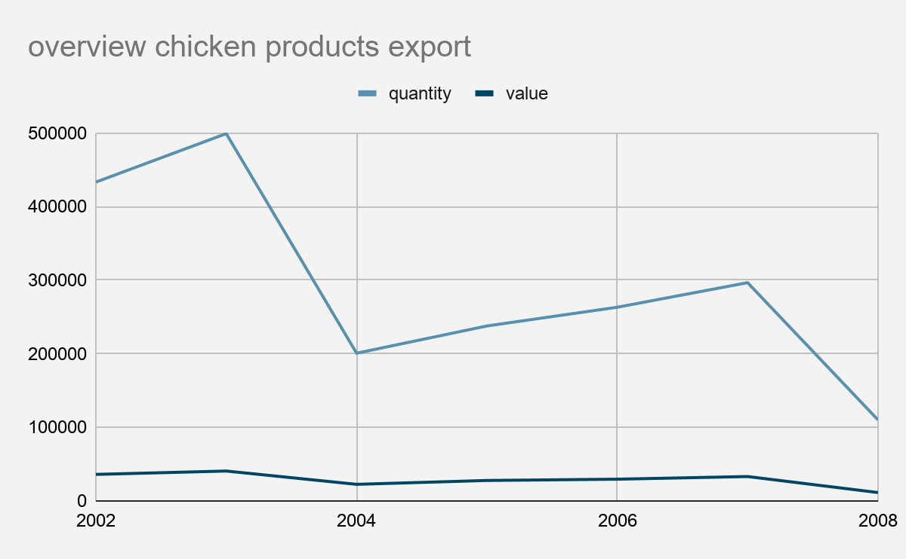
Source:http://fic.nfi.or.th/search_index.php?date_timepicker_start=2003-01-20&date_timepicker_end=2008-12-20&cate=Industry+Overview

The overview of 2003

In 2003 at first-third quarter demand for chicken was increased 3.96 percent due to the higher price of pork people turned to consume more chicken from this point price of chicken increased 2.7 percent, moreover in March-May of 2003 Europe was facing with H5N1, for the japan and Europe market demand to import more frozen chicken that caused the frozen export sector increased 13.5 percent compared to the previous year, However in November 2003 Thailand also facing with H5N1 that made the demand for chicken in domestic and exported was decline and we were facing with the new competitors (China, Vietnam) in this market that affect the price of chicken was lower in the last quarter. Overeive of this year the export still increased 11.7% due to the demand for more frozen chicken in Europe but the price failed since more competition was higher in this market.

The overview of 2004

Overall, the private consumption index decreased slightly from 5.4% to 3.7% for the first nine months in 2004 due to the reduction of customer trust in products, which bird flu was one of the causes that affected the consumption area. However, compared to the situation in 2003, for instance, the spreading of SARS, Thailand could handle things better in 2004. To be more specific, the government was able to control the situation, such as launching the policy to boost the tourism sector such as the extension of the low-cost airline’s routes, building awareness to people, including understanding the situation better. Eventually, pork products were taking advantage of the impacts of bird flu. The price of pork increased as people were afraid to consume chicken and the price of eggs was too expensive for them. Not only affect the domestic economy, yet the international exporting of frozen chickens as well due to the ban on exportation of chicken from Thailand, which dropped by 92.8%. Therefore, the price rose slightly due to the growth of demand.

The overview of 2005

In 2005, the demand of chicken and egg was in a normal situation also the price of chicken was higher while price of pork was slightly decreased due to higher demand for chicken, the amount of consumption chicken was recovery to the normal situation since people have more information, understanding, and the government policy to control the H5N1 that made people understand the nature of H5N1, so this reason created trust on people. Moreover farmers were turned to using a close system method to do chicken farming that create low risk for chicken to infect by disease. For the export sector this year we exported the processed chicken to the main market Japan, and the EU(European Union) to substitute the frozen chicken that was affected by H5N1 in the previous year.

The overview of 2006

In 2006, even though the demand decreased in 2005 the Thai economy was slightly better than in 2005 as a result of an increase in exports. In the agriculture sector, farmer’s revenue has increased by 30.3 percent because in the first half of the year the weather quality and the amount of water are in favor. For the poultry sector, because the virus only spread once in July 2006; hence, it didn’t affect the consumer trust that much. At time, most of the poultry was already converted into a closed system; consequently, demand for poultry has increased while domestic consumption hasn't increased that much and the European Union which is the important importer still forbids poultry import from Thailand until the end of December 2007. For the travel sector, in 2006 the travel sector was getting better in every section from last year, especially in southern Thailand. The number of travelers increased by 20 percent from last year. The unstable politics in September affected the travel sector in a short period.

The overview of 2007

In this period, the bird flu did not affect much in Thailand because it had occurred since 2004 and at that time there were other larger impacts that affected the country more, so mostly, it was all about the adjustment between demand and supply, which including price and export sector in order to find the perfect solution for the poultry industry. In the domestic sector, due to the demand for processed chickens for exportation, the price of chickens and eggs increased. However, to control the excess demand, the production of chickens was adjusted to lower. As well as in the international export, the processed chickens were limited to the given amount of export to the EU market, which was one of the most significant markets for the poultry industry, and the other excess quota would be imposed a higher tax instead, which the exporting measure about quotas are represented below. Overall, Thailand still could not export frozen chicken this year, implying that the existing competitors like Brazil could take advantage of this since there was no bird flu in their country.

Types | Amount of quota (Tons) | Taxes imposed within quota | Taxes imposed beyond quota (Euro/Tons) | Quotas for Brazil (Tons) | Quotas for Thailand  (Tons)
Salted Chicken | 264,245 | 15.4% | 1,300 | 170,807 | 93,438
Turkey | 103,896 | 8.5% | 1,024 | 92,300 | 11,596
Processed chicken | 230,453 | 10.9% | 1,024 | 73,000 | 157,453

Source https://www.kasikornresearch.com/th/analysis/k-econ/business/Pages/7733.aspx

Current period ( from 2017 to 2020)

Since Thailand was banned from the export of frozen chicken, then Thailand decided to export more processed chicken instead and that was successful because the poultry industry had been growing continually. Finally, processed chicken became the main product of this industry by capturing 27.8% of all quantity market share around the world as shown in the diagram.

World Chicken Exports (by product)
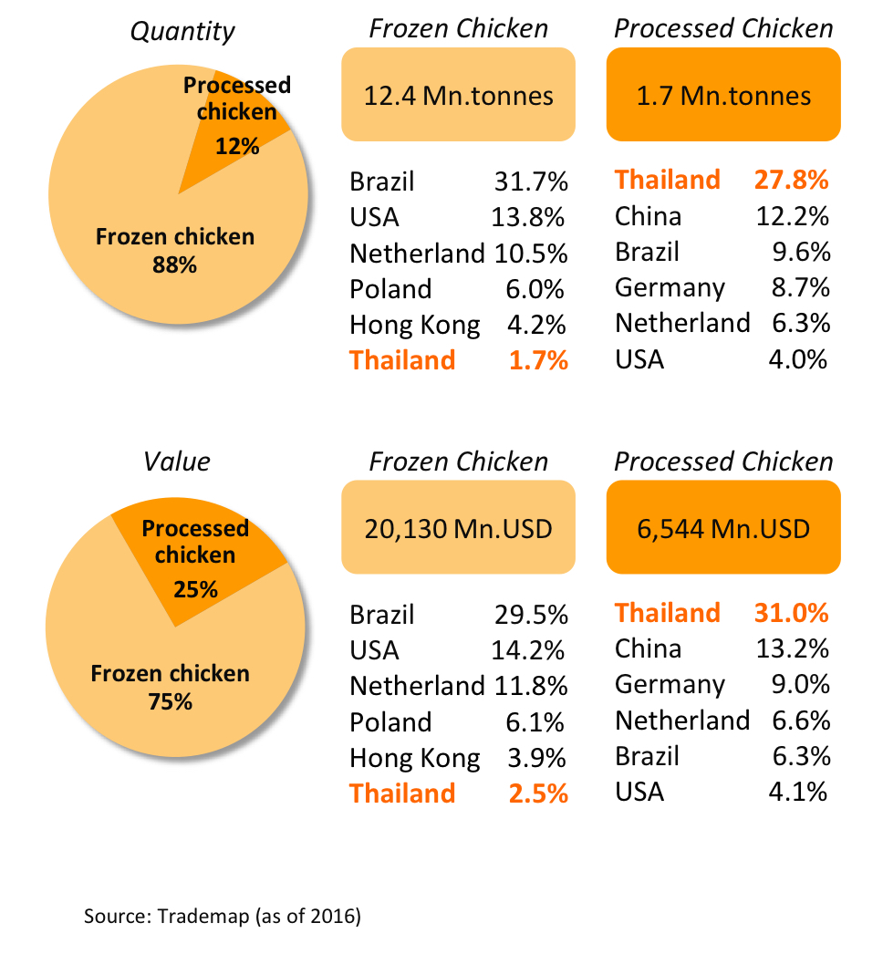
Source https://www.krungsri.com/bank/getmedia/aec17abe-4a8d-4e4f-8d38-815bd58cf1c6/IO_Chicken_181018_TH_EX.aspx

In 2017, as we can see from the diagram Japan was the largest export market of both frozen and processed chicken from Thailand by obtaining 63% and 56% respectively, while another interesting export market for the processed chicken was EU, even for frozen chicken EU captured by only 4%
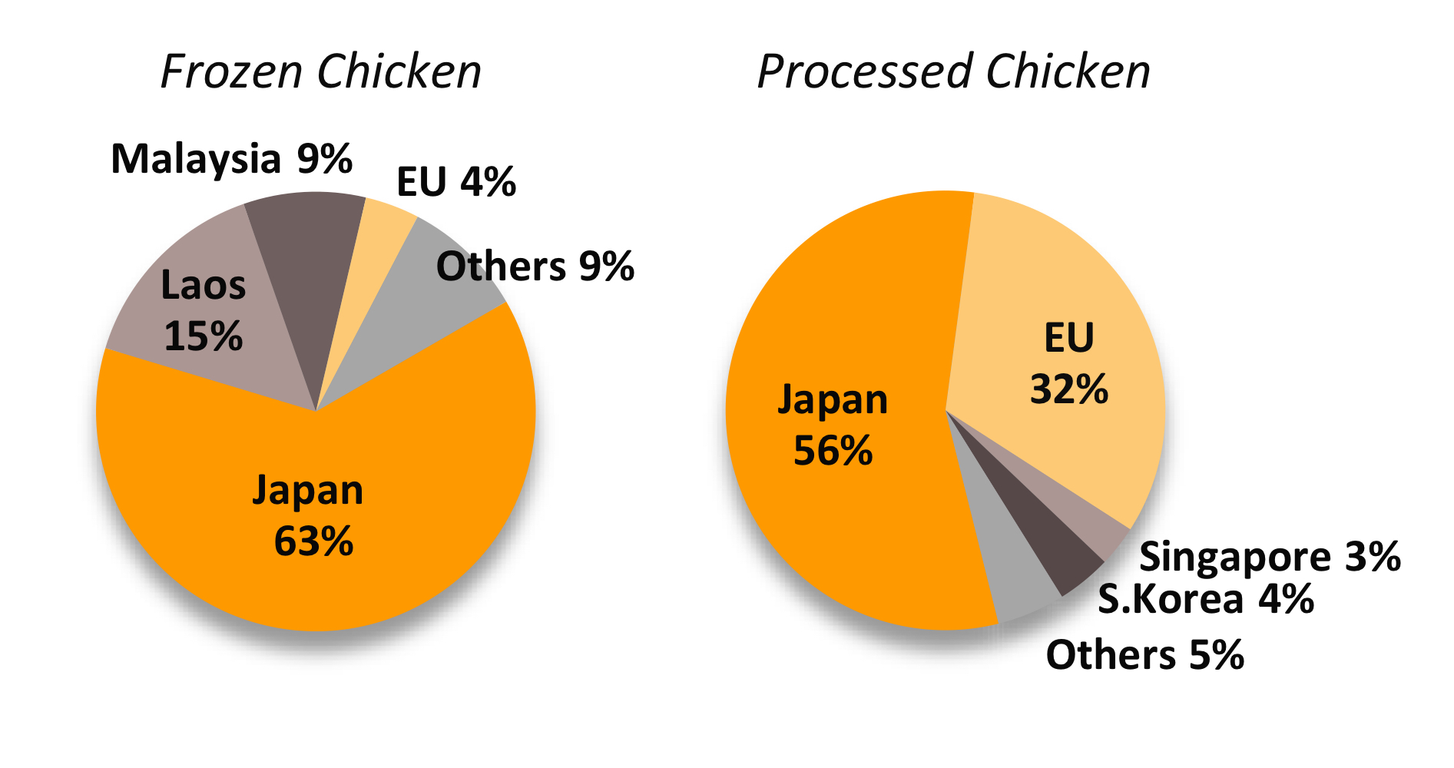
Thai Chicken Export Market by Type (2017)
Source https://www.krungsri.com/bank/getmedia/aec17abe-4a8d-4e4f-8d38-815bd58cf1c6/IO_Chicken_181018_TH_EX.aspx

After the spreading of bird flu decreased, Thai chicken farming was enhanced to EVAP or Evaporative Air Cooling Farming that controlled the appropriate temperature and humanity of the livestock housing, which resulted in increasing consumer trust for Thai frozen chicken.

However, due to Covid-19 in 2020, Many measures were launched and affected the poultry industry such as lockdown measures. As a result, the export value fell in Japan by 0.5%, the EU by 17%, South Korea by 26%, and Malaysia by 5%. Luckily, since the price of pork in China has risen, so export value increased by 97% because China now allowed to import chicken from Thailand after the bird flu in 2004.

On the one hand, if we consider the short-run impacts of the poultry industry, consumers seemed to consume more on poultry products because they were panic about the outbreak, and policy measures such as lockdown measures, a social distancing that making them did not or could go out to buy necessary things much as usual, so they would buy it once with the large amount.
On the other hand, in the long-run, it may have effects from Covid-19, for example, domestically, many factories were shut down during the spreading of Covid-19, meaning that there would be a huge amount of unemployment, and all of them would have no opportunities for making a living since no jobs mean no money. While the export market is still in good shape since Thailand is now the seventh world largest producer of broiler meat.

Policy Responses
We are going to focus on two main sectors, which are on the producer side and economic side, how the government imposed control measures to help and relieve people, and also mentioned the adjustment in the export sector during the spreading of the H5N1 in Thailand.

Producer side

More than 200,000 people, both producers, and laborers got negative effects from the spreading of H5N1 in 2004. The Ministry of Labour was trying to control the situation by launching a measure policy to help people both directly and indirectly such as producers, who produced chicken products and also any other products related to chicken such as chicken farming equipment.

The measures were as follows
- Measure to slow the unemployment and termination of the contract between producers and workers by allowing them to work but only got some parts of salaries as well as welfare workers, which the government would provide compensation as necessary.
- Offering jobs for unemployed, especially for unskilled or low-skilled workers.
- Helping producers and workers to reduce as much expense as possible by letting them pay for social securities later, while maintaining the benefits
- Encouraging people to work for second jobs in their nearby areas in order to reduce the risks from losing jobs.
- Encouraging people to work for jobs that could make a living such as jobs that used machines in the skill development center, and also providing them some money for unemployed, who had no money.

Export sector

In 2003-2004 the amount of chicken consumption sharply declined due to the bird influenza spread in Thailand and other countries. Back then many countries were not allowed to import the poultry product Thailand as the first ranking of export chicken product in Asia, we were lost 25,000 million baht, till 2009 Thailand still export only 997 million baht and the main market of export was Japan and Vietnam while other was trying to import chicken product from American and Europe. After we cannot export the frozen chicken to other countries Thai producer turned to export processed chicken that ready-to-eat and ready-to-cook through this point it's made the value of export chicken increased to 20,853 million baht in 2004 that growth 31 percent compare to 2003 and still keep going till 2007 the value of export chicken was 32,205 million baht on average in 2003-2007 growth rate of export was 20 percent. Until now the proportion of processed chicken is 97 percent of all types of poultry export. To recovery the export sector the Thai government was support by

- Trying to control the quality standard of chicken and stop the spreading of bird influenza, Before the producer exports the products they need to have health certificates from the livestock department, also support the producer to use a close system faring to the low risk to get infected and support the vaccine for chicken.
- Not charge export taxation for the exporter. Moreover the government has projects that control the amount of chicken in the market and manage the amount of export to not exceed the demand and control the price indirectly. Furthermore, Thailand charges import tax in the group of chicken with a 30 percent rate.

Comparison between Thailand and other countries

In this research, we are going to focus on the difference between Thailand and the other two countries, which are Vietnam and Cambodia.

- Vietnam

First occurred in December 2003 and spread in many provinces by 57 of 64 provinces within four months, which was just a short period, so Vietnam applied on many useful measures for economic stability. First, they improved disease control, prepared for the upcoming epidemic response such as building awareness among people through communication programs, for instance, teaching students in the school about the basic things that they needed to know, and also using advanced technologies to help with the infection.

Mostly, the measure that was implemented in Vietnam was close to the one in Thailand. To illustrate, Thailand and Vietnam both got stamped out, which was the measure that would kill the infectious chickens within a given area of the outbreak, movement control, screening, and compensation, which in Vietnam it was in a limited amount.

As a result, those measures were effective due to the support evidence, which were confirmed cases and fatality rate had declined. Besides, the equipment to prevent bird flu had the adequate capacity to implement. However, compared to Thailand, in terms of the death cases, Vietnam had much more than Thailand. Moreover, it seemed like in Vietnam they did not concern much about the export sector since mostly chickens were consumed in the household sector.

- Cambodia

There had also been so many cases since 2005 and only a few of them had survived because in Cambodia people did not carefully take care of themselves and stay away from that poultry during the outbreak, especially children, because of the culture there they treated chicken as a pet, so they were not aware of the negative impacts on H5N1. Nevertheless, overall, the country still tried to raise awareness by using radio campaigns to give useful prevention messages. However, due to the ban on poultry imports, most cases were affected by domestic poultry.

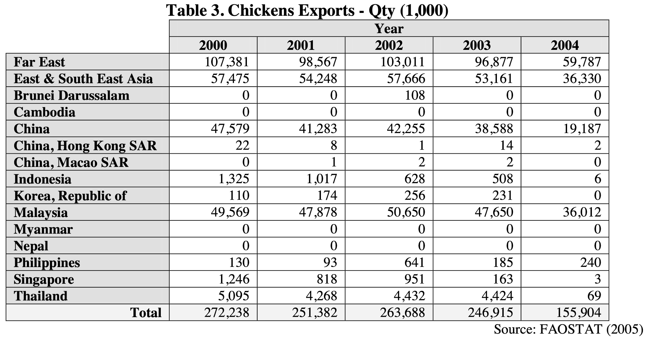
Compared to Thailand, Cambodia at that time was kind of a poor country, meaning that the policy measure that they imposed would not include compensation, not like in Thailand or Vietnam. While other measures that had in both countries were stamping out within a given area, and providing information about bird flu. In addition, Cambodia also did not focus much on export sectors like Thailand as we can see below that chickens export from Cambodia was zero, implying that they did not export any.
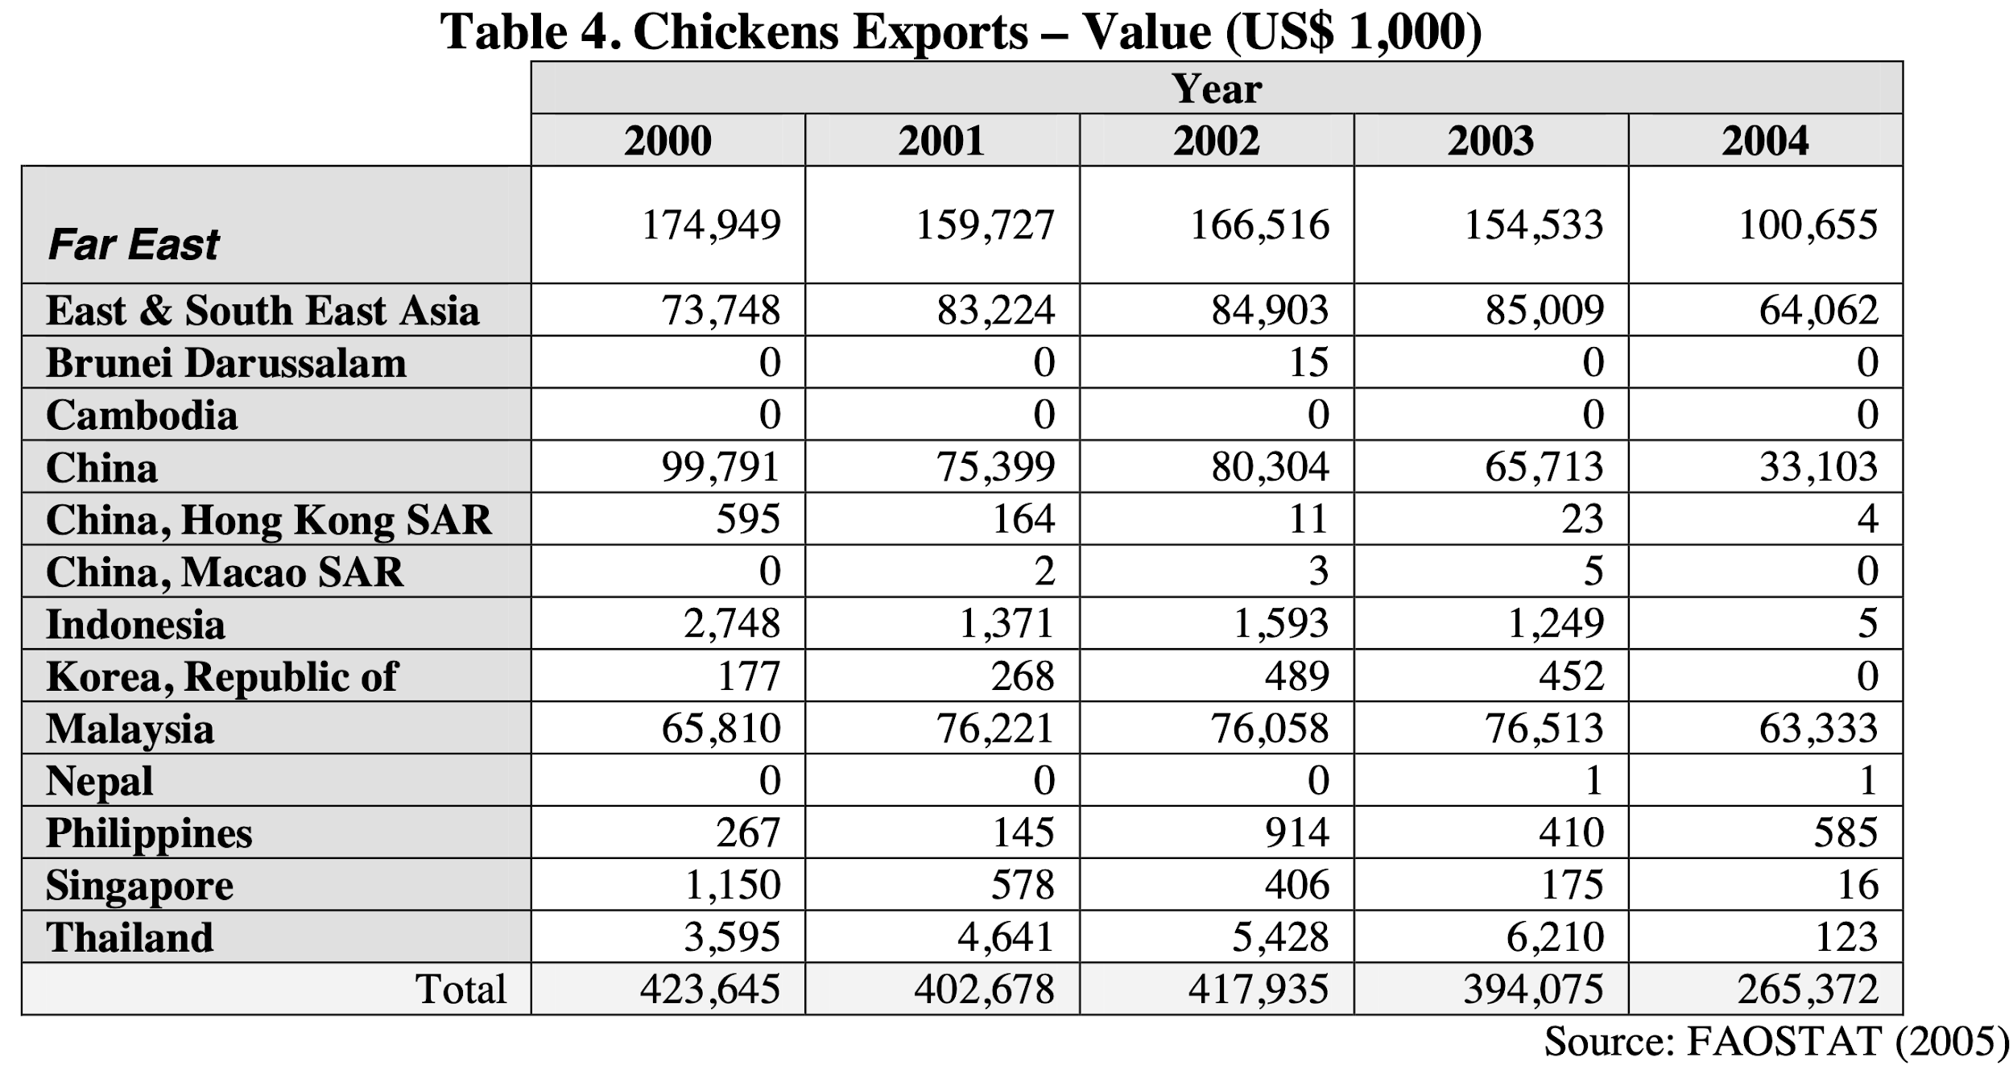

To conclude, the policies that were applied in these three study countries, most of them were similar to each other and most of them were effective. However, the restrictions in each country also got some impacts. As mentioned prior, Cambodia could not be able to give out compensation because they were poorer than the other two countries, so that the producer and worker or anyone who got effects directly might not be able to survive during the spread.

Summary and Discussion

To sum up, H5N1 is a virus that grows from birds which can spread in both poultry and people. The first outbreak was found in Thailand in 2004 and there was also an outbreak in Southeast Asian countries, including China and Hongkong. The virus mostly appeared between December and March because it's winter which is a season of migration of poultry from the northern.
This virus created a severe loss in overall economics in Thailand especially, poultry farms such as chickens and birds. At that time, it made the people afraid and afraid to consume foods and products that came from the poultry. It’s a really tough time for traders and entrepreneurs to sell their products. Many of them had to switch to other jobs which continually affects the laborers or employees of those businesses to lose their work. Moreover, the disease happened suddenly, so the giving of information from the government sector or mass media was not really clear on many issues. Including the part of the researchers themselves also not having any clear confirmation of information.
In that situation, we had to admit that the governments worked so hard to try to handle the virus along with controlling the economic situation. They imposed many effective policies to both producers and consumers to stabilise the economics which is not to tax the export products but instead collect the import taxes, changing the products from chickens to processed chickens, support farmers from the opened system to close system, paid the compensation to the people who affected by the virus, stamp out the surveillance, not to give fake news to people to control the raise awareness, and etc. this resulted in reduced the unemployment rate which is the most important factor that impacts the economics in the country.
In the future, if the virus happened again we think we can better handle the situation since the virus appeared to our world in various times and now we have a lot of new technologies that developed from the past and can be productive to control the virus.

References
Bank Of Thailand. (2006). Bank of Thailand. Bot.or.Th. http://www.bot.or.th/BOTWebSite/DataBank/Econcon/econreport/monthly/index_th_i.asp
Center for Disease Control and Prevention. (2017, February 6). Avian Influenza in Birds. CDC. https://www.cdc.gov/flu/avianflu/avian-in-birds.htm
Center for Disease Control and Prevention. (2018, December 12). Highly Pathogenic Asian Avian Influenza A(H5N1) Virus. CDC. https://www.cdc.gov/flu/avianflu/h5n1-virus.htm
Center of Disease Control and Prevention. (2015, March 18). Highly Pathogenic Asian Avian Influenza A(H5N1) in People. CDC. https://www.cdc.gov/flu/avianflu/h5n1-people.htm
Coston, M. (2014). H5N1 Propagation.
Department of Foreign Trade. (n.d.). เว็บไซต์กรมการค้าต่างประเทศ > Intro. Www.Dft.Go.Th. Retrieved December 20, 2020, from https://www.dft.go.th/th-th/
Department of Foreign Trade. (2019, August 28). ความตกลงการค้าเสรี อาเซียน - เกาหลี. เว็บไซต์กรมการค้าต่างประเทศ. https://www.dft.go.th/th-th/DFT-Service/ServiceData-Information/dft-service-data-privilege/Detail-dft-service-data-privilege/ArticleId/5064/Project-TH-KOR-AEC
Elci, C. (2006). Natural Resources 104 Natural Resoures The Impact of HPAI of the H5N1 Strain on Economies of Affected Countries. https://core.ac.uk/download/pdf/6989909.pdf
EXIM knowledge center. (n.d.). สมาคมผู้ผลิตไก่ฯ ปรับลดเป้าส่งออกปี 2563 เหลือเท่าปี 2562. Kmc.Exim.Go.Th. Retrieved December 20, 2020, from https://kmc.exim.go.th/detail/economy-news/20201104130726
Food intelligence center Thailand. (n.d.). ศูนย์อัจฉริยะเพื่ออุตสาหกรรมอาหาร Food Intelligence Center Thailand. Fic.Nfi.or.Th. Retrieved December 20, 2020, from http://fic.nfi.or.th/search_index.php?page=2&date_timepicker_start=2003-01-20&date_timepicker_end=2008-12-20&cate=Industry%20Overview
KASIKORN RESEARCH CENTER. (2006, November 17). ไก่และผลิตภัณฑ์ในตลาดอียูปี 2550. ศูนย์วิจัยกสิกรไทย. https://www.kasikornresearch.com/th/analysis/k-econ/business/Pages/7733.aspx
Krungsri Research. (2018). แนวโน้มธุรกิจ/อุตสาหกรรม ปี 2561-63. https://www.krungsri.com/bank/getmedia/aec17abe-4a8d-4e4f-8d38-815bd58cf1c6/IO_Chicken_181018_TH_EX.aspx
MAYO CLINIC. (2020, June 13). ARDS - Symptoms and Causes. Mayo Clinic. https://www.mayoclinic.org/diseases-conditions/ards/symptoms-causes/syc-20355576
MGR online. (2007, March 16). คาดส่งออกไก่เนื้อปีนี้ได้ประมาณ 3 แสนตัน. Mgronline.com. https://mgronline.com/business/detail/9500000030873
Netherlands Embassy in Bangkok. (2016). The Poultry Sector in Thailand. Google.com. https://www.google.com/url?sa=t&rct=j&q=&esrc=s&source=web&cd=&ved=2ahUKEwi3ot7FntrtAhUh4jgGHRZhAG4QFjADegQIBxAC&url=https%3A%2F%2Fwww.rvo.nl%2Fsites%2Fdefault%2Ffiles%2F2016%2F12%2FFACTSHEET-POULTRY-SECTOR-IN-THAILAND.PDF&usg=AOvVaw3fGfJwjS2SwIvPgPOiLFMA
THE WORLD BANK. (2015, May 12). Vietnam Avian and Human Influenza Control and Preparedness. World Bank. https://www.worldbank.org/en/results/2015/05/12/vietnam-avian-and-human-influenza-control-and-preparedness
Tiensin, T., Chaitaweesub, P., Songserm, T., Chaisingh, A., Hoonsuwan, W., Buranathai, C., Parakamawongsa, T., Premashthira, S., Amonsin, A., Gilbert, M., Nielen, M., & Stegeman, A. (2005). Highly Pathogenic Avian Influenza H5N1, Thailand, 2004. Emerging Infectious Diseases, 11(11), 1664–1672. https://doi.org/10.3201/eid1111.050608
TMB. (2020, September). Industry insight. https://media.tmbbank.com//uploads/analytics_industry/file/media/741_file_th.pdf
Workpoint. (2018, March 28). workpointTODAY. WorkpointTODAY. https://workpointtoday.com/
World Health Organization. (2012). WHO | faqs: H5N1 influenza. Who.Int. https://doi.org//entity/influenza/human_animal_interface/avian_influenza/h5n1_research/faqs/en/index.html
World Health Organization. (2014, March 7). 6th new human case of avian influenza H5N1 in Cambodia in 2014. Www.Who.Int. https://www.who.int/westernpacific/news/detail/07-03-2014-6th-new-human-case-of-avian-influenza-h5n1-in-cambodia-in-2014
สำนักงานเศรษฐกิจการคลัง. (2006). ผลกระทบทางเศรษฐกิจและการเตรียมรับมือ กับการแพร่ระบาด ของไข้หวัดนกจากคนสู่คนท่ัวโลก. http://www2.fpo.go.th/FPO/admin/scripts/getpdf.php?id=2471

Appendices
Export Value and Quantity for Chicken of Thailand
Types | Unit/year | 2003 | 2004 | 2005 | 2006 | 2007 | Growth rate  (percentage)
Frozen chicken | quantity(tons) | 370,588 | 26,581 | 1,940 | 7,966 | 18,567 | 54.07
 | value  (million baht) | 24,775 | 1,746 | 243 | 592 | 997 | 8.15
Processed chicken | quantity(tons) | 128,635 | 174,248 | 235,897 | 253,333 | 278,117 | 22.54
 | value  (million baht) | 15,904 | 20,853 | 27,606 | 29,011 | 32,205 | 20.10
Total | quantity(tons) | 499,222 | 200,829 | 237,837 | 261,299 | 296,685 | -0.55
 | value  (million baht) | 40,678 | 22,599 | 27,849 | 29,603 | 33,201 | 1.98
Quota for Export Chickens
Types | Amount of quota (Tons) | Taxes imposed within quota | Taxes imposed beyond quota (Euro/Tons) | Quotas for Brazil (Tons) | Quotas for Thailand  (Tons)
Salted Chicken | 264,245 | 15.4% | 1,300 | 170,807 | 93,438
Turkey | 103,896 | 8.5% | 1,024 | 92,300 | 11,596
Processed chicken | 230,453 | 10.9% | 1,024 | 73,000 | 157,453

World Chicken Exports (by product)

Thai Chicken Export Market by Type (2017)

