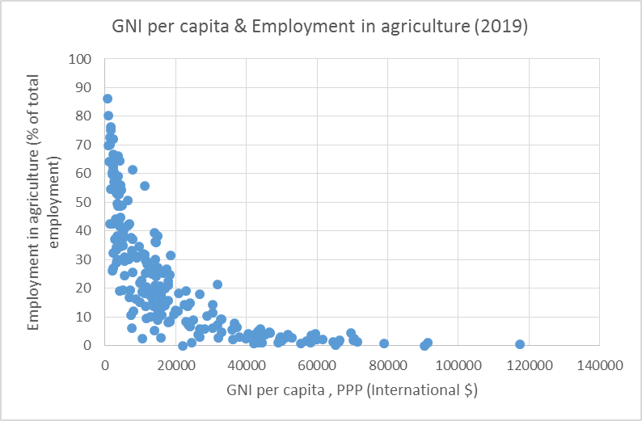
1)

(no data of male employment available for 2020)

As shown in the graph, there is a negative correlation between GNP per capita and agricultural employment. According to this graph, higher levels of GNP per capita are associated with a lower percentage of employment as a share of total employment. This relationship demonstrates that when countries earn more, workers shift from agriculture to other industries, which is consistent with Kuznets' curbe curve mechanism. This process takes time since the richer people receive more income within a smaller industrial sector in the beginning, and as the industry grows, others are included and they receive higher income.

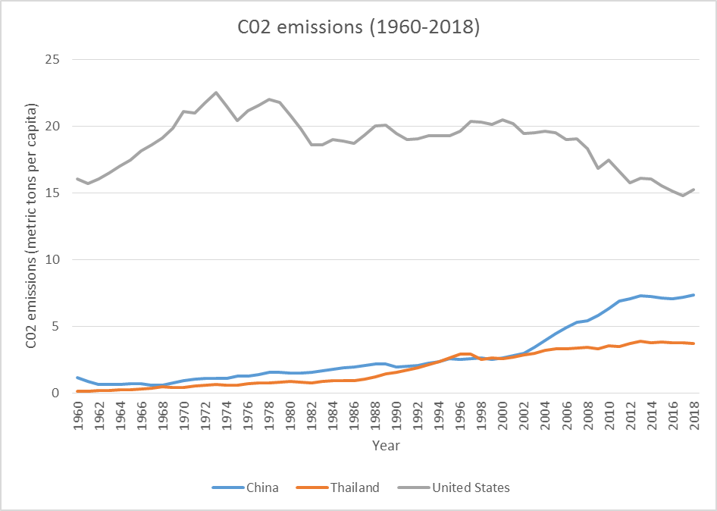
2)

Ever since 1960, the United States has emitted more CO2 than Thailand and China. The United States' CO2 emissions are decreasing. From 1960 to 1974, there was a significant increase in CO2 emissions. This is due to the fact that the United States was one of the first countries to become industrialized and begin emitting greenhouse gases. The line fluctuated after 1974, but it was on a declining trend until 2018. Because they realized how much CO2 they had emitted and devastated the ecosystem, the United States began to reduce their CO2 emissions.

Thailand and China, on the other hand, were almost at the same level in 1960, as seen in the graph, and they began to drift apart in 2004. After 2004, China's CO2 emissions soared, while Thailand's gradually climbed. Thailand and China follow the path of the United States in terms of country development, implying that they were industrialized much later than the United States. This explains the recent falling trend in the United States and the upward trend in Thailand and China.

Good observation and select interesting indicators to say about economic development, but if adding reference of CO2 emission trend in the US would be better.
Score: 10

