Exercise 3
Keynesian Cross and the Multiplier
- The Keynesian consumption function assumes that 0 < MPC < 1; what is the basis for such assumption?
- Consumption function = C₀+C₁(Y) /C₁= MPC or marginal propensity to consume
MPC = proportion of income that we use to consume which is also the amount of consumption depended on income.
MPC’s function assumes to be 0 < MPC < 1 since it is an economic theory that consumption will rise as income rises, so the measure MPC will not surpass the income. For example, one may have 200 baht as income but MPC is 0.6

- Assume a CLOSED economy with NO government. Let the autonomous consumption (C₀) be 200 and MPS marginal propensity to save be 0.3. Draw and write equations for both saving and consumption functions.
- Income = saving + consumption
-Y= S+C
- MPS + MPC =1 / 1 = income
0.3+MPC=1
MPC= 0.7
Consumption function: C= C₀+C₁(Y) = 200+0.7(Y)
Saving function: S= Y-C = Y-(200+0.7(Y)) = -200+0.3Y
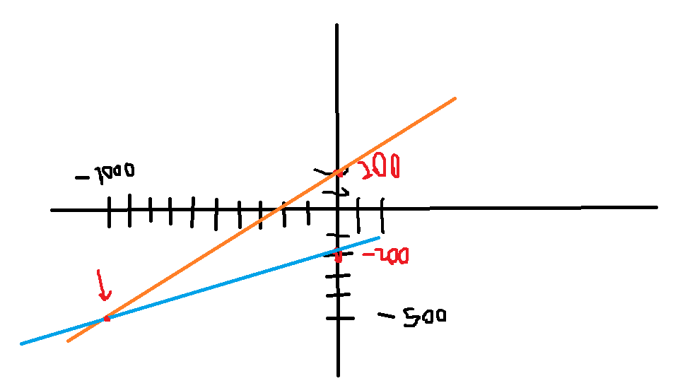

- Let the saving function be S = -150 + 0.35Y. Find and draw the consumption function.
- S= income-consumption C₀₌ 150 / C₁= 0.65
S= Y-( C₀+C₁(Y)) Consumption function:
S = -150 + 0.35Y C= C₀+C₁(Y)
S= Y-(150+0.65Y) C= 150+0.65Y
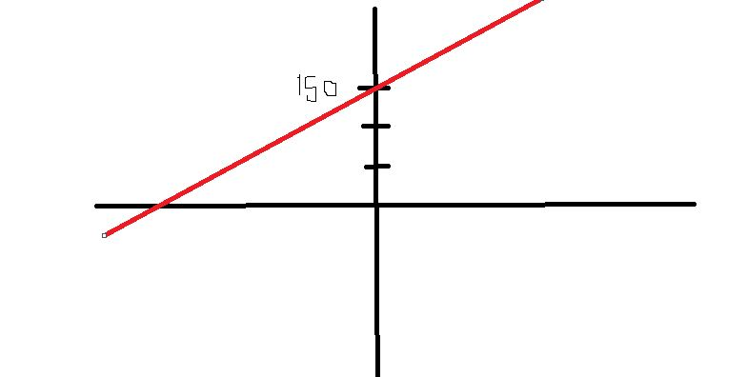Consumption function
C= 150+0.65Y
- How do the followings affect the AE graph (i.e. explain how the graph changes) and the equilibrium output?
- All firm managers decide to buy fewer machines.
(I decreases, AE goes down, Y* goes down)
- The government decides to build more roads.
(G increases, AE goes up, Y* goes up)
- The citizens decide to save more at all income levels (S₀ goes up).
(S increases, AE goes down, Y* goes down)
- The citizens decide to save larger proportion of income (MPS goes up).
(MPS goes up, MPC goes down along with AE, Y* goes down)
- The government decides to raise tax.
(T increases, AE decreases, Y* decreases)

Graph when AE falls/decreases:
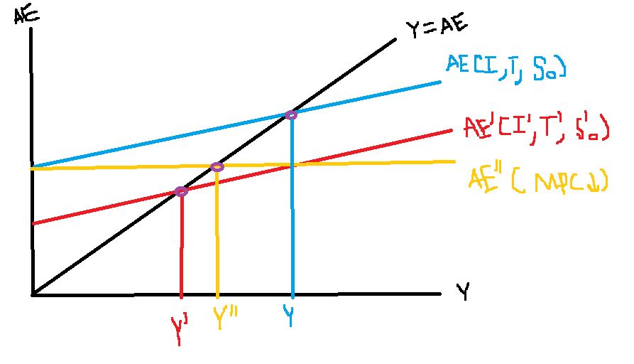
Graph when AE rises/increases:
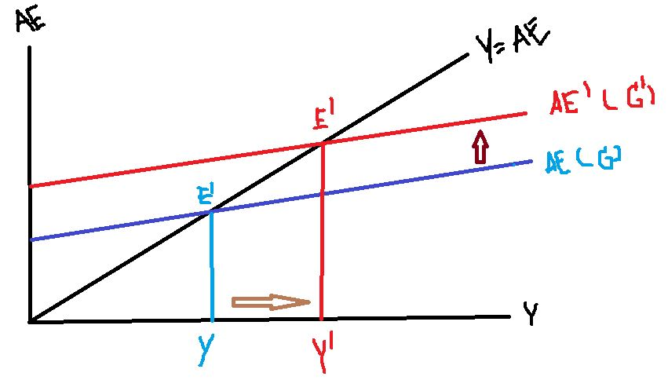
- In the Keynesian Cross Model, suppose that aggregate output is greater than aggregate expenditure. Explain the adjustment process towards the equilibrium.
- As aggregate output is greater than the aggregate expenditure, the Keynesian model will show that there is a surplus. [supply(GDP)>demand(plan)]
- This will result in having inventories accumulated, in other words, having more output. Then, the business needs to cut off production to have Y at the equilibrium. (reduce production)

- Let C = 60 + 0.6Y and I = 20. Find the equilibrium output with the saving/investment approach.
- Y = C + S To get equilibrium output: S = I
S = Y – C 0.4Y – 60 = 20
S = Y – (60 + 0.6Y) Y = 80/0.4
S = Y- 60 -0.6Y Y* = 200
S= 0.4Y – 60
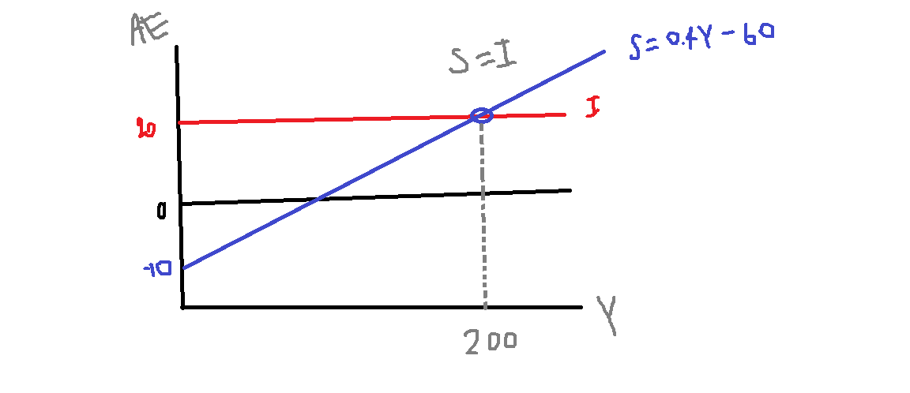

- Let S = -60 + 0.4Y and I = 20. Find the equilibrium output with the standard approach. Now, suppose I increases by 20. Find the new equilibrium and the investment multiplier.
Investment multiplier: Change in Y*/change in I
= 50/20 = 2.5
So, when I increases by 1, output will increase 2.5 unit.
If I increases by 20, output will increase 50 unit
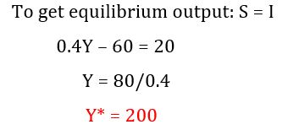
If I increases by 20
Then, 0.4Y – 60 = 40
Y* = 250# = new equilibrium output

- With the multiplier effect, an injection of money (for example, investment) can lead to a greater proportional increase in output. Explain how this can happen.
- At the time money injected, firm will have more money to operate their businesses. So, firm can buy more machines, hire more people in labor which will create more money flow of income, labor with more income, and increase in output.
- How is the investment multiplier related to MPC? Explain the intuition behind such relationship. (Hint: Question 9)
- When there is expenditure, firm receives more money and produce more for demand. So, when firm receive more fund, they can use it to buy new machines, pay to labors.
- When labors have more money, MPC will then increase. This creates more money in circular flow and increase size of multiplier and change output as well.
- *change in Y over change in I* = 1/1-slope of AE = 1/1-MPC
- What is the Paradox of Thrift? Explain it with diagram.
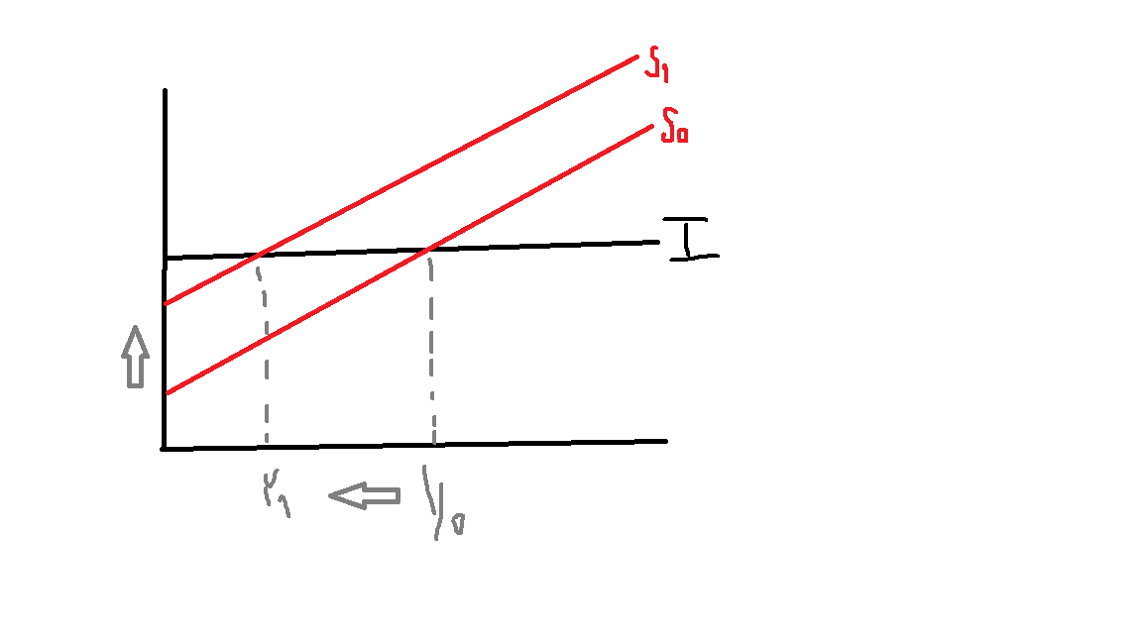
- It means that increasing in autonomous saving will make aggregate demand decrease.
Phenpojana H. 0770

