Flying baht prompts top brass meet

Former ministers warn of looming debt menace
- Published: 24 Jan 2013 at 00.00
- Bangkok Post Newspaper section: News
The soaring value of the baht prompted Prime Minister Yingluck Shinawatra to meet top government officials yesterday.
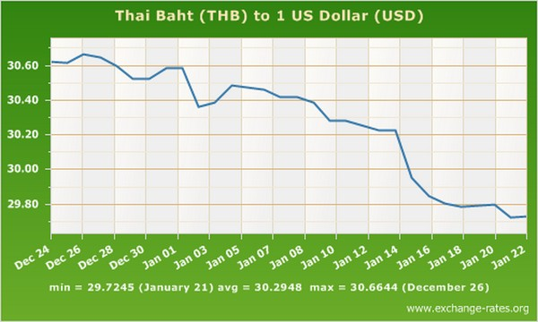
After the meeting Ms Yingluck played down fears over the currency's rapid appreciation, saying so far the strengthening of the baht posed no risks to the economy.
Ms Yingluck met Finance Minister Kittiratt Na-Ranong, Bank of Thailand (BoT) governor Prasarn Trairatvorakul and National Economic and Social Development Board (NESDB) secretary-general Arkhom Tempitayapaisit.
The meeting was prompted by the local currency closing yesterday at 29.77 baht to the US dollar, surging in value from 31.36 baht to the dollar on the same date last year.
The prime minister ordered the Finance Ministry and the NESDB to work closely to manage the baht.

American and Japanese quantitative easing has caused currency inflows into Thailand, resulting in the baht appreciation, Ms Yingluck said.
"There is no sign of danger, but we want to be prepared and have alternatives to offer to the private sector," she said. "Don't panic. The government will take appropriate measures and keep the public informed."
Ms Yingluck said the BoT estimates that the baht is likely to continue to appreciate, but at a slower pace.
Mr Kittiratt said the currency strengthening was caused by short-term flows into the country and speculators trading on the baht.
Mr Kittiratt said investments in infrastructure projects and imports of machinery would over the long run stabilise the baht.
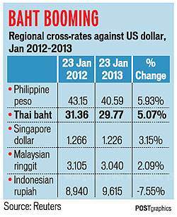
He said the increase in inflows was the result of high market confidence in the government's economic policies, combined with the effect of quantitative easing by other countries.
Meanwhile, former finance minister Thirachai Phuvanatnaranubala said the currency problem will only worsen later this year. He said inflows caused by US and Japan monetary policy would pose challenges for Thailand.
Mr Thirachai said if the government cuts interest rates to curb the baht's appreciation then it would lead to more loans being taken out. He warned that the government's populist policies, such as the first-car and first-house schemes, could be "excessive" if the economy is not in the doldrums and could lead to households struggling with debt.
Another former finance minister, MR Pridiyathorn Devakula, voiced concerns about spiralling public debt.
He said public debt is estimated to increase by 7.97 trillion baht between October 2012-September 2019 to 10.3 trillion baht, or 63.7% of GDP. He blamed the government's first-car scheme and the rice pledging scheme, as well as other massive loans it has taken out, including 350 billion baht for water management.
Public debt was at 43.9% of GDP at the end of last September. "If the government continues with this populism, public debt might increase to 70% of GDP. [In this situation] we will not die but surely we will be weak," MR Pridiyathorn said. "No one in this government is concerned with fiscal discipline. They just want to pursue populist policies without being respectful to taxpayers." Addressing the same forum, Mr Kittiratt said the currency should not be allowed to become so strong as to threaten exports and tourism.

