PORTUGUESE ECONOMY – GROWTH & CURRENT ACCOUNT

We based our analysis in a comparison of the two considered indicators taking into consideration Current Account of Portugal and Thailand, as percentage of GDP, and, the Real growth rate in the same circumstance.
We compose our data between 1996 and 2016 once we consider it to be sufficient to get an overview of the Portuguese Economy. The Data was extracted trough PORDATA platform, a Portuguese database that collects data from official sources as Eurostat, BP Stat, among others. Also, for the data on Thailand we went to the Bank of Thailand.
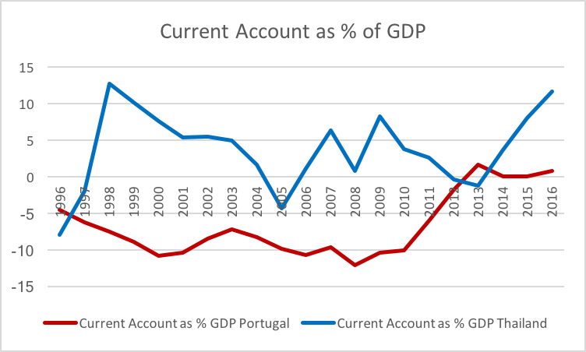

As we can observe in the graphic, Portuguese Current Account, as percentage of GDP, had been negative until 2012 where it reached a neutral result. It was a combination of persistent and high external deficits and the adoption of a currency that they did not control, which created a situation conducive to the European crisis. Since then, it is situated in positive values reaching its maximum in 2013 (1.6 % of GDP) and slightly decrease in the next years. These values were attainable due to the financial rescue executed by European Central Bank, European Commission and International Monetary Fund. This combined with TROIKA austerity measures leaded to a positive current account.
In the case of Thailand, the current account only registered negative values before 1997. After the crisis, the current account had been highly positive, even though decreasing, until reached its minimum, since 1996, -4.3% in 2005.
Comparing the two countries, only before 1996 and in 2013, Thailand’s current account was lower than Portuguese’s; in the other years, our native country registered lower values in almost of the considered years. It gains more strength in 2008, when subprime crises truly affected Portuguese Economy.
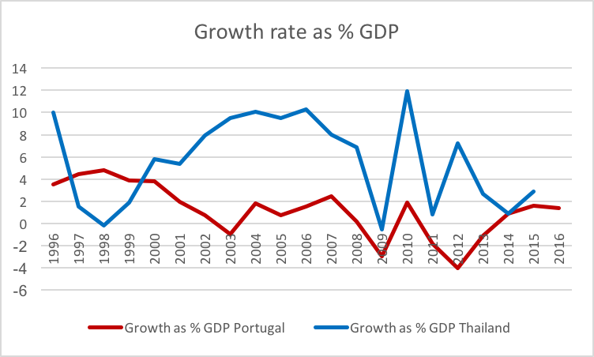

As of the Growth of real GDP in %, Portugal had a decreasing growth until 2013 reaching -0.93%. Then it increased and returned to decrease in 2009 due to the Great Recession. From this point forward,
The growth of GDP present volatility and increased in 2010 due to the financial rescue, but decreased again until 2012. After that Portugal has been presenting a steady increase in growth of GDP, achieving positive and more stable values until the now.
In Thailand we also observe many volatility, however it presents values higher than Portugal’s and it was almost always positive. In 1998 the growth was negative due to the 1997 Asian Financial Crisis reaching -0.2%. From that point forward it went up a lot, reaching 10.3% in 2006. Then, in 2009 there was an abruptly decrease to negative values due to Subprime crisis. Then it presented many volatilities with very unstable values, but always positive.
Comparing both countries we can see some similarities due to both countries being affected by world crisis and then having the same volatilities in the growth of GDP. Thailand presents more high values than Portugal which is normal because Portugal is more developed than Thailand and it is harder to grow at high percentage levels.

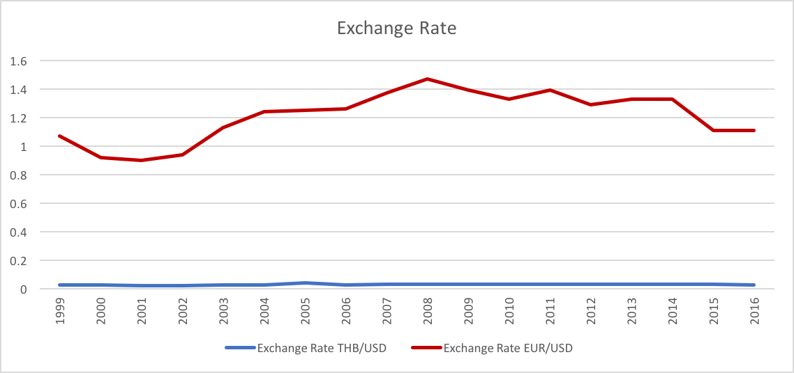

In terms of Exchange Rate of Thai Baht to USD and Euro to USD we can observe that the euro is stronger than the Thai Baht relatively to USD.
Analyzing the volatility, we can see that the Thai Baht maintained its weight through the years with slightly increase in 2005; the Euro to USD suffered a lot of volatility because Euro and USA are two very strong economies and, as they develop, both Euro and USD, gain and lose strength making the Euro to USD decrease and increase across time.
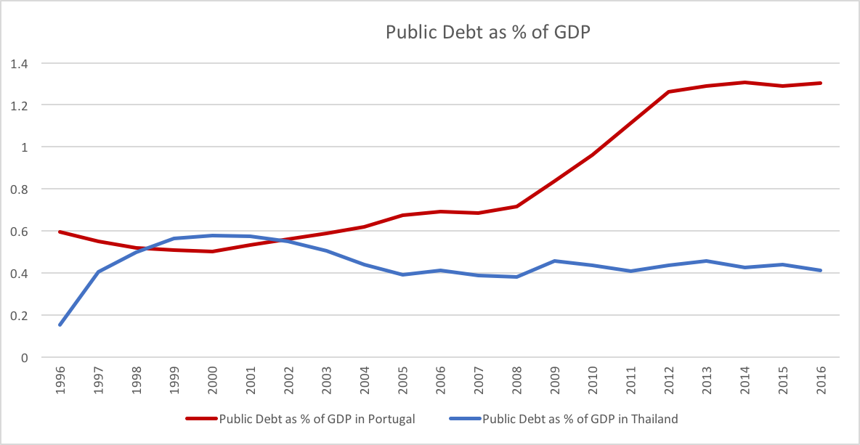
The maximum ratio of Euro to Dollar was obtained in 2008 during the subprime crisis that made the value of dollar decrease a lot. However, in Thailand we don’t see any volatility at all in 2008 mainly because the Thai Baht followed the dollar in the subprime crisis, not affecting the ratio between the two.
As we can observe in the graph, Portugal had been an indebted country over time, but since 2008 Public Debt increase exponentially until 2012. This may be justified by the highly dependency of Portugal on US capital & financial market. To aggravate this fact, the GDP of Portugal has been stagnating since 2006 and with the public debt increasing this makes the Public Debt as % of GDP higher and higher in the last years.
Financial crisis deeply affects Portuguese Economy at a point that TROIKA* had to intervene making the Public Debt stagnating and slightly decreasing in 2015. In 2006, with the entrance of the New Government it starts increasing again (approximately 130% of GDP).
Thailand reached the maximum of Public Debt in 2000, approximated 60% of GDP, which can be a result of 1997’s Asian Financial Crisis and, since then, it had been decreasing until 2015. After this year, it had been showed volatility around 40% of GDP.

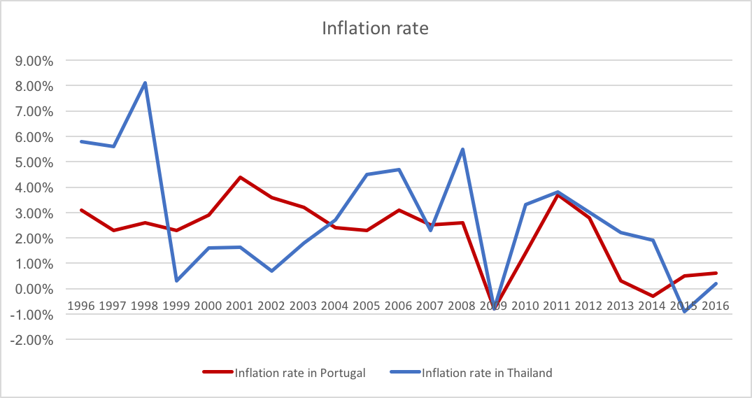
*TROIKA is a designation given to “European Commission, International Monetary Fund and European Central Bank, who formed a group of international lenders that laid down stringent austerity measures when they provided bailouts, or promises of bailouts for indebted peripheral European state.” in Financial Times.

Regarding the Inflation Rate, we can observe that both countries had some volatility in the inflation rate, however it wasn’t too high nor too negative in any country. In 1998 we see a high decrease of inflation in Thailand from around 8% to around 0,5%, this is mainly explained by Asian Financial Crisis in 1997. Also, in both countries we observe the effect of the subprime crisis in the inflation rate, both decreasing to -0.8% in 2009. Later in 2015, Portugal had, once again, deflation which increased in 2016 again to positive levels.
As Thailand has its own currency, it is easier to control the inflation rate because the bank of Thailand can supply more or less money in order to keep the inflation controlled. Portugal is in a different scenario, as it is a member of the European Union, the money supply is dependent of the Central Bank making Portugal more vulnerable to inflation.

Students:
Gonçalo Silva Ramos
Carla Sofia Peixoto Pedroso

