Student Information
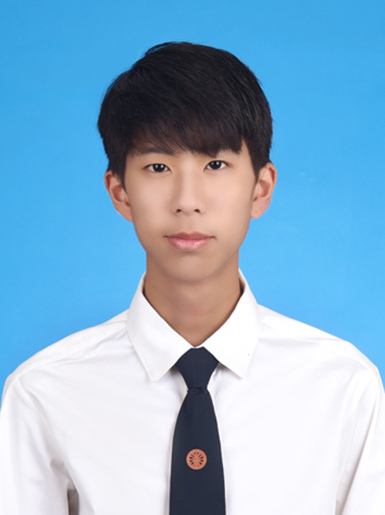e here.]
EE211 Microeconomics
Semester 1/2020
- Name - Rujiwat Eiamsirikulmit
- Nickname - Win
- Email - rujiwat.eia@st.econ.tu.ac.th
Phone Number - 0952496972
- Year of program: [/] 1st year [] 2nd year [] 3rd year [] 4th year
- Major area (if any) - Business economics
- Minor area (if any) - Finance minor
- Classes that you have already taken
- I have already taken EE211 , ST216 , TU101 , and TU105
- Classes that you are currently taking
- EE211
- Classes that you plan to take in the next semester(s) or next academic year(s)
- EE212 , MA216 , TU106 , TU103 , and TU104
- What is/are your favorite subject(s)?
- Of course economics.
- What do you expect to learn from this class?
- I expect I will have knowledges about economics and solving business problems on my own company in the future.
- What is your concern, if any, about being in this class?
- No.
- What would you suggest to enhance your learning experience while taking this class? Is there any teaching technique that other instructors use and you particularly like? If so, please suggest.
- Actually your teaching is well, so I don’t have any suggestion.
- Briefly describe your career aspiration(s). List the top two choices if there are many.
- Omakase restaurant owner
- Businessman
- Other comments and/or suggestions.

(Note: All information is to be used for teaching purpose only, and will be kept confidential.)

