Natchalin Iwsakul
6104640153
Assignment 2
- Reduced Form - lnD_{t} = π₀ + π₁lnS_{t} + π₂lnP_{x2t} + π₃lnP_{x3t} + π₄P_{x4t} + π₅ lnGDP_{t} + ε_{2t}
where π₀ = β₂₀ – β₂₁ β₂₀ - β₂₁ ε _{1t} π₁= β₂₁ π₂ = – β₂₁ β₁₂
Β₁₁ Β₁₁ Β₁₁
π ₃ = – β₂₁ β₁₃ π₄ = – β₂₁ β₁₄ π₅ = β₂₂
Β₁₁ Β₁₁
lnS_{t} = δ₀ + δ₁lnD_{t} + δ₂lnGDP_{t} + δ₃lnP_{x2t} + δ₄lnP_{x3t} + δ₅lnP_{x4t} + ε_{1t}
where δ₀ = β₁₀ – β₁₁ β₂₀ – β₁₁ ε _{2t} δ₁ = β₁₁ δ₂ = – β₂₂ β₁₁
Β₂₁ Β₂₁ B₂₁
δ ₃ = β₁₂ δ₄ = β₁₃ δ₅ = β₁₄
To create reduced form, there can only be exogenous variables on the right side. Thus, what left on the right side are lnGDP, lnP_{x2t},lnP_{x3t},lnP_{x4t}.
- I estimate lnP_{dt} with the reduced form and then predict lnP_{dt}hat.
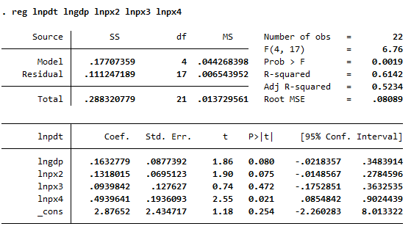

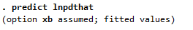

- Then, I regress lnP_{dt}hat on both lnS_{t} and lnD_{t} equation.
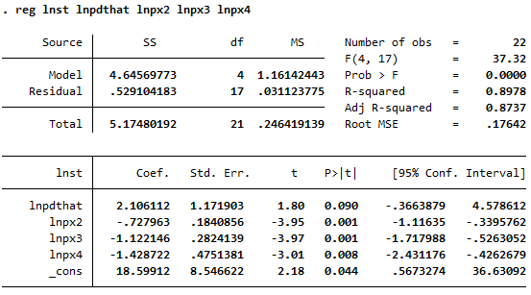

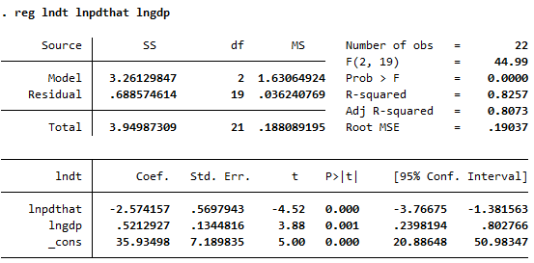

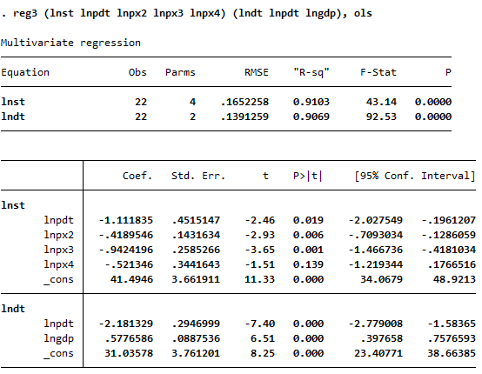
- OLS -

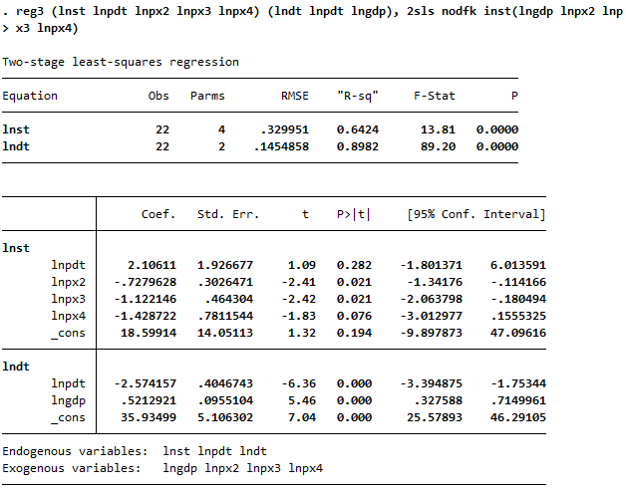
2SLS -

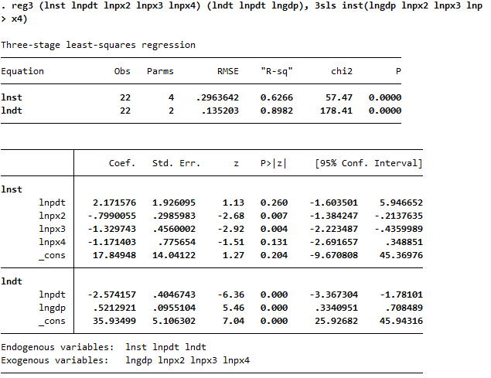
3SLS –

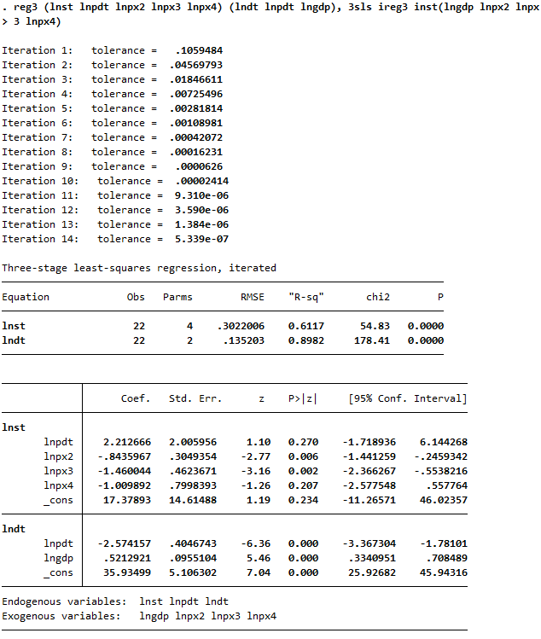
I3SLS –

Concerning on the asymptotic property, 3SLS is the most appropriated model as it also fixes the correlation of error terms, if any, not just only endogeneity problem like 2SLS.
- Β₂₁ shows the effect of Domestic Price at time t to Domestic Demand at time t. β₂₂ also is the effect of change in GDP at time t to Domestic Demand at time t.

