Transcript
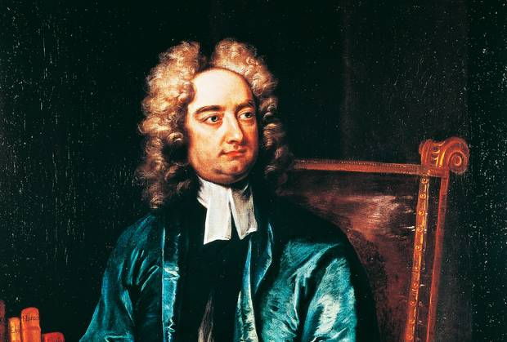
Scene 1: Biography of author(No)

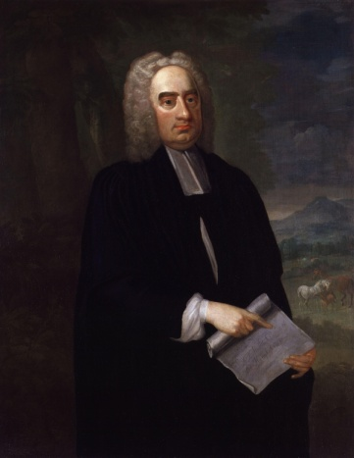
(No)Jonathan swift was a satirist, essayist, poet and priest. He was born in Dublin, Ireland on 30 November 1667 and he died at the age of 77.

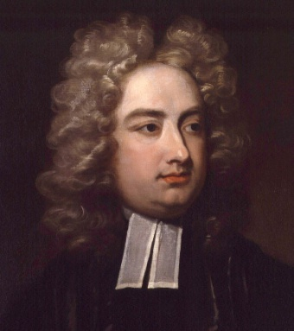
In 1745, Jonathan Swift died and buried near Dublin’s St Patrick’s Cathedral.

During his time, it was in between the transition from the Renaissance to the Enlighten period. He is best known as a satirist.
Scene 2: Setting of Gulliver’s Travels
(Keng)Gulliver’s Travels has four different settings; each of them foreshadows the next.
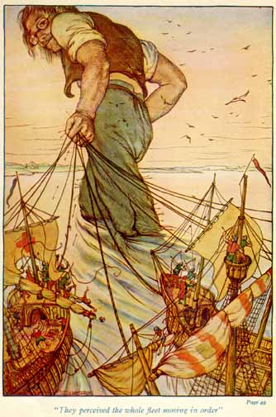
The first setting is when Gulliver's ship is wrecked during his first voyage , he washes up on the beach in the land of Lilliput, where its inhabitants are barely six inches tall.

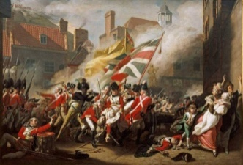
Lilliput is Swift’s satirical representation of the pettiness and small-mindedness of the church and state. Gulliver helps the Lilliputians defeat the Blefuscans , which is their enemies that also represents eighteenth century France, England’s traditional enemy.

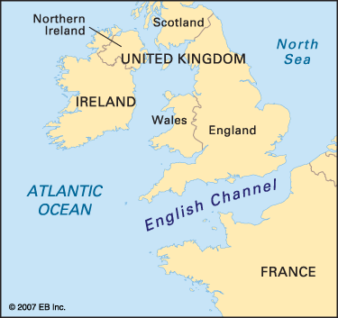
By the eighteenth century, both England and France were fighting wars on and off for centuries with both political and religious reasons.

The reminiscence of the channel that separates England from France is an eight- hundred –yard- wide channel that separates Lilliput from Blefescu . Then, he assists in negotiating a peace treaty between the two countries.
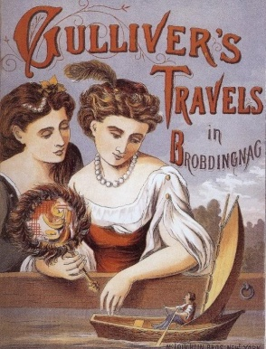
The second setting is on his second voyage. In this setting, he continues his satire on enlightenment ideals and English society in Brobdingnag, a land that accentuates human grossness because of the inhabitants’ stupendous size.

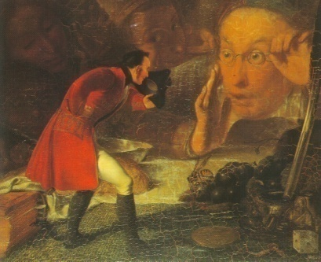
In Brobdingnag, Gulliver begins to see the foolhardiness of the English court and England in general which Brobdingnag represents.

After being kept by a young girl as a curiosity, Gulliver ends up in the Brobdingnagian court where the king becomes thoroughly disgusted by Gulliver's account of eighteenth-century British politics and culture. However, Gulliver eventually escapes from Brobdingnag .

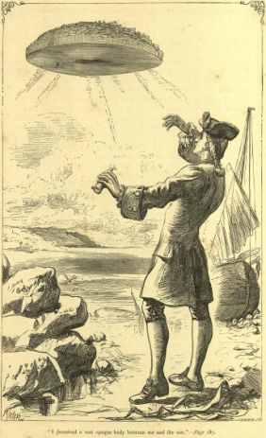
(No)The third setting is Gulliver's third voyage to Laputa, called the Flying Island by. His experience on this land shows how dangerous his rationalistic, scientific, and progressive views are.

In this setting, Swift satirized the scientific community in Great Britain. The Laputans, who are all a race of absent-minded scientists and philosophers, carry out experiments that have no practical value to the larger society,



for instance, trying to soften marble in order to make pillows; and training spiders to replace silkworms to create silk; and even attempt to build a house from the roof down.


The Laputans represent dreamy idealists who cannot apply the theories they set for.
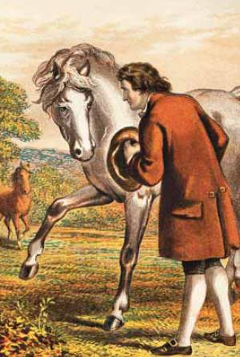
The fourth setting is the fourth voyage of Gulliver to the land of the Houyhnhnms. Swift continues satirizing in the land of the Houyhnhnms in this setting.

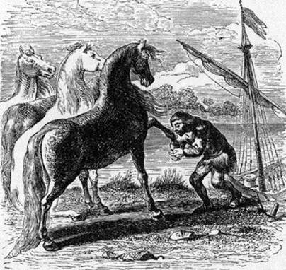
He demonstrates that the final results of the rationalistic philosophy permeated English thought during the late seventeenth and eighteenth centuries.

The fourth settings of Gulliver's voyages provide Swift with the opportunity to discuss everything he feels is wrong with mankind in general and British society with the locals.

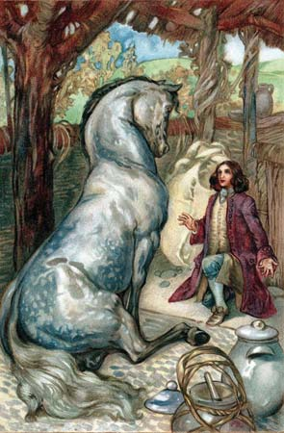
The land of the Houyhnhnms is presented as a decency, benevolence, and civility ruling every horse’s actions. Here, Gulliver finds no wars and no courts and passes his time in contemplation.
However, the love of family is also unknown because the Houyhnhnms regard it as unnecessary, though a marriage is regarded as rational, necessary purely to maintain the population. The land of the horses exemplifies the argument that human mind is a blank slate controlled and developed entirely by impressions made by the environment.

Scene 3: Analysis(Earth)

(Earth)The main issues for his satire were religion,
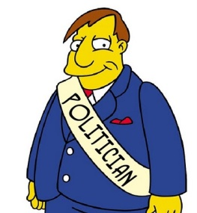
politics,


society


and culture.



He used Lilliputians' religious divisions between those who wear low-heeled and high-heeled shoes
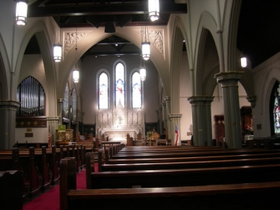

and those how open their eggs from the small and large ends first to satirize the ridiculous division between the religions in that time: low church


and high church as known as the protestant and catholic.
A low church rejected the tradition of high church which was too complicated compared to the simple one and Protestants rejected the Catholic Church to live.
This is a simple way of studying both religions which were his target for his satire.
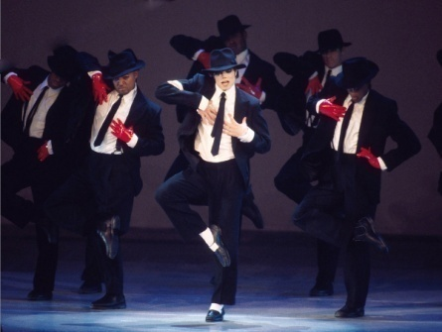
(Bank)Next, he satirizes the politics in his time by mentioning that the king of Lilliput chooses his noble men based on their ability to dance rather than on theirs skills in managing the kingdom.

This illustrates how the politicians in that time gained the power.
In the peaceful society of Brobdingnag , Swift uses the race of giants, their size and views on government as an effective satirical tool.

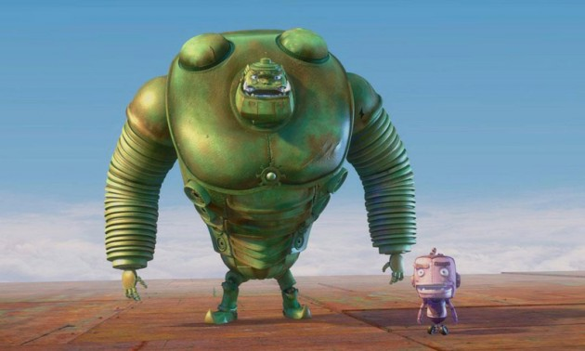

In contrast to the size of the Lilliputians that mocks their pettiness, he uses the size of the Brobdingnagdian to mock their pride and pretension.
Swift mocks their desire to have a large government and to assert their own importance.
Though Gulliver is of smaller stature, Swift uses this setting to satirize his own pride and, by extension, the pride of the English people.
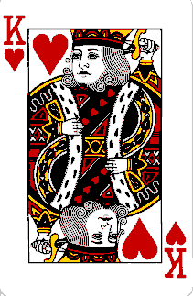

When the king asks Gulliver to tell him about the English government, Gulliver happily complies with the idea that he can impress the king with the accomplishments of his native land. However, the king concludes they are a "pernicious race of little odious vermin."
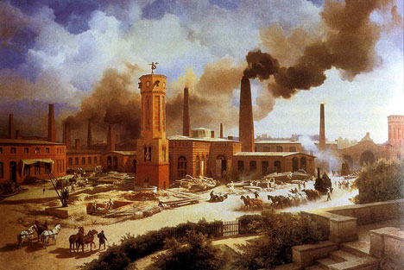
In the land of the Houyhnhnms, Swift criticizes the nature of man by using the differences between the rational horses, and the yahoos which was referred to the servants. His view is that man should be controlled by the higher elements of his nature but is seen as a victim of the baser elements.

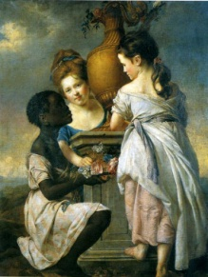
The economic environment at that time in Britain was an industrial one that needed lots of labors to operate factories.

Non-white people were usually the servants to the white people and they were treated indecently. British Empire treated non-whites as lower humans; this was regarded as Swift's intention to contempt the cultures at that time.
Scene 4: How can we compare Swift’s Guilliver’s Travels and Nineteen Eighty four?
(Hugo)We can conclude that both of these stories criticize society and politics. However, each one accomplishes its goals by using very different but effective methods that have made each a classic literature.
(Keng)In addition, the problem of corruption and greed of leaders can still be seen in our present day. There are many times that Thai people have to raise awareness on the issues of corrupted management of the government through demonstrations. In the book, Gulliver always shows his proud of being from the European country that has a superior culture, political system and education.
Nowadays, people face the same problem when they are a minority in some places such as the Thailand.

(Sun) The Gulliver’s Travels is a great book because it is a fantasy novel that is about adventures of Gulliver to many exotic places. They all exist in an imaginary world that the author creates. The book partially illustrates the history of England in the 17th century.
It also teaches readers many lessons. For example, we can see how the land was colonized. It is an entertainment that interests readers. Readers of all ages can broaden their imagination to picture the scene of each part of the book. Next, the method of satiring the British society is excellent. Swift conveys his messages in a delightful way but shows the satirical ideas behind the story beautifully so his messages make the readers enjoy the contents. Gulliver develops his characters over time and adeptly adapts to the new environment.
Lastly, the setting of Houyhnhnms shows a good example of society that is peaceful and utopian in Swift’s mind.
The loacation: Library and Belgium

