Natchalin Iwsakul 6104640153
Assignment 1

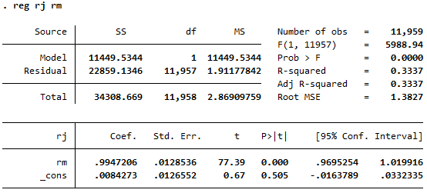
CAPM –

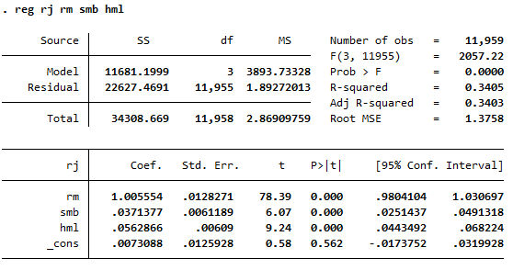
FF model-

- Jensen Alpha is insignificant as P-value of the alpha is 0.505 which is more than our confident level (0.05). Thus, we fail to reject Null hypothesis H0: B1 = 0 which shows insignificance of the Alpha. T-statistic of the alpha is 0.67 which when compares to t-critical (1.96) falls into the acceptance area of Null hypothesis which is insignificance.

- Having the same risk as the market means that having Beta1 equals to 1. Thus, I do the hypothesis test on both CAPM and FF model to see if rm=1 or not.
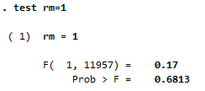
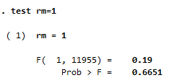
CAPM FF
As shown above, with significant level of 0.05, Portfolio j has the same risk as the market as both models’ P-value fail to reject H0: B1=1. CAPM: 0.6651>0.05. FF: 0.6813>0.05.

- Size premium is significant as the P-value of Beta of SMB is 0.000 which is less than 0.05 significant value. So, we reject the Null Hypothesis H0: Beta SMB is equal to 0. Also, the t-stat of Beta of SMB is more than t-critical (6.07>1.96). Thus, it falls into rejection area and that rejects Null hypothesis as well as P-value.
- Growth premium is significant as the P-value of Beta of HML is 0.000 which is less than 0.05 significant level. So, we reject the Null Hypothesis H0: Beta HML is equal to 0. Also, the t-stat of Beta of HML is more than t-critical (9.24>1.96). Thus, it falls into rejection area and that rejects Null Hypothesis as well as P-value.
- To know whether CAPM or FF is more appropriate, we have to test Ho: β2 = β3 = 0.
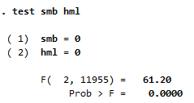
As shown on the left, the P-value is 0.000 which is less than 0.05. It means that we reject null hypothesis Ho: β2 = β3 = 0.
Thus, FF model is more appropriated than CAPM.

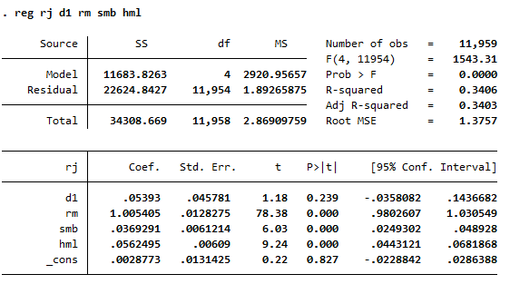

From the calendar effect regression above, the January effect is insignificant as the P-value of D1 is 0.239 which is more than 0.05 significant level. And, the t-stat is 1.18 which is less than the t-critical 1.96 as well. Thus, it falls into the acceptance area. Both methods lead to the acceptance in Ho: γ1 = 0 which means that the January effect is insignificant.
- From the Stata table in question 6, all of the variables are positive, includes return on market as well. Thus, it means that the rj will be positive as well. The P-value of F-test is 0.000 which is less than 0.05 significant level. It means that we reject Ho: all the betas equal to zero which shows that the overall betas are significant. Also, the R-squared shows us that 34% of rj can be explained by these variables. However, in the individual test, D1 is insignificant as their p-values is less than 0.05 significant level. Other than that, rm, smb, and hml are significant as the p-values are all equal to 0.000 which is less than 0.05 significant level.
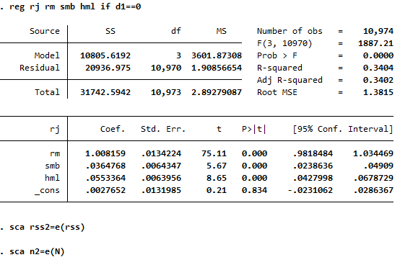
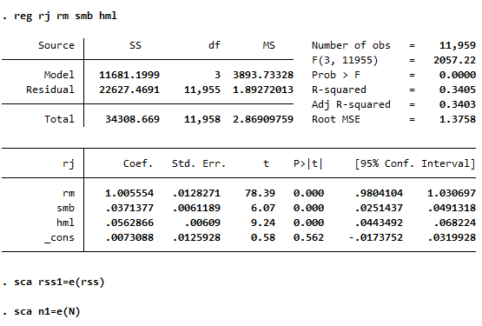

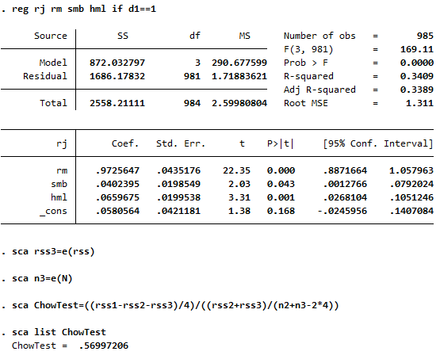

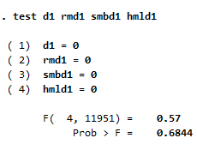
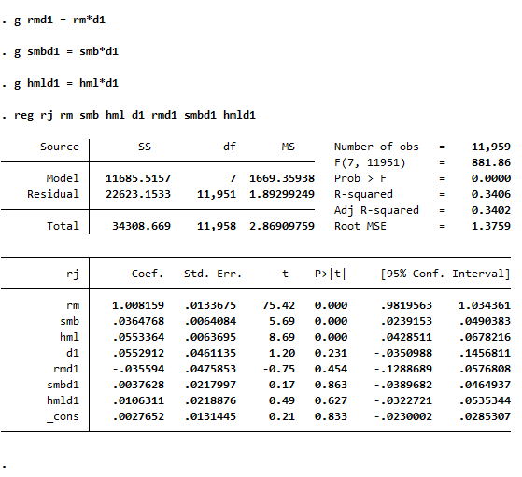

As you can see on both Chow test and FF test, they fail to reject the January effects where Ho: D1 = rmd1 = smbd1 = hmld1 = 0. Therefore, January and other month share the same structure of the Fama-French model.

