Chapter 2
Calculus of Single Variable

Here we will discuss only the calculus of optimization of a twice-differentiable single-variable function $y=f\left(x\right)$. See also Appendix to Chapter 1 of Baldani, et. al. [2005], p. 22-36.

2.1 Derivative

Definition 2.1 Let $f:S→R$, $S⊆R$, be a function. The derivative of the function f at $x$, $x∈S$, is defined as,

$$f^{'}\left(x\right)=\lim_{h⟶0}{\frac{f\left(x+h\right)-f(x)}{h}.}$$

The derivative exists if, and only if, the limit does.

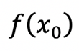
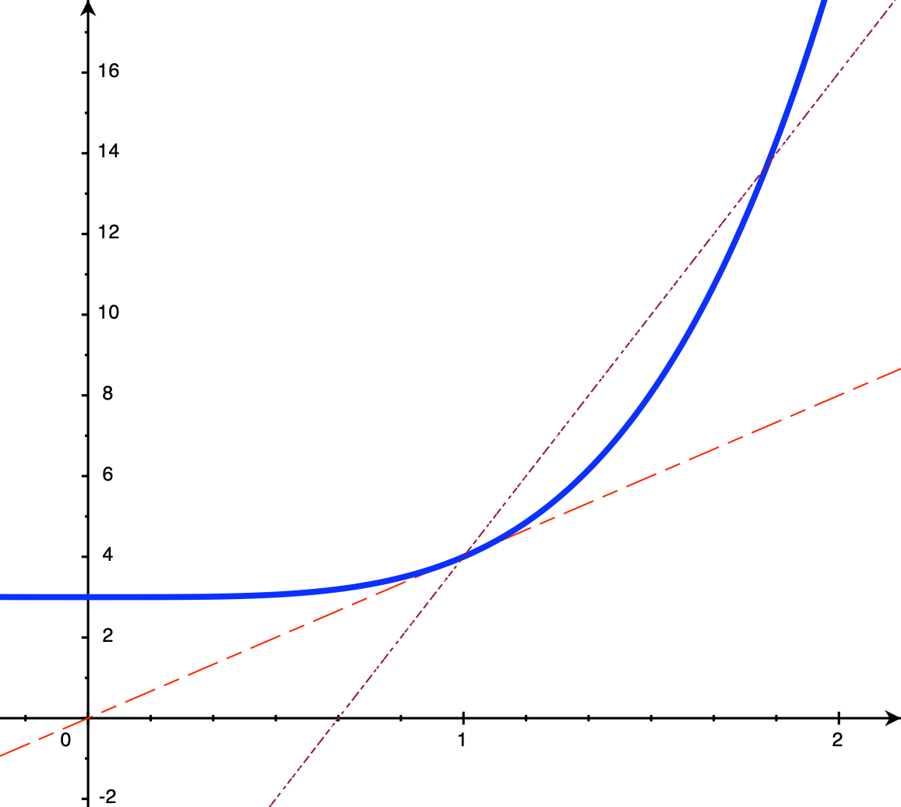
$$f\left(x_{0}+h\right)$$
$$x_{0}$$
$$x_{0}+h$$

Figure 2.1 Derivative of f at $x_{0}$

- f is said to be differentiable at $x_{0}$if $f'\left(x_{0}\right)$ exists.
- f is said to be differentiable if it is differentiable at each $x∈S$, and we can write $f∈C^{1}$, where $C^{1}$ is the set of all differentiable functions.
- $f'\left(x_{0}\right)$is interpreted as the slope or instantaneous rate of change of the function f at $x_{0}.$
- $f'\left(x_{0}\right)$ is also a function from the same domain $S$ to $R$.
- If ่$y=f(x)$, we can write $f^{'}\left(x\right)=\frac{dy}{dx}=\frac{df\left(x\right)}{dx}$ .

The followings are formulae of derivative frequently used.

- If $f\left(x\right)=ax^{n}$, then $f^{'}\left(x\right)=anx^{n-1}$.
- If
$$f\left(x\right)=\sum_{i=1}^{n}{g_{i}\left(x\right), }$$then

$$f^{'}\left(x\right)=\sum_{i=1}^{n}{g_{i}^{'}\left(x\right). }$$

- If $f\left(x\right)=g\left(x\right)h(x)$, then
$$f^{'}\left(x\right)=g\left(x\right)h^{'}\left(x\right)+h\left(x\right)g'(x)$$.
- If $f\left(x\right)=\frac{g\left(x\right)}{h(x)}$, then
$$f^{'}\left(x\right)=\frac{g\left(x\right)h^{'}\left(x\right)-h\left(x\right)g'(x)}{[h{\left(x\right)]}^{2}}.$$
- If $f\left(x\right)=ln⁡(x)$, then $f^{'}\left(x\right)=\frac{1}{x}$.
- If $f\left(x\right)=e^{x}$, then $f'\left(x\right)=e^{x}$.
- If $f\left(x\right)=\log_{a}\left(x\right)$, then $f^{'}\left(x\right)=\frac{1}{x}\log_{a}{e},$
$\text{where} a>0, a≠1.$

- If $f\left(x\right)= a^{x}$, then $f^{'}\left(x\right)=a^{x}\ln{a}, a>0.$ .
- Chain Rule: If $z=h\left(x\right)=g\left(f\left(x\right)\right), y=f(x)$, then

$$h'\left(x\right)=g'\left(f\left(x\right)\right)f'(x) \\ \frac{dz}{dx}=\frac{dz}{dy}\frac{dy}{dx}.$$
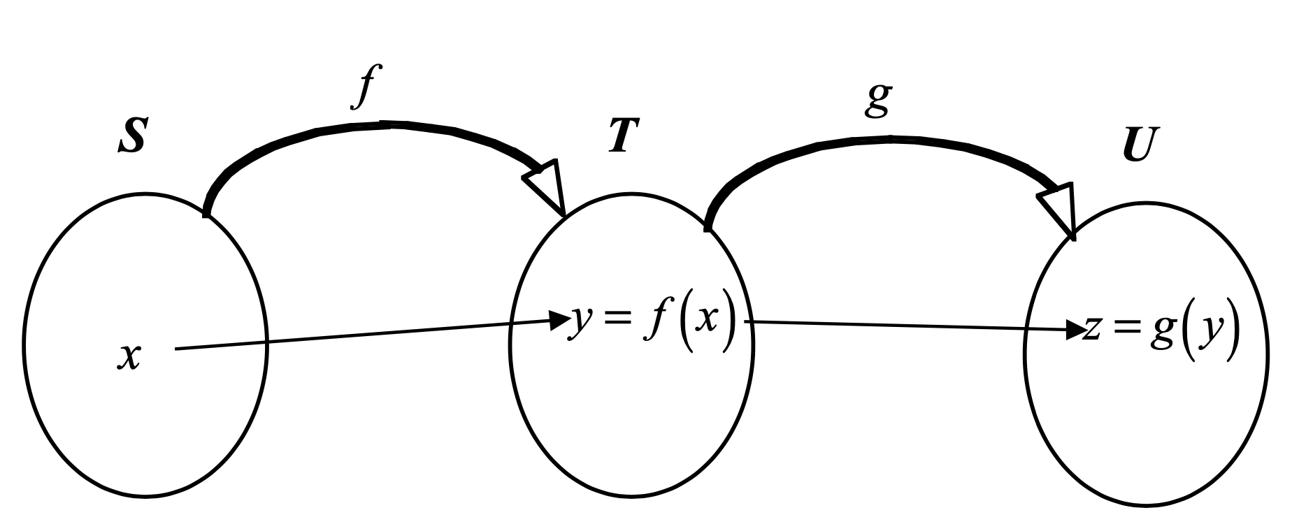

Figure 2.2 Diagram for a composite function

Example If $h\left(x\right)=ln⁡(f\left(x\right))$, then $h^{'}\left(x\right)=\frac{1}{f\left(x\right)}f^{'}\left(x\right)$.
Example If $h\left(x\right)=e^{f\left(x\right)}$, then $h^{'}\left(x\right)=e^{f\left(x\right)}f^{'}\left(x\right).$
Example Let $z=y^{5}$, and $y=(1-x^{3})$. The derivative of y with respect to x is given by

$$\frac{dz}{dx}=\frac{dz}{dy}\frac{dy}{dx} \\ =\frac{d}{dx}(y^{5})\frac{d}{dx}(1-x^{3})$$

HW Find the derivative of the following functions.

- $s={\left(t^{2}-3\right)}^{4}$

- $s=ln⁡(t^{2}-3)$
- $z=\frac{3}{{\left(1-y^{2}\right)}^{0.4}}$
- $y=\left(x^{2}+4\right)log⁡(2x^{3}-1)$
- $y=1+x+x^{2}+…+x^{n}$
- $PV=A(1+\frac{1}{1+r}+\frac{1}{{\left(1+r\right)}^{2}}+…+\frac{1}{{\left(1+r\right)}^{n}})$
- $F=Ae^{rt}$

2.2 Examples of Derivatives in Economics

Example: The derivative of the consumption function $C=a+bY$ is just $\frac{dC}{dY}=b$.
Example: From the budget line function,

$p_{x}x+p_{y}y=B$,

we can write $y=\frac{B}{p_{y}}-\frac{p_{x}}{p_{y}}x$, and thus $\frac{dy}{dx}=-\frac{p_{x}}{p_{y}}$.
Example: Suppose the total product as a function of $L$ is given by, $TP\left(L\right)=2L^{\frac{2}{3}}$, the marginal product which is the slope of total product will be just

$$MP\left(L\right)=\frac{dTP\left(L\right)}{dL}=\frac{4}{3}L^{-\frac{1}{3}}$$

Example: Taking the derivative on both sides of the equation $TP\left(L\right)=AP\left(L\right)×L$, we have

$$\frac{dTP(L)}{dL}=MP\left(L\right)=AP\left(L\right)\frac{dL}{dL}+L\frac{dAP\left(L\right)}{dL} \\ =AP\left(L\right)+L\frac{dAP\left(L\right)}{dL}$$

HW Can you get the same relation between $MP\left(L\right)$ and $AP(L)$ by taking the derivative on both sides of the equation $AP\left(L\right)=\frac{TP\left(L\right)}{L}$?

Example: If the demand $p=f(q)$ is a linear function, the marginal revenue curve is also linear with slope twice that of the demand function, in absolute value. Since price is by definition the average revenue, we can write

$$p=AR\left(q\right)=a-bq \\ TR\left(q\right)=AR\left(q\right)×q=aq-bq^{2} \\ MR\left(q\right)=\frac{dTR\left(q\right)}{dq}=a-2bq$$

Example: Elasticity of demand

$$\frac{\%ΔQ}{\%ΔP}=\frac{ΔQ}{ΔP}\frac{P}{Q} \\ =\frac{dQ}{dP}\frac{P}{Q}$$

Example: The elasticity of demand can be shown to be $\frac{dln\left(Q\right)}{dln\left(P\right)}=\frac{dQ}{dP}\frac{P}{Q}$.

Proof Let $r=lnP$. So $P=e^{r}$. By chain rule,

$$\frac{dlnQ}{dlnP}=\frac{dlnQ}{dP}\frac{dp}{dlnP} \\ =\frac{dlnQ}{dP}\frac{dP}{dr} \\ =\frac{1}{Q}\frac{dQ}{dP}e^{r} \\ =\frac{dQ}{dP}\frac{P}{Q}$$

HW Show that the elasticity can also be given as $\frac{dlog_{a}Q}{dlog_{a}P}$ for any base a.

Example: If a demand function is given by $Q=P^{-2}$, we have
$$lnQ=-2lnP$$
$$\frac{dlnQ}{dlnP}=-2$$

That is, this demand function has a constant elasticity being $-2$ at any price.

Example Continuous time interest rate as an extension of discrete time case.

In discrete time case,

$$Y\left(t+1\right)=\left(1+r\right)Y\left(t\right)⟹Y\left(t\right)=Y\left(0\right){\left(1+r\right)}^{t}.$$

Analogously, in continuous time

$$Y\left(t+1\right)=\left(1+r\right)Y\left(t\right)$$
$$⟹Y\left(t+1\right)-Y\left(t\right)=rY\left(t\right) \\ ⟹\frac{Y\left(t+Δt\right)-Y\left(t\right)}{Δt}=iY(t)$$

We have
$$\lim_{Δt→0}{\frac{Y\left(t+Δt\right)-Y\left(t\right)}{Δt}=Y^{'}\left(t\right)=iY\left(t\right).}$$.
We can solve this differential equation as shown in the following problem.

Problem From $Y^{'}\left(t\right)=iY(t)$, we have by solving a simple differential equation
a) $Y\left(t\right)=Y\left(0\right)e^{it}$
b) $i=ln⁡(1+r)$.

2.3 Derivatives and Increasing Functions

Definition 2.2 A function $f:S→R$, $S⊆R$ is increasing in an interval $A, A⊆S$ , if for any $x_{1},x_{2}∈A,$

$$x_{1}≤x_{2}⟺f\left(x_{1}\right)≤f\left(x_{2}\right).$$

- If $A=S$, the function is simply called increasing.
- We can also define a function to be increasing at a single point $x_{0}$ as given in Definition 2.3 below.

Definition 2.3 A function $f:S→R$, $S⊆R$, is increasing at $x_{0}$, if there exists $ε>0$such that for any
$x∈\left(x_{0}-ε,x_{0}\right), f\left(x\right)≤f\left(x_{0}\right),$ and$x∈\left(x_{0},x_{0}+ε\right)$, $f\left(x_{0}\right)≤f\left(x\right)$.

Theorem 2.1 For a function $f:S→R$, $S⊆R$ that is differentiable at $x_{0}$, if $f$ is increasing at $x_{0}$, then $f'(x_{0})≥0$

Proof Since $f$is increasing at $x_{0}$, there exists $ε>0$ such that for any $x_{1}∈\left(x_{0},x_{0}+ε\right)$, $f\left(x_{0}\right)≤f\left(x_{1}\right)$. Write $x_{1}=x_{0}+h,0<h< ε,$ we have,

$$\frac{f\left(x_{0}+h\right)-f\left(x_{0}\right)}{h}≥0$$

Since $f$ is differentiable at $x_{0}$, $f^{'}\left(x_{0}\right)$ is equal to the right limit and nonnegative, i.e.,

$$f^{'}\left(x_{0}\right)=\lim_{h→0^{+}}{\frac{f\left(x_{0}+h\right)-f\left(x_{0}\right)}{h}}≥0.$$

The left limit can be similarly shown to be nonnegative as in the problem below.$∎$

Problem Show by similar argument, for any $x_{2}∈\left(x_{0}-ε,x_{0}\right)$, $f\left(x_{2}\right)≤f\left(x_{0}\right)$, with $x_{2}=x_{0}+h,-ε<h<0$, we have

$$\lim_{h→0^{-}}{\frac{f\left(x_{0}+h\right)-f\left(x_{0}\right)}{h}}≥0.$$

Problem Show by counterexample that the reverse of the above Theorem 2.1 is false. That is, if $f'(x_{0})≥0$, the function is not necessarily increasing at $x_{0}$.

Definition 2.4 A function $f:S→R$, $S⊆R$, is decreasing at $x_{0}$, if there exists $ε>0$such that for any
$x∈\left(x_{0}-ε,x_{0}\right), f\left(x\right)≥f\left(x_{0}\right),$and $x∈\left(x_{0},x_{0}+ε\right)$, $f\left(x_{0}\right)≥f\left(x\right)$.

Corollary 2.1 For a function $f:S→R$, $S⊆R$ that is differentiable at $x_{0}$, if $f$ is decreasing at $x_{0}$, then $f^{'}\left(x_{0}\right)≤0.$

Proof Directly from Theorem 2.1.

Definition 2.5 A function $f:S→R$, $S⊆R$, is strictly increasing at $x_{0}$, if there exists $ε>0$such that for any
$x∈\left(x_{0}-ε,x_{0}\right), f\left(x\right)<f\left(x_{0}\right),$and $x∈\left(x_{0},x_{0}+ε\right)$, $f\left(x_{0}\right)<f\left(x\right)$.

Definition 2.6 A function $f:S→R$, $S⊆R$, is strictly decreasing at $x_{0}$, if there exists $ε>0$such that for any
$x∈\left(x_{0}-ε,x_{0}\right), f\left(x\right)>f\left(x_{0}\right),$and $x∈\left(x_{0},x_{0}+ε\right)$, $f\left(x_{0}\right)>f\left(x\right)$.

- Note: a function $f$ is increasing if and only if $-f$ is decreasing.
- Note: a function $f$ is strictly increasing if and only if $-f$ is strictly decreasing.

Theorem 2.2 For a function $f:S→R$, $S⊆R$ that is differentiable at $x_{0}$, if$f^{'}\left(x_{0}\right)>0$, then f is strictly increasing at $x_{0}$.

Proof (By contradiction) Suppose that $f^{'}\left(x_{0}\right)>0$, but $f$ is not increasing at $x_{0}$. It means that for any $ε>0$, either

- there always exists some $h,$ $0<h<ε,$ such that $f\left(x_{0}+h\right)≤f\left(x_{0}\right)$. Thus,

$$\lim_{h→0^{+}}{\frac{f\left(x_{0}+h\right)-f(x_{0})}{h}}≤0,$$

or

- there always exists some $h,$ $-ε<h<0,$ such that $f\left(x_{0}+h\right)≥f\left(x_{0}\right)$. Thus,

$$\lim_{h→0^{-}}{\frac{f\left(x_{0}+h\right)-f(x_{0})}{h}}≤0.$$

In either case, it contradicts $f^{'}\left(x_{0}\right)>0.∎$

Problem Show that the following two statements are equivalent:
- if $f^{'}\left(x_{0}\right)<0$then $f$ is strictly decreasing at $x_{0}$
- if $f^{'}\left(x_{0}\right)>0$then $f$ is strictly increasing at $x_{0}$

Problem Show by counterexample that if the function is strictly increasing, it is not necessary that $f^{'}\left(x_{0}\right)>0.$

Corollary 2.2 For a function $f:S→R$, $S⊆R$ that is differentiable at $x_{0}$, if$f^{'}\left(x_{0}\right)<0$, then f is strictly decreasing at $x_{0}$.

Proof By Theorem 2.2.$∎$

We now show the derivative of function that is increasing over an open interval.

Theorem 2.3 Let function $f:S→R$, $S⊆R$, be a function that is differentiable in open interval $(a,b)⊆S$. The function $f$ is increasing in $(a,b)$, if, and only if, $f^{'}\left(x\right)≥0$, $x∈(a,b)$.

Note: Unlike the function being increasing at a point, here we have the equivalence of being increasing and nonnegativity of derivative over an open interval.

Proof $\left(⟹\right)$ Suppose there exists $x_{0}∈(a,b)$ such that $f^{'}\left(x_{0}\right)<0$. By Corollary 2.2, $f$ is strictly decreasing at $x_{0}$. Thus we can find two points $x_{0}$ and $x_{0}+ε$, for some $ε>0$such that $f\left(x_{0}\right)>f\left(x_{0}+ε\right)$. Thus $f$ is not increasing in $(a,b)$.
.
$\left(⟸\right)$ Suppose $f^{'}\left(x\right)≥0$, $x∈(a,b)$, but$f$ is not increasing in $(a,b)$. There exist $x_{1},x_{2}∈(a,b), x_{1}<x_{2}$ but $f\left(x_{1}\right)>f(x_{2})$. By Mean Value Theorem (See Appendix I of Chapter 2), there exists $x_{0}∈\left(x_{1},x_{2}\right)$ such that

$$f^{'}\left(x_{0}\right)=\frac{f\left(x_{1}\right)-f(x_{2})}{x_{1}-x_{2}}<0,$$

Thus we have a contradiction.$∎$

Corollary 2.3 Let function $f:S→R$, $S⊆R$, be a function that is differentiable in open interval $(a,b)⊆S$. The function $f$ is decreasing in $(a,b)$, if, and only if, $f^{'}\left(x\right)≤0$, $x∈(a,b)$.

Example The function $f\left(x\right)=2x^{3}+x-2$ is always increasing.

Example The function $f\left(x\right)=x^{2}+4x+36$ is increasing if $x>-2$.

HW Is $s={\left(t^{2}-3\right)}^{4}$ an increasing function? In which range of the values of t?

HW Is $F=Ae^{rt}$ an increasing function? For which range of values of t? (r is a positive parameter)

Theorem 2.4 Let function $f:S→R$, $S⊆R$, be a function that is differentiable in open interval $\left(a,b\right)⊆S$. If $f^{'}\left(x\right)>0$, for all $x∈(a,b)$, then $f$ is strictly increasing in $\left(a,b\right)⊆S$.

Proof Suppose $f^{'}\left(x\right)>0$, for any $x∈(a,b)$, but $f$ is not strictly increasing in $\left(a,b\right)⊆S$. Thus, there exist $x_{1},x_{2}∈(a,b)$, such that $x_{1}<x_{2}$, but $f\left(x_{1}\right)≥f(x_{2})$. By Mean Value Theorem (see Appendix I of Chapter 2), there exists $x_{0}∈\left(x_{1},x_{2}\right)$ such that

$$f^{'}\left(x_{0}\right)=\frac{f\left(x_{2}\right)-f(x_{1})}{x_{2}-x_{1}}≤0.$$

Thus we have a contradiction.$∎$

Problem Show that the reverse of the above Theorem 2.4 is false. That is, there is some function $f$ that is strictly increasing in $\left(a,b\right)⊆S$, there can be some $x_{0}∈(a,b)$, where $f^{'}\left(x_{0}\right)=0$.

Corollary 2.4 Let function $f:S→R$, $S⊆R$, be a function that is differentiable in open interval $\left(a,b\right)⊆S$. If $f^{'}\left(x\right)<0$, for all $x∈(a,b)$, then $f$ is strictly decreasing in $\left(a,b\right)⊆S$.

Proof By Theorem 2.4.$∎$

2.4 Second- and Higher-Order Derivatives

Since the derivative $f'(x)$ is also a function of x, we can take the derivative of $f'(x)$, and this is called the second-order derivative of $f$ at x.

Definition 2.7 The second-order derivative of $f:S→R$, $S⊆R$, is given by,

$$f″(x)= \frac{d}{dx}f'(x) \\ =\frac{d^{2}}{dx^{2}}f\left(x\right) \\ =\frac{d^{2}y}{dx^{2}}$$

- The k^{th}-order derivative of $f:S→R$, $S⊆R,$ is recursively given by,

$$f^{k}\left(x\right)=\frac{d}{dx}f^{k-1}\left(x\right),$$

where $f^{k-1}\left(x\right)$ is the ${\left(k-1\right)}^{st}$-order derivative of $f$at $x, k=2,3,…$.

- $f$is twice-differentiable at x if $f″\left(x\right)$exists.
- $f$ is k-time-differentiable at x if $f^{k}\left(x\right)$exists.
- $f$ is twice-differentiable, write $f∈C^{2}$, if it is twice-differentiable at each $x∈S$.
- $f∈C^{k}$ if it is k-time differentiable at each $x∈S.$

HW Find the second-order derivatives of the following functions.
- $s={\left(t^{2}-3\right)}^{4}$
- $s=\ln\left(t^{2}-3\right)$
- $z=\frac{3}{{\left(1-y^{2}\right)}^{0.4}}$
- $y=1+x+x^{2}+…+x^{n}$
- $PV=A[1+\frac{1}{1+r}+\frac{1}{{\left(1+r\right)}^{2}}+…+\frac{1}{{\left(1+r\right)}^{n}}]$
- $F=Ae^{rt}$

2.5 Optimization: Single Variable

Figure 2.3 Graph of a function with maximum and minimum points.

Definition 2.8 A point $x^{*}$ is a local maximum point of $f:S→R$, $S⊆R$, if

$f\left(x^{*}\right)≥f(x)$,

for any $x∈S,$such that $\left|x-x^{*}\right|<ε$for some $ε>0$.

Definition 2.9 A point $x^{*}$ is a local strict maximum point of $f:S→R$, $S⊆R$, if

$f\left(x^{*}\right)>f(x)$,

for any $x∈S, x≠x^{*}$, such that $\left|x-x^{*}\right|<ε$ for some $ε>0$.

Definition 2.10 A point $x^{*}$ is a global maximum point of $f:S→R$, $S⊆R$, if

$f\left(x^{*}\right)≥f\left(x\right)$,

for any $x∈S$.

Definition 2.11 A point $x^{*}$ is a global strict maximum point of $f:S→R$, $S⊆R$, if

$f\left(x^{*}\right)>f(x)$,

for any $x∈S, x≠x^{*}$.

- Definitions for minimum points are defined similarly.

HW Using the definition of the maximum and minimum points,

Show that $x^{*}$ is a local maximum point of $f(x)$ if and only if it is a local minimum point of $–f\left(x\right).$That is, $\max{f\left(x\right)⇔}\min{-f(x)}$.

Show that $\max{f\left(x\right)⇔}\max{cf\left(x\right), c>0}$.

2.5.1 Necessary Conditions When a maximum point where the function is twice differentiable, two conditions follow.

Theorem 2.5 If $x^{*}$ is a local maximum point of $f:S→R$, $S⊆R$, and $f∈C^{2}$, then
- $f^{'}\left(x^{*}\right)=0$, and
- $f^{″}\left(x^{*}\right)≤0.$

Proof If $x^{*}$ is a local maximum point but $f^{'}\left(x^{*}\right)≠0$, it means either $f^{'}\left(x^{*}\right)>0$ or $f^{'}\left(x^{*}\right)<0$. That means $f$ is strictly increasing or strictly decreasing at $x^{*}$. Thus, $x^{*}$ cannot be a maximum point. So we must have $f^{'}\left(x^{*}\right)=0.$

If $f^{'}\left(x^{*}\right)=0$ but $f^{″}\left(x^{*}\right)>0,$ then $f^{'}\left(x^{*}\right)$ is strictly increasing at $x^{*}$. There exists some $ε>0$ such that for $x∈\left(x^{*}-ε,x^{*}\right)$, $f^{'}\left(x\right)<f^{'}\left(x^{*}\right)=0,$ so $f$ is strictly decreasing at $x$. Similarly, for $x∈\left(x^{*},x^{*}+ε\right)$, ${0=f}^{'}\left(x^{*}\right)<f^{'}\left(x\right),$ so $f$ is strictly increasing at $x$. Thus, $x^{*}$ is a strictly minimum point so it cannot be a local maximum point.$∎$

- Note that the second part of the proof above also proves the sufficient conditions to be discussed below. (See Theorem 2.6)

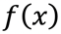
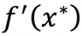

Figure 2.4 Graph of $f\left(x\right)$and its derivative $f'(x)$ at the maximum points.

Example Profit Maximization.

$$π\left(q\right)=TR\left(q\right)-TC\left(q\right) \\ \frac{dπ\left(q\right)}{dq}=\frac{dTR\left(q\right)}{dq}-\frac{dTC\left(q\right)}{dq} \\ =MR\left(q\right)-MC\left(q\right).$$
If $q^{*}$ is an output level that maximizes (locally) profit, by the first order necessary condition,

$$\frac{dπ\left(q^{*}\right)}{dq}=0⟺MR\left(q^{*}\right)=MC(q^{*})$$

and second order necessary condition,

$$\frac{d^{2}π\left(q^{*}\right)}{dq^{2}}≤0 \\ ⟺\frac{dMR\left(q^{*}\right)}{dq}≤\frac{dMC\left(q^{*}\right)}{dq} \\ ⟺\text{Slope of }MR\left(q^{*}\right)≤\text{Slope of }MC\left(q^{*}\right).$$

2.5.2 Sufficient Conditions What are the conditions that once attained are sufficient to announce a point being a maximum one. The necessary condition is not enough to guarantee a maximum point as seen in the graph below.

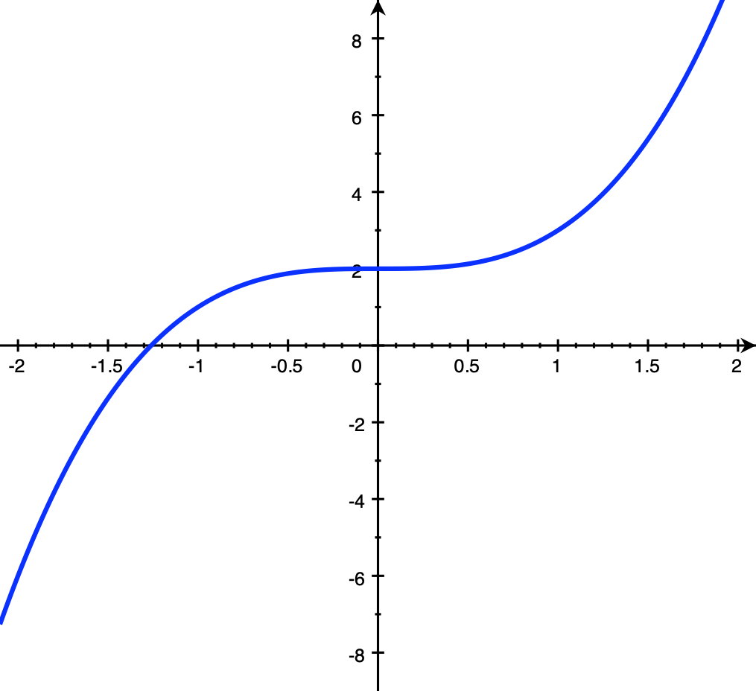
Figure 2.5 Graph of $y=x^{3}+2$.

As shown in the proof of the necessary condition, we have,

Theorem 2.6 If $f:S→R$, $S⊆R$, and $f∈C^{2}$ and
- $f^{'}\left(x^{*}\right)=0$, and
- $f″\left(x^{*}\right)<0,$
then $x^{*}$ is a local maximum point.

Proof See the proof of Necessary Conditions, Theorem 2.5.$∎$

- Sufficient conditions actually guarantee local strict maximum
- Sufficient conditions cannot guarantee global maximum nor minimum. We need a much stronger assumption for global maximum.
- Each point $x^{*}$ that satisfies the first-order sufficient condition is called a critical point. Then only the critical point that also satisfies the second-order sufficient condition will be guaranteed to be a maximum point.
- There could be others maximum points that are not detected by the sufficient conditions.

Example Find the point of maximum profit. $TR\left(q\right)=10q^{\frac{1}{2}}$, $TC\left(q\right)=20+0.6q$.

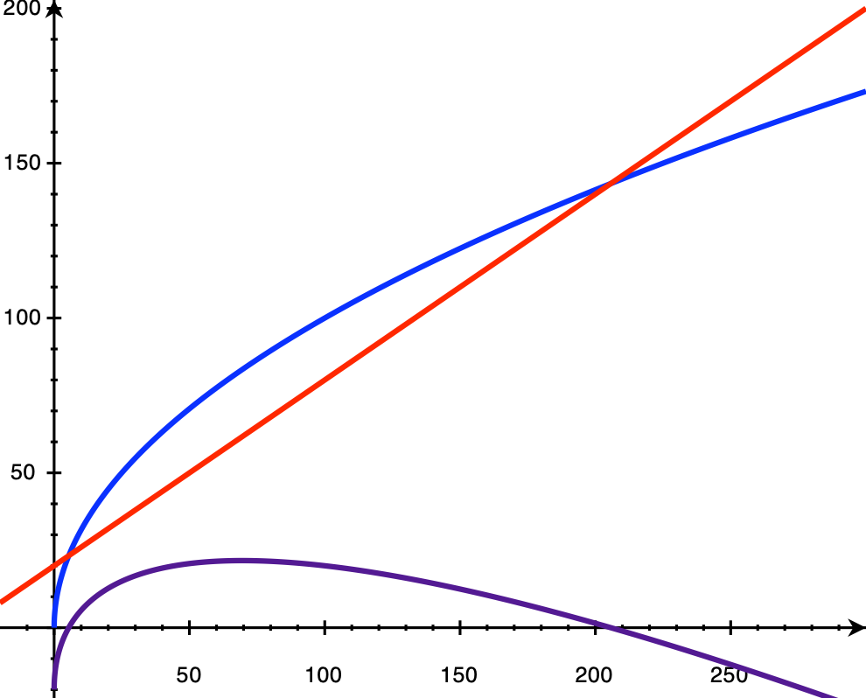
Figure 2.6 Profit maximization.

$$π\left(q\right)=10q^{\frac{1}{2}}-\left(20+0.6q\right) \\ π'\left(q^{*}\right)=5{q^{*-}}^{\frac{1}{2}}-0.6=0 \\ q^{*}={\left(\frac{0.6}{5}\right)}^{-2}=69.44, \\ \text{and }π''\left(q^{*}\right)=-\frac{5}{2}{q^{*}}^{-\frac{3}{2}}<0.$$

We can conclude that the critical point $q^{*}=69.44$ is a local strict maximum point.

HW As a continuation of the previous example,
- Find the value of the profit at $q^{*}=69.44$.
- If $TR\left(q\right)=10q^{\frac{1}{2}}$as before but $TC\left(q\right)=2,000+0.6$, will $q^{*}=69.44$ still be the point of local maximum profit?

HW Find the maximum and minimum points of the functions
a) $f\left(x\right)={\left(x^{2}-16\right)}^{3}$.
b) $f\left(x\right)=x^{3}+6x^{2}-36x+90$
c) $f\left(x\right)=x^{2}e^{x}$
d) $f\left(x\right)=\frac{5x+2}{x^{2}+1}$.

Theorem 2.7 Let the composite function $h:S→U$ be given by $h\left(x\right)=g(f\left(x\right))$, where $f:S→T$ and $g:T→U$ . If the function $g:T→U$ be an strictly increasing function such that its derivative is always positive, i.e., $g^{'}\left(y\right)>0$ for any $y∈T$, then for any $x^{*}∈S$

$$\left.\begin{matrix}f^{'}\left(x^{*}\right)=0, \\ f″\left(x^{*}\right)<0\end{matrix}\right\}⟺\left\{\begin{matrix}h^{'}\left(x^{*}\right)=0, \\ h″\left(x^{*}\right)<0.\end{matrix}\right.$$

Proof By the Chain Rule,

$$h^{'}\left(x^{*}\right)=g'(f\left(x^{*}\right)f^{'}\left(x^{*}\right)=0 \\ h″\left(x^{*}\right)=g^{'}\left(f\left(x^{*}\right)\right)f″\left(x^{*}\right)+f^{'}\left(x^{*}\right)\frac{d}{dx} g^{'}\left(f\left(x^{*}\right)\right) \\ =g^{'}\left(f\left(x^{*}\right)\right)f″\left(x^{*}\right)<0. ∎$$

Example Consider the function $f\left(x\right)=3-x^{2}$. Using the sufficient conditions, we obtain a local maximum point $x^{*}=0$. Then, this point $x^{*}$ also satisfies the sufficient conditions for the functions

$$h\left(x\right)=e^{f\left(x\right)}=e^{3-x^{2}} \\ r\left(x\right)=\ln\left(f\left(x\right)\right)=\ln\left(3-x^{2}\right), 3-x^{2}>0.$$

But the point $x^{*}=0$ does not satisfy the sufficient conditions for the function

$$s\left(x\right)=g\left(y\right)={\left(y-3\right)}^{2}={\left(-x^{2}\right)}^{2}=x^{4}.$$

Can you verify this?

HW
- Under the same assumptions as in the above Theorem 2.7, is it true that
$$\left.\begin{matrix}f'\left(x^{*}\right)=0, \\ f″\left(x^{*}\right)≤0\end{matrix}\right\}⟺\left\{\begin{matrix}h'\left(x^{*}\right)=0, \\ h″\left(x^{*}\right)≤0.\end{matrix}\right.$$

- If$g^{'}\left(y\right)≥0$ for any $y∈T$, does any conclusion of Theorem 2.7 has to be modified?
- If $g^{'}\left(y\right)<0$ for any $y∈T$, does any conclusion of Theorem 2.7 has to be modified?
- Can we assume in Theorem 2.7 only that $g^{'}\left(y^{*}\right)>0$ only at $y^{*}=f(x^{*})$?

2.6 Concave and Convex Functions

Definition 2.12 The function $f:S→R$, $S⊆R$, is a concave (convex) function, if

$$f\left(λx_{1}+\left(1-λ\right)x_{2}\right)≥λf\left(x_{1}\right)+\left(1-λ\right)f\left(x_{2}\right) \\ (≤)$$

for any $x_{1},x_{2}∈S$, and $0≤λ≤1$.

Definition 2.13 The function $f:S→R$, $S⊆R$, is a strictly concave (convex) function, if

$$f\left(λx_{1}+\left(1-λ\right)x_{2}\right)>λf\left(x_{1}\right)+\left(1-λ\right)f\left(x_{2}\right) \\ (<)$$

for any $x_{1},x_{2}∈S$, and $0<λ<1$.

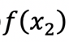
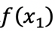
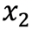
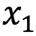
Figure 2.7 A concave function.

- According to the definition, a function is concave if the straight line connecting any pair of points on the graph of the function is never above the graph of the function.
- Linear function is both concave and convex.
- If $f$ and $g$ are concave, then $f+g$ is also concave.
- If $f$ is concave, then $-f$ is convex.

HW If $f$ and $g$ are concave, then is $f-g$ also concave?

Theorem 2.8 Let $f:S→R$, $S⊆R$, be a differentiable function. The function $f$ is concave (convex) if, and only if,

$$f\left(y\right)-f\left(x\right)≤f^{'}\left(x\right)\left(y-x\right),$$
$$(≥)$$

for any $x,y∈S.$

Proof See Appendix II of Chapter 2.$∎$

Note that the statement $f\left(y\right)-f\left(x\right)≤f^{'}\left(x\right)\left(y-x\right)$ is equivalent to

- $\frac{f\left(y\right)-f\left(x\right)}{\left(y-x\right)}≤f^{'}\left(x\right)$, if $y>x$ and
- $\frac{f\left(y\right)-f\left(x\right)}{\left(y-x\right)}≥f^{'}\left(x\right)$, if $y<x$.

Theorem 2.9 Let $f:S→R$, $S⊆R$, be a differentiable function. The function $f$ is strictly concave (convex) if, and only if,

$$f\left(y\right)-f\left(x\right)<f^{'}\left(x\right)\left(y-x\right),$$
$$(>)$$

for any $x,y∈S, x≠y.$

Proof See Appendix II of Chapter 2.$∎$

Theorem 2.10 Let $f:S→R$, $S⊆R$, be a differentiable function. The function $f$ is concave if, and only if, $f'$ is decreasing.

Proof $\left(⟹\right)$Let $x,y∈S$, and $x<y$. If $f$ is concave, then

$$\frac{f\left(y\right)-f\left(x\right)}{\left(y-x\right)}≤f^{'}\left(x\right)$$
$$\frac{f\left(x\right)-f\left(y\right)}{\left(x-y\right)}≥f^{'}\left(y\right).$$

Thus, $f^{'}\left(x\right)≥f^{'}\left(y\right)$ so $f'$ is decreasing.

$(⟸)$ Suppose $f^{'}$ is decreasing. Let $x,y∈S$, and $x<y$. By Mean Value Theorem, there exists $z∈(x,y)$, such that

$$\frac{f\left(y\right)-f\left(x\right)}{\left(y-x\right)}=f^{'}\left(z\right)$$

Since, $f'$ is decreasing and $x≤z$, then $f^{'}\left(z\right)≤f^{'}(x)$, and thus

$$\frac{f\left(y\right)-f\left(x\right)}{\left(y-x\right)}=f^{'}\left(z\right)≤f^{'}\left(x\right).$$

Thus $f$ is concave by Theorem 2.8. $∎$

Theorem 2.11 Let $f:S→R$, $S⊆R$, be a differentiable function. The function $f$ is strictly concave if, and only if, $f'$ is strictly decreasing.

Problem Prove Theorem 2.11.

Theorem 2.12 If $f:S→R$, $S⊆R$, is twice differentiable, then
- $f$ is concave $⟺f^{″}\left(x\right)≤0$, for any $x∈S$.
- $f^{″}\left(x\right)<0$, for any $x∈S⟹f$ is strictly concave

Proof (a) From the previous results:

$f$ is concave $⟺$ $f'$ is decreasing (Theorem 2.10)
$⟺$ $f^{″}\left(x\right)≤0$, for any $x∈S.$ (Corollary 2.3) $∎$

(b) $f^{″}\left(x\right)<0$, for any $x∈S$ $⟹$ $f'$ is strictly decreasing
$⟺f$ is strictly concave.

The implication is due to Corollary 2.4, and the equivalence by Theorem 2.11.$∎$

- For part (b) above, consider $f\left(x\right)=-x^{4}$ to show that the opposite direction of the implication is false.

HW Which of the following functions concave or convex?
a) $f\left(x\right)=x^{2}$
b) $f\left(x\right)=x^{2}-6x+5$
c) $f\left(x\right)=x^{3}-6x^{2}+5x+100$
d) $f\left(x\right)=\ln{x}$

Theorem 2.13 Let $f:S→R, S⊆R$,
- If $f$ is concave, a local maximum point $x^{*}$ is also a global one.
- If $f$ is strictly concave, a local maximum point $x^{*}$ is also a strictly global one.

Proof (a) Note that the function is not assumed to be differentiable or even continuous. If $x^{*}$ is a local max of $f$, there exists some $ε>0$ such that $f\left(x\right)≤f(x^{*})$, for any ${x∈(x}^{*}-ε,x^{*}+ε)$.

Suppose that $x^{*}$ is a local maximum point but is not a global one. That means there exists some $\hat{x}∈S$, $\hat{x}∉(x^{*}-ε,x^{*}+ε)$ such that $f\left(\hat{x}\right)>f\left(x^{*}\right)$. We can assume without loss of generality that $\hat{x}>x^{*}$. Since $f$ is concave, for any $0≤λ≤1$, we have

$$f\left(λx^{*}+\left(1-λ\right)\hat{x}\right)≥λf\left(x^{*}\right)+\left(1-λ\right)f\left(\hat{x}\right) \\ >λf\left(x^{*}\right)+\left(1-λ\right)f\left(x^{*}\right)=f\left(x^{*}\right).$$
Choose $x_{0}=λ_{0}x^{*}+\left(1-λ_{0}\right)\hat{x}$. Since $\hat{x}>x^{*}$, we have ${x^{*}<x}_{0}$ and if we choose $λ_{0}$ such that

$$0<\left(1-\frac{ε}{\hat{x}-x^{*}}\right)<λ_{0}<1,$$

so that

$$x_{0}=λ_{0}x^{*}+\left(1-λ_{0}\right)\hat{x} \\ =\hat{x}-λ_{0}\left(\hat{x}-x^{*}\right) \\ <\hat{x}-\left(1-\frac{ε}{\hat{x}-x^{*}}\right)\left(\hat{x}-x^{*}\right) \\ =\hat{x}-\hat{x}+x^{*}+ε \\ =x^{*}+ε.$$

We have, $x_{0}∈\left(x^{*},x^{*}+ε\right)$, and thus $f\left(x_{0}\right)≤f\left(x^{*}\right)$ by the assumption that $x^{*}$ is a local maximum. But $f\left(x_{0}\right)>f\left(x^{*}\right), x_{0}∈\left(x^{*}-ε, x^{*}+ε\right)$ by concavity of $f$ as shown above. We have a contradiction.$∎$

Problem Show that the proof above also works when $x^{*}>x$.

Problem Prove part (b) of Theorem 2.12.

Theorem 2.13 Let $f:S→R, S⊆R$, and differentiable at $x^{*}$,
- If $f$ is concave, whenever $f^{'}\left(x^{*}\right)=0$, $x^{*}$is a global maximum point.
- If $f$ is strictly concave, whenever $f^{'}\left(x^{*}\right)=0$, $x^{*}$ is a strictly global maximum point.

Proof We will show only part (a). Since $f$ is concave and $f^{'}\left(x^{*}\right)=0$, by Theorem 2.8, for any $y∈S$

$$f\left(y\right)-f\left(x^{*}\right)≤f^{'}\left(x^{*}\right)\left(y-x\right)=0$$

Thus $f\left(x^{*}\right)≥f\left(y\right)$ and $x^{*}$ is a global max.$∎$

Problem Prove part (b) of Theorem 2.13.

HW (Continued) Are the maximum and minimum points of the functions below global ones?

a) $f\left(x\right)={\left(x^{2}-16\right)}^{3}$
b) $f\left(x\right)=x^{3}+16x^{2}-36x+90$
c) $f\left(x\right)=x^{2}e^{x}$
d) $f\left(x\right)=\frac{5x+2}{x^{2}+1}$

Additional HW (optional): Baldani, et. al. [2005], p. 36, #A3, A4, A6.

2.7 Differentials

The derivative of $y=f(x)$, $\frac{dy}{dx}=f'(x)$ can be used to approximate a change in $y, Δy$, as the result of a change in x, $Δx$. That is,

$$f\left(x_{0}+Δx\right)≈f\left(x_{0}\right)+f^{'}\left(x_{0}\right)Δx,$$

and thus the change in y is approximated by,

$$Δy=f\left(x_{0}+Δx\right)-f\left(x_{0}\right)≈f^{'}\left(x_{0}\right)Δx.$$

From the Figure below, the smaller the value of $Δx$ the better the approximation of $Δy$.

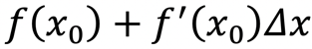
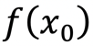
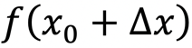
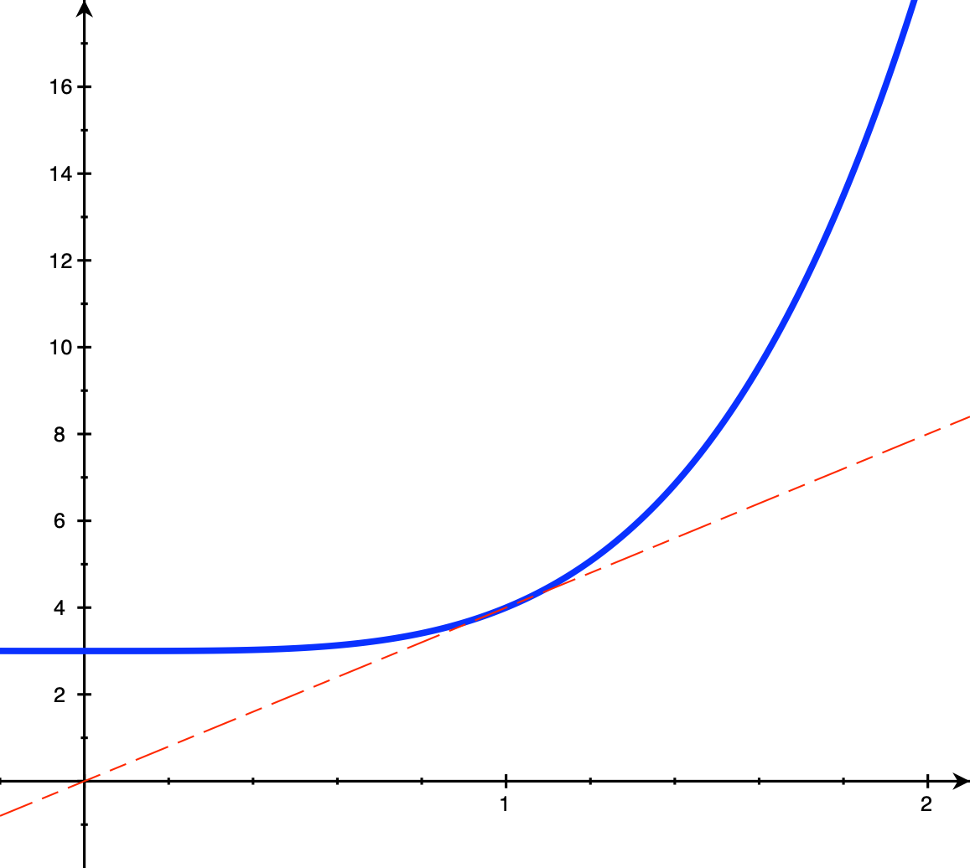

Figure 2.8 The approximation of the change in $f(x_{0})$ when $x_{0}$ changes by $Δx$.

See Taylor’s Polynomial for a more general approximation.

We define the differential of $y$ at $x^{*}$ as this approximation when the change in x is approaching zero.

Definition 2.14 Let $f:S→R$, $S⊆R$ be a function, and $y=f(x)$. The differential of $y$ at $x_{0}$, denoted by $dy$, is given by,
$$dy=f^{'}\left(x_{0}\right)dx,$$

where $dx$ is just $Δx$ as it is approaching zero.

- Whenever we have derivative, we have differential, and vice versa.

Example From the Total Revenue and Total Cost functions $TR\left(q\right)=10q^{\frac{1}{2}}$ and $TC\left(q\right)=20+0.6q$, the differentials are given by

$$dTR\left(q\right)=MR\left(q\right)d q=5q^{\frac{1}{2}}dq \\ dTC\left(q\right)=MC\left(q\right)dq=0.6dq.$$

At $q^{*}=64$, if one more unit of outpuis produced, then $Δq=1$ and the additional revenue received is

$ΔTR≈5{\left(64\right)}^{-\frac{1}{2}}Δq=\frac{5}{8}Δq=\frac{5}{8}$,

and additional cost incurred is

$ΔTC=0.6Δq=0.6$.

Note that the additional cost is exactly 0.6 because the cost function is linear.

The followings are formulae of derivative frequently used.

- $d\left(Ay+Bz\right)=Ady+Bdz$, $A$and $B$ are constants.
- $d\left(yz\right)=zdy+ydz$.
- $d\left(\frac{y}{z}\right)=\frac{zdy-ydz}{z^{2}}$.
- Chain Rule: If $w=h(y)$, and $y=f\left(x\right)$then
$dw=h^{'}\left(y\right)dy=h^{'}\left(y\right)f^{'}\left(x\right)dx$.

Note that, if $y=f\left(x\right)$and $z=g\left(x\right)$, then $dy=f^{'}\left(x\right)dx$ and $dz=g^{'}\left(x\right)dx$ and the derivative formulae in Section 2.1 apply.

HW (Continued) Find the differential of the profit function. At $q^{*}=64$, what is the approximate additional profit if we produce one more unit?

HW Write the differential of the following functions.
- $s={\left(t^{2}-3\right)}^{4}$
- $s=\ln\left(t^{2}-3\right)$
- $z=\frac{3}{{\left(1-y^{2}\right)}^{0.4}}$
- $y=1+x+x^{2}+…+x^{n}$
- $PV=A\left(1+\frac{1}{1+r}+\frac{1}{{\left(1+r\right)}^{2}}+…+\frac{1}{{\left(1+r\right)}^{n}}\right)$
- $F=Ae^{rt}$.

Appendix I

Theorem 2.14 (Rolle’s Theorem, Simon & Blume, page 824) Suppose that $f:\left[a,b\right]→R^{1}$ is continuous on $\left[a,b\right]$ and $C^{1}$ on $(a,b)$. If $f\left(a\right)=f\left(b\right)=0$, then there is a point $c∈(a,b)$ such that $f^{'}\left(c\right)=0$.

Proof If $f$ is constant on $[a,b]$, then $f^{'}\left(c\right)=0$, for all $c∈(a,b)$. If $f$ is not constant on $[a,b]$, we will assume without loss of generality that $f$ is sometimes positive on $(a,b)$. By Weierstrass’s theorem, $f$ achieves its maximum at some point $c∈[a,b]$. Since $f\left(c\right)>0,$ $c$ must lie in the open interval $(a,b)$. By the usual first-order condition (Theorem 2.5) for an interior max on $R^{1}$, $f^{'}\left(c\right)=0$.$∎$

Theorem 2.15 (Mean Value Theorem, Simon & Blume, page 825) Let $f:U→R^{1}$ be a $C^{1}$ function on a (connected) interval $U$ in $R^{1}$. For any points $a,b∈U$, there is a point $c∈(a,b)$ so that

$$f\left(b\right)-f\left(a\right)=f^{'}\left(c\right)\left(b-a\right).$$

Proof Construct the function

$$g\left(x\right)≡f\left(b\right)-f\left(x\right)+\frac{f\left(b\right)-f\left(a\right)}{b-a}\left(x-b\right).$$

One checks that $g\left(a\right)=g\left(b\right)=0$. By Rolle’s theorem, there is a point $c∈(a,b)$ so that $g^{'}\left(c\right)=0$. Taking derivative of $g$ with respect to $x$, we have

$$g^{'}\left(x\right)=-f^{'}\left(x\right)+\frac{f\left(b\right)-f\left(a\right)}{b-a}$$
$$g^{'}\left(c\right)=0⟹0=-f^{'}\left(c\right)+\frac{f\left(b\right)-f\left(a\right)}{b-a}.∎$$

Appendix II

Theorem 2.8 Let $f:S→R$, $S⊆R$, be a differentiable function. The function $f$ is concave (convex) if, and only if,

$$f\left(y\right)-f\left(x\right)≤f^{'}\left(x\right)\left(y-x\right),$$
$$(≥)$$

for any $x,y∈S.$

Proof $\left(⟹\right)$ If $f$ is concave, for any $x,y∈S, 0≤t≤1$,

$$tf\left(y\right)+\left(1-t\right)f\left(x\right)≤f\left(ty+\left(1-t\right)x\right) \\ t\left(f\left(y\right)-f\left(x\right)\right)≤f\left(ty+\left(1-t\right)x\right)-f\left(x\right) \\ f\left(y\right)-f\left(x\right)≤\frac{f\left(x+t\left(y-x\right)\right)-f(x)}{t} \\ f\left(y\right)-f\left(x\right)≤\frac{f\left(x+t\left(y-x\right)\right)-f\left(x\right)}{t\left(y-x\right)}\left(y-x\right).$$

Letting $t→0$, we have $f\left(y\right)-f\left(x\right)≤f'(x)\left(y-x\right)$

$\left(⟸\right)$ For any $x,y∈S$, write
$$z_{t}=ty+\left(1-t\right)x,$$

where $0≤t≤1$. We have

$$f\left(x\right)-f\left(z_{t}\right)≤f^{'}\left(z_{t}\right)\left(x-z_{t}\right) \\ =f^{'}\left(z_{t}\right)\left(x-x-t\left(y-x\right)\right) \\ =-tf^{'}\left(z_{t}\right)\left(y-x\right)$$
$$f\left(y\right)-f\left(z_{t}\right)≤f^{'}\left(z_{t}\right)\left(y-z_{t}\right) \\ =f^{'}\left(z_{t}\right)\left(y-x-t\left(y-x\right)\right) \\ =f^{'}\left(z_{t}\right)\left(1-t)\left(y-x\right)\right)$$

Multiplying $\left(1-t\right)$ and $t$ on both sides of the above inequalities, we have

$$\left(1-t\right)\left(f\left(x\right)-f\left(z_{t}\right)\right)≤-t(1-t)f^{'}\left(z_{t}\right)\left(y-x\right) \\ t\left(f\left(y\right)-f\left(z_{t}\right)\right)≤t\left(1-t\right)f^{'}\left(z_{t}\right)\left(y-x\right).$$

Adding up the above inequalities, we have

$$tf\left(y\right)+\left(1-t\right)f\left(x\right)≤f\left(ty+\left(1-t\right)x\right).∎$$

Theorem 2.9 Let $f:S→R$, $S⊆R$, be a differentiable function. The function $f$ is strictly concave (convex) if, and only if,

$$f\left(y\right)-f\left(x\right)<f^{'}\left(x\right)\left(y-x\right),$$
$$(>)$$

for any $x,y∈S, x≠y.$

Proof $\left(⟸\right)$ Same as the proof of the previous Theorem 2.8 but with strict inequality.

$(⟹)$ Same as the proof of the previous Theorem with strict inequality, we have for any $x,y∈S, 0<t<1$,

$$f\left(y\right)-f\left(x\right)<\frac{f\left(x+t\left(y-x\right)\right)-f\left(x\right)}{t\left(y-x\right)}\left(y-x\right).$$

Letting $t→0$, we have inequality, (not strict inequality)

$$f\left(y\right)-f\left(x\right)≤f^{'}\left(x\right)\left(y-x\right).$$

It remains to be shown that it is not possible for

$$f\left(y\right)-f\left(x\right)=f^{'}\left(x\right)\left(y-x\right).$$

Because, if it is then, assuming without loss of generality that $x<y,$

$$f^{'}\left(x\right)=\frac{f\left(y\right)-f\left(x\right)}{\left(y-x\right)}.$$

By Mean Value Theorem (See Appendix I of Chapter 2), there exists $z∈(x,y)$ such that

$$f^{'}\left(z\right)=\frac{f\left(y\right)-f\left(x\right)}{\left(y-x\right)}.$$

If the only possible value of $z$is $z=x$, then we have strict inequality everywhere else. If $z∈\left(x,y\right)$, then $x<z$ so

$$\frac{f\left(x\right)-f\left(z\right)}{\left(x-z\right)}>f^{'}\left(z\right)=f^{'}\left(x\right).$$

At the same time,

$$\frac{f\left(z\right)-f\left(x\right)}{\left(z-x\right)}<f^{'}\left(x\right)$$

Since the left hand sides of the last two inequalities are identical, we have the contradiction.$∎$

