

IS 216: End-User Application Development Program

Exercise 10 – Anfield Inc.

Anfield Inc. a global company sells "MacBook" and "HP" notebooks. The company divides its marketing department based on Regions, which are Asia, Europe, North America, and Australia. Also, each region has only one manager in charge and the sales they generate is shown below. In addition, each region sells HP and Macbook at different prices (price discrimination).

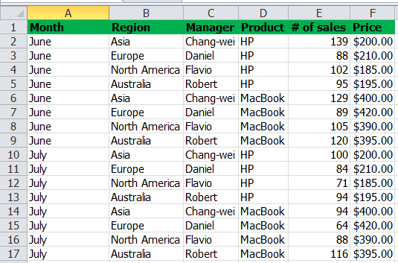

You have been hired to help the CEO find the following answers.

- What is the total revenue in North America?
- What is the total revenue generated by Flavio in June?
- What is the total revenue of MacBook?
- What is the total revenue of HP in Europe?

