Assignment 3

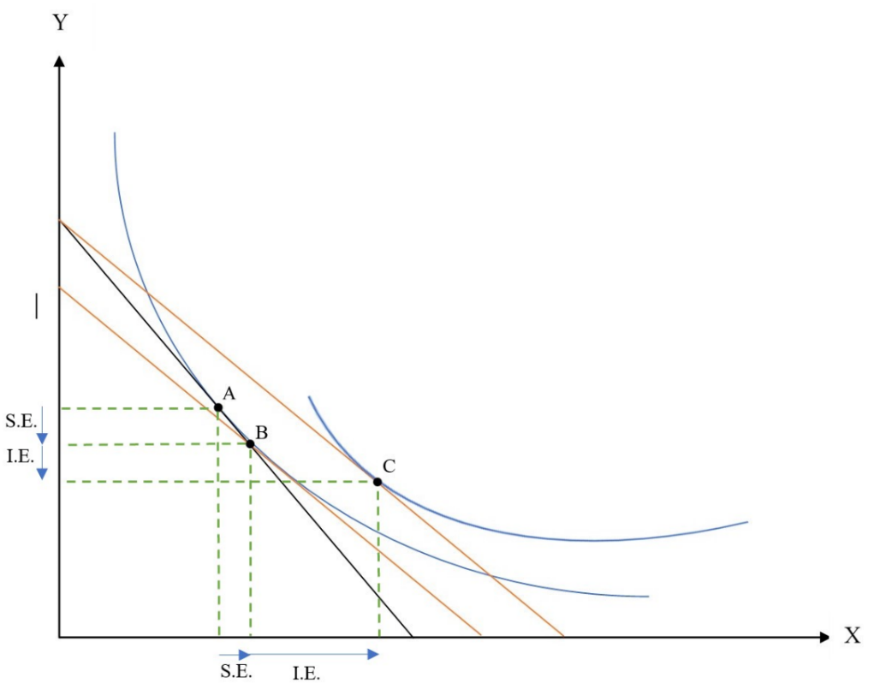
Question 1 Sec 1 – Px falls
a)

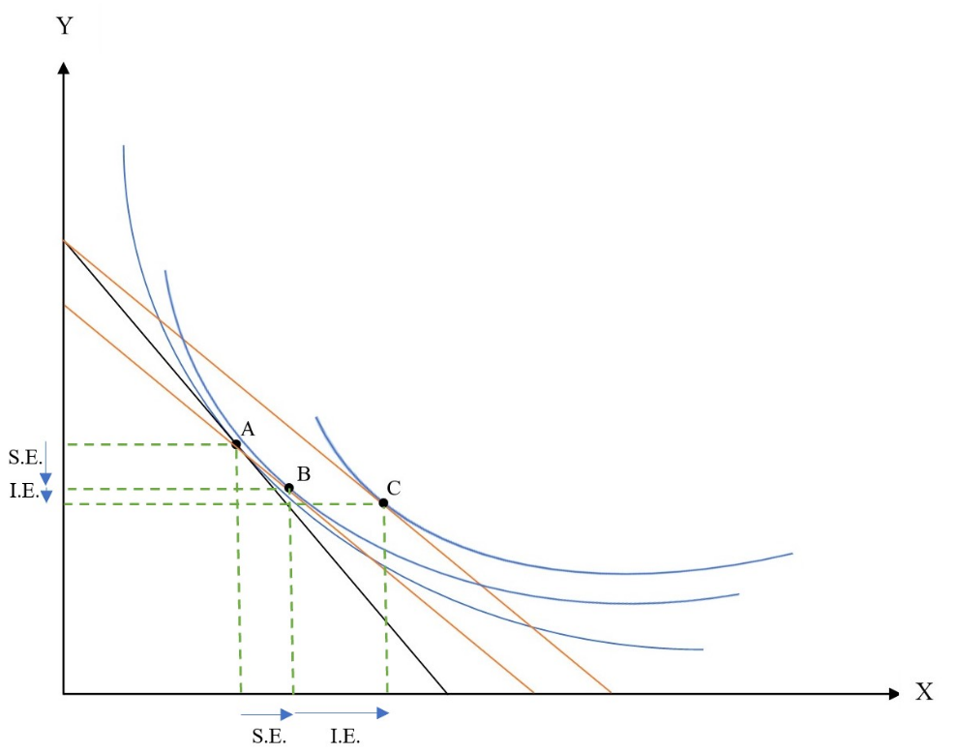

The initial consumption is basket A. Substitution effect moves consumption basket to basket B, more X less Y. X is normal good, income effect increases amount of X consumed. Y is inferior good, income effect decreases amount of Y consumed (change from basket B to C).

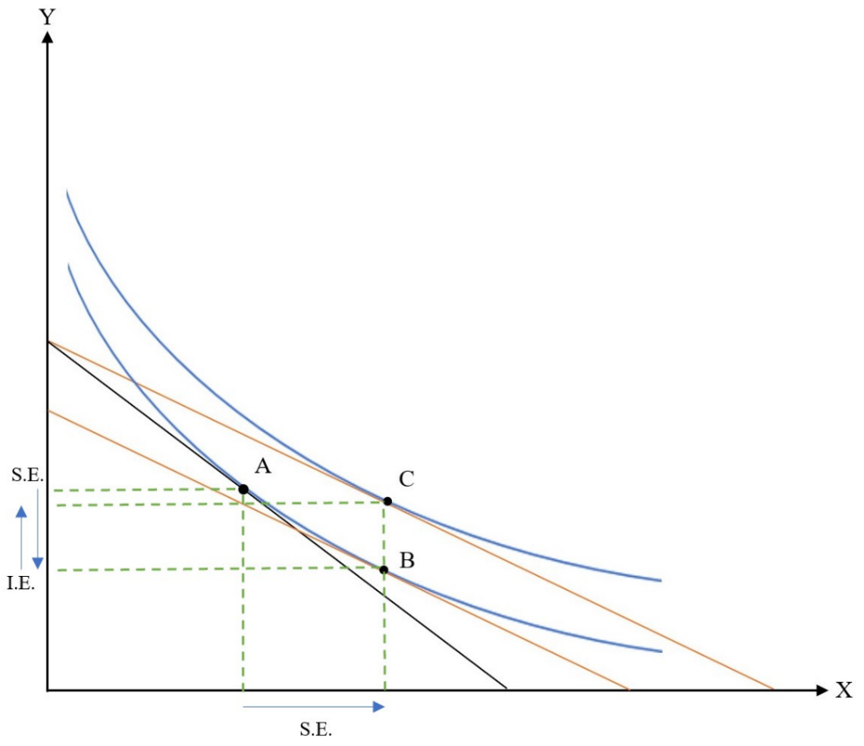
b)

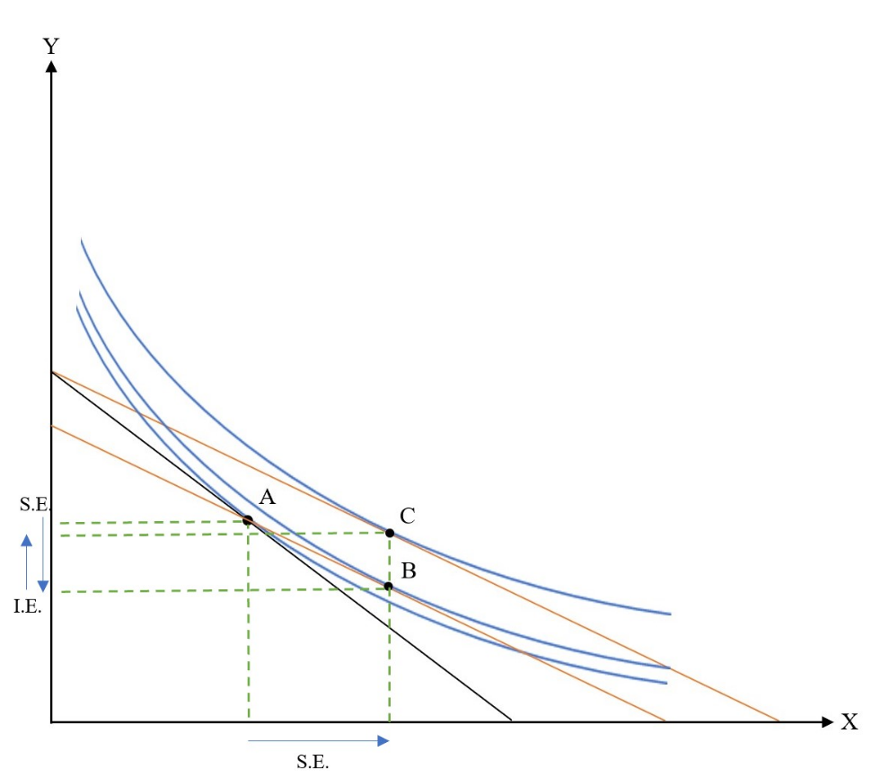

Assuming Y is normal good. Substitution effect move consumption basket from A to B, more X less Y. Income affect only affect amount of Y, Y increases (from B to C).

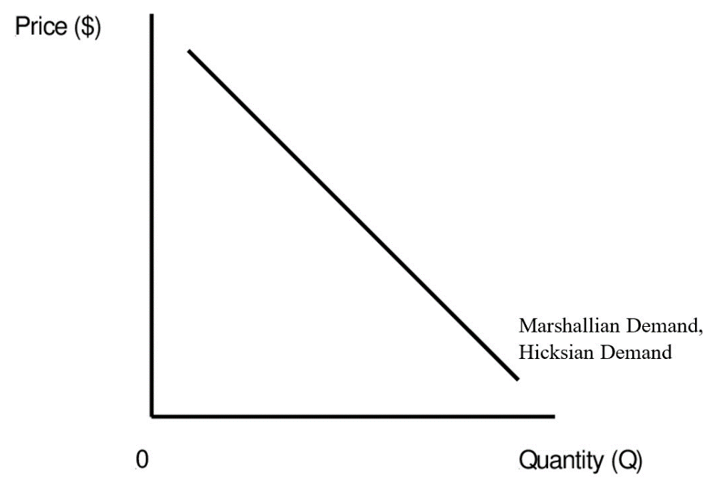

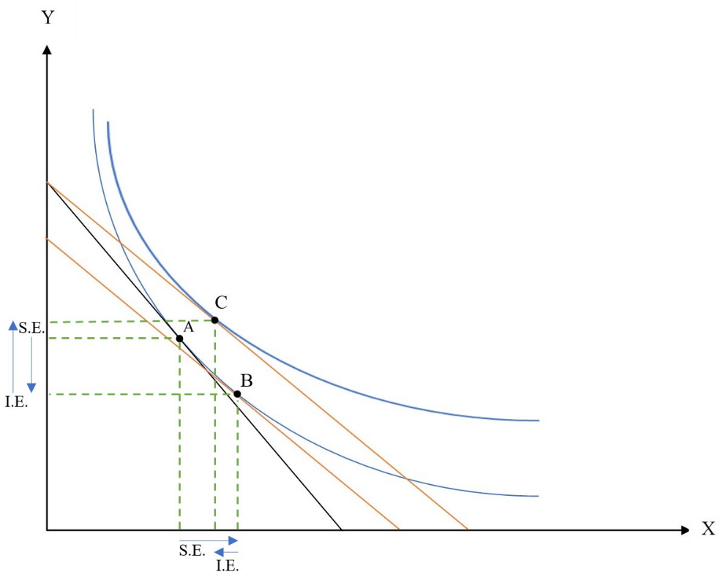
c)

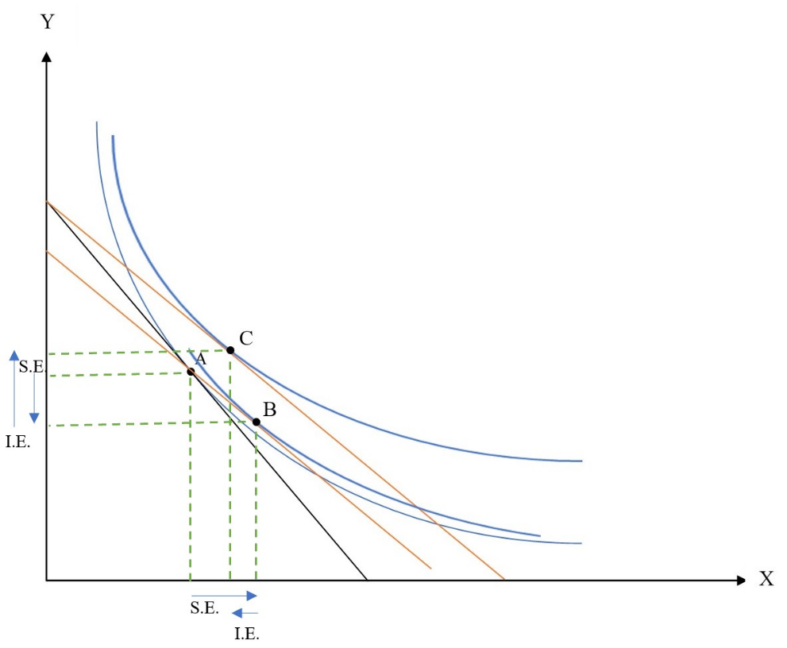

Assuming Y is normal good. Substitution effect moves consumption basket from A to B, more X less Y. Income effect moves consumption basket from B to C. Since X is inferior good, X at C is less than X at B. Substitution effect stills dominate income effect.
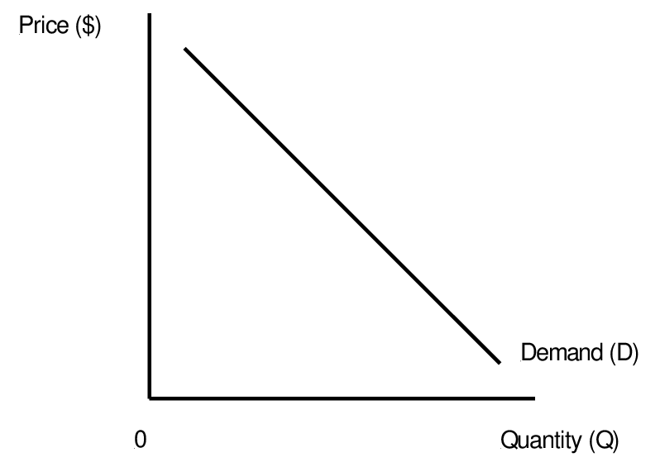
Hicksian Demand
Marshallian Demand

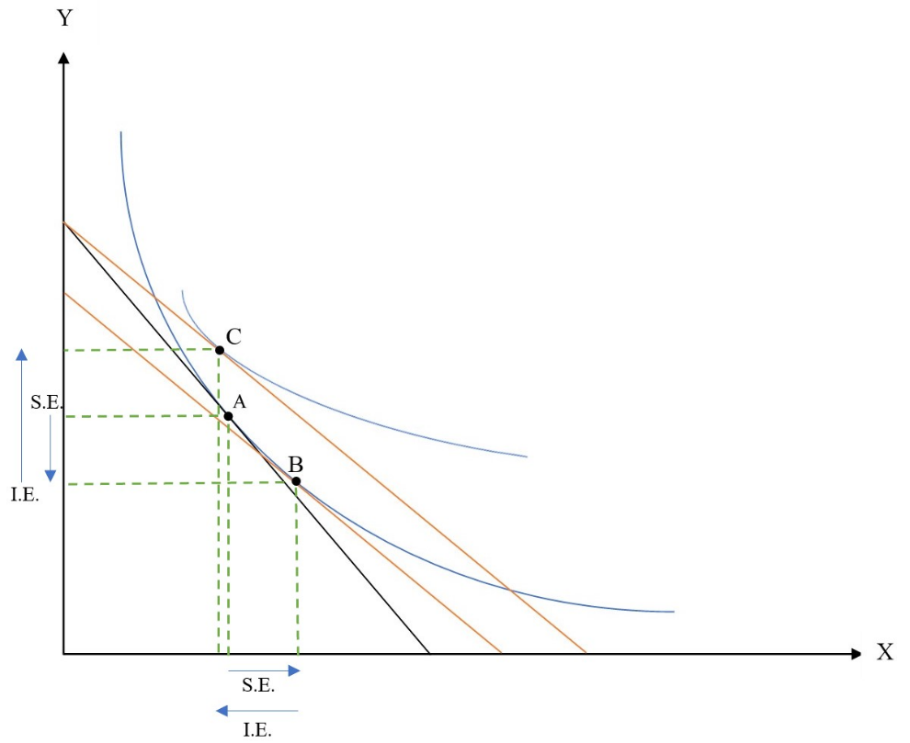
d)

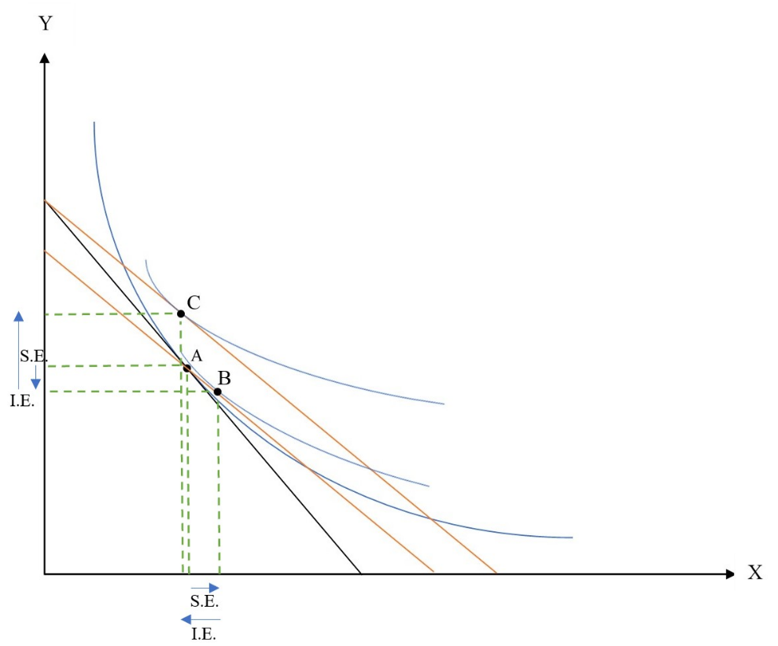

Assuming Y is normal good. Substitution effect moves consumption basket from A to B, more X less Y. Income effect moves consumption basket from B to C. Since X giffen good, Income effect dominate substitution effect. After Px declines, this consumer demands less X.

Marshallian Demand
Hicksian Demand

Question 1 Sec 2 – Px rises
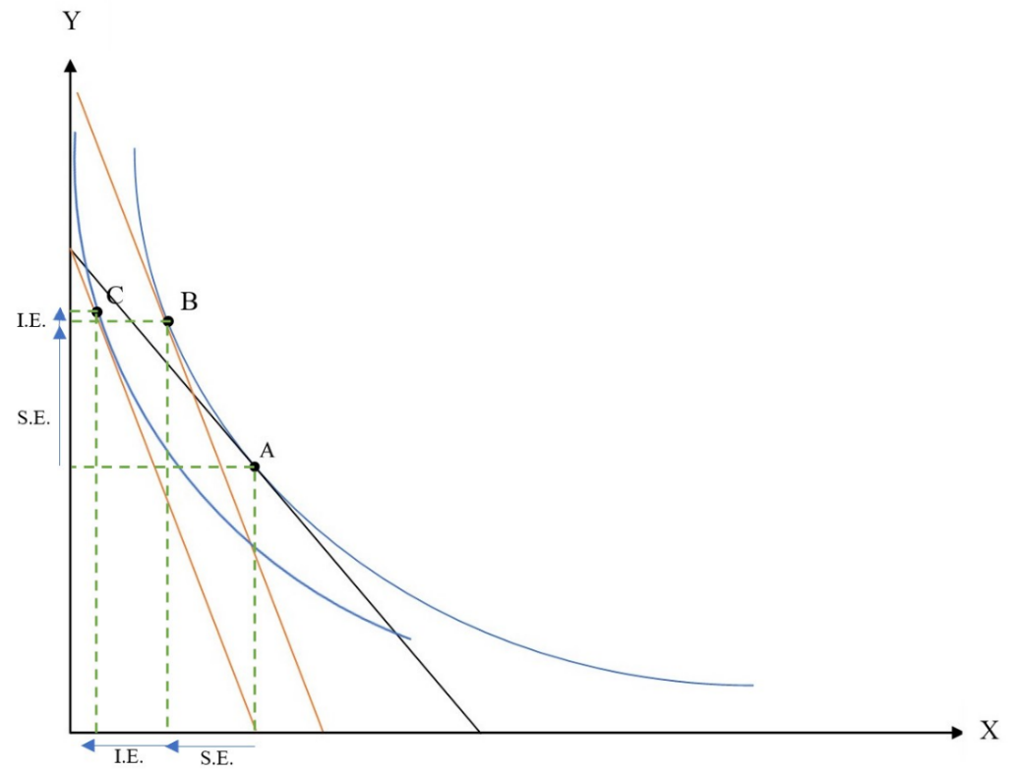
a)

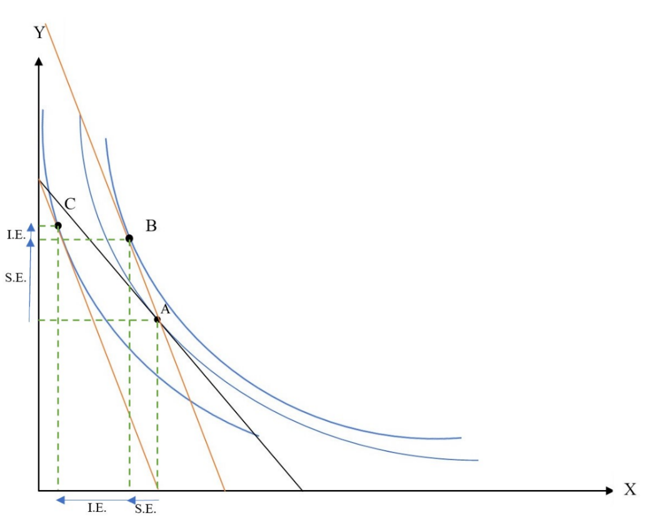

The initial consumption is basket A. Substitution effect moves consumption basket to basket B, less X more Y. X is normal good, income effect decreases amount of X consumed. Y is inferior good, income effect increases amount of Y consumed (change from basket B to C).

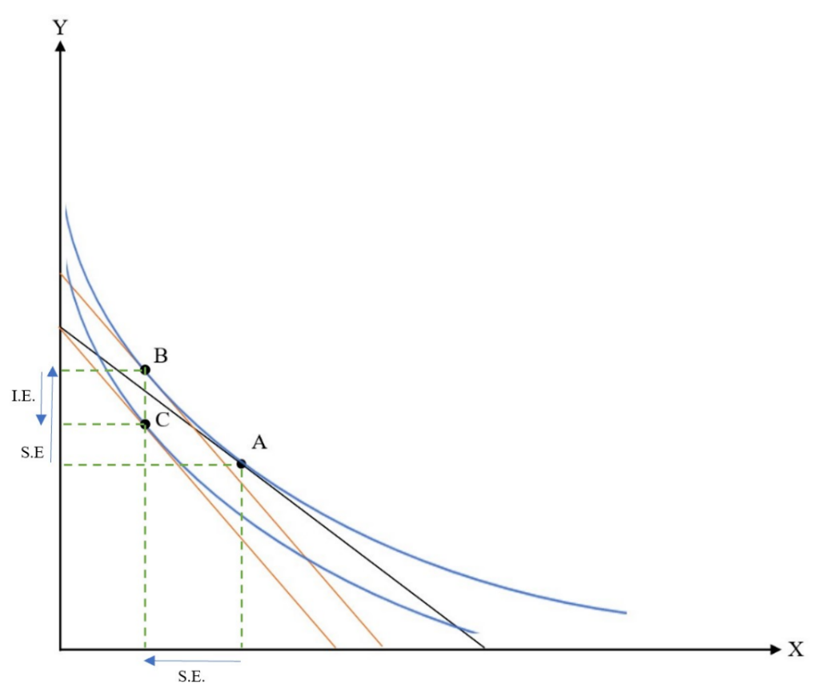
b)

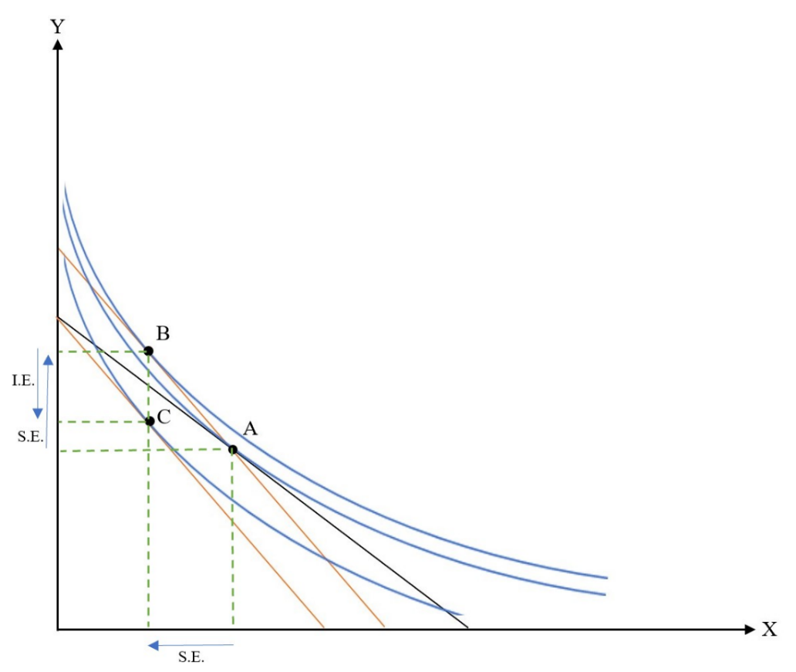

Assuming Y is normal good. Substitution effect move consumption basket from A to B, less X more Y. Income affect only affect amount of Y, Y decreases (from B to C).

Marshallian Demand,
Hicksian Demand

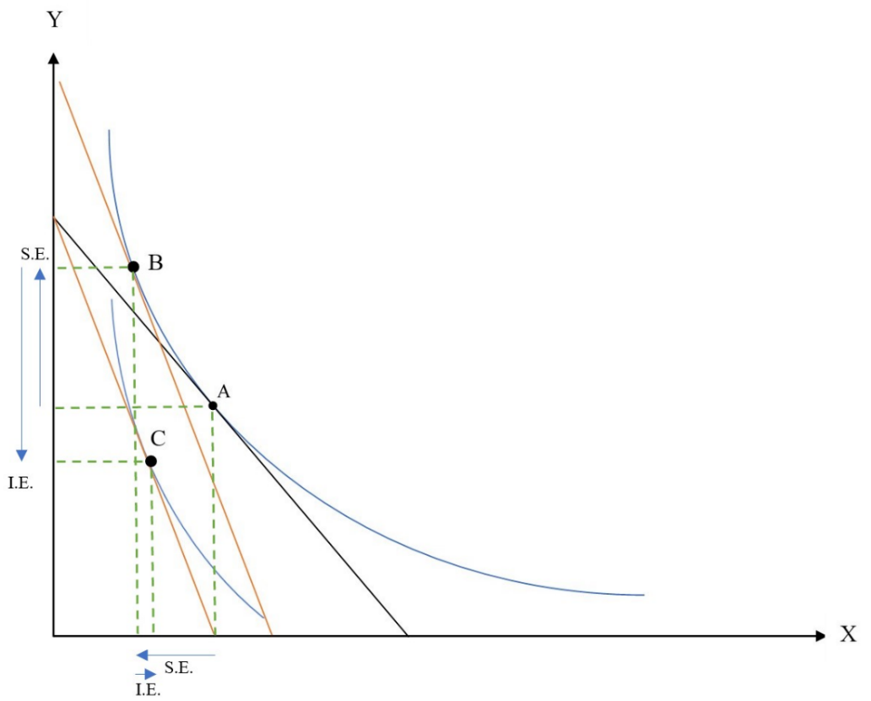
c)

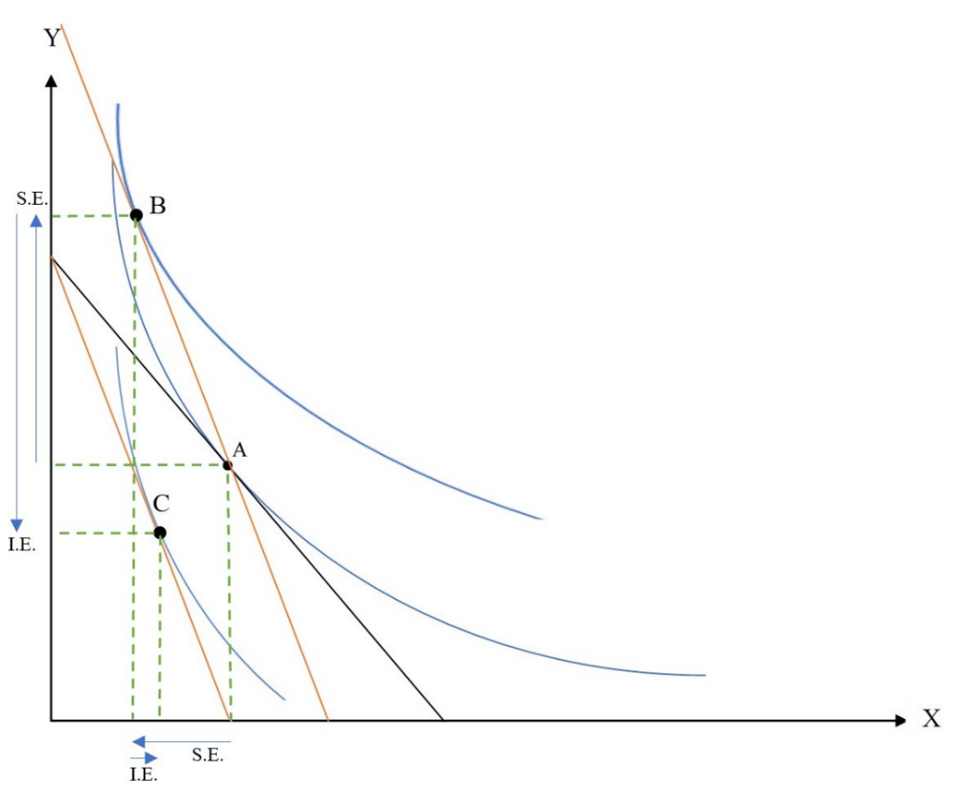

Assuming Y is normal good. Substitution effect moves consumption basket from A to B, less X more Y. Income effect moves consumption basket from B to C. Since X is inferior good, X at C is more than X at B. Substitution effect stills dominate income effect.

Hicksian Demand
Marshallian Demand

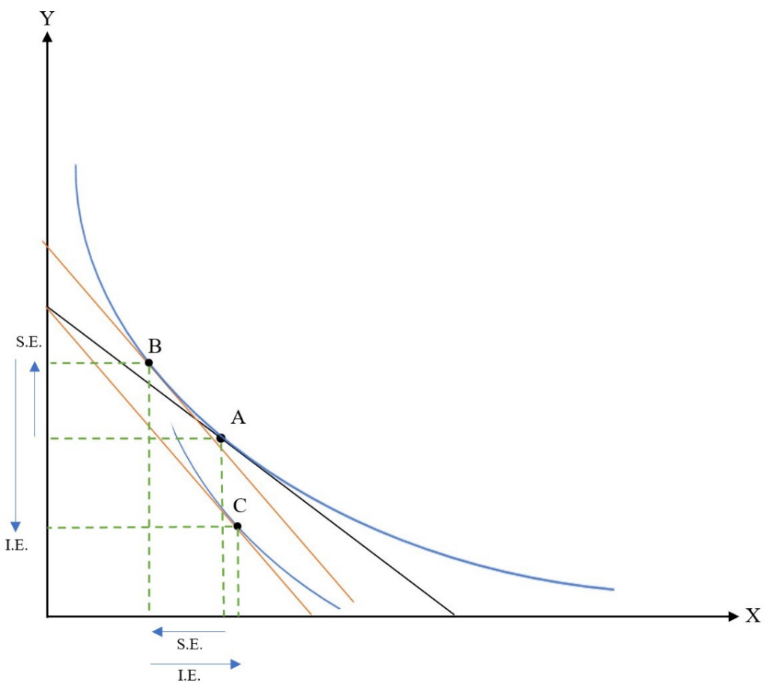
d)

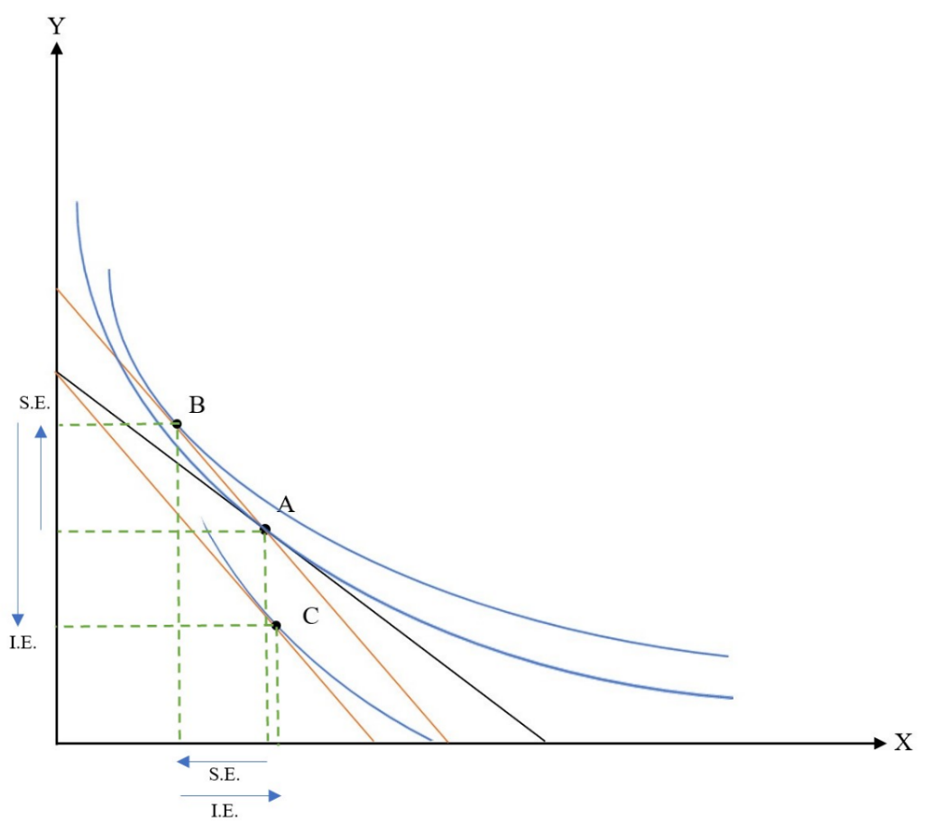

Assuming Y is normal good. Substitution effect moves consumption basket from A to B, more X less Y. Income effect moves consumption basket from B to C. Since X giffen good, Income effect dominate substitution effect. After Px rises, this consumer demands more X.

Marshallian Demand
Hicksian Demand

