The Dog That Didn't Bark: What Soybean Prices Say About Trade Deal
China's promise to buy more U.S. farm products hasn't pushed up agricultural futures—a sign of doubt about the real economic impact
The Wall Street Journal: January 21, 2020
In an 1892 mystery story by Sir Arthur Conan Doyle, Sherlock Holmes figures out what happened to a missing racehorse named Silver Blaze by observing a dog that didn't bark in the night. Likewise, sometimes what doesn't happen in markets can be a clue to something significant.
In the case of the recently signed U.S. trade deal with China, the dogs have been notably quiet in Chicago's agricultural futures markets. Despite China's commitment to buy more American farm products, prices haven't gone up--a sign that investors and traders don't see the accord having much real economic impact.
The price of a bushel of soybeans is lower than it was when Donald Trump was elected president in November 2016. It is little changed from when Mr. Trump ramped up his trade confrontation with China and has lost ground in the days since the deal was announced. Prices for wheat, pork and dairy products have been similarly stable.
Prices are supposed to be the market's barking dog. When they rise, it is a signal of soaring demand or a shock to supply. When they fall, the opposite. Because markets are forward looking, especially futures contracts traded in Chicago, expected changes in demand and supply should move prices almost as much as actual changes.
Soaring stock prices are a sign of broad optimism about the U.S. economy and likely some relief that trade confrontations are receding. At the same time, quiet commodities markets suggest investors and others don't see foresee any big shifts in the supply of, or demand for, farm products.
Investors and others might doubt China will live up to its commitments or that its promised purchases will simply shift demand from one country to another, or from one year to the next--without fundamentally changing the fortunes of American farmers.
Soybeans, by far the largest component of U.S.-China agricultural trade, are a window into all of this.
Chinese negotiators committed to increase purchases of U.S. farm products by $32 billion over the next two years. The deal is part of a broader agreement by China to increase purchases of a wide range of U.S. products, including energy and manufactured goods, by $200 billion over two years.
Scott Henry, an Iowa soybean farmer, said he is looking to invest in farmland because he's optimistic about the sector with trade disputes receding. "We think the buying opportunity is now," he said. Still, he harbors some skepticism that China will follow through on its commitments after months of back-and-forth negotiations.
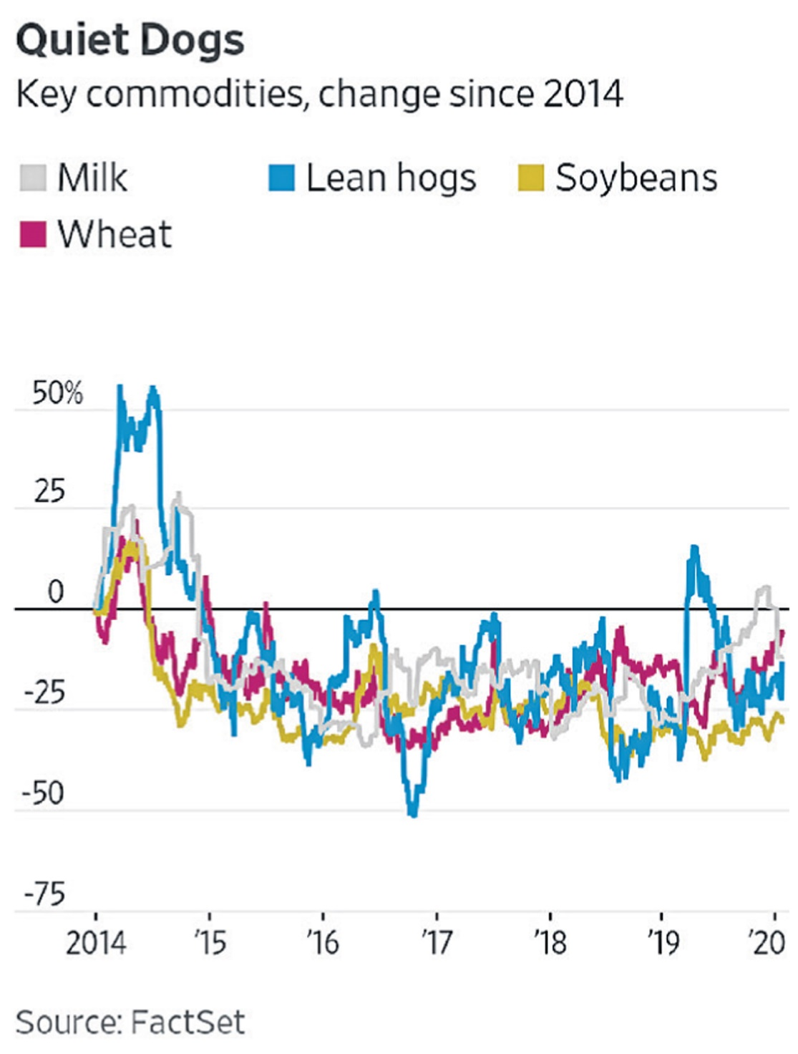
"Let's see that first ship go to China," he said.
The dynamics of global commodities markets explain some of the investor skepticism.
Brazil and the U.S. are both major exporters of soybeans. Of the 85 million tons of soybeans that China imported in 2019, 57 million tons were supplied by Brazil, estimates Ken Morrison, a former commodities trader for Cargill Inc., the agriculture giant, who now writes a newsletter on the industry.
If China shifts its purchases from Brazil to the U.S. to comply with the new deal, global demand wouldn't change. Such a shift might push up the price of U.S. soybeans relative to Brazilian soybeans. But Brazil's soybeans would then be cheaper in other markets, giving it a new advantage outside of China. The result: the gap between U.S. and Brazilian soybeans would likely close, leaving the price of U.S. soybeans little changed.
If the price doesn't change, are American farmers better off? The answer is yes if they are able to sell more. Right now, at least, that's not in the outlook. The U.S. Department of Agriculture estimates that American farmers will plant 84 million acres in the 2020-2021 planting year. While that is more than the 76 million acres in 2019-2020, it is less than as much as the 87 million planted the year before.
What if China bought more soybeans on global markets overall, rather than simply shifting purchases from one country to another? China could order its state-owned storage companies to buy more. But without an increase in national demand, the extra soybeans would end up in storage facilities, putting downward pressure on prices down the road. China could buy more next year to meet its goal, then buy less in 2022.
Another challenge: Beyond two state-owned enterprises, Mr. Morrison noted, most of China's soybean market is driven by private firms.
"This thing can't work in a competitive marketplace," Mr. Morrison said of the trade deal.
Mr. Morrison does see potential benefits for U.S. farmers in the agreement, including possible reforms to how China manages import quotas for wheat, corn and rice. When it comes to broad purchase promises, though, he said the deal leaves China the option of coming up short if market forces dictate.
"The parties acknowledge that purchases will be made at market prices based on commercial considerations and that market conditions, particularly in the case of agricultural goods, may dictate the timing of purchases within any given year," the agreement says.
The U.S. and China have ended up in an odd position. China, a one-party state with communist roots, insists that market forces determine the outcome of its purchase commitments. Meanwhile the U.S., a voice for capitalism, depends on massive state intervention to meet purchase commitments.

