1. Estimate VARs models using spot return (rspot) and future return (rfuture) as endogenous variables and determine the most appropriated lags models using SBIC.

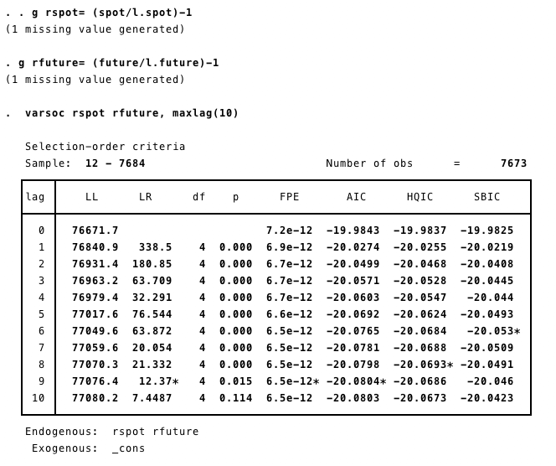
With the lowest error term, according to SBIC, lag term 6 = -20.053 is the most appropriate model.

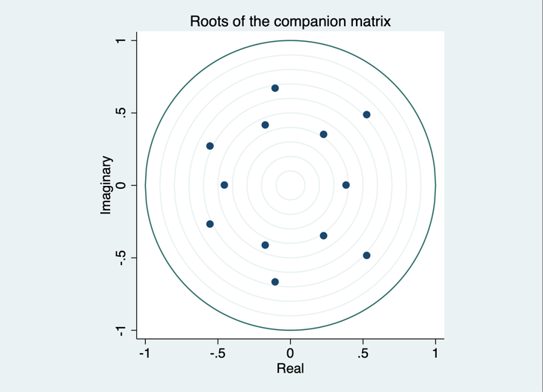
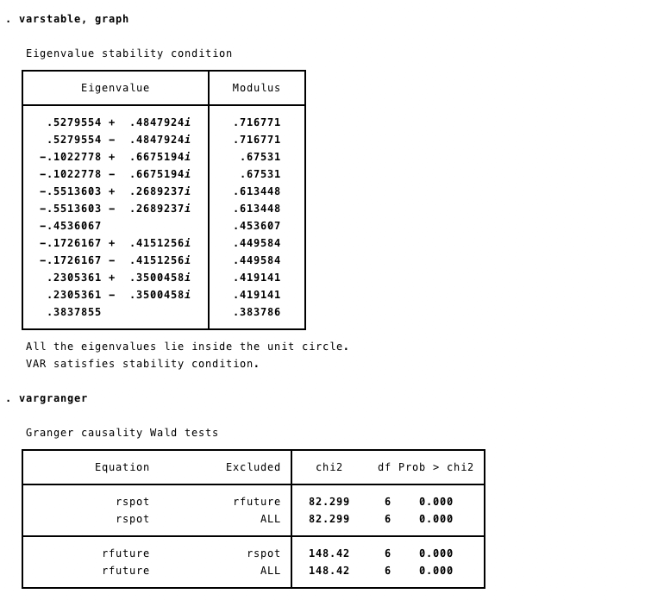
2. Perform stability test and Granger exogeneity test.

According to stability test, all eigenvalues lie in unit circle, meeting the stability and stationary condition.

From Granger test, with p-value < 0.05, we reject null hypothesis. Therefore, return of spot and return of future are endogenous variables.

3. Perform Impulse response analysis and determine which variable has more impact.

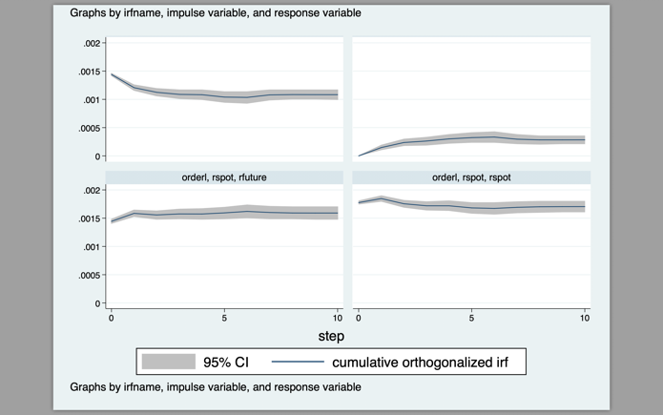
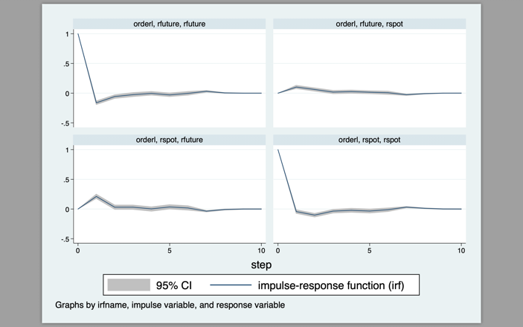
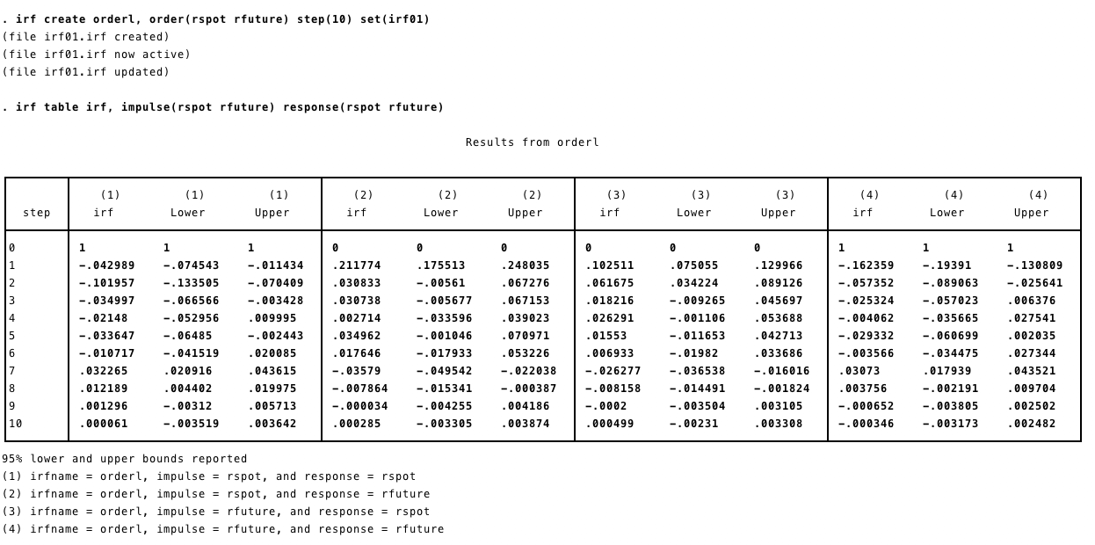
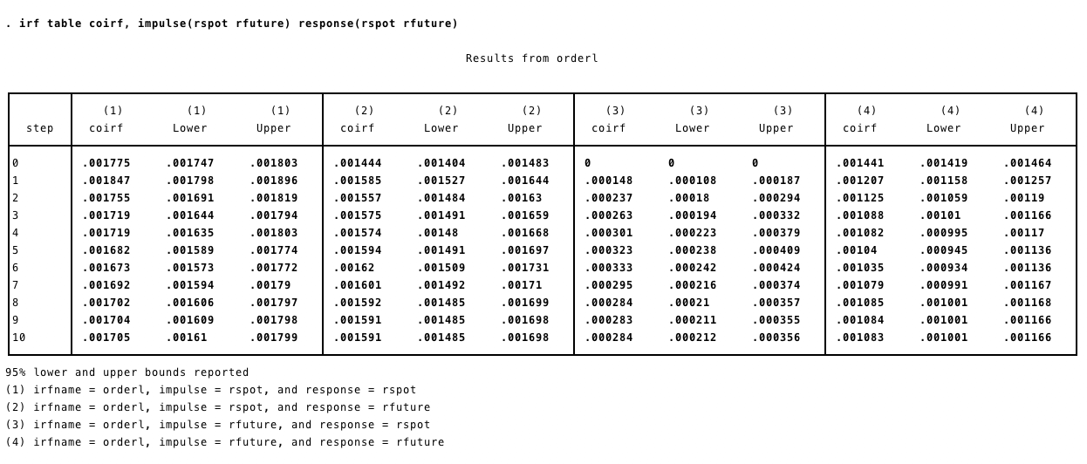

From the result, all variables have positive impact. When look at magnitude, rspot has more impact on rfuture.

4. Perform Forecast error variance decomposition and determine variable that has more impact on each endogenous variable.

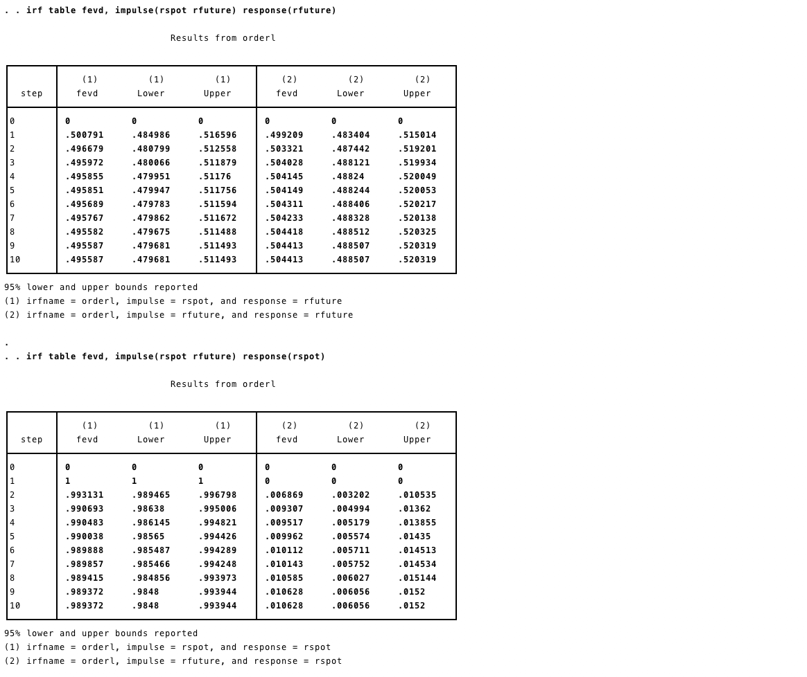

From FEVD test, rspot has an impact on rfuture more then rfuture has an impact on rspot.

