Equilibrium Price Dispersion in
Retail Markets for Prescription Drugs

One of the factors that affect price dispersion is high consumer search cost on retail prices for prescription drugs. The “law of one price” is virtually never empirically valid. Price dispersion will arise when there is a positive (but uncertain) probability that a randomly chosen customer knows only one price. Even in the market with homogeneous product, price may differ if consumers incur high search cost about price information.
Pharmacy differences explain roughly one-third of the price variation, price patterns are not consistent with a strict differentiated products story.

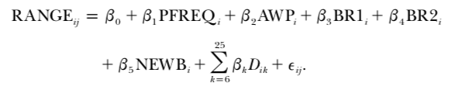

This regression is being used in this research paper. The dependent variable is the price range across pharmacies in town j for the prescription. AWP is drug’s acquisition cost (based on its listed average wholesale price) which control potential impact of price levels on dispersion. BR1 and BR2 are dummies for two kinds of brand-name drugs; one is facing competition from generic equivalents and another don’t. this distinction captures the idea that consumers who choose to buy brand-name prescriptions even when generics are available may be insensitive to price which may be reflected in the distribution of prices. NEWB is also a dummy variable but for Newburgh, and the D variables are indicators for 20 categories of drug therapy. They are included for crude control for the composition of the drug’s users; price distributions will be sensitive to different demographic groups’ differing propensities to search.
Price dispersion is related to consumer search in the sense of implications for policies affecting the costs of acquiring price information. If dispersion is generated by imperfect price information, programs or policies that centralize price information ( or improve the accessibility) may result in lower prices for consumers. The price advertising is often prohibited by law which the finding suggests that such absence may result in higher prices and more price dispersion than if there is advertising.

