Forty seven million Americans, or about 15% of the population live in poverty (povertyusa.org). What exactly does living in poverty mean? It is defined by the U.S. government and is determined by a certain threshold. This threshold is determined based on household size and family member ages. Used as just a statistical measure, this threshold is not an accurate representation of the big picture regarding poverty. This essay will not only compare the facets of poverty between America and Thailand, but examine the factors that either cause or are a characteristic of living in poverty.
Employment and Poverty
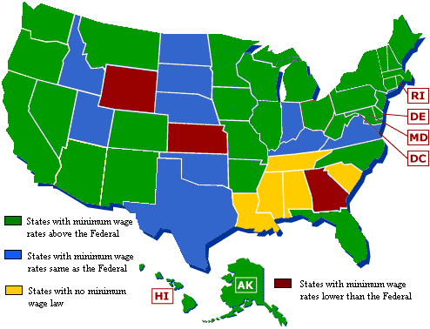
The unemployment rate in America as of October 2016 is 4.9%, which has stayed relatively constant throughout the year (Bureau of Labor Statistics). It has been steadily declining since post 2009 from a peak of 10%. As of 2015, 65.3% of the male population is employed while 5.4% is unemployed. For women, 53.7% are employed and 5.2% are unemployed. Roughly 36 million Americans, or 11% of the general population work part time. Part time is defined as between 1-34 hours a week. 17% are part time workers due to economic reasons which mostly includes slack work, business conditions and only being able to find part time work. Fewer cases are due to being a seasonal worker or starting/ending their job during the week (Bureau of Labor Statistics). In Thailand, the unemployment rate is considerably less, at 0.7%. There is a low unemployment rate due to the huge service sector. The federal minimum wage rate in the US is $7.25 per hour compared to 300 baht a day in Thailand. Assuming each person works 8 hours in a day, that’s a difference of about 1700 THB daily. Although it seems like a lot, the cost of living in the United States is quite higher. The poverty line for an individual was set at $12,000 a year in 2014 while the ADB set the threshold at $456 a year (povertyusa.org). Each state has its own minimum wage laws and workers are entitled to the higher minimum wage. In the map above, states that have minimum wage lower, or the same as the federal rate, or none at all are concentrated in the Southeast and Central US.
Are “poor” Americans really poor compared to Thailand?
While Americans are considered poor due to a poverty threshold, are they really poor relative to Thailand’s definition? “For example, according to the government's own data, nearly two thirds of households defined by Census as "poor" have cable or satellite television. Eighty five percent have air conditioning” (Robert Rector).
Geography of Poverty
In the United States a large factor that contributes to poverty is geographic location. People living in poverty tend to be bunched up in certain areas called regions and counties rather than being spread evenly across the country (USDA ERS). Significant poverty rates exist especially in the Southern region. The South has had the highest difference in poverty rate between its urban and rural areas, a difference of 6% compared to other regions. The rural poverty rate in the South was 21.7% from 2010-2014. Looking at the graph below, one can see how high percentage poverty rates in rural areas are concentrated heavily in the South and Southeast regions of the United States. In Thailand, regions with high poverty rates are concentrated in the North and Northeast.
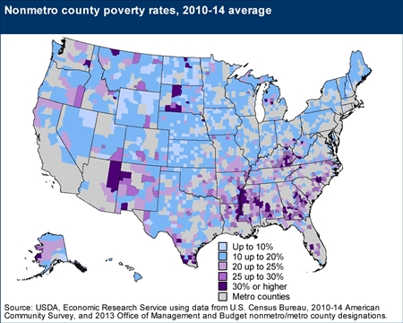
Additionally, an important factor to consider is whether a county is persistently in poverty. Counties are persistent poverty, that is, if 20% or more of its populations were living in poverty over the last 30 years. 11.2% of all U.S. counties are persistently poor and a large number, about 85.3% of these counties are rural.
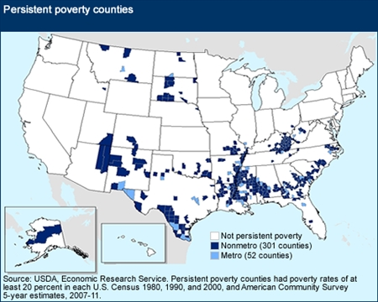
Looking at the graph above, one can see that persistent poverty counties are also concentrated in the South and Southeast regions of the country. In fact, 84% of persistent poverty counties are located in the South. This data is significant because people who live in these areas are much more likely to experience factors of poverty outside of their control such as poor housing and health conditions, higher crime and school dropout rates. These factors result in limited opportunities for the counties residents (USDA ERS).
Poverty Demographics
Other important factors to consider in American poverty are demographics by age, race/ethnicity, and family composition. Race is significant because it often is a large contributing factor to counties with high poverty rates. Of all ethnicities in rural areas, Blacks and African Americans have the highest poverty rate in 2014 of 36.9%. 33% of American Indians and Alaskan natives are poor while 27.5% of Hispanics are poor (USDA ERA)⁵. Overall, 26% of all Blacks and 24% of all Hispanics are poor, representing the ethnicities with the highest level of poverty (povertyusa.org). Urban rates of poverty are lower for these ethnicities with 26% for blacks, 25.4% for American Indian/Alaskan Native, and 23.9% for Hispanics. One important thing to note is the United States immigration policy. Two-thirds of immigrant households – that is counting both immigrants and their U.S.-born children – from Mexico, Honduras, and Guatemala live in poverty or near poverty while other Latin-American immigrant groups fare a little less badly (David Frum). The graph above shows the percentage difference between recent immigrant groups established immigrants, and natives in poverty characteristics. It shows a high correlation between immigration and poverty rates. Similar to Thailand’s poor, immigrant groups in America earn income from their own unskilled labor. Furthermore, the proportion of Hispanic women giving birth outside marriage was 53% in 2011, a rate that has been steadily increasing since 1992 (David Frum). What this signifies is that more and more Hispanic children are being born into poverty – about 5.9 million.

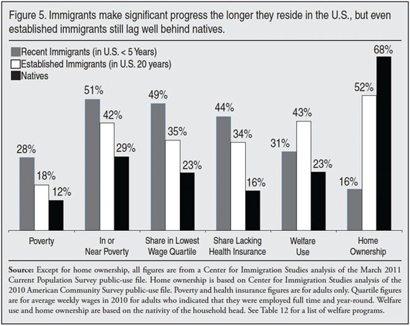

Similarly, poverty rates are also higher in rural areas compared to urban areas when regarding family composition. In rural areas, female head of households with related children and no spouse present have a huge 48.4% poverty rate and female head of households with no spouse present have a 37.7% poverty rate compared with 20.4% poverty in male head of household with no spouse present. This shows the significance of how having a married couple within a household affects poverty rate.
Poverty Reduction
Thailand relies on the service sector for its poverty reduction effect as the poor earn income from their own labor assets. In America, a large factor in poverty reduction is its welfare state. In 2008, the federal government spent $679 billion to provide cash, food, housing, medical care, and targeted social services to poor Americans (Robert Rector). This amounts to about $6,000 per person in the lowest income third of the population. Welfare programs include SNAP – a food program for low income families where participants receive a debit card that can be used inside grocery stores to purchase food. There are Pell Grants that give up to $5,550 a year that encourages low income students to pursue postsecondary education. Finally, TANF (Temporary Assistance for Needy Families) is a program that pays cash to low income families with the goal of helping individuals find work. Since 1964, the US has spent $14.3 trillion on welfare programs for those in need. Thailand on the other hand has spent a small percentage of GDP, about 2.4% during 1997-2000 on health and welfare.
Human Development Index
The Human Development Index measures life expectancy, knowledge, and standard of living. In 2013 the average years of education in America was 12.9 compared to 7.3 years in Thailand. Life expectancy in the US is 5.4 years higher than in Thailand. Despite having continuous increase in tuition costs for postsecondary education and in healthcare, the US still has an HDI of .915 as of 2014
What Does This Tell Us?
To reduce poverty America needs to look at several different things that represent the root of the problem. One of these is the immigration policy, as accepting more immigrants is correlated with accepting more poverty. If the US wants to reduce poverty it will need to make its immigration poverty stricter and based on skill rather than kinship. Bringing in immigrants with unique skills may give them a higher likelihood of finding higher paying work and avoiding unemployment.
Adding on, welfare reform is needed. Incentives must be added to food stamps, housing and cash grants that encourage individuals to find work and fund a sustainable lifestyle. TANF does this, as it requires participants to be actively seeking work and show proof of that (Robert Rector). Federal funding should shift away giving “freebies” to instead providing programs and assistance for minorities that encourage them to continue their education. Also, funding should focus on providing more sex education and birth control resources to the poor to reduce out of marriage births. Currently, 38% of all children born in the U.S. are born out of marriage (Robert Rector). This commonly happens to the least educated women in society where there is lack of access to education and birth control. It is important to reduce this number to reduce the number of children being born into poverty.
Finally, more focus should be placed on those counties in the South that are persistently in poverty and have high rates of poverty. Incentives can be given to businesses to move infrastructure into those areas that can provide income and employment to the residents.
Conclusion
In conclusion while the US seems to have a higher poverty rate and unemployment rate than Thailand, the poor in America are not really “poor” relative to those in Thailand. Poor Americans have basic access to necessary material things as well as some “luxury” goods like TVs, air conditioning, refrigerators, houses without overcrowding, etc. Thailand can look to America to promote longer education and providing access to healthcare for everyone. On the other hand, America can look to Thailand to provide incentives within its welfare program that will get more citizens to work instead of surviving just off of welfare benefits.

http://www.povertyusa.org/the-state-of-poverty/
http://www.worldometers.info/world-population/us-population/
http://www.bls.gov/cps/tables.htm#empstat
https://www.ers.usda.gov/topics/rural-economy-population/rural-poverty-well-being/geography-of-poverty/
http://www.minimum-wage.org/federal-minimum-wage
http://www.heritage.org/research/testimony/understanding-and-reducing-poverty-in-america
http://www.theatlantic.com/politics/archive/2014/05/hispanic-immigration-and-poverty/361523/
http://www.mylifeelsewhere.com/compare/united-states/thailand

http://www.bls.gov/cps/tables.htm#empstat
http://www.povertyusa.org/the-state-of-poverty/
http://www.heritage.org/research/testimony/understanding-and-reducing-poverty-in-america
https://www.ers.usda.gov/topics/rural-economy-population/rural-poverty-well-being/geography-of-poverty/
https://www.ers.usda.gov/topics/rural-economy-population/rural-poverty-well-being/geography-of-poverty/
http://www.povertyusa.org/the-state-of-poverty/
http://www.theatlantic.com/politics/archive/2014/05/hispanic-immigration-and-poverty/361523/
http://countryeconomy.com/hdi/usa

