Individual Assignment 1
- Discuss one Insurance product and comment on its benefits
Krungthai-AXA is an organization offering insurance products in order to extend its power in market and disperse risk through variety product channels. “Sabaijai my life” is one of insurances that is made for the person who want every steps of their life to be as safe as possible. The condition covers from the age of 18 up to 65 years which considered as a long-term condition which covers the current period of my life, that’s why it makes me feel interested in it. This insurance doesn’t require the medical check-up and no cash is needed when using its card, AXA Hospicare card, with more than 200 hospitals nationwide. Moreover, it provides the highest of total insured sum up to 1,000,000 baht. The condition also provides service in 24 hours around the world and the premium is start from only 3 baht per day. The insurance is divided into three main options for customers to choose and manage their own money which are mostly covering in the similar field such as the loss of life, sight, hearing, and speech, medical expense for accident, travelling by motorcycle, murder and annual premium for each class of carrier. But customers will have an ability to choose some coverage that they don’t want into other fields as in choices it provides. Comparing first and third options, “My life A” and “My life C”, these two options are quite the same, only the amount of money on each field of coverage are different which is clearly seen that option C gives the lower money of protection bases on the different minimum money required for such protections. In contrast, “My life B” provides some additional coverage like broken bone, burns, internal injury and dental treatment, however, it lowers the proportion of medical expense down to only 5,000 baht per each accident.
Therefore it is the customer’s responsibility to consider of the choice and condition which will give them the highest benefit in their life.
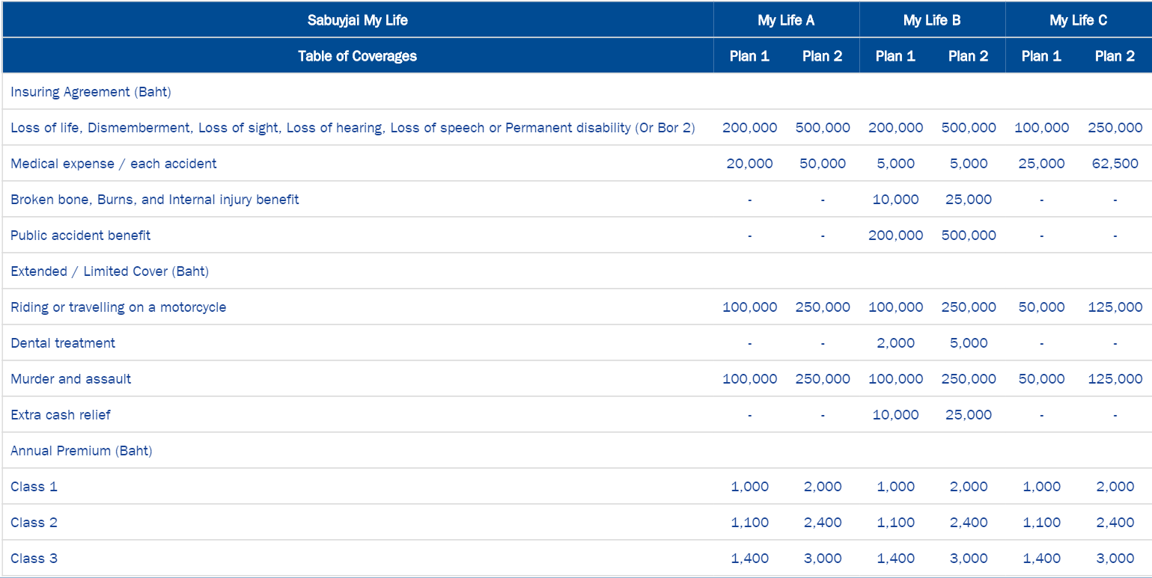

2) Which mortgage would result in higher total payments?
Total payment of the mortgage can be found by this formula
Total payment = Amount of payment * Number of months * Number of years
- Mortgage A: $970 a month for 30 years
= $970 * 1 month * 30 years
= $349,200
- Mortgage B: $760 a month for 5 years and $1,005 for 25 years
= ($760 * 1 month * 5 years) + ($1,005 * 1 month * 25 years)
= $347,100
Therefore, mortgage A provides higher total payment than mortgage B by $=2,100

3) What are the two main types of consumer credit?
- Close-End Credit:
This credit is used for a specific purpose, amount, and period of time. The payments are normally paid in equally amounts at the end of each period, usually monthly. Moreover, the credit also require interest on the purchase price as a cost of borrowing. It doesn’t allow to add an additional purchases, and once the original amount is paid off, customers must reapply if further credit is needed. The repayment period could extend months or years, depending on the original arrangement. Normally, seller will retain the form of ownership controlling to the goods until the repayment is completed. Mortgage loans and automobile loans are examples of closed-end credit.
- Open-End Credit:
This type of credit is very common to people’s life. Credit card is one of a good example. This credit is usually used to make small payment with on restriction and the exact period of using the credit. The customers are only given the limit of the credit then they can decide whether to use the service or not. If the customer chooses to use this credit, it will require you to repay the money in the end of a specified period, usually monthly. The interest is also charged as the cost of its service. Using a credit card issued by a store, a bank card such as VISA or MasterCard, or overdraft protection are examples of open-end credit.

4) What are the general rules of measuring credit capacity?
Initially, knowing the budget for basic necessities is important. The person should determine his own money management in necessities such as clothing, food, or education and other durable goods like new phone. These following general rules is help to determine his capacity of credit.
- Debt Payment to Income Ratio (DTI) = Monthly debt payment/ Monthly income
This ratio is one way lenders use in measuring a borrower’s ability to manage monthly payment and pay for him or her debts. It can be calculated by dividing total recurring monthly debt by gross monthly income, and it is expressed as a percentage. The higher the percentage, the lower the ability for borrower to pay back money as proportion of debt is very high compares to income him or her gains which should not be more than 20%.
- Debt to Equity Ratio (D/E) = Liability/ Net Worth
Net worth is the difference between the total value of an individual’s assets and that his or her liabilities. This formula compares an individual’s total debt to total net worth. The debt to equity ratio shows the percentage of personal financing that borrowed. The higher debt to equity ratio, the higher amount of debt relative to the available equity resulting in lower ability to pay back the loan. The ratio should not be higher than 0.5.

5) A few years ago, Michael Tucker purchased a home for $100,000. Today, the home is worth $150,000. His remaining mortgage balance is $50,000. Assuming that Michael can borrow up to 80 percent of the market value, what is the maximum amount he can borrow?

The statement says that he can borrow up to 80% of the market value which is now equals to $150,000. Therefore, looking at only this part, he can borrow up to 80%*$150,000 = $120,000. However, he still owe in remaining mortgage balance with $50,000. So, the amount he can actually borrow on the maximum of $120,000 - $50,000 = $70,000.

