Rattanasiri kaonui 6104841383
The paper that I choose is “Factor affecting the intention to play gacha game of teenage and working-age”
In this research, they aimed to answer the question of 1)what is the intention to play games of different demographic by classifying them as gender, age, education, job, and monthly income. 2)research more on their behavior of playing gacha games. 3)research on the influence that conforms others to play gacha games.4)research the controlled behavior of intention on playing gacha games. 5)research the enjoyment
In this paper, they use a simple questionnaire and divide it into three-part. The first part is about the demographic of the respondents including gender, age, education, job, and monthly income. The second part is about the factor of the intention of playing gacha games by using the 4 factors: attitude, conformation, controlled behavior, and enjoyment. And using the Likert scale to measure the outcome. The third part is the intention of playing gacha games. Also, use the Likert scale to measure the result.
For the theoretical model,this paper use the behaviour model from อุดลย์ จาตุรจคกุล and ดลยา จาตุรจคกุล.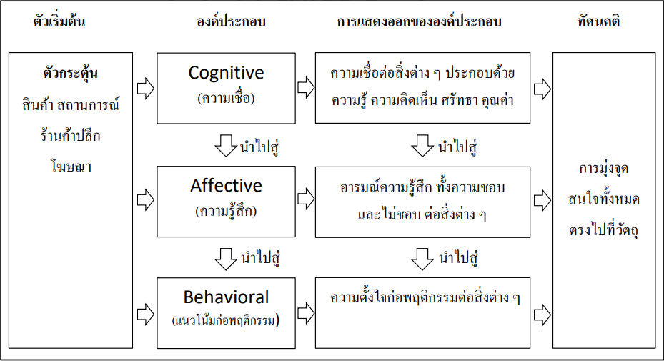
For empirical model, this paper use the gacha model from M.Koeder ,Tanaka and Sugai
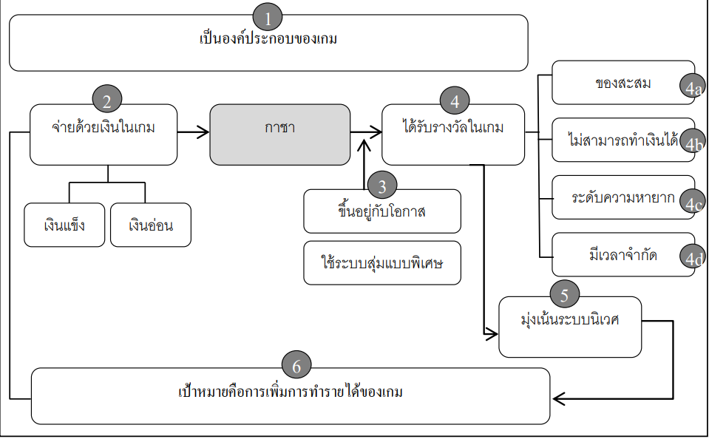

The results from the paper are 1).From 400 samples,276 are men(69%), 142 are aged from 15-21(35.50%),201 are bachelor degree(50.25%),184 are student(46%),and 124 have monthly income less than 5,000 baht (31%). 2). The number one factor is the ability to control the behavior.3). The research found that from the sample, the intention of respondents has very high to play gacha games. 4). Gender and age have a big influence on the intention of playing gacha games.
The strength of this research is that the implementation of data is very good and easy to understand by providing both graphs and explanations. The weakness is that the sample is very sample compare to the amount that people play gacha(over millions of people).

