Assignment 6

1.
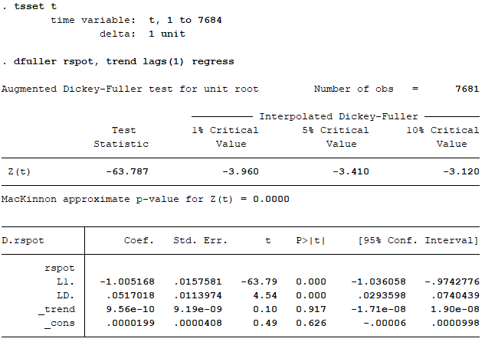
From running dfuller, we can see that MacKinnon p-value is equal to 0.00 which is less than 0.05 significant value. Thus, we reject the H₀: there is unit root. Rspot is stationary at level or I(0).

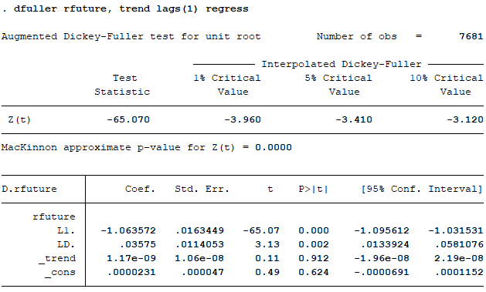
Same as rspot, rfuture has the p-value equals to 0.00. Thus, rfuture is also stationary at level or I(0).

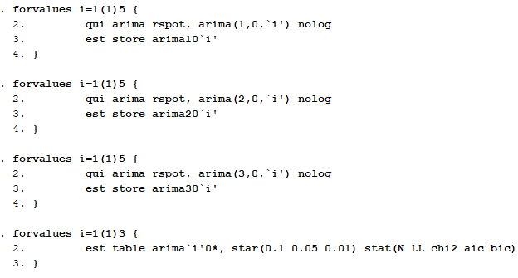
Rspot:

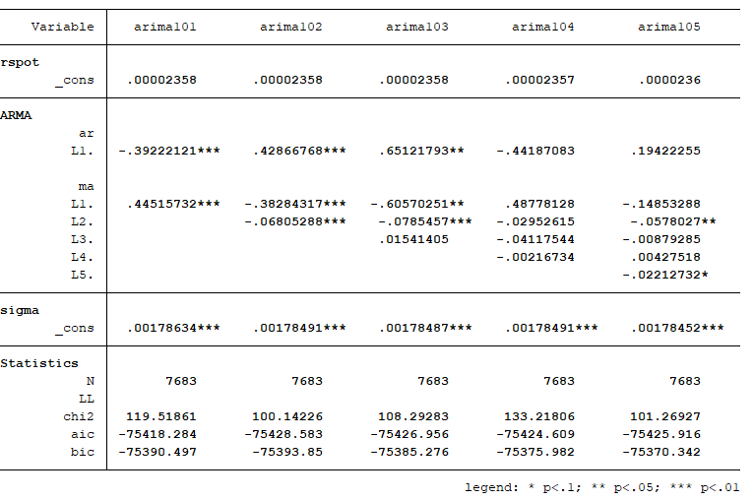

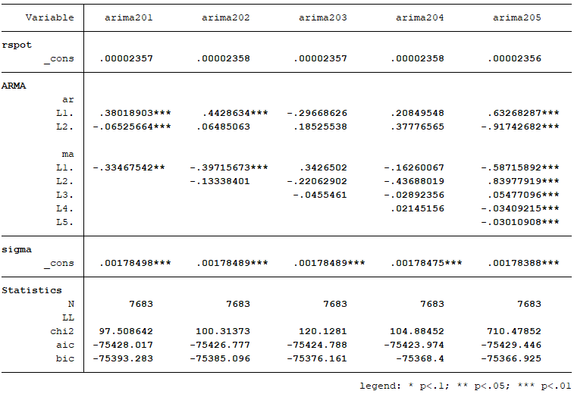

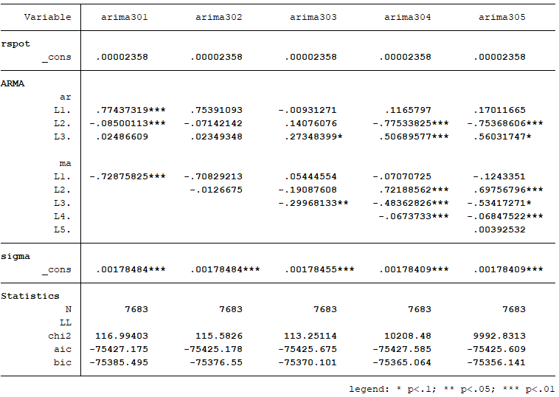
From looking at BIC of each ARIMA(p, d, q), the most appropriated model is ARIMA(1, 0 , 1) which has the lowest BIC of all (-75393.85). Thus, the most appropriated P, D, Q for rspot is 1, 0, and 1, respectively.

Rfuture:
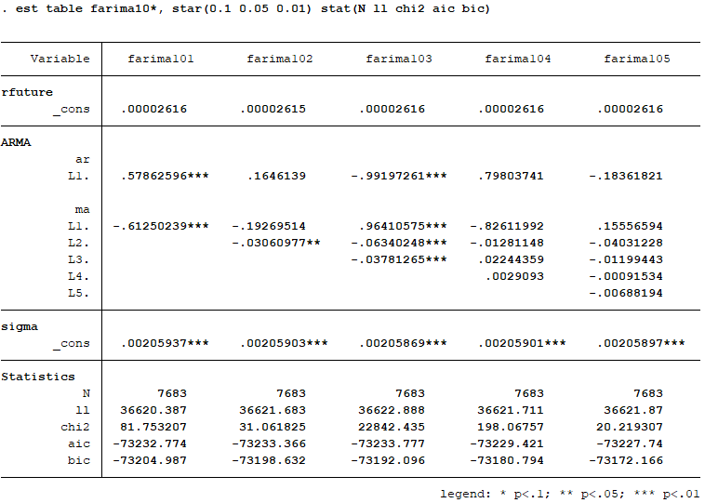

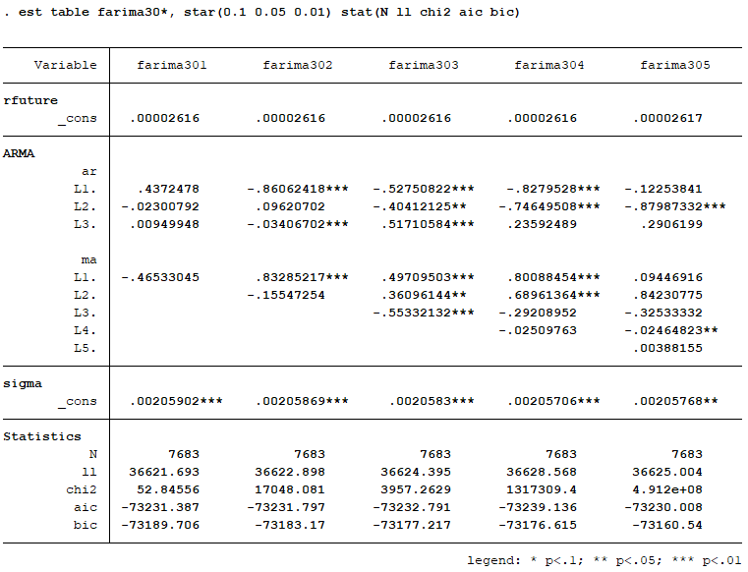
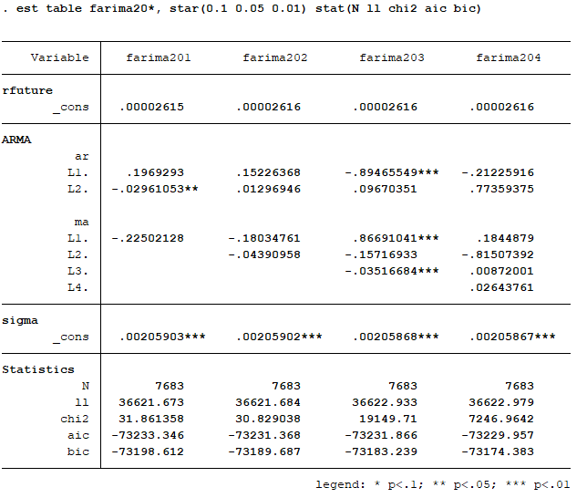

*rfuture ARIMA(2, 0, 5) encounters a problem where “flat log likelihood encountered, cannot find uphill direction”. So, it cannot be found.

After running ARIMA(p, d ,q) on rfuture, I found that the most appropriated model with the least BIC is ARIMA(1, 0, 1). Thus, the appropriated p, d, and q of rfuture is 1, 0, and1, respectively.

2.
For Spot Series static,
RMSE = sqrt(.0244773/7684) = 0.001785
For Spot Series dynamic,
RMSE = sqrt(.02459747/7684) = 0.001789
For Future Series static,
RMSE = sqrt(.03258357/7684) = 0.002059
For Future Series dynamic,
RMSE = sqrt(.03263977/7684) = 0.002061

3.
For Spot Series dynamic,
For Future Series dynamic,

Code
tsset t
g rspot = (spot/l.spot) - 1
g rfuture = (future/l.future) - 1
*==================================================
dfuller rspot, trend lag(1) regress
dfuller rfuture, trend lag(1) regress
*================================================== 1st question rspot
forvalue i=1(1)5 {
qui arima rspot, arima(1,0,`i') nolog
est store arimars10`i'
}
forvalue i=1(1)5 {
qui arima rspot, arima(2,0,`i') nolog
est store arimars20`i'
}
forvalue i=1(1)5 {
qui arima rspot, arima(3,0,`i') nolog
est store arimars30`i'
}
forvalue i=1(1)5 {
qui arima rspot, arima(4,0,`i') nolog
est store arimars40`i'
}
forvalue i=1(1)5 {
qui arima rspot, arima(5,0,`i') nolog
est store arimars50`i'
}
forvalue j=1(1)5 {
est table arimars`j'0*, star(0.1 0.05 0.01) stat(N ll chi2 aic bic)
}
*================================================== 1st question rfuture
forvalue i=1(1)5 {
qui arima rfuture, arima(1,0,`i') nolog
est store arimaf10`i'
}
forvalue i=1(1)5 {
qui arima rfuture, arima(2,0,`i') nolog
est store arimaf20`i'
}
forvalue i=1(1)5 {
qui arima rfuture, arima(3,0,`i') nolog
est store arimaf30`i'
}
forvalue i=1(1)4 {
qui arima rfuture, arima(4,0,`i') nolog
est store arimaf40`i'
}
forvalue i=1(1)4 {
qui arima rfuture, arima(5,0,`i') nolog
est store arimaf50`i'
}
forvalue j=1(1)5 {
est table arimaf`j'0*, star(0.1 0.05 0.01) stat(N ll chi2 aic bic)
}
*================================================== 2nd question
**================================================== 2nd question rspot static forecast
arima rspot, arima(1,0,2) nolog
predict rspothat_s, xb
twoway (line rspothat_s t, sort) (scatter rspot t, sort)
g fe_spot=rspot-rspothat_s
g sfe=fe^2
sum sfe
dis r(sum)
**================================================== 2nd question rspot dynamic forecast
arima rspot, arima(1,0,2) nolog
predict rspothat_d, y dynamic(.)
twoway (line rspot t, sort) (scatter rspothat_d t, sort)
g dfe=rspot-rspothat_d if t<7685
g sdfe=dfe^2
sum sdfe
dis r(sum)
**================================================== 2nd question rfuture static forecast
arima rfuture, arima(1,0,1) nolog
predict rfuturehat_s, xb
twoway (line rfuture t, sort) (scatter rfuturehat_s t,sort)
g fe_future=rfuture-rfuturehat_s
g sfe_future=fe_future^2
sum sfe_future if t>=2
dis r(sum)
**================================================== 2nd question rspot dynamic forecast
arima rfuture, arima(1,0,1) nolog
predict rfuturehat_d, y dynamic(.)
g dfe_future=rfuture-rfuturehat_d
g sdfe_future=dfe_future^2
sum sdfe_future if t<7685
dis r(sum)
*================================================== 3rd question
**================================================== 3rd question rspot dynamic forecast
arima rspot, arima(1,0,2) nolog
predict rspothat, y dynamic(.) t0(7684)
predict rspothat2, y dynamic(.) t0(7685)
predict rspothat3, y dynamic(.) t0(7686)
predict rspothat4, y dynamic(.) t0(7687)
twoway (line rspot t, sort) (scatter rspothat2 rspothat3 rspothat4 t, sort)
**================================================== 3rd question rspot dynamic forecast
arima rfuture, arima(1,0,1) nolog
predict rfuturehat, y dynamic(.) t0(7684)
predict rfuturehat2, y dynamic(.) t0(7685)
predict rfuturehat3, y dynamic(.) t0(7686)
predict rfuturehat4, y dynamic(.) t0(7687)
twoway (line rfuture t, sort) (scatter rfuturehat2 rfuturehat3 rfuturehat4 t, sort)
*********

