HIV/AIDS and Poverty

6204640236 Pokhin Kajohnchalearmsak
6204640988 Lertdej Deesomlert
6204641077 Tumnurat Pucksanonthachai
6204641507 Miss Pinpetch Ronnapusit

This paper is a part of EE406 Contemporary Economics Issues
Section 3, Semester 1/2020
Bachelors of Economics
Thammasat University

Abstract
This paper examines the relationship between HIV/AIDS and poverty. The three major factors : income inequality, residential segregation and poverty are positively correlated with HIV incidence. There are also minor factors, resulting from major factors, that contribute to HIV prevalence. For instance, poor healthcare / uneducation caused by poverty. On the other hand, HIV/AIDS can also lead to poverty as well. The low income tends to be more vulnerable to HIV prevalence as it affects their workabilities resulting in losses of income. In addition, they tend to be unable to receive any treatment. This results in supply of human capital declining and decelerates economic growth at national level and global level worsening the situation in undeveloped countries. In terms of effective policies, policies that have the tendency to work are often global scale policies. These policies receive a lot of attention as well as support and pressure from society and other countries. However, what really matters the most is the concept of people's commitment toward solving the issue and a good government system that people can rely on. By having these factors, this will help people solve the HIV problem.

Introduction 3
Poverty as a cause of HIV 3
1.1 Family in poverty compared to HIV rate. 3
1.1.1 statistic of family in poverty compared to HIV percentage. 4
1.1.2 Reasons why families in poverty increase the chance of getting HIV. 4
1.Uneducation 5
1.1.3 Map of HIV percentage compared to family in poverty. 6
1.2 Income inequality related to HIV. 7
1.2.1 Statistic of Income inequality related to HIV. 7
1.2.2 Reasons why income inequality is related to HIV. 8
1.2.3 Map of HIV prevalence compared to income inequality. 8
1.3 Correlation between residential segregation and HIV incidents. 9
1.3.1 Statistic of Correlation between residential segregation and HIV incident. 9
1.3.2 Reasons why residential segregation increase the chance of HIV contraction 10
1.3.3 Map of residential segregation compared to HIV incidents. 10
1.4 Conclusion of the cause for HIV 11
2.Poverty and Inequality after HIV/AIDS has emerged 11
2.1 HIV/AIDS decelerates economic growth 11
2.1.1 Poverty exposes workers to HIV/AIDS 11
2.1.2 Impact on labour force and human capital 12
2.2 The magnitude of the epidemic and its impact in the most seriously
affected countries. 14
2.2.1 HIV country prevalence ranking 14
2.2.2 Eswatini 16
2.3 HIV/AIDS, poverty and sustainable development 17
2.3.1 poverty of access to crucial public goods and services 17
How HIV/AIDS affects poverty and inequality? 18
3. Policy on both national and global scale 19
3.1 Global organizations’ responses 19
3.1.1 The Joint United Nations Programme on HIV and AIDS (UNAIDS) 19
3.1.2 World Health Organization (WHO) 20
3.2 Past policy : Successful and Unsuccessful 21
3.2.1 Successful Policy - HIV/AIDS Prevention in Uganda 21
3.2.2 Failed Policy - Africa’s Political Response to HIV/AIDS (2002) 22
3.3 Possible implementation 23
Conclusion 23
References 24

Introduction
HIV/AIDS is a global pandemic. From the biomedical perspective, HIV is a virus. HIV stands for Human Immunodeficiency Virus. The virus attacks the immune system, and weakens the body’s ability to fight infection and disease. Whereas, AIDS is a condition (stage 3 HIV). Contracting to HIV can lead to the development of AIDS.
By an anthropological perspective, the HIV/AIDS epidemic is caused by poverty, starvation and hunger, war, unemployment, uneven regional development, sex traffic, migration and working away from home, prostitution and selling sex, drug transactions, and discrimination. This work considers the way in which poverty affects the HIV/AIDS epidemic.
Two fundamental factors that influence the distribution of HIV are factors such as availability of resources (time and money) and the maturity of the epidemic. During the early stage, all areas of the country are not affected with the same intensity. Poor people living in rural areas that lack the resources to move around are more likely to be safe. On the other hand, people with more money and are living in urban areas are more likely to receive the virus since these people potentially have the upperhand in meeting more people and engaging in sexual relationships with multiple partners. In the long run, once the disease has become mature and spread thoroughly. The poorest populations in rural areas then become prone to receiving the virus. With this, the concept of HIV/AIDS often are associated with the word “poor” because poor people throughout the society statistically have higher chances of getting infected by disease faster and easier. They lack the education and resources to protect themselves.
This leads to our research objective which is to study the relationship between HIV/AIDS and poverty. How poverty causes HIV/AIDS prevalence and, vice versa, how HIV/AIDS leads to poverty and inequality. In addition, we also research and criticize whether organizations’ policies are effective or not. This is conducted at both national level and global level.

Poverty as a cause of HIV

1.1 Family in poverty compared to HIV rate.

-HIV/AIDS and poverty are linked at global level, There are strong bi-directional linkages between HIV/AIDS and poverty. HIV/AIDS is both a manifestation of poverty conditions that exist, taking hold where livelihoods are unsustainable, and the result of the unmitigated impact of the epidemic on social and economic conditions. HIV/AIDS is at the same time a cause and an outcome of poverty, and poverty is both a cause and an outcome of HIV/AIDS. Cross-country evidence indicates strong and significant associations between HIV prevalence and aspects of socio-economic performance. In general, the higher the level of HIV, the lower the level of economic performance. However, There are exceptions to the relationship between HIV/AIDS and poverty, in particular in Africa where some countries with very high HIV prevalence rates are also among the richest, that mean poverty isn’t the only culprit for HIV rate, so there are other factors that contributed to HIV rate too.

1.1.1 statistic of family in poverty compared to HIV percentage.

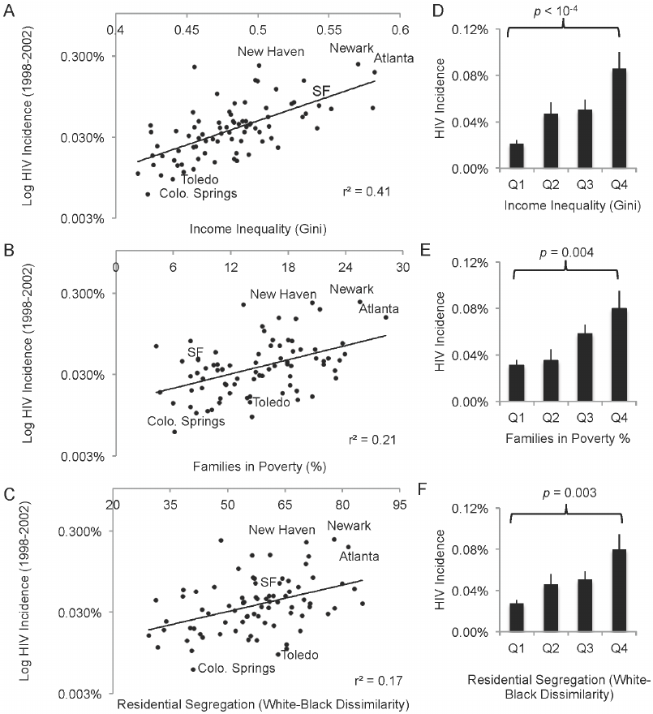
Source:https://www.researchgate.net/figure/Income-inequality-segregation-and-poverty-positively-and-synergistically-correlate-with_fig1_261757544

-This graph is the total reported HIV incidence in 80 large U.S. cities from 1998 to 2002. In the middle graph is the comparison between families in poverty and HIV incident, you can see an increase in Poverty leads to an increase in HIV incidence. Poverty positively and synergistically correlates HIV incidence across 80 U.S cities.

1.1.2 Reasons why families in poverty increase the chance of getting HIV.

1.Uneducation
-It has been said that HIV is transmitted rapidly among the poor’s society and this is proven to be true. Within the poorer society, the majority of people do not have the money / availability to go to school and receive education. This leads to lack of knowledge in terms of how to prevent the disease as well as its effects. Without money, this also resulted in wrong decision making. In this case, many people choose not to buy condoms as it is considered irreverent and a waste of money. Therefore, resulting in inconsistent uses of condom. In addition, health care is also considered to be lower in standard therefore, these people have hard time getting support which in this case they may have weaker immune systems which result in the person prone to have effect by other diseases more. Examples of this could be seen in the case of the Africa region. Africa currently has the highest rate of AIDS and a large reason for the high transmission rates is because of the lack of education provided to youth. Many children do not uses protective sex due lack of money, rsource and knowledge. When infected, most children die within one year because of the lack of treatment.

2.Lack of Healthcare / Drug problem
-Poverty can cause drug problems because poverty will lead to inadequate housing and poor education, in the end People in poverty will be more vulnerable to HIV/AIDS. According to research, the use of drugs among the poor society also affects the rate of transmission of HIV. Oftentimes, drugs are considered a topic often related to the poor. This is true as deprivation acts as an important key element that causes someone to start using drugs. Deprivation can involve many things in this case such as poverty, inadequate housing, poor education and lack of job or social opportunities. With the uses of drugs, a person's chance of receiving HIV is significantly higher. This come in two form, when people inject drugs and share needles / other drug equipment and when drugs impair judgment / people have unprotected sex with an infected partner. According to research, 7 of the 10 UNAIDS regions, accounting for 90% of the global population, injecting drug users are considered among the most important risk groups for HIV. This shows us that people who use drugs are another category of people that are more likely to get in contact with the disease.

3.Limited Space / Slum
-Many of the poor families that live in urban areas can't afford proper housing, they have to live in highly populated urban residential areas, or in other words we call it “slum”. In 2008, the global urban population surpassed the rural population and by 2050 more than 6 billion will be living in urban centres. A growing body of research has reported on poor health outcomes among the urban poor but not much is known about HIV prevalence among this group. A survey of nearly 3000 men and women was conducted in two Nairobi slums in Kenya between, where respondents were tested for HIV status. In addition, data from the Kenya Demographic and Health Survey were used to compare HIV prevalence between slum residents and those living in other urban and rural areas. The results showed strong intra-urban differences. HIV was 12% among slum residents compared with 5% and 6% among non-slum urban and rural residents, respectively.

1.1.3 Map of HIV percentage compared to family in poverty.

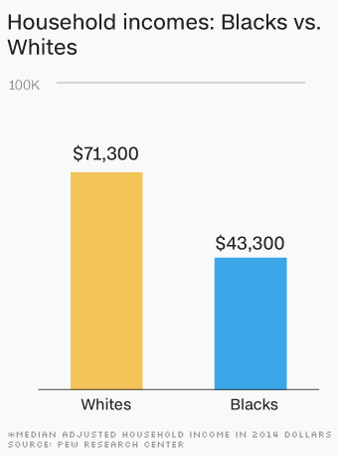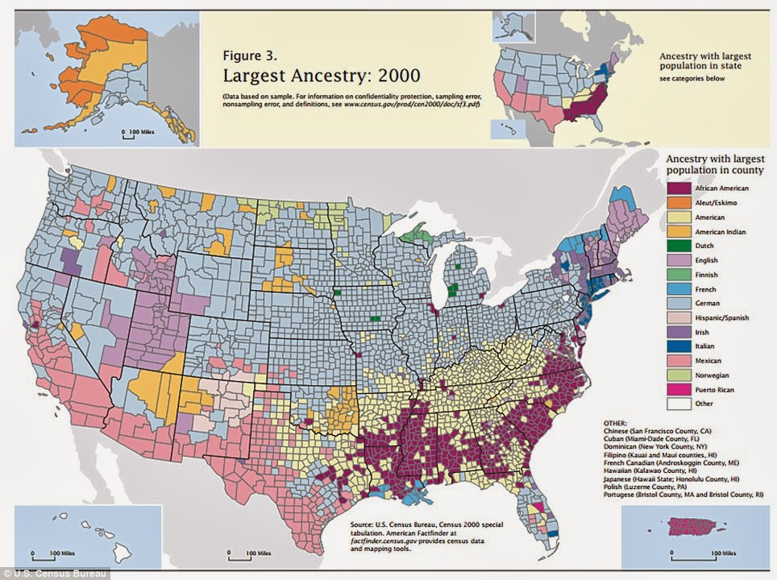
Source:https://money.cnn.com/2016/06/27/news/economy/racial-wealth-gap-blacks-whites/index.html
https://www.dailymail.co.uk/news/article-2408591/American-ethnicity-map-shows-melting-pot-ethnicities-make-USA-today.html

-In the United States income distribution is distribute unevenly between Blacks people and Whites people, Whites people received income more than blacks people which mean more of the blacks population living under poverty than Whites people is, which lead to higher prevalence of HIV among Blacks people and most of the black peoples live in the southern states of USA, that mean in the south their will be more rates of HIV.

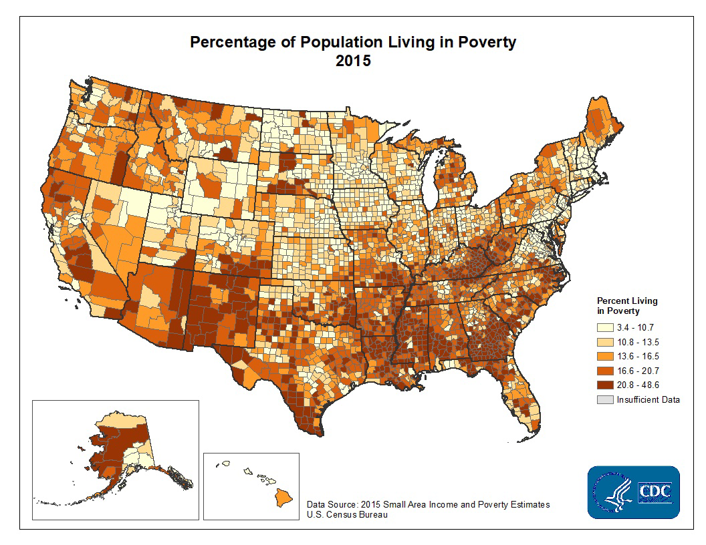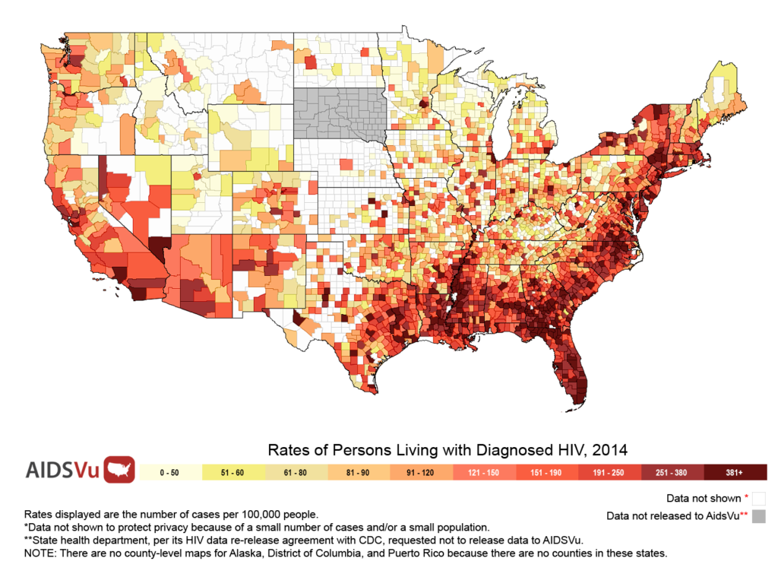
Source:https://www.cdc.gov/dhdsp/maps/sd_poverty.htm
https://www.cdc.gov/dhdsp/maps/sd_poverty.htm

-This is the comparison between poverty and HIV, First map shows you the Percentage of Population living in poverty, Second map shows you rates of people living with Diagnosed HIV. You can see that the southern states have the highest Percentage of Population living in poverty, because most of the blacks people living in the south and those blacks people received less income which lead to poverty and at the end more HIV rates..

——————————————————————————————————

1.2 Income inequality related to HIV.

-The ecological relationship between health and wealth has been well characterized in the global development field. The literature suggests that the cycle is self-perpetuating. Societies with higher wealth may have better living, working and housing conditions, have less stress, and are able to purchase better health care. In turn, a healthy society affords more productive workers and lower economic toll for health spending. The relationship between income and HIV is more complex than that between income and health, more generally. Some studies in generalized HIV epidemics in sub-Saharan Africa have found no association; others show that poverty is associated with lower HIV prevalence rates, while higher socioeconomic status indicators such as education and income are associated with higher HIV prevalence
More recently, studies have found that HIV prevalence is more strongly associated with income inequality rather than with absolute level of income.

1.2.1 Statistic of Income inequality related to HIV.
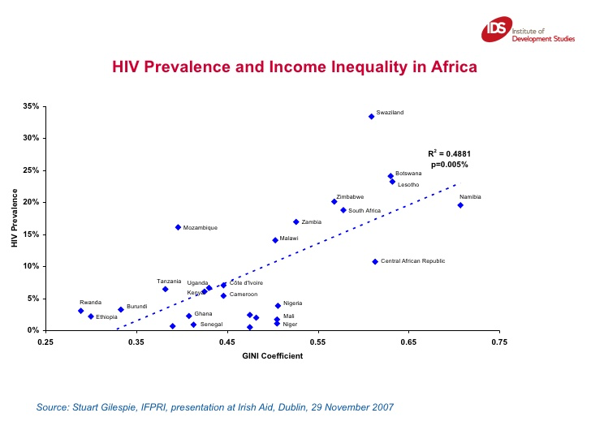
Source:https://www.slideshare.net/katecommsids/understanding-hiv-and-aids-in-the-context-of-poverty-and-inequality-presentation

-This graph is the comparison between HIV prevalence and Income inequality in 27 countries of the Sub-Saharan Africa region. From this graph you can see an increase in GINI coefficient leads to an increase in HIV prevalence. Income inequality (represented as the Gini coefficient, where higher values correspond to greater inequality). Income inequality is positively correlated with HIV prevalence across 27 Sub-Saharan Africa countries.

1.2.2 Reasons why income inequality is related to HIV.

-The reason why income inequality is related to HIV is because higher wealth may have better living, working and housing conditions are also better and are able to purchase better healthcare. Rich people also can afford for medical services while Poorer people can’t afford for medical services. In addition, health care is also considered to be lower in standard for the poor, which leads to a higher chance of contracting HIV. Income inequality also causes uneducation among the lower income people too, Without education this also resulted in wrong decision making and lack of knowledge in terms of how to prevent the disease, which in the end can lead to more chances of contracting HIV among the poor.

1.2.3 Map of HIV prevalence compared to income inequality.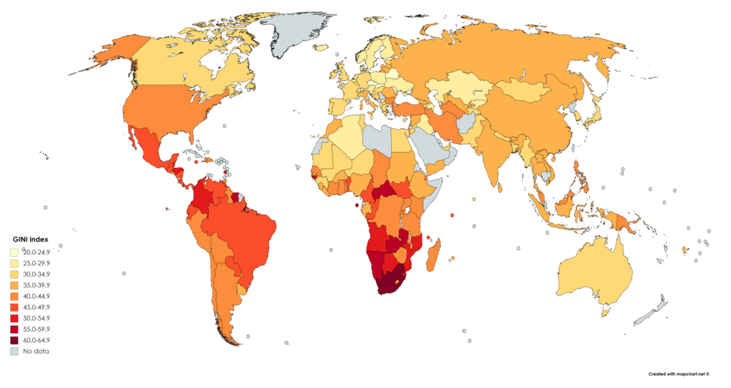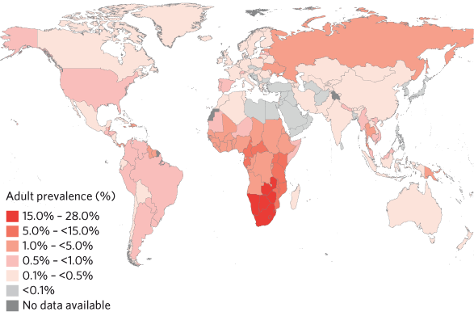
Source: https://en.m.wikipedia.org/wiki/List_of_countries_by_income_equality
https://www.who.int/hiv/data/global_data_slideshow.html

-This is the comparison of HIV prevalence and income inequality. First map shows the GINI index globally(representing “Income inequality”), the Second map shows HIV prevalence in adults globally. You can see that the highest HIV prevalence is in the Sub-Saharan Africa region especially in the country of South Africa because in Sub-Saharan African, South Africa has one of the most GINI indexes in the world, which means the country of South Africa representing high income inequality. In the end, South Africa will have a higher HIV prevalence because higher income inequality leads to higher prevalence of HIV.

—————————————————————————————————

1.3 Correlation between residential segregation and HIV incidents.

-HIV can affect anyone regardless of sexual orientation, race, ethnicity, gender, age, or where they live. However, in the United States, some racial/ethnic groups are more affected than others, given their percentage of the population. This is because some population groups have higher rates of HIV in their communities, thus raising the risk of new infections with each sexual or injection drug use encounter. Additionally, a range of social, economic, and demographic factors such as stigma, discrimination, income, education, and geographic region affect people’s risk for HIV. For example Blacks/African Americans accounted for 42% of HIV diagnoses in the USA, but they are only 13% of the total US population. Hispanics/Latinos accounted for 27% of HIV diagnoses in the USA, but they are only 18% of the total US population.

1.3.1 Statistic of Correlation between residential segregation and HIV incident.
Source:https://www.researchgate.net/figure/Income-inequality-segregation-and-poverty-positively-and-synergistically-correlate-with_fig1_261757544

-The total reported HIV incidence in 80 large U.S. cities. In the bottom graph, you can see an increase in Residential segregation leads to an increase in HIV prevalence. Residential Segregation(black-white dissimilarity index), a measure of black-white segregation where 0 is completely integrated and 100 completely segregated. Residential Segregation is positively and synergistically correlated with HIV incidence across 80 U.S. cities.

1.3.2 Reasons why residential segregation increase the chance of HIV contraction

-The reason why residential segregation increases the chance of HIV contraction is Public health care infrastructure tends to distribute unevenly between different communities, it will be abundant in higher class communities and less in the lower class community, which will be harder to notice and prevent contracting of HIV. lower class population also have poorer environments such as poverty, homelessness, and poor housing conditions, then more injecting drug used in the poorer communities and unprotected sex because lack of education, In the end, lower class communities will have higher prevalence of HIV.

1.3.3 Map of residential segregation compared to HIV incidents.
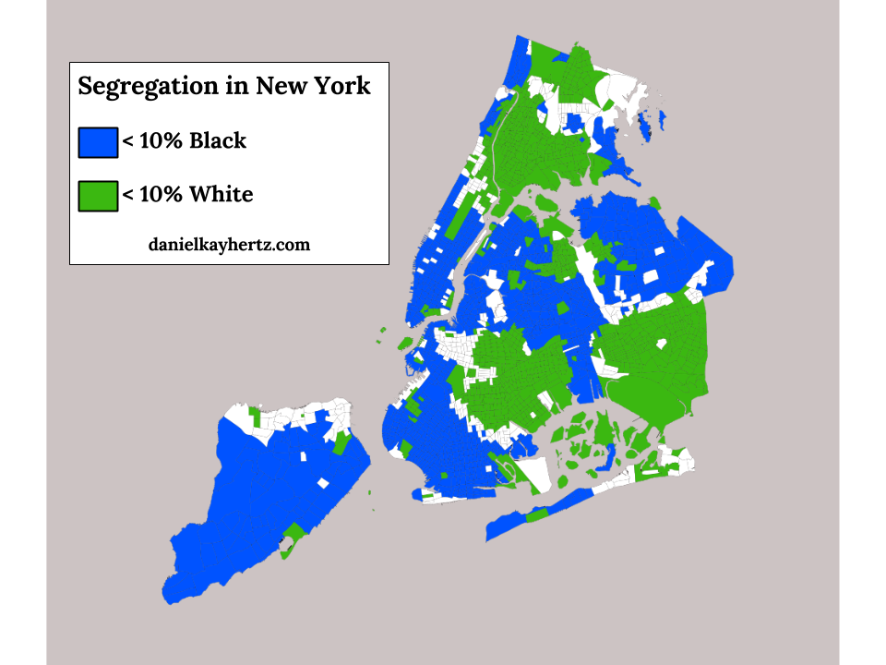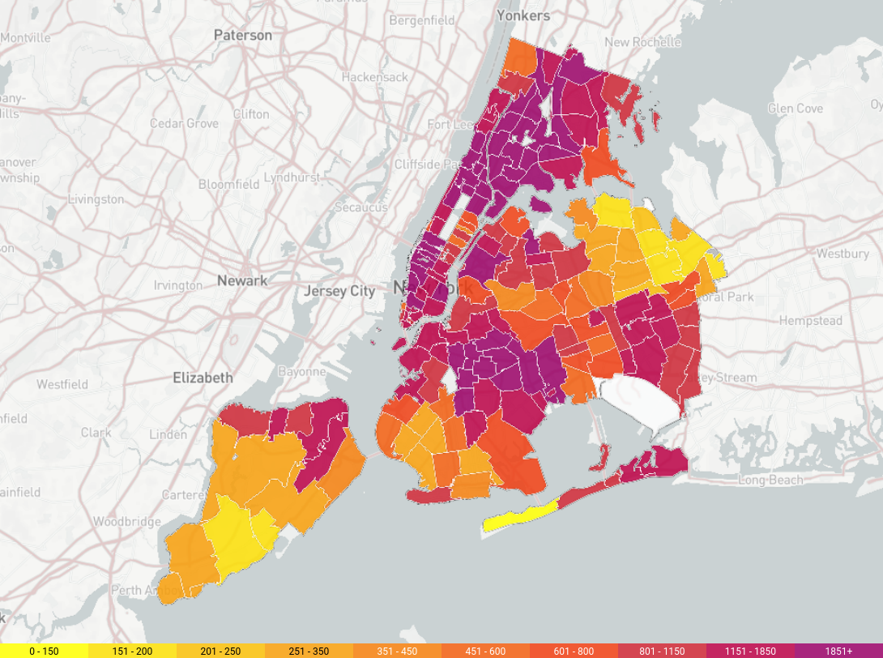
Source: https://danielkayhertz.com/2014/04/14/how-segregated-is-new-york-city/
https://blogs.baruch.cuny.edu/geteducatedhiv/?page_id=157

-This is the comparison between residential segregation and HIV incidents. First map show you racial segregation in New York City, Second map show HIV incident in New York. From the map we can assume that, the more residential segregation the more HIV incidents, Which lead to higher population with HIV in the Blacks majority area such as Brooklyn and Bronx districts because in those areas have high residential segregation.

1.4 Conclusion of the cause for HIV

-In conclusion Income inequality, residential segregation and poverty positively are synergistically correlated with HIV prevalence. There are major factors and minor factors that contribute to the prevalence of HIV, The major factors are 1.Poverty, 2. Income inequality and 3.Residential segregation. Some of the minor factors that can contribute to the prevalence of HIV are the product from the major problems. For example uneducation, slum living and poor healthcare can be attributed to the prevalence of HIV and all of these 3 minor factors are caused from one of the major factors that is 1.poverty. There may be other minor factors that we still haven't discovered yet, but this is sufficient for the estimation and calculations for the prevalence of HIV.

——————————————————————————————————

2.Poverty and Inequality after HIV/AIDS has emerged

2.1 HIV/AIDS decelerates economic growth
The epidemic is taken into account to be a vital factor of slowing the pace of the economic process at national level. Its effects can be in several ways such as : slow or reverse growth in labour supply; reduction in savings and investments in families due to HIV/AIDs-related health expenditures; public spending diversion from investments in physical and human capital to health expenditures which result in slower growth of Gross Domestic Product, etc.

2.1.1 Poverty exposes workers to HIV/AIDS
In a biological context, poverty leads to lack of access to adequate food and hence, malnutrition. Malnourishment can greatly compromise a human’s immune system, making it more susceptible to infectious diseases such as HIV/AIDS. Health economist Eileen Stillwaggon argued that the prevalence of HIV is highly correlated with decreased protein consumption, falling calorie consumption, inequality in income distribution, and infectious disease variables (Stillwaggon, 2006).
Poverty also leads to the lack of education and illiteracy. These people tend to be unskilled labour and are engaged in the informal economy. They are considerably more vulnerable to HIV infection, and less able to gain access to care, support and treatment, than those in the formal sector. Relevant factors include: the informal economy’s labour-intensive nature and inadequate or non-existent labour legislation and enforcement of existing laws; absence of worker representation; absence of steady income; gender inequality; inadequate social protection; low levels of literacy; fewer employment-related benefits; the presence of many young people; poor opportunities for skills enhancement; poor health and safety standards; and lack of access to health facilities(Conference of African Ministers, 2006). In addition, The informal economy is generally a more important source of employment for women than for men. Women’s share of informal employment worldwide remains between 60 and 80 per cent (Becker, 2004).
To conclude the two contexts aforementioned, poverty drives workers, espeacially female, to exchange sex for food, and to resort to sex work for survival when they are excluded from formal sector employment and all other work options are too low-paying to cover their basic needs. In these circumstances, individuals are poorly motivated and poorly equipped to take the necessary steps to protect themselves from HIV.
On the international level, migration can also play a significant role in transmitting infectious diseases. The level of migration can explain the dissimilarity in HIV prevalence figures in different parts of Africa (Decosas, 1999). Social, economic and political factors in origin and destination countries influence the risk of HIV infection of international labour migrants. These include separation from spouses, families and familiar social and cultural norms, language barriers, substandard living conditions, and exploitative working conditions, including sexual violence. The resulting isolation and stress may lead migrant workers to engage in behaviours, e.g. unsafe casual or commercial sex, which increase HIV risk. This risk is exacerbated by inadequate access to HIV services and fear of being stigmatized for seeking HIV-related information or support.(UNDP, 2004). Particularly, undocumented migrants, of whom there are many in the informal sector, avoid formal health-care systems as they fear discovery by the authorities. For the same reason, they are also reluctant to be part of any kind of prevention or support programme.

2.1.2 Impact on labour force and human capital
The number of workers either fully or partially unable to work due to HIV and AIDS has fallen dramatically since 2005, and this trend is projected to continue, as portrayed in figures S-4 and S-5. The total number of those estimated to be fully unable to work is expected to decline to about 40,000 in 2020 from a 2005 level of about 350,000 – an 85 per cent decline for men and a 93 per cent decline for women. The corresponding decline for partial inability to work is from 655,000 to 95,000, 81 per cent for men and 91 per cent for women. These trends largely follow those for mortality, except that the number of cases is lower. A high proportion of those identified as likely to be work-impaired are also facing death in the near future due to their lack of access to ART-antiretroviral therapy (International Labour Organization [ILO], 2018)
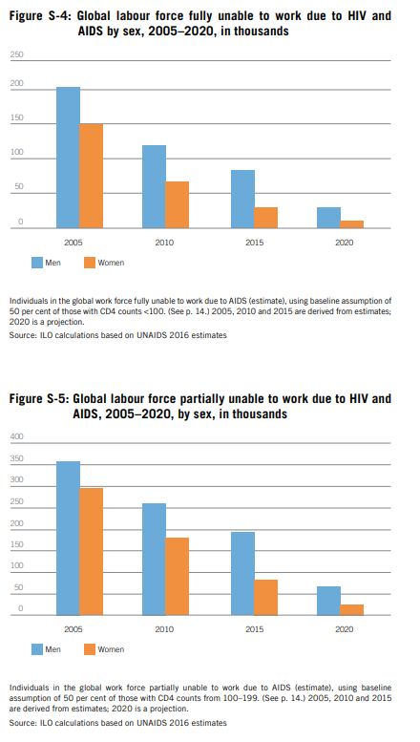
Although global labour force unable to work due to HIV has been decreasing,illness of a household member means loss of the contribution to work and income of the person affected, an increase in medical expenses, and diversion of other family members from work and school attendance to caring for the patient. Death results in a permanent loss of income (whether from farm work, wages or remittances), funeral and mourning expenses. And the removal of children (usually in the 8-15 age group and disproportionately girls) from school, both to save money and to increase family labour, results in a severe loss of a family’s future earning potential.Women are particularly vulnerable to the economic impact of HIV/AIDS, with little economic security and few rights to land or property: in one way or another, many end up dependent for survival on the favours or protection of male partners(Lisk, 2002).
Hence,the HIV/AIDS epidemic will have a large impact on the supply of human capital. Because of AIDS, there is pressure on children to drop out of school to support themselves. In addition, HIV-positive women have fewer babies, partly because they may die before the end of their child-bearing years, and children are themselves infected and may not survive to school age: so the number of children in school is falling. This will affect the supply of human capital in the longer run.

2.2 The magnitude of the epidemic and its impact in the most seriously affected countries.

2.2.1 HIV country prevalence ranking

Among all countries worldwide, those in sub-Saharan Africa have the highest rates of HIV. The countries with the highest rates of HIV include Eswatini, Lesotho, Botswana and South Africa. In 2019, Eswatini had the highest prevalence of HIV with a rate of 27 percent. Other countries, such as Zimbabwe, have significantly decreased their HIV prevalence. Community-based HIV services are considered very important to the prevention and treatment of HIV.

Ranking of countries with the highest prevalence of HIV in 2000 and 2019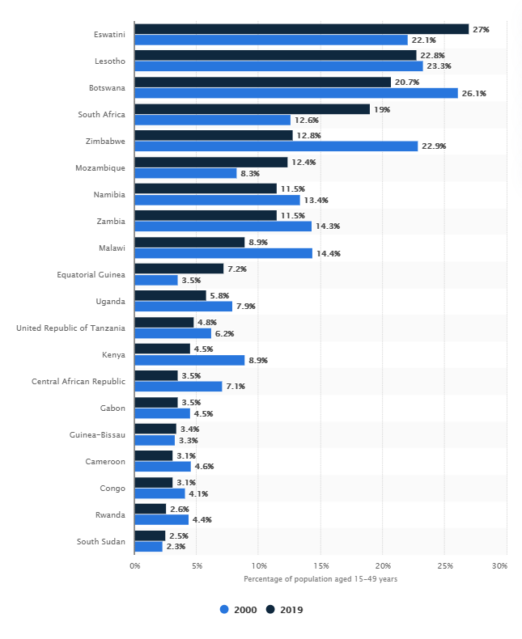
Source : Statista (2019) https://www.statista.com/statistics/270209/countries-with-the-highest-global-hiv-prevalence/
Surveyed by UNAIDS https://www.unaids.org/en/resources/documents/2020/HIV_estimates_with_uncertainty_bounds_1990-present

2.2.2 Eswatini

In 2019, Eswatini, despite its small population, has the highest prevalence of HIV in the world with 200,000 people living with HIV; 27% of adults in Eswatini were living with HIV; 4,500 new HIV infections; 2,300 AIDS-related deaths; 95% of these adults were accessing antiretroviral treatment and 84% of infected children were on antiretroviral treatment (UNAIDS, 2020).
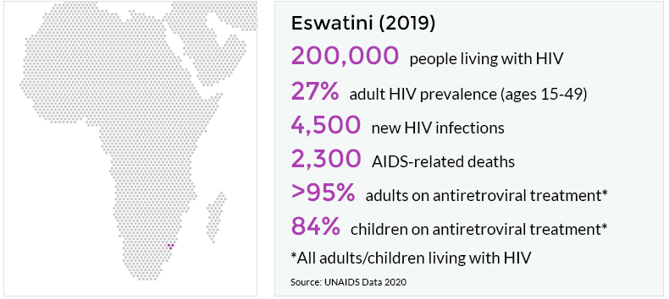
Source : Avert. (2020). HIV AND AIDS IN ESWATINI
https://www.avert.org/infographics/hiv-and-aids-eswatini

The key factors that influence the spread of HIV in Eswatini are : Multiple and Concurrent Sexual Partners, Sex work, HIV Stigma & discrimination, Gender inequality and gender based violence, Early sexual debut, Intergenerational sex and Men who have sex with men. (Swaziland Ministry of Health, 2014)

Human Development Index (HDI)

The HDI is a summary measure for assessing long-term progress in three basic dimensions of human development: a long and healthy life, access to knowledge and a decent standard of living. A long and healthy life is measured by life expectancy. Knowledge level is measured by mean years of schooling among the adult population, which is the average number of years of schooling received in a life-time by people aged 25 years and older; and access to learning and knowledge by expected years of schooling for children of school-entry age, which is the total number of years of schooling a child of school-entry age can expect to receive if prevailing patterns of age-specific enrolment rates stay the same throughout the child's life. Standard of living is measured by Gross National Income (GNI) per capita expressed in constant 2011 international dollars converted using purchasing power parity (PPP) conversion rates. To ensure as much cross-country comparability as possible, the HDI is based primarily on international data from the United Nations Population Division (the life expectancy data), the United Nations Educational, Scientific and Cultural Organization Institute for Statistics (the mean years of schooling and expected years of schooling data) and the World Bank (the GNI per capita data). To allow for assessment of progress in HDIs, the 2019 Human Development Report includes recalculated HDIs from 1990 to 2018 using a consistent series of data (UNDP,2019).
HIV/AIDS epidemic and HDI—including life expectancy, years of schooling, and GNI per capita- have an inverse relationship. Less developed countries, as measured by HDI, are likely to have a more severe HIV/AIDS epidemic. National socioeconomic status tends to affect the HIV/AIDS epidemic more negatively in nations with higher HIV/AIDS mortality, prevalence, and incidence rates(American Journal of Infection, 2014).

Eswatini’s HDI value and rank
Eswatini’s HDI value for 2018 is 0.608— which put the country in the medium human development category—positioning it at 138 out of 189 countries and territories. The rank is shared with Congo. Between 1990 and 2018, Eswatini’s HDI value increased from 0.545 to 0.608, an increase of 11.6 percent; life expectancy at birth decreased by 2.5 years; mean years of schooling increased by 2.5 years and expected years of schooling increased by 1.8 years. Eswatini’s GNI per capita increased by about 57.9 percent. (UNDP, 2019)

Impacts of HIV/AIDs on human development
With Eswatini’s HDI value, we can conclude that HIV/AIDS relatively affects the national human development in three dimensions : reducing the choice of Eswatini citizens to live a long and healthy life; decreasing access to knowledge and education and limiting the choice for achieving a decent standard of living.

2.3 HIV/AIDS, poverty and sustainable development

2.3.1 poverty of access to crucial public goods and services

HIV/AIDS can be the biggest single obstacle to the achievement of poverty reduction and sustainable development in poor and least developed countries, in particular sub-Saharan Africa. Poverty itself is complex and multi-faceted, and encompasses many forms of deprivation over and above income poverty and consumption deficiencies. It is critical to examine the role of the HIV/AIDS epidemic in maintaining or exacerbating a range of the components of poverty, including poverty of access to crucial public goods and services.
Education :The majority of adolescents and young people globally do not have accurate and comprehensive knowledge about HIV. HIV-related illnesses impede learner attendance and education outcomes, as does stigma and discrimination in school settings. Teachers and education staff are also impacted. National education sectors can make schools safer, healthier and more inclusive places for learners and teachers living with and affected by HIV. They can also make a transformative impact in the lives of young people by providing them with quality comprehensive sexuality education, which empowers them with the knowledge and skills they need to make responsible and informed health decisions, to improve their self-esteem and to change harmful attitudes and gender and social norms. (UNAIDS)
Healthcare : Lack of universal health coverage, including sexual and reproductive health services and harm reduction for people who inject drugs, restricts access to HIV prevention and treatment. Most people acquiring HIV infection acquire it through sexual transmission or transmission from mother to infant during pregnancy, childbirth or breastfeeding. HIV-sensitive universal health coverage can play a vital role in promoting health equity, while integration with rights-based services for sexual and reproductive health, noncommunicable diseases, hepatitis, tuberculosis and other conditions can improve broader health outcomes(UNAIDS).

How HIV/AIDS affects poverty and inequality?

The epidemic exacerbates or maintains poverty and inequality at an individual, national and global level. At an individual level, those with low income have a higher tendency to be exposed and infected. Moreover, poverty also restricts these people from access to crucial public goods and services— education and healthcare. As a result, they tend to work in an informal economy and once they get exposed, fear of stigmatization and budget constraints obstruct them from treatment causing a significant loss of income to them and their family due to inability to work.
At a national level, the inability to work also affects a large impact on supply of human capital. Undeveloped countries, particularly in Sub Saharan Africa, are exposing more to HIV/AIDs worsening their human development which is one of the key parts to improve human capital and economy. This maintains or exacerbates their poverty resulting in inequality among countries. At an international level, migration plays a vital role in spreading the disease. Hence, it disturbs global workforce and economic growth.

3. Policy on both national and global scale

3.1 Global organizations’ responses

3.1.1 The Joint United Nations Programme on HIV and AIDS (UNAIDS)

The Joint United Nation Programme (UNAIDS) HIV and AIDS roadmap 2020 aims to reduce the global numbers of people newly infected by HIV globally to fewer than 500 000 (75% reduction against 2010 targets). The policy announced is “a call to action: a 10-point plan for accelerating HIV prevention at the country level.” (UNAIDS) The plan lays out concrete steps that each country can take in order to accelerate progress towards meeting its 2020 commitments on HIV prevention. Something to note, all actions need to be adjusted as each country experiences different situations resulting in different planning processes.
1. Conduct a strategic assessment of key prevention needs and identify policy and programme barriers to progress (UNAIDS, 2017).
2. Develop or revise national targets and road maps for HIV prevention 2020 (UNAIDS, 2017).
3. Make institutional changes to enhance HIV prevention leadership, oversight and management (UNAIDS, 2017).
4. Introduce the necessary legal and policy changes to create an enabling environment for prevention programmes (UNAIDS, 2017).
5. Develop national guidance, formulate intervention packages, identify service delivery platforms and update operational plans (UNAIDS, 2020).
6. Develop a consolidated prevention capacity-building and technical assistance plan (UNAIDS, 2020).
7. Establish or strengthen social contracting mechanisms for civil society implementers, and expand community-based responses (UNAIDS, 2020).
8. Assess available resources for prevention and develop a strategy to close financing gaps (UNAIDS, 2017).
9. Establish or strengthen prevention programme monitoring systems (UNAIDS, 2017).
10.Strengthen national and international accountability for prevention (UNAIDS, 2017).
UNAIDS have proposed the roadmap 2020 design which intends to use new policy in improving the HIV situation. Starting in 2017, the effect of this programme has resulted in a positive effect. With the United National involved, this comes in a form of cooperation from hundreds of countries. Therefore, this resulted into a big scale implementation and policy toward HIV as it is a world scale programme. This overall helps raise attention and awareness toward the problem informing us about the current issue and its effect. In addition, with many countries' support, countries with not enough resources / supply were able to receive the help they need. In addition, countries were pressured to take action due to political images. Lastly, the policy will be running as long as 2030, therefore this will benefit solving the problem in the long run as well as giving countries guidelines on how to deal with current / possible HIV situations.

3.1.2 World Health Organization (WHO)

In 2016, WHO (World Health Organization) published “GLOBAL HEALTH SECTOR STRATEGY ON HIV 2016–2021 TOWARDS ENDING AIDS.” announcing The five strategic directions that guide priority actions by countries and by WHO presented below
Strategic direction 1 : what is the situation?– Focuses on the need to understand the HIV epidemic and response as a basis for advocacy, political commitment, national planning, resource mobilization and allocation, implementation, and programme improvement (World Health Organization, 2016). Strategic direction 2 : what services should be delivered?– Addresses the first dimension of universal health coverage by describing the essential package of high-impact interventions that need to be delivered along the continuum of HIV services to reach country and global targets, and which should be considered for inclusion in national health benefit packages (World Health Organization, 2016). Strategic direction 3 : how can these services be delivered?– Addresses the second dimension of universal health coverage by identifying the best methods and approaches for delivering the continuum of HIV services to different populations and in different locations, so as to achieve equity, maximize impact and ensure quality (World Health Organization, 2016). Strategic direction 4 : how can the costs of delivering the package of services be covered?– Addresses the third dimension of universal health coverage by identifying sustainable and innovative models for financing HIV responses, approaches for reducing costs and financial protection systems so that people can access the services they need without incurring financial hardship (World Health Organization, 2016). Strategic direction 5 : how can the trajectory of the response be changed?– Identifies those areas where there are major gaps in knowledge and technologies, where innovation is required to shift the trajectory of the HIV response so that actions can be accelerated (World Health Organization, 2016).
WHO organization policies have proven to be successful to an extent. From implementing the policy, previous data have shown us that the global HIV epidemic has claimed fewer lives in 2015 than at any point over the two past decades. In addition, there were also fewer people who are newly infected with HIV. HIV infections among children are getting eliminated and the massive introduction of antiretroviral therapy has also reduced the global number of people dying from HIV-related cases. Statiscally, to about 1.1 million in 2015 – 45% fewer.

3.2 Past policy : Successful and Unsuccessful

3.2.1 Successful Policy - HIV/AIDS Prevention in Uganda

Looking at an example of successful policy in Uganda, we will discuss what are the key factors that made this policy effective. Previously, there were 50,000 new HIV infections in Uganda in 2017, among them are adolescents & young adults. The prevention program has 3 main objectives. 1. Increase adoption of safer sexual behavior & reduce in risk, 2 scale up coverage and use of biomedical HIV prevention interventions as part of integrated health care services, 3 mitigate underlying socio-cultural, gender and other factors that drive the HIV epidemic.
The number of male condoms distributed rose from 87 million in 2012 to 240 million by the late 2015. But the number is far below the amount required according to the population size. The government aims to increase the supply chain in order to eventually meet the amount needed.
In 2016, around 1,730 operating health facilities offered antiretroviral treatment (ART). Uganda introduced into the country with accordance with the World Health Organization guideline, which all tested positive candidates have to enroll in. Nearly 898,200 people enrolled in the treatment, only 67% of adults & 47% of children. There were some difficulties for young people aged 15-19, which they are more likely to drop out of the care. The resson being discrimination, and time on traveling to clinics.
As many of the citizen avoidance of seeking help/remedies from the governments are due to Social Stigma & discrimination. The 2015 survey conducted that stigma comes in the form of external & internal to be high, with more than half experiencing some form of prejudice from the fact of having HIV. The most common forms of stigma are gossip(experienced by 60%), verbal harassment, insult, threat(experienced by 37%), sexual rejection(21.5% more female than male).
The success in the prevention in Uganda came in a form of behavioral changes in the late 1980s. Which at the time the acknowledgement by the government of the problem was high from the rate of HIV/AIDS. By the acknowledgement by the officials/staff, the problem has a much bigger chance of being tackled/remedy in a much broader scope. And the supportive & easily communicated staff in the local community also make the spread of information with higher efficiency in terms of time, and reach. The policy that was acknowledged to be a success is. With the use of ABC approach. A (Abstinence, delayed sexual behavior for youth), B (Be faithful, reduction is sexual activeness), C (Condom, use of protection). By changes in the behavior they inform & able to reach citizens at any type, area. It effectively points out what people don’t know by informing them. Changing the behavior, which fixes the problems at their root, the informed citizen can also pass down/ replicate the information to the future generation.
Zimbabwe also has a similar solution/ policy implementation to the problem. By changing citizen behavior, with reduction in multiple sexual partnerships and promote of the use of condom during casual sex. HIV prevention programs also communicate through church, workplace. With HIV prevalence dropping from 26% to 14% between 1997 to 2009.

3.2.2 Failed Policy - Africa’s Political Response to HIV/AIDS (2002)

Looking at an example of unsuccessful policy implemented by Africa (majorities of countries), we will discuss an important factor that causes the policy to fail in this region. In 2002, Africa implemented a policy and took action in reducing the effect of the widespread virus HIV. There was a political announcement / declaration in which the African’s authorities implemented the use of nevirapine (mass quantity) for pregnant women infected with HIV in order to reduce mother to child transmission.
The policy did not go well as there were many important key factors which prevented the policy effectiveness. First of all, political instability, the World Bank has previously reported that one out of every five Africans experiences wars or civil conflicts. This shows us the condition that the African are experiencing which is that of protracted civil war and lawlessness. Some countries also experience military regimes which have little interest in medical treatment due to current war situations. In addition, some countries also experience many other problems such as institutional decay, economic mismanagement, state corruption, civil violence, etc.
Most importantly, the majority of people in Africa are considered poor due to these problems mentioned above resulting in an economic crisis. Therefore, this resulted in African people not having time and money due to the downward economic situation and political spiral.
Another reason that made this policy ineffective would be the reason of trust and commitment within the communities. With an unstable government, people lose trust toward the policy implemented which results in people deciding not to follow the policy and paying less attention to it. In addition, South Africans have shown much of the mistrust towards western’s science / medicine, and public health due to historical conflict.
Commitment / Avoidance also played a very important role, at an individual level, the silence action can be perceived as how many adults were not recognizing the risks involved in HIV transmission through sexual action, and result in deciding to continue risky sexual practices. In addition, people fear of discrimination and society perception also played important role in making youngers not seeking help. However, this problem was solved in some countries such as Uganda and Botswana. In terms of cultural aspect, the silence from people in this case represents limited discussion both public / private on HIV/AIDS. At the public policy level, the African political leaders were slow to recognize the crisis nature of the epidemic thus resulting in slow action to finding effective solutions.
In conclusion, the policy implemented throughout Africa did not go well and was not successful as only a small number of people in some country were affected by the policy. Mostly, the infected one were taken care off but this does not stop the problem. People who took the drugs experience better health conditions. However, this does not stop the virus from spreading. This problem happens due to many factors such as lack of communication and coherenceness within the community. The mistake from this policy tells us how systems throughout Africa face problems correlated with state systems and cultural views which result in people not viewing the problem as an emergency. Therefore resulting in Africa becoming the continent that has the highest HIV prevalence rate with the highest being 27%.

3.3 Possible implementation

All in all, we are able to see that throughout history there have been both successful and unsuccessful policies that work. It appears that global scale policy implementations tend to have higher success rate as people pay more attention to the policy. This is also due to higher support and pressure that each country receives. Therefore, improving the country's commitment and process of work. We also found out the main important key factor that is required in order to improve the situation. People's commitment and stable government system is the key essential factor in this case. In order to reduce HIV rate, people must work together in following policies and regulation. For example, using protection such as condom in order to continue safety sex practice. This is something hard to achieve as people lack trust and resources. This is when a stabilized government system comes into play. In order to make people have trust and faith in the government, the authorities must have good relationships with its people. A stable government can be seen when a country has good economic structure, no corruption, no war, etc. This shows us how HIV rate relies on both people and government as well as how both people and government rely on each other.

Conclusion

It is a two-ways relationship between AIDS/HIV and poverty. In this case, poverty correlates with HIV incidence. The main reason that causes aids are factors such as poverty, income inequality and residential segregation. This later on resulted in other problems such as uneducated and poor healthcare. Our finding is poverty has a positive correlation with HIV prevalence.
On the other hand, HIV/AIDS maintains or exacerbates poverty and inequality as well. At an individual level, HIV/AIDS causes people with low income to have higher tendencies in terms of being exposed to the epidemic. In addition, they also experience working in the informal economy which results in people unable to work and losing income due to their restriction from unstable healthcare service. These people would be identified as poorer people which increases the inequality gap. This overall resulted in less efficiency on supply of human capital at the national level. At the international level, migrant workers could play a vital role in transmission.
Observing multiple policies, it appears that global scale policies tend to have a higher successful rate because people pay more attention to them. In addition, individual countries also receive higher support and higher pressure from other countries to take action to reduce HIV. We also found out that people’s commitment and stable government system is the solution to solving the epidemic/disease problem. When people work together with the government, this helps keep the epidemic under control and reduce its infection rate.

References

AIDS AND THE SUSTAINABLE DEVELOPMENT GOALS. (n.d.). UNAIDS. https://www.unaids.org/en/AIDS_SDGs
Avert. (2020, April 15). HIV and AIDS in Uganda. https://www.avert.org/professionals/hiv-around-world/sub-saharan-africa/uganda
Avert. (2020). HIV AND AIDS IN ESWATINI
https://www.avert.org/infographics/hiv-and-aids-eswatini
Becker, K. F. (2004). The informal economy. Sida. Retrieved from https://www.rrojasdatabank.info/sida.pdf
Brummer, D. (2002). Labour Migration and HIV/AIDS in Southern Africa. International Organisation for Migration Regional Office for Southern Africa. https://sarpn.org/documents/d0000587/Labour_migration_HIV-AIDS.pdf
Emory University’s Rollins School of Public Health in partnership with Gilead Sciences, Inc. and the Center for AIDS Research at Emory University (CFAR). (JUNE 20, 2017) AIDSVu Annual Release of New Maps and Resources. https://aidsvu.org/launch2017/
Fassin, D. The politics of AIDS in South Africa: beyond the controversies. US National Library of Medicine. Retrieved December 18, 2020, from https://www.ncbi.nlm.nih.gov/pmc/articles/PMC1125376/
Genuis, S. J. (2005). HIV/AIDS prevention in Uganda: why has it worked? Postgraduate
Medical Journal, 81(960), 615–617.
https://doi.org/10.1136/pgmj.2005.034868

Goliber, T. (2003, July 26). Africa’s Political Response to HIV/AIDS – Population
Reference Bureau. Population Reference Bureau.
https://www.prb.org/africaspoliticalresponsetohivaids/
International Labour Organization, International Organization for Migrant and UNAIDS. (2008). HIV and International Labour Migration. Retrived from https://www.unaids.org/sites/default/files/media_asset/jc1513_policy_brief_labour_migration_en_0.pdf

International Labour Organization (ILO). (2018). The impact of HIV and AIDS on the world of work: Global estimates. https://www.ilo.org/wcmsp5/groups/public/---ed_protect/---protrav/---ilo_aids/documents/publication/wcms_630244.pdf
International Labour Organization. (2009). HIV/AIDS and the world of work. Retrieved from https://www.ilo.org/wcmsp5/groups/public/---ed_norm/---relconf/documents/meetingdocument/wcms_090177.pdf
Jennifer R. Robbins. (April 2014). Beyond Race and Place: Distal Sociological
Determinants of HIV Disparities. https://www.researchgate.net/figure/Income-inequality-segregation-and-poverty-positively-and-synergistically-correlate-with_fig1_261757544

JESSICA JERREAT. (2 September 2013). Fascinating illustration shows the
of EVERY county in the US.
https://www.dailymail.co.uk/news/article-2408591/American-ethnicity-map-shows-melting-pot-ethnicities-make-USA-today.html
Lisk, F. (2002). Labour market and employment implications of HIV/AIDS. http://www.oit.org/wcmsp5/groups/public/---europe/---ro-geneva/---sro-moscow/documents/publication/wcms_247865.pdf
National Center for Chronic Disease Prevention and Health Promotion , Division for Heart Disease and Stroke Prevention. (November 14, 2018). Socioenvironmental Maps—Poverty.
https://www.cdc.gov/dhdsp/maps/sd_poverty.htm
Stillwaggon E. (2006) AIDS and the ecology of poverty. Avialable at https://www.researchgate.net/publication/227466841_AIDS_and_the_Ecology_of_Poverty.
UNAIDS. South Africa takes bold steps to provide HIV treatment for all. Retrieved
December 18, 2020, from
https://www.unaids.org/en/resources/presscentre/pressreleaseandstatementarchive/2016/may/20160513_UTT

UNAIDS. (2011, March 15). Zimbabwe: an HIV prevention success story.
https://www.unaids.org/en/resources/presscentre/featurestories/2011/march/20110315zimbabwe

UNAIDS. (2014). SWAZILAND GLOBAL AIDS RESPONSE PROGRESS REPORTING 2014. https://www.unaids.org/sites/default/files/country/documents/SWZ_narrative_report_2014.pdf
UNAIDS. (2017, October 18). HIV Prevention 2020 Road Map — Accelerating HIV
prevention to reduce new infections by 75%.
https://www.unaids.org/en/resources/documents/2017/hiv-prevention-2020-road-map
UNDP. (2020). Human Development Report 2020 : Eswatini (Kingdom of). http://hdr.undp.org/sites/all/themes/hdr_theme/country-notes/SWZ.pdf
World Health Organization. (2016, July 11). Global Health Sector Strategies for HIV,
viral hepatitis, STIs, 2016-2021. https://www.who.int/hiv/strategy2016-2021/en/

World Health Organization. (2017, March 6). Prevent HIV, test and treat all - WHO
support for country impact.
https://www.who.int/hiv/pub/progressreports/2016-progress-report/en/

