Does Spanish flu relate to the result of WWII?
Pornwarat Foongpiriya 6204641218
Wiraphat Lin 6204641473
Nuttanun Slisatakorn 6204641481
Kanokporn Hanthamle 6204641663

Abstract
This paper tries to assess the impact of Spanish flu to the outcome of WWII by estimating population and GDP of superpower countries. Assumptions, methods, and outcome will be discussed in the following paragraphs.
Regarding population, we have made 3 assumptions to simplify the calculation: 1. Spanish flu does not affect reproductive behavior of the people, 2. Constant average net rate of growth including birth and non-birth growth and 3. Number of death tolls will be added at the last year of the pandemic (1920). On this ground, population without the flu can be estimated by adding back the death tolls to the 1920’s population of each countries time average net rate of growth until year 1938. After the estimation, we can obtain very little change difference in population ratio compared to that of with Spanish flu. Hence, with respect to population change, Spanish flu has very little effect on the outcome of the war
Not only population is important for the Allies powers to succeed, but also the aggregate size of economies. During WWII, both overall real GDP and per capita income of the Allies side were higher than that of the Axis which was the major factor leading to victory in the end. Thus, this paper focuses on the impact on GPD of the flu, comparing the growth rate for two cases—with flu and without flu. In order to calculate and estimate the impact, several assumptions are required: the impact to real GDP affected by economic activities and deaths, the severity of flu is determined by flu death rate; the world average severity of flu which is severe scenario will be applied for the hypothesis if information of which country is non-exist, the effect of flu pandemic on GDP had only lasted from 1918 to 1920. Then, combining these negative perhaps positive impacts will give the outcome consistent to the assumption and integrate the result with the case of real GDP affected by the flu in order to summarize and conclude, comparing the ratio of both sides, what would have been happened if there were no Spanish flu.
Introduction
As of today, the discussion regarding the end of WWII is something that has been discussed extensively; however, the pandemic, specifically, the Spanish flu, is not of those. It is undeniable that COVID-19 has immensely hit our world. Hence, it has intrigued us to find whether it is possible that the Spanish flu can influence the outcome of WWII or not?
Plus, back in the days, there were interesting sequence of events: a pandemic, economic recession, and, eventually, a war. To be exact, The Spanish flu, economic recession, and rise of fascism (Hitler). We are not claiming that history will repeat itself. We are just curious about the outcome of current world situation. As mentioned, the world is going through a tough period of COVID-19. The repercussion of the pandemic is certainly an economic recession. Furthermore, there is currently a strong tension between China and the US. As illustrated, it is not difficult to notice some similarity from these two sequences. Hence, we would like to know if the pandemic has certain influence on the war or not by looking at the effect of the Spanish flu on WWII.
Methodology
This paper look into two important factors that can determine the outcome of the war: population and GDP of the great power countries (Germany, Japan, Italy, Britain, France, Soviet Union, and the US).
Population, according to ‘The economics of World War II: an overview’, Mark Harrison, 1998, is a crucial factor during wartime since it contributes to the upper limit of production and personnel potentially available for war. To assess the potential difference of the war result with and without Spanish flu, population with and without the flu will be calculated and compared. To roughly estimate population, we have made 3 assumptions: 1. Spanish flu does not affect reproductive behavior of the people, 2. Constant average net rate of growth including birth and non-birth growth and 3. Number of death tolls will be added at the last year of the pandemic (1920). On this ground, population without the flu can be estimated by adding back the death tolls to the 1920’s population of each countries time average net rate of growth until year 1938.
Regarding GDP, to accentuate the point where GDP plays the most significant role in determining the result: near end of the war. This paper will look at two aspects that can cause change in GDP: change from less economic activities and change from deaths caused by the pandemic.
Population
Allies power
The UK
At the end of the outbreak, with around 230 thousand deaths, the population of the UK was 43.6 million. If the flu had not happened, population would be around 43.9 million. Total casualties to population was only 0.004 percent. With total population of 47.5 million as of 1938 (Harrison, 1938), average rate of growth is 0.0047 percent yearly. Therefore, the total population without Spanish flu as of 1938 will be 47.7 million (around 250 thousand more than population with the flu). Among the Allies, the UK was second least affected by Spanish flu. This might reflect the effectiveness in combatting against the pandemic in term of policies and healthcare. Consider the fact that the UK was one of the most globalized country at the time, the outcome was not much of a surprise. However, with small rate of growth, the estimated population as of 1938 was not as much different from that without. Therefore, in term of the flu’s contribution to the outcome of the war, the effect was not as significant.
The US
As of 1920, the population of the US was around 106.5 million. Total deaths from Spanish flu was 675 thousand, accounting for around 0.006 percent of the population at the time. Hence, total population of the US would be around 107.1 million. In 1938, the population of the US was 130.5 million (Harrison, 1938). Net average growth rate of 0.0114 percent per year can be derived. This rate is the highest among the Allies countries. At this rate, in 1938, without Spanish flu, total population would be 131.3 million, which is 827 thousand more compared to the population with Spanish flu. With higher growth rate, without the flu, total population difference can be almost 1 million which is almost equal to the total difference in without the flu of the great power in Axis power. That is, in term of deciding the outcome of the war, change in population in the US could be significant to the result.
France
France was affected by Spanish flu the least among Allies great power with only 0.00487 percent of the total population at the time. The total population of France as of 1920 was 38.5 million. If the flu had not happened, deaths of 187 thousand would not have occurred and total population in 1920 would have been 38.6875 million. However, the net population growth rate is almost the least; 0.0048 percent yearly. Therefore, total difference of the population between with and without Spanish will not be as much. With the flu, total French population was around 42 million (Harrison, 1938). Without the flu, the population will be 42.2 million. Even though the effect of Spanish flu was minimal, due to small growth rate, the difference of two cases was only around 200 thousand. From the total Allies’ difference of 4.6 million, France contributes to only around 4 percent which is clearly not so significant.
The USSR
With the most population, total effect in term of both difference and total death tolls of the USSR will be the biggest. In 1920, the population of the USSR was around 137.7 million with Spanish flu. The effect of the flu was the largest among Allies countries in term of both numbers and ratio to the population: 2.7 million and 0.02 percent. Therefore, total population without Spanish as of 1920 will be 140.4 million. The net average population growth rate is 0.0108 percent yearly. Hence, as of 1938, the population without the flu would be around 170.4 million; 3.2 million more than that with the flu. This difference is the largest contribution to the total difference of the two cases of the Allies’ great power countries and can be the decisive factor for this research’s conclusion.

The Axis Powers
Italy
The population of Italy, after the Spanish flu, at the beginning of 1920 was around 36 million people. Where areas the predicted population of Italy at the beginning of 1920 without the Spanish flu would be at around 36.4 million people. Italy would have had around 400 thousand more people by the end of 1920. With an estimated population growth rate of 0.0105 per year, by 1938, Italy’s population was around 42.9 million people. During the same year without the Spanish flu, Italy would have around 43.4 million people (Harrison, 1938), with the constant estimated growth rate of 0.0105 yearly. By the end of 1938 however, without the Spanish flu, Italy would have had around an astounding 1 million more people. In this case, Germany seems to be the least affected of the three by the Spanish flu in the Axis Powers. Germany’s small growth rate may have played a part in the lower differences in numbers, but on the contrary, Italy has the lower growth rates than of Japan’s, and the number still reach millions. This indicates that over time, the Spanish flu’s drastic effect on the population of Italy increases, considering the instability of the country and especially with the flu outbreak right after World War One – the Spanish flu outbreak happening during 1918, end of World War One, to 1920.

Germany
After the end of the outbreak of the Spanish flu, the population of Germany at the beginning of 1920 was around 61.7 million people. Without the Spanish flu, the predicted population of Germany would have been around 61.8 million people. Without the Spanish flu, by the end of 1920, Germany would have had around 57 thousand more people. Consider the fact that Germany was also affected by the Spanish flu, that is small number of differences compared to those of Italy’s. But we must take Germany’s constant estimated growth rate into account, which is 0.0047 units lower than of Italy’s. With Germany’s estimated growth rate of 0.0058 per year, in 1938, Germany’s population was at 68.6 million people (Harrison, 1938). Where areas, if the Spanish flu had not occurred, Germany’s population would be at around 68.2 million people. By the end of 1938, still without the Spanish flu, Germany would have had around 450 thousand more people. Although there is not much difference between having or not having the Spanish flu, there is a possibility that Germany had better healthcare and treatment than the rest of the countries in the Axis powers. But on a similar note, over time, the number of differences between the number of population and the predicted population without the Spanish flu increases per usual.

Japan
Even though Japan is on the other side of her European counterparts, Japan was still heavily affected, if not the most affected, by the Spanish flu as well. At the beginning of 1920 after the Spanish flu, Japan had a population of around 55.9 million people. Without the Spanish flu, of the same year, Japan would have had a population of around 56.3 million people. Right away we can recognize the major differences between the two numbers. By the end of 1920, if the Spanish flu had not happened, Japan would have had an overwhelming 1.2 million or more people. Considering that Japan has the highest estimated growth rate of the three Axis powers, it would make much more sense. With the estimated growth rate difference of 0.0035 units more than Italy and 0.0082 units more than Germany, it might not come out as much of a surprise. But on the contrary, growth rate is not the only reason to blame for this substantial difference, but also as mentioned above, healthcare too. In 1938, Japan had a population of around 70.8 million people (Harrison, 1938), compared to the 71.3 million people that they should have had at the same year without the flu. With Japan’s estimated growth of 0.014 per year, by the end of 1938 without the Spanish flu, Japan would have had a staggering 1.5 million more people. Japan seems to be the most affected among the three of the Axis Powers, reasons may lean towards the estimated population growth, health care and technological advancements. But at the same time, Japan experienced the same affects as her European counterparts, over time, increase in numbers of possible population if the Spanish flu had not happened.
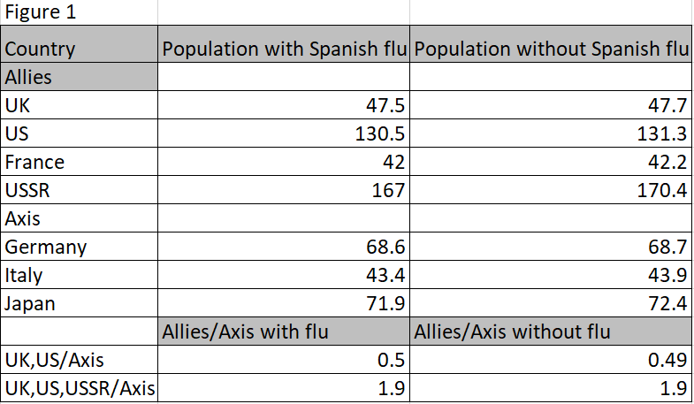
From figure 1, we calculated the ratio of Allies’ population and Axis’ population according to Mark Harrison. The two ratios with and without the Spanish flu barely change. We have conducted two ratios to reflect the ratio of population at two period of war: at the start and at the end. Hence, we can draw a conclusion that the Spanish flu does not have significant effect to the outcome of WWII with respect to population.

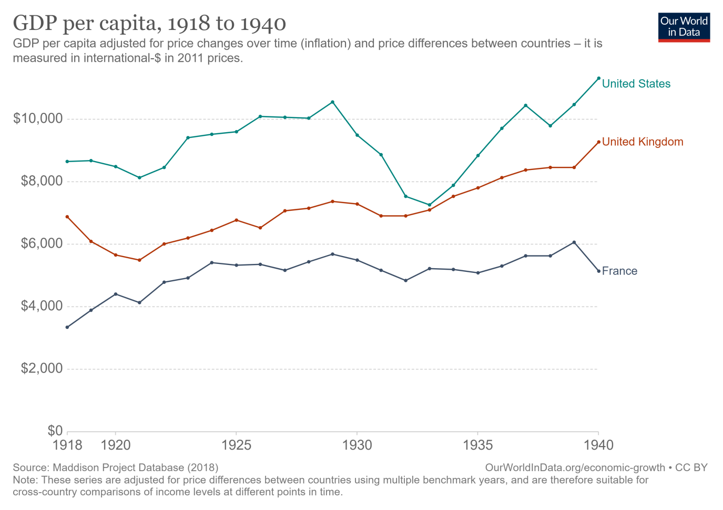
GDP
Allies

For the Allies, Sample countries are United States, United Kingdom and France. The data illustrates the real GDP per capita from 1918 to 1940 calculated by using 2011 price as base year measured in US dollars. During pandemic, in 1918 to 1920, USA’s GDP per head dropped from $8,648 to $8,485 and, in UK, $6,888 to $5,656. However, France had opposite from them which increased from $3,348 to $4,399. Therefore, the real GDP per capita growth rates in USA, UK and France were approximately -1.8%, -17% and 23%, respectively.

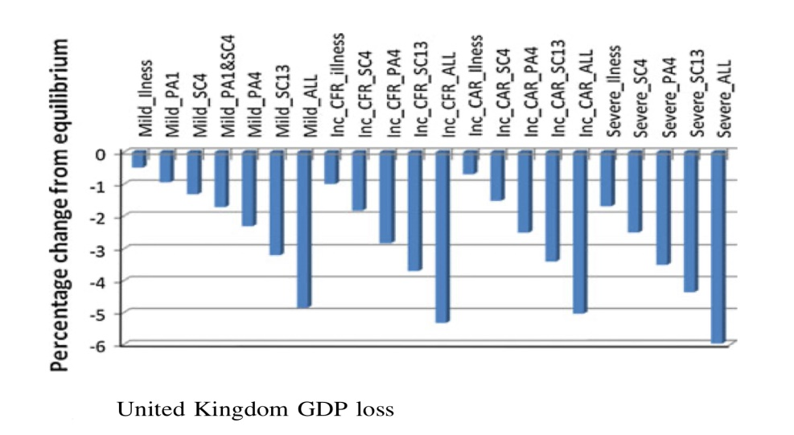
UK

Source : Marcus, R., Richard, D., John, W., & Beutels, P.(2020). The macroeconomic impact of pandemic influenza : estimates from models of United Kingdom, France, Belgium and the Netherlands.
In UK, National clinic attack of Spanish flu is around 25 percent (SPI-M modeling summary, 2018) so, it is considered as mild flu (or basic flu). As there is no information of specific period about school closure and prophylactic absence at that time, we assume that all protections had occurred at that time (13 weeks for SC and 4 weeks for PA). So, in this case, the impacts of disease reduced the GDP by about 5 percent which is less than in case of severe disease by 1 percent.
This is the percent change in main component of GDP which includes Agriculture (Agg), Retail (Ret), Hotels and restaurants (H_R), Freight and Public transport (FPT), Tourism and travel (T_T), Post and Telecommunications (P_T), Insurance (INS), Education (Edu), Health and social work (H_S), Non-essential items (N-E) and other (Oth) in severe disease scenario.
It can be seen from the line chart that there was lower equilibrium in all GDP’s majority components such as domestic output, household consumption, exports and imports. The most sector which affected by flu in domestic output was hotels and restaurants in both domestic output and household consumption. The reason is that hotels and restaurants usually are luxury goods but, during the pandemic, PA and SC considerably decreased the income of people. From the figure 6, the agriculture sector was slightly changed because people prioritized the basic need items. However, the largest negative percentage was agriculture in exports and tourism and travels in imports. Non-essential items had the best conditions in exporting and importing compared to others.

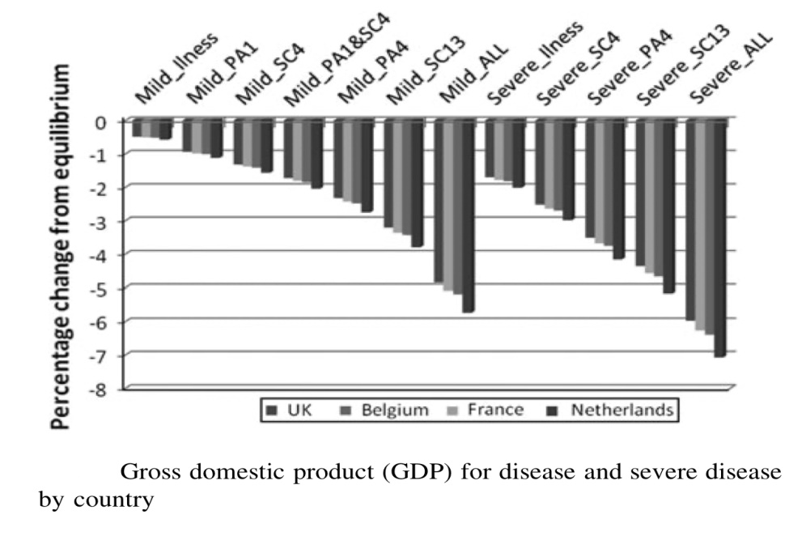
France

Source : Marcus, R., Richard, D., John, W., & Beutels, P.(2020). The macroeconomic impact of pandemic influenza : estimates from models of United Kingdom, France, Belgium and the Netherlands.

France encountered with 5.2 percent reduction in GDP. Although impact from Spanish flu damaged France economy worse than UK, France still has growth rates in GDP per capita. In 1918, Thousands of industries among France had set up then; there is increase in hiring female, youth, elderly labors and disabled soldiers. Also, US provided essential items for economy such as food, steel, coal, construction materials etc. and, monetarily, $3.6 billion loan and money through over millions of Americans soldiers (Philippe Bernard & Henri Dubief, 1985)
From data X, in domestic output and consumption, Education sectors received the worst influence which deducted from equilibrium almost 8 percent similar to hotel and restaurants sectors so, we suggest that school closure in France could be relatively intense. Compared to UK, similarly, agriculture is the highest percent reduction in both exports and imports also, the non-essential considered lower than most of the others. Even though these diagrams indicate the severe scenario, we convinced that the effect in proportion of effect as percentages in each sector would be almost identical. Therefore, it is substitutable for mild flu case in terms of tendency.

USA and USSR
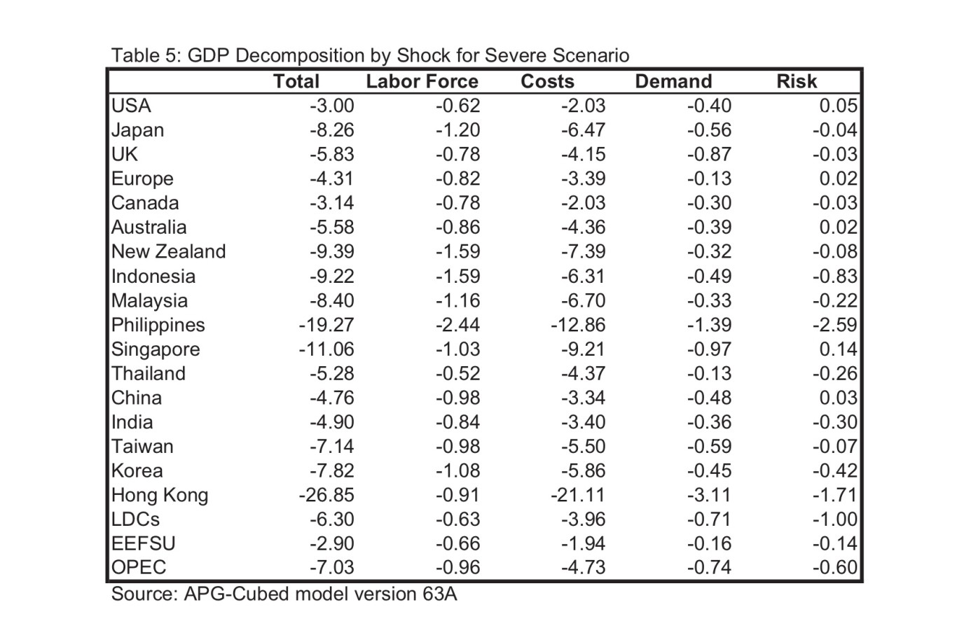

Table 5 proclaims that the severe flu lead to subsidence in GDP in terms of output productivity which derives from labor force, costs, demand and risk by 3 percent.
In data Y, Yst is an outcome such as manufacturing employment in local areas in year t and the coefficient beta j derived by a
The influenza significantly had effects on both household consumption and labor supply of economy country in order to lower the chances of spreading infection (Eichenbaum et al., 2020).From diagram A) B) and C), There was negative growth rate in manufacturing and employment. On supply side, firms and workers had less opportunity to generate their income because quarantine directly limited the productivity and employees in production. So, this created the reduction of economic activities in all sectors of business. Moreover, Due to uncertain income and revenue, firms invest less and tried to avoided risks which made even worse condition for economy. In terms of magnitude, mortality rates in 1918 brought 8 percent fall in manufacturing employment, 0.5 percent in employment-to-population and 6 percent in output. On the other hand, demand side, social distancing prevented growth of consumption of people and spending behavior depressed demand in the markets. Moving on to bank, diagram D) and E) indicated the variation of total bank assets and losing in charges-off to asset and the outcome was not great. The reason of shrink in bank asset was a part from lowering real economic activities thus, the reduction in aggregate demand and aggregate supply lessen the credit from supply and deposits from household. (Sergio et al., 2020)
In industrial production, the figure 6, at the yellow stripe between July 1918 and January 1919 shows decline in production about 20 percent.
The last one, table shows that the 1918 flu impairs EEFSU (Eastern Europe and Former Soviet Union)’s economy by 2.9% for the severe scenario.
Axis
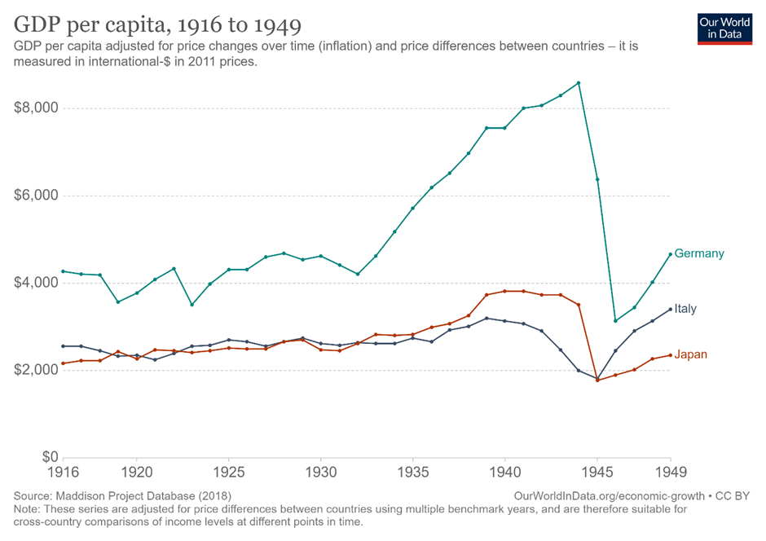

This graph shows the trend of real GDP per capita from 1918 to 1940, using 2011 as its based year, of each of the main players—Germany, Japan, and Italy— in World War II from Axis powers. As World War II began in 1939 and lasted until 1945, it can be seen from the graph that there is a drop in GDP during that period due to the war. The data from this graph will later be used for GDP growth rate calculation for years from 1918 to 1940.
The result has been recorded on the excel. As the flu had lasted from 1918 to 1920, at that time, the growth rate is adjusted by denial the impact (highlighted rows)
Germany and Italy
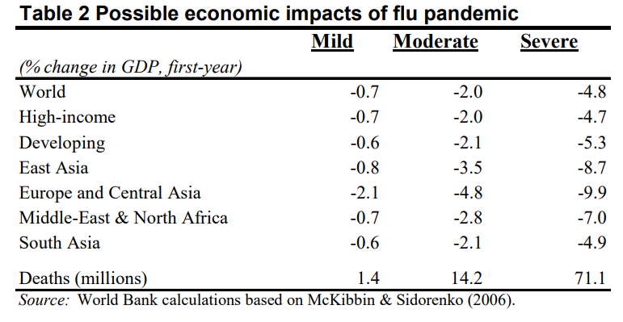
Flu can be characterized in terms of transmissibility and deadliness, however, even a flu having regular characteristics could lead to severe outcomes if there are limited immunity and vaccination. As different regions would face different level of impact of the flu pandemic, the decline of GDP would differ in each region.

Table 2 reports the results of different stages of the estimated economic impacts on GDP as the consequences of flu pandemic. The first scenario, mild, is based on the Hong Kong flu; the moderate flu has the characteristics of the 1957 Asian flu; and the severe model is benchmarked on the Spanish flu. Each of these scenarios assumes that efforts by individuals and official agencies to limit the spread of the disease are no more effectual than those observed during previous epidemics and reflects differences in population density, poverty, and the quality of healthcare available. For the whole picture, a mild pandemic would reduce output by less than 1 percent of GDP on average, a moderate one would have a negative impact by approximately 2 percent, and a severe pandemic by almost 5 percent, establishing a global recession (McKibbin and Sidorenko, 2006). Basically, hardest hit countries would be the developing ones because economic impacts are stressed by higher population density and poverty in some countries (Burns A. , Mensbrugghe D. , Timmer H.). As in this research, the impact of Spanish flu is assumed to be severe for Germany, Italy, and Japan, so decrease in GDP growth rate of 9.9 is used for cases in Germany and Italy. For Japan, different estimation is used.

Japan
Summarized in table 5, McKibbin and Sidorenko (2006) showed estimate of total impact of GDP growth rate in each country as it decomposes the economic factors that affect into four factors: a fall in the labor force as a result of increase in fatality and illness with different degree in different countries, an increase in cost of operating business, a change in buyer preference or consumer demand, and a reassessment of risk as investors observe the response of government and its policy implementation. Note that the assumption of the flu impact on an economy is a severe one also holds for Japan. Thus, growth rate of -8.26 is used to calculate for Japan’ s GDP.
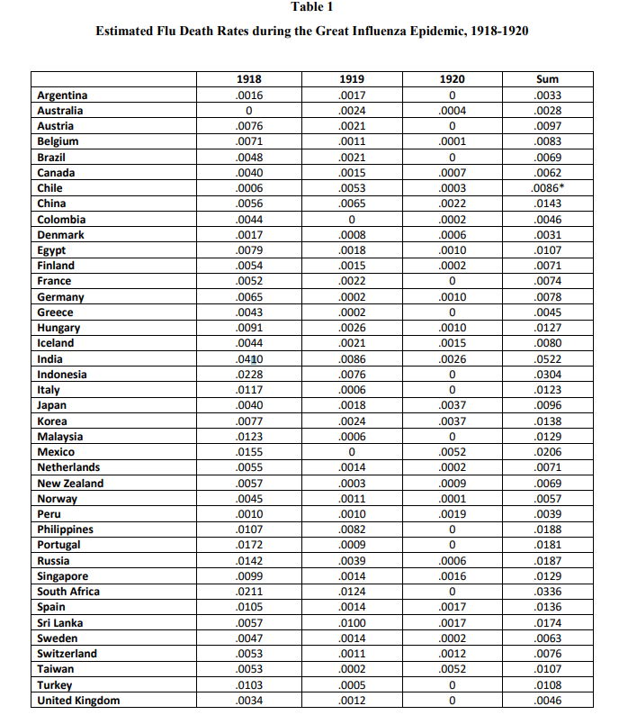

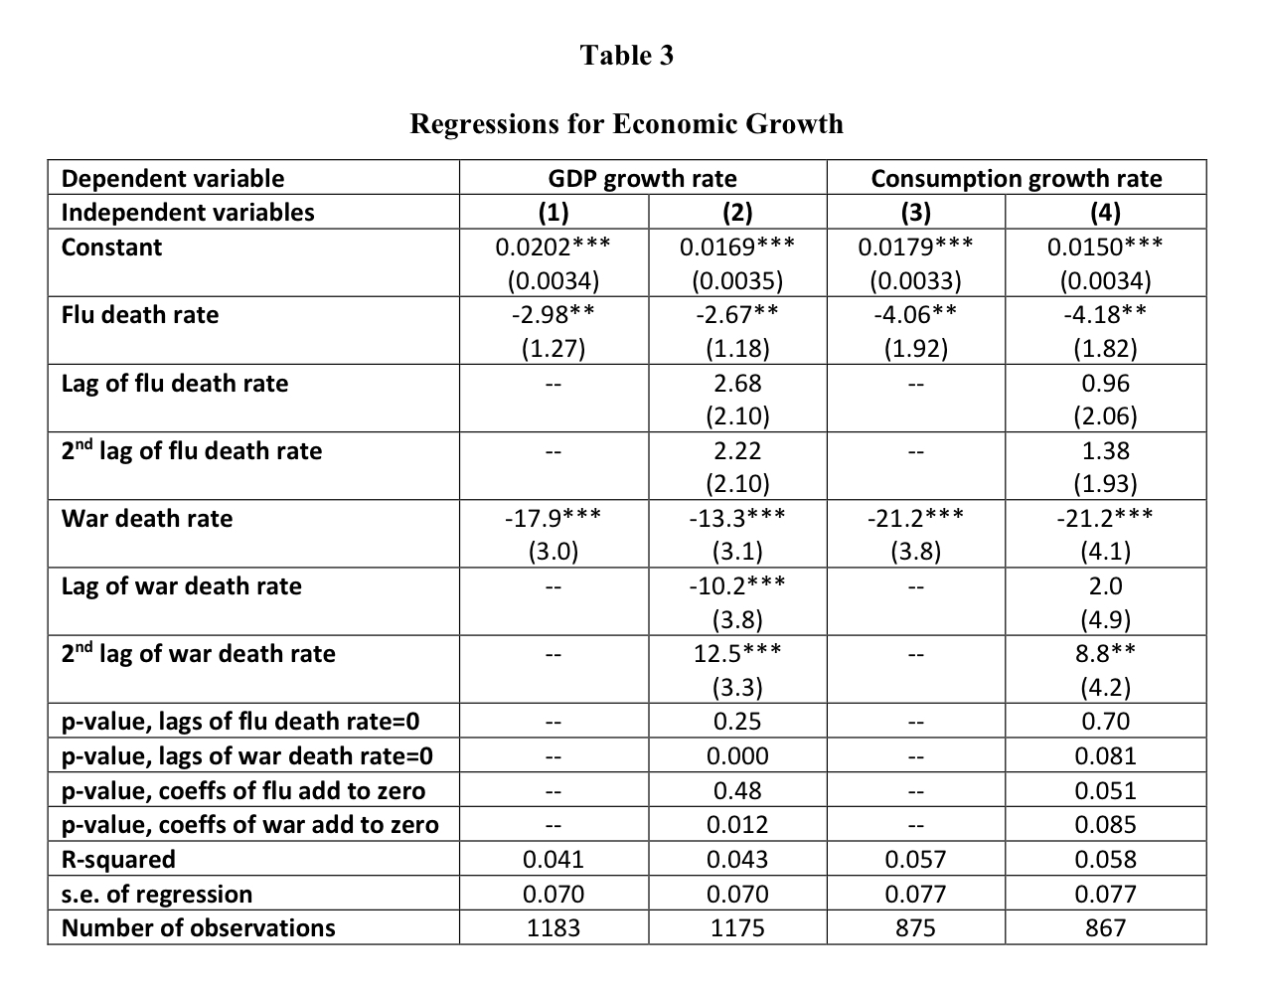
Source: Barro, J. R., Ursúa, F. J., & Weng, J. (2020). The Coronavirus and the great influenza pandemic: lessons from the “Spanish flu” for the Coronavirus’ potential effects on mortality and economic activity. Cambrigde: National Bureau of Economic Research.

Burns, et. al (2006) demonstrated that WHO has proposed in 2005 that flu for such characteristics is estimated to infect as much as 35 percent of the world’s population, and RTI reported that it spreads throughout the world within 180 days. A more virulent case such as the Spanish flu which was more deadly for healthy adults than a normal flu, could have much more serious consequences; for about 1 in 40 infected individuals had been killed or about 71 million (Barry, 2005). Moreover, some authors suggest that 180–260 million of people could have died in a worst-case scenario (Osterholm, 2005).
From table 1, as Spanish flu was during 1918 to 1920, the total 2 years’ FDRs, in the third column of table, are applied for computation.
Table 3 represents the magnitude of recessions in economic growth in various factors. In GDP growth rate subject, the first column implies negative effect of flu to growth rate temporarily but it permanently affect to real GDP per capita levels (Robert et al., 2020).So, in second row and first column is suitable for using in assumption. A number in the slot is the approximation of decline in the growth rates if the total FDR is 1. For example, if the death rate is 0.5, the outcome can be calculated by multiply 0.5 with -2.98. For this reason, after calculation of Allies countries, the numbers in USA, UK and France are roundly -1.5%, -1.4% and -2.2% respectively. For Axis powers, the growth rates of Germany, Italy and Japan are -2.32, -3.67, and -4.5 respectively.
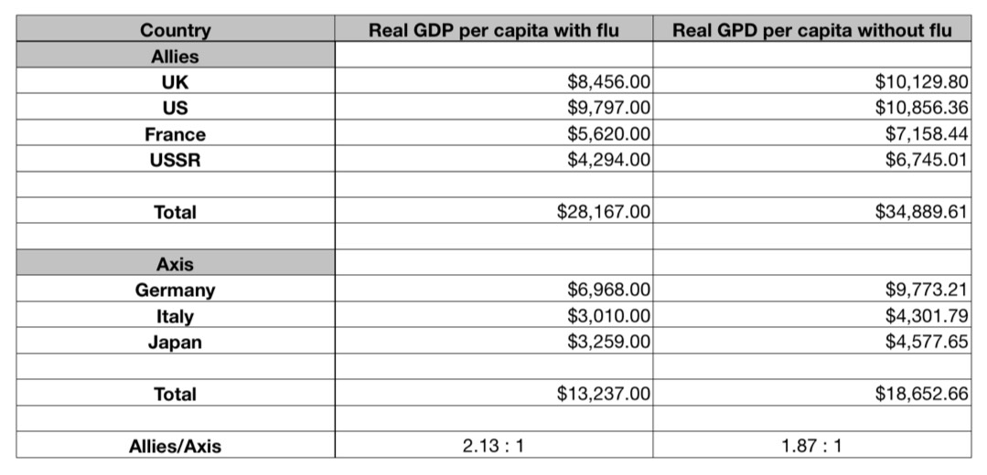
Conclusion
From the result of our research, we could possibly draw a conclusion that the occurrence of the Spanish flu had a positive effect on the Allies. With more GDP advantage, it could mean better weapon industry which played a significant role in determining the war result. This could lead to a less prolonged war. However, we can see that the impact of the pandemic is not significant enough to change the outcome of the war.

Bibliography
Mark Harrison (1998), The economics of World War II: an overview, The economics of World War II: Six Great Powers in International Comparison, (pp.1-42). Cambridge: Cambridge University Press, 1998.
UK office for national statistics, UK Population estimates 1851 to 2014. Retrieved from https://www.ons.gov.uk/peoplepopulationandcommunity/populationandmigration/populationestimates/adhocs/004356ukpopulationestimates1851to2014
U.S. Census Bureau (2000), Population Estimates Program, Population Division. Retrieved from https://www2.census.gov/programs-surveys/popest/tables/1900-1980/national/totals/popclockest.txt

Tacitus.nu, population of Eastern Europe. Retrieved from https://www.tacitus.nu/historical-atlas/population/russia.htm
Statista, Population of France from 1700 to 2020. Retrieved from https://www.statista.com/statistics/1009279/total-population-france-1700-2020/
Kristian Blickle Federal Reserve Bank of New York Staff Reports, no. 921, Pandemics Change Cities: Municipal Spending and Voter Extremism in Germany, 1918-1933
Spanish flu in Italy. Retrieved from https://europepmc.org/article/med/29525806
Akihiko Kawana,* Go Naka,* Yuji Fujikura,* Yasuyuki Kato,* Yasutaka Mizuno,* Tatsuya Kondo,* and Koichiro Kudo, Spanish influenza in Japanese Armed Force, 1918-1920. Retrieved from https://www.ncbi.nlm.nih.gov/pmc/articles/PMC2725954/
GDP per capita, 1870 to 2016. Retrieved from https://ourworldindata.org/search?q=GDP+per+capita+in+USA
Barro, J. R., Ursúa, F. J., & Weng, J. (2020). The Coronavirus and the great influenza pandemic: lessons from the “Spanish flu” for the Coronavirus’ potential effects on mortality and economic activity. Cambrigde: National Bureau of Economic Research.
Burns, A., Mensbrugghe, D., & Timmer H. (2006). Evaluating the Economic Consequences of Avian Influenza.
McKibbin, J. W. & Sidorenko, A. A. (2006). Global Macroeconomic Consequences of Pandemic Influenza. Miscellaneous Publications.
Marcus R., Richard D., John W. & Philippe B. (2009). The macroeconomic impact of pandemic influenza : estimates from models of United Kingdom,France,Belgium and The Netherlands. Springer.
Sergio C.,Stephan L. & Emil V.(2020).Pandemics depress the economy, public health intervention do not : evidence from the 1918 flu. New York : Federal reserve bank.
Warwick J.& Alexandra A. (2006). Global macroeconomic : consequences of pandemic influenza. Australia : Centre for Applied Macroeconomic Analysis (CAMA).
Francois R.(2020). What happened to the US economy during the 1918 influenza pandemic? : A view through high-frequency data. Chicago : Federal reserve bank of Chicago.

Appendix

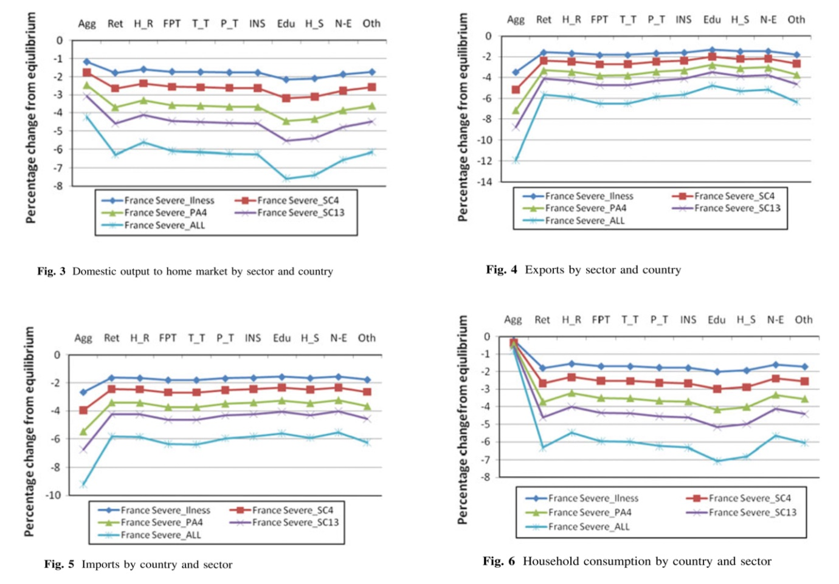
Data X

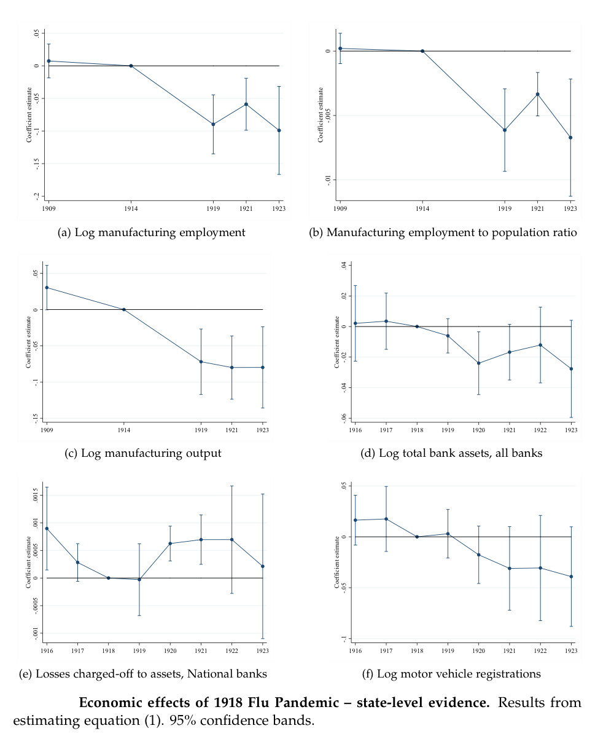

Data Y
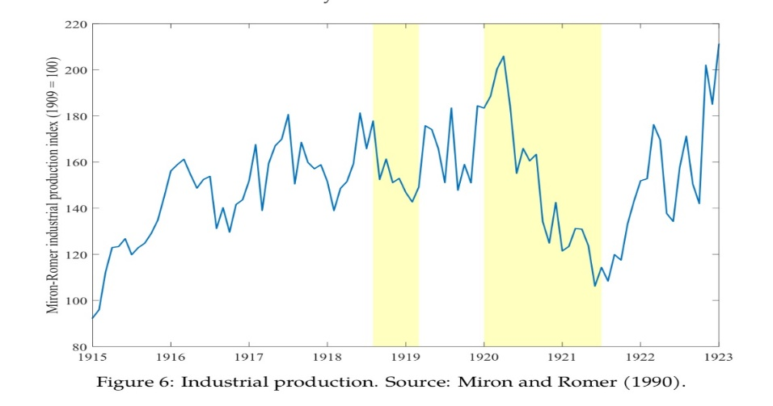

Axis

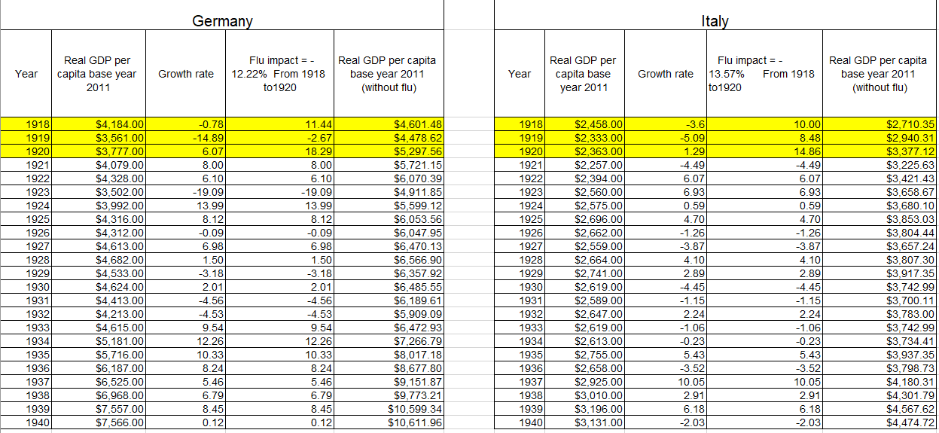

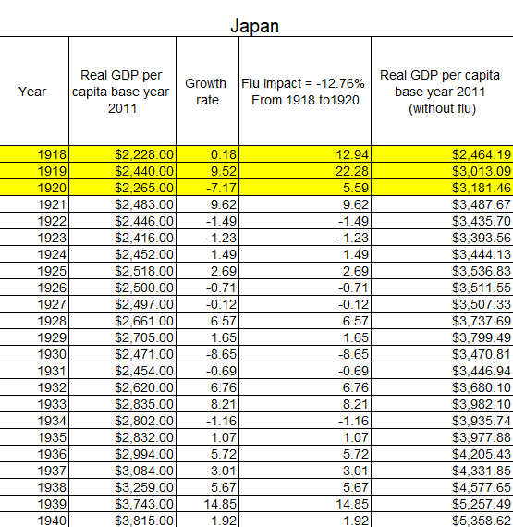

Allies



