Comparative analysis of the tourism sector
Thailand and the Netherlands

Kirsten Eummelen
5904930178
Introductory to Thai economy

Introduction

In this paper, I am going to compare the tourism sector of Thailand with my own country, the Netherlands.
Tourism is very large and influential sector in a lot of countries. It generates 9.8 % of global GDP, according to the world travel and tourism council. Moreover, the tourism sector has always had an overall growth. It forecast is that it will grow 4% annually. This makes it one of the fastest growing sectors. In the recent years, tourism has been growing faster than the overall economy and faster than sectors as automotive and financial services. Especially for developing countries, tourism is one of the main income sources.
It creates jobs and leads to infrastructure development. It has shown resilience over time.
Tourism accounts for 7 % in international exports.
Last year, in 2015, the tourist arrivals increased by 4.6%, according the world tourism organization.
Tourism was influenced by three major factors in 2015: the unusually strong exchange rate fluctuations, the decline in the price of oil and other commodities, and increased global concern about safety and security. (UNWTO, 2016)
The exchange rate fluctuations had a negative effect on the tourism sector and the decline in oil prices had a positive effect because disposable household incomes have increased.
In figure 1, it is shown how the tourism sector grew globally, with 1995 as a base year.

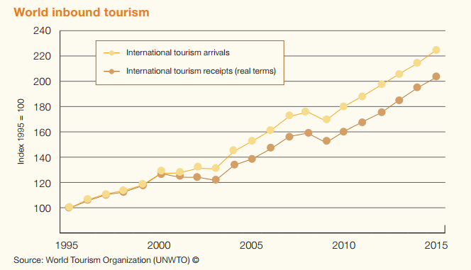

Figure 1, international tourism arrivals and receipts

Tourism in Thailand
Thailand is south-east Asia’s top destination. It grew substantially; it has been growing a lot in the period from 2000-2015. Tourism is a large earner of foreign exchange for Thailand.
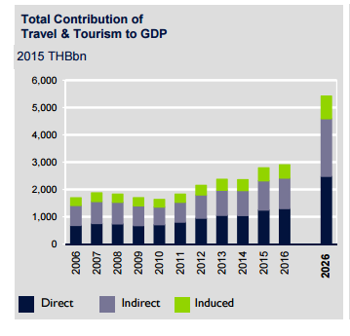

Figure 2: total contribution of travel & tourism to GDP in Thailand (source: WTTC)

Figure 2 shows the contribution of the travel and tourism sector to Thailand’s GDP. In 2015, the total contribution was 20.8% of GDP and is expected to grow to 30.5% of GDP in 2026.
A distinction is made between direct, indirect and induced effects. The direct impact of tourism is the internal spending, so the spending of the individuals but also the spending of the government on projects like museums. The indirect impact includes the investment of the government and services purchased by the tourism sector. The induced impact is the GDP and spending of those employed by the sector.

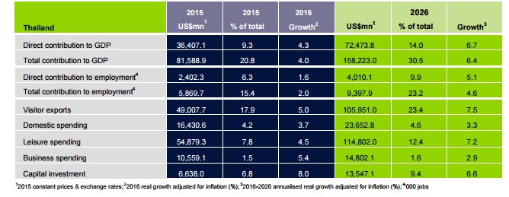

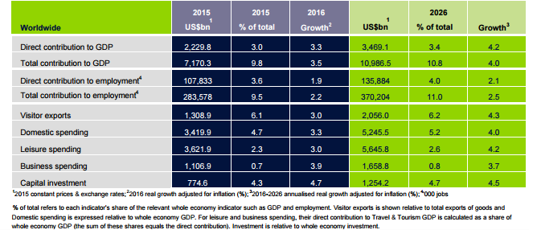
Figure 3: estimates and forecasts of the tourism and travel sector, Thailand vs Worldwide (source: WTTC)

Figure 3 shows the estimates and forecasts regarding tourism in Thailand and worldwide. When comparing the growth rates, we can conclude that the growth of 2016 in Thailand is more or less the same as the overall growth in the sector worldwide, nevertheless the forecasted growth in Thailand will be a lot more than the overall worldwide growth.

Tourism in Thailand is very versatile, with a rich culture. The friendliness of the Thai is often used as an explanation why Thailand is such a good destination for travels and tourism.
The strength of Thailand tourism’s sector is explained by the governor of tourism authority of Thailand as: ‘most tourists are quite familiar with Thailand’s unique ability to solve its international problems without any serious incident’.

Tourism in Thailand has been an important issue for the government since the third national social development plan. The government is involved to make sure Thailand earns foreign exchange and solve the balance of payment problem.
The world travel & tourism council (WTTC) shows that tourism has a big impact on the economic and social development of a country. It acquires data for the global tourism sector.
These data is needed to make policies and investment decisions, concerning the tourism sector.

Although all these positive economic effects, we also have to look at in from the other end. First of all, the numbers may seem more positive than they are. There is a great amount of leakage involved with the tourism sector, in Thailand 70% of the income earned by the tourism sector leaves Thailand, via big international companies. This is especially a problem for third world countries.
Another issue is that of economic dependence, if a country depends to much on a sector and does not diversify enough, I can become dependent of this sector, this brings along enormous risks if there are shocks concerning the tourism sector.
Lastly, there is also an environmental impact, tourism can harm the environment in many ways, there can be a loss of natural habitat or increased pollution. A good example to show this is that the Thai government has had to close a few islands because of the environmental damage to these islands. A lot of the air pollution in Thailand is caused by the transportation of tourists within the country.

Tourism in the Netherlands
Tourism is an important economic sector for the Netherlands. The tourism sector has been growing with a higher growth rate than the economy as a whole in the last 5 years.
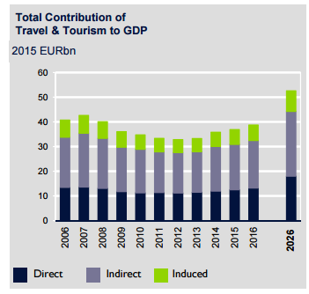
Figure 4: total contribution of travel and tourism to GDP in the Netherlands. (source: WTTC)

Figure 4 shows the total contribution of travel and tourism to GDP in the Netherlands, in 2015 this was 5.5 % of GDP and the forecast for the year 2025 is 6.4 % of GDP. When comparing this to Thailand, the tourism sector is of less economic importance to the Netherlands than to Thailand.

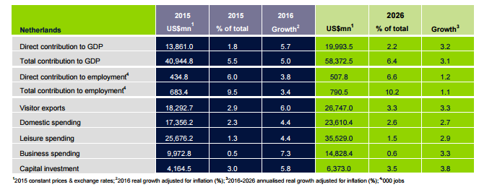
Figure 5: estimates and forecasts of the tourism and travel sector, the Netherlands vs Worldwide (source: WTTC)

Observing figure 5, the conclusion can be made that the situation in the Netherlands is the opposite of the situation in Thailand. In the Netherlands, the growth in 2016 is more than the average of the worldwide growth. However, the forecasted growth will be lower in the Netherlands than worldwide in 2026.

What characterizes the tourism sector of the Netherlands is short trips to the cities and villages with a rich and old culture, flower attractions and the vibrant capital city Amsterdam. The CBS ( a governmental institution that gathers statistical information about the Netherlands) reports about the activities done by tourists in Netherlands. The most popular activity was making a city walk, followed by going to a bar or restaurant, went shopping or made a walk in nature.

We can say that the tourism sector in the Netherlands has a positive economic impact, it generates jobs and contributes to its GDP. However, also in the Netherlands, tourism has a negative impact on the environment. Again, the transportation of the tourist has a negative impact, it causes pollution and noise disturbance. Tourism can also have effects on the ecosystems. It also has an increasing impact on the local population, when looking at the increasing overnight stays per day per square kilometer.

Tourism policies Thailand vs Netherlands
The TAT(tourism authority of Thailand) is responsible for the promotion in Thailand. The TAT has a few goals. First of all, they want to develop the E-tourism (on the internet) and apply the information technology in marketing. Further, they want to aim at the organization and management development. They support cooperation, on as well the domestic as the international level. Moreover, they want to promote the development of more proactive marketing activities. Lastly, they want to use tourism as an instrument to tackle with the economic problems of Thailand.
The cabinet has agreed to national tourism development master plan for the years 2012-2016. The goal is to become one of the top 5 destinations in Asia. This plan consists of 5 strategies.

- Develop infrastructure and logistics
- Development and rehabilitation of tourism sites
- Development of the creative economy, with new products and services
- Create confidence in Thailand among visitors
- Participation of the public sector in the tourism sector
The cabinet agreed on a plan with new tourism strategies in 2015. This plan makes sure tourism promotion stays on the national agenda. It aims at preserving national resources and the Thai culture. A important goal is distribute more to local communities and to raise awareness about sustainable development. There are 3 strategies:
- Promote Thailand as a quality leisure destination
- Facilitate travel for tourism, promote tourism safety and develop a logistic system
- Develop tourism personnel and improve related laws and mechanisms.

In the Netherlands, the ministry of economic affairs is responsible for tourism policy. It funds the Netherlands Board of tourism and conventions, this board does most of the international marketing. It also stimulates innovation, entrepreneurship and sustainability.
This all happens on the national level. On the regional level, there are other authorities that take care of this. Provinces and cities can decide themselves to spend money on promoting their tourism sector.
There are two policies:
- Policy for the hospitality sector: this group wants the Netherlands to be the country with the greatest diversity of experiences in the world.
- Policy for inbound tourism. They want to gain from increased growth in this sector.
In the overall policy of the government, there is more and more a focus on the sustainability and preventing any negative impacts on the environment.

Conclusion
When comparing the tourism sector in Thailand with the tourism sector in the Netherlands, it is possible to make some conclusions.
First of all, the tourism sector in Thailand is substantially larger than in the Netherlands, it has a bigger economic impact and leads to much more employment. Unfortunately, this doesn’t always have to be a good thing, when the economy becomes too dependent of this sector and doesn’t diversify enough, this can lead to big problems.
The characteristics of the tourism sectors are also different, this is mainly a consequence of the different nature and climate of the countries. Thailand is a very big country with a lot of nature and beaches, the Netherlands are a much smaller country and their main tourist attractions are the cities and villages.
When looking at the government policies of the two countries, they are quite similar. They both focus a lot of innovation of the sector, on promotion of the tourism internationally seen and more and more on a more sustainable and “green” industry.

References

- WTTC ( 2016) ‘Travel and tourism, economic impact Thailand 2016’

- WTTC (2016) ‘Travel and tourism, economic impact the Netherlands 2016’

- Website of the world tourism organization

- Richter L. The politics of tourism in Asia, University of Hawaii press, 1989

- Website of tourism organization of Thailand

- Website of world bank

- United nations environment programme, ‘negative economic impacts of tourism’

- Kimpee O. (2016) negative impact of tourism to the environment

- CBS (2015), trendrapport toerisme, recreatie en vrije tijd 2015

- OECD (2016), “Netherlands”, in OECD Tourism Trends and Policies 2016, OECD Publishing, Paris.

- Jackson R. Geography of travel and tourism, Delmar learning, 1990

- The government public relations department of Thailand, strategies to promote Thailand as a high-quality tourism destination, 2015

